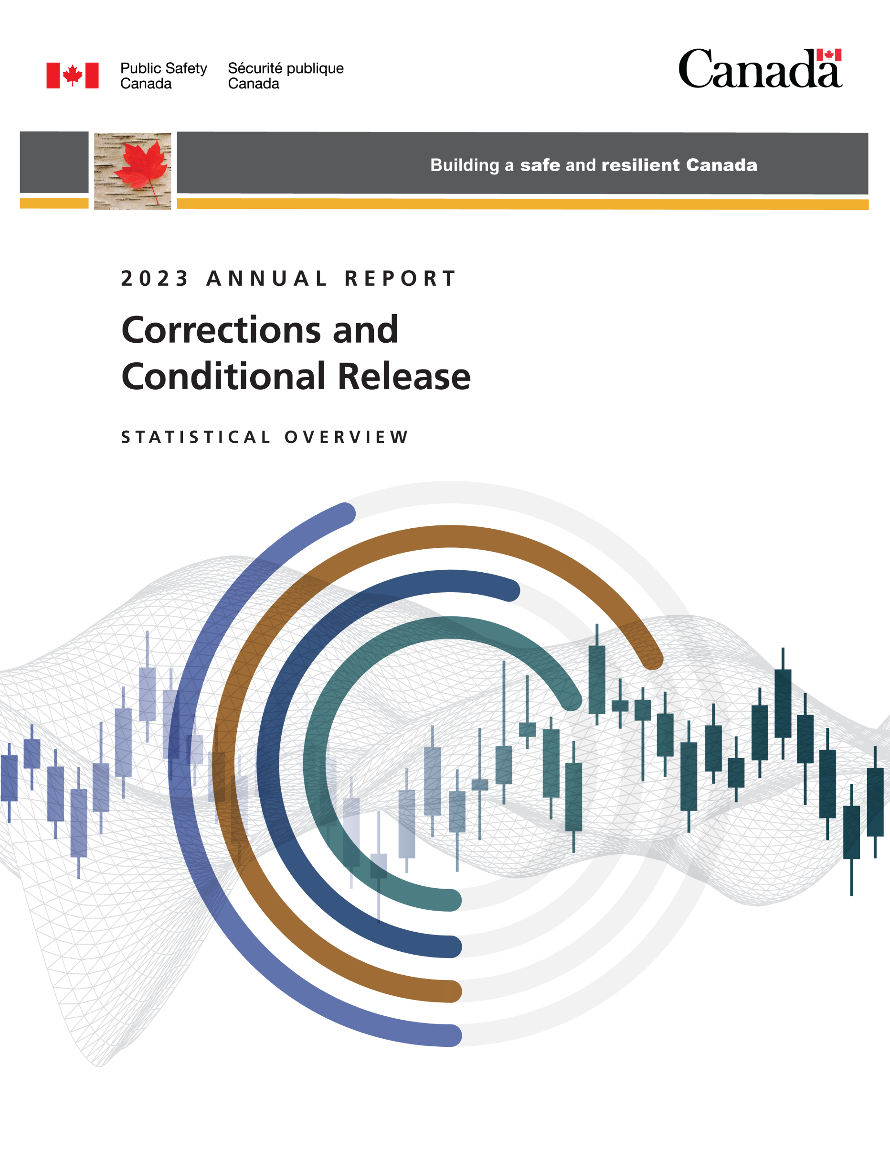

Read this publication online at:
https://www.publicsafety.gc.ca/cnt/rsrcs/pblctns/ccrso-2023/index-en.aspx
The purpose of the Corrections and Conditional Release Statistical Overview (CCRSO) is to assist the public in understanding statistical information on corrections and conditional release.
Aussi disponible en français sous le titre : L’Aperçu statistique : Le système correctionnel et la mise en liberté sous condition
This Word document is provided as an alternative format to its accessible web version. While the layout and imagery of the two formats may differ in some areas to meet different access needs, the content is the same. Please visit Canada.ca, or contact Public Safety Canada if you require other alternative formats.
To obtain permission to reproduce Public Safety Canada materials for commercial purposes or to obtain additional information concerning copyright ownership and restrictions, please contact:
Public Safety Canada, Communications
269 Laurier Ave. W
Ottawa Canada K1A 0P8

Communications@ps-sp.gc.ca
www.PublicSafety.gc.ca
© His Majesty the King in Right of Canada, as represented by the Ministers of Public Safety and Emergency Preparedness, 2025.
Publication date: 2025-07
Catalogue Number: PSI-3E-PDF
ISSN: 1713-1073

Corrections and Conditional Release Statistical Overview 2023
This document was produced by the Public Safety Canada Portfolio Corrections Statistics Committee which is composed of representatives of Public Safety Canada, Correctional Service of Canada, Parole Board of Canada, the Office of the Correctional Investigator and the Canadian Centre for Justice and Community Safety Statistics (Statistics Canada).

Preface
The Corrections and Conditional Release Statistical Overview (CCRSO) has been published annually since 1998. The purpose of the CCRSO is to assist the public in understanding statistical information on corrections and conditional release. A primary consideration in producing the CCRSO was to present general statistical information in a user-friendly way that will facilitate understanding by a broad audience. There are several features of this document that make it different from typical statistical reports:
- The visual representation of the statistics is simple and uncluttered, and under each chart, a few key points assist the reader in extracting relevant information from the chart.
- For each chart, a table of numbers corresponds to the visual representation. In some instances, the table includes additional numbers (e.g., a 5-year series), even though the chart depicts the data for the most recent year (e.g., Figure A2).
The data used in the CCRSO reflects the most recent data available at the time of preparation. For much of the report, data are available from the 2023 calendar year or for the April 1, 2022 - March 31, 2023 fiscal year. For some data, there is a lag in reporting and as such, the most recent data available are from 2021 (or April 1, 2020 - March 31, 2021). There are a few figures for which the cycle of data collection is more infrequent – for example, the General Social Survey on Canadians’ Safety (Victimization) is administered on a 5-year cycle with the most recent available data being from 2019.
Considering much of the data reported for 2020-21 was collected during the COVID-19 pandemic, the report provides an important snapshot of how the pandemic has impacted the criminal justice system. Therefore, some data trends observed between 2019-20 and 2020-21 should be interpreted with caution. The impacts of the COVID-19 pandemic may also be reflected in the data reported for 2021-22 and 2022-23.
The CCRSO includes data from partners that have different measures and methods for assessing gender and sex, and use different labels for these terms. For consistency across reporting, in the CCRSO, when sex was measured, the terms Male, Female, and Another sex were used; when gender was measured, the terms Men and Women and Boys and Girls were used.
In addition, beginning with the 2021 CCRSO, some data that was previously labelled as measuring ethnicity has been changed to race to more accurately reflect the identity concepts used by partners. As research measures pertaining to racialized groups advance, these terms and identity concepts may change in future years.
Considering the different types of crime statistics and terminology presented in the CCRSO, a certain level of data literacy is essential for accurate interpretation of the data. For example, some figures and tables in the CCRSO display frequencies, while others display rates; frequency and rate data answer different questions and inform responses to crime in different ways. To optimize the public’s ability to form an accurate, informed, and critical interpretation of different crime statistics and terminology presented in the CCRSO, a data literacy focused companion product was published along with the 2022 CCRSO and is available on https://www.publicsafety.gc.ca/cnt/rsrcs/pblctns/ccrso-2022-dt-ltrcy/index-en.aspx.
To continually improve this annual publication, we welcome your comments. Any correspondence regarding this report, including permission to use tables and figures should be directed to PS.CPBResearch-RechercheSPC.SP@ps-sp.gc.ca.

Table of contents
Preface 4
Contributing Partners 10

Section A: Crime and the Criminal Justice System 12
- Police-reported crime rate 13
- Police-reported crime rate by province/territory 17
- Police-reported violent victimization: 5-year trend 20
- Police-reported violent victimization of sexual and non-sexual violent offences by age: 5-year trend 24
- Police-reported violent crime by type and gender of victim 29
- Self-reported victimization rate 33
- Self-reported violent victimization rate by type, gender, and age 36
- Self-reported victimization reported to police 40
- The rate of adults charged 44
- Criminal Code and other Federal Statute charges among adults: 5-year trend 48
- Decisions in adult criminal court 53
- Length of adult custodial sentences 57
- The rate of youth charged 61
- Criminal Code and other Federal Statute charges among youth: 5-year trend 65
- Youth criminal court sentences: 5-year trend 70
- Youth criminal court sentences for most serious sentence: 5-year trend 74
- International incarceration rates 78
- International incarceration rates: 10-year trend 81

Section B: Corrections Administration 84
- Corrections costs federally and provincially/territorially 85
- Number of CSC employees by location 90
- Cost of incarceration in a federal institution: 5-year trend 93
- The number of Parole Board of Canada employees 96
- The number of employees in the Office of the Correctional Investigator 98
- Most common offender complaints to the Office of the Correctional Investigator 100

Section C: Federal Offender and Registered Victims Populations 103
- Offenders under the responsibility of CSC 104
- Number of registered victims and number of offenders with a registered victim: 5-year trend 107
- The number of in-custody offenders: 10-year trend 110
- Number of admissions to CSC facilities 113
- Warrant of committal admissions to CSC facilities by sex: 10-year trend 118
- Number of registered victims by gender: 5-year trend 121
- CSC total offender population by sentence length 124
- Offences of victimization among registered victims 127
- Warrant of committal admissions to a CSC facility by age 131
- Number of registered victims by age 135
- Warrant of committal admissions to a CSC facility for Indigenous and non-Indigenous offenders by age 138
- Age distribution of the CSC offender population 142
- CSC offender population by self-reported race 146
- Number of registered victims by race 150
- CSC offender population by religion 155
- CSC offenders by Indigenous and non-Indigenous self-identification 161
- Offenders in custody at a CSC facility by security risk classification 166
- Admissions to federal jurisdiction with a life and/or indeterminate sentence*: 10-year trend 168
- Proportion of offenders with life and/or indeterminate sentences 173
- Percentage of total offender population serving a sentence for a violent offence 179
- Indigenous offenders under the responsibility of CSC 183
- Number of authorizations for transfer to Structured Intervention Units in federal institutions 189
- Percentage of successful transfers out of Structured Intervention Units in federal institutions 191
- Structured Intervention Units: Time Outside of Cell 193
- Structured Intervention Units: Duration of Stay 196
- Characteristics of Offenders in Structured Intervention Unit Cells by Indigenous and non-Indigenous 198
- Reasons for Transfer to Structured Intervention Units 200
- Number of offender deaths while in custody: 10-year trend 203
- The number of escapees from federal institutions: 10-year trend 208
- CSC offenders in community under supervision: 10-year trend 211
- Offenders under provincial/territorial supervision on probation or conditional sentence: 10-year trend 215
- Population of offenders on provincial parole: 10-year trend 218

Section D: Conditional Release 221
- Number of CSC offenders granted temporary absences: 10-year trend 222
- Offenders released from federal institutions including Healing Lodges on parole: 10-year trend 226
- Federal day and full parole grant rates: 10-year trend 231
- Federal day and full parole grant rates by Indigenous and non-Indigenous offenders: 10-year trend 236
- Number of federal Elder-Assisted parole hearings: 10-year trend 242
- Proportion of sentence served prior to being released on parole: 10-year trend 246
- Proportion of sentence served prior to being released on parole by Indigenous and non-Indigenous offenders: 10-year trend 250
- Outcome of federal day parole supervision periods 255
- Outcome of federal full parole supervision periods 259
- Offenders released from federal institutions including Healing Lodges on statutory release: 10-year trend 263
- Outcome of federal statutory release supervision periods 267
- Rates of violent offence convictions for offenders on federal conditional release: 10-year trend 270

Section E: Special Applications of Criminal Justice 273
- Number of initial detention reviews: 10-year trend 274
- Annual judicial review hearings 278
- Number of Dangerous Offender designations 282
- Number of long-term supervision orders imposed 287
- Record suspensions and pardons: 5-year trend 292

Section F: Federal Services to Registered Victims 296
- Number of contacts with registered victims: 5-year trend 297
- Number of victim statements received for consideration in release decisions: 5-year trend 300
- Requests for financial assistance to attend parole hearings: 5-year trend 302
- Number of Parole Board of Canada contacts with victims: 10-year trend 304
- Victim presentations at PBC Hearings: 10-year trend 306
- Number of requests made by victims to access the PBC decision registry: 10-year trend 308
- Number of decisions sent from PBC decision registry 311

Contributing Partners

Public Safety Canada
Public Safety Canada (PS) is Canada’s lead federal department for public safety, which includes emergency management, national security and community safety. Its many responsibilities include developing legislation and policies that govern corrections, implementing innovative approaches to community justice, and providing research expertise and resources to the corrections community.

Correctional Service Canada
The Correctional Service of Canada (CSC) is the federal government department responsible for administering custodial sentences of a term of 2 years or more, as imposed by the courts. CSC is responsible for managing institutions of various security levels and supervising offenders under conditional release in the community.

Parole Board of Canada
The Parole Board of Canada (PBC) is an independent administrative tribunal responsible for making decisions about the timing and conditions of release of offenders into the community on various forms of conditional release. The Board also makes pardon, record suspension and expungement decisions and recommendations respecting clemency through the Royal Prerogative of Mercy.

Office of the Correctional Investigator
The Correctional Investigator is the ombudsperson for federal offenders. The Office of the Correctional Investigator (OCI) conducts investigations into the problems of offenders related to decisions, recommendations, acts or omissions of the Correctional Service of Canada that affect offenders individually or as a group.

Canadian Centre for Justice and Community Safety Statistics (Statistics Canada)
The Canadian Centre for Justice and Community Safety Statistics (CCJCSS) is a division of Statistics Canada. The CCJCSS is the focal point of a federal-provincial-territorial partnership, known as the National Justice Statistics Initiative, for the collection of information on the nature and extent of crime and the administration of civil and criminal justice in Canada.

Section A:
Crime and the Criminal Justice System



Police-reported crime rate

Figure A1. Police-reported crime rate. Rate per 100,000
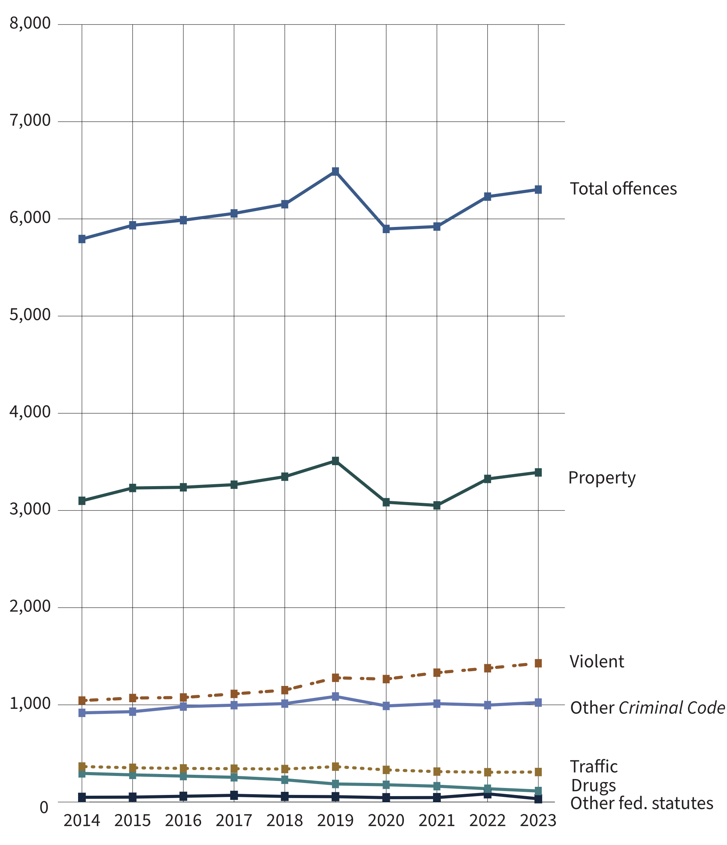
Source: Table 35-10-0177-01, Incident-based crime statistics, by detailed violations, Canada, provinces, territories and Census Metropolitan Areas.
- The police-reported crime rate increased 12.0% from 2014 to 2019, then decreased 9.1% from 2019 to 2020. From 2020 to 2023, the police-reported crime rate increased 6.9%. Fluctuations in the total police-reported crime rate between 2019 and 2022 may be due to the imposition and cessation of the COVID-19 pandemic lockdown restrictions.
- Despite fluctuations in the 10-year period between 2014 and 2023, the total police-reported crime rate slightly increased (+8.8%) from 2014 (5,793) to 2023 (6,302).
- The only type of offence that meaningfully increased from 2020 to 2023 was violent crime (+12.9%). Though, over the past year (from 2022 to 2023), there was only a slight increase in violent crime (+3.7%).
- The offence types that meaningfully decreased from 2020 to 2023 were other federal statutes (-25.6%) and drug offences (-36.0%).
- Notably, the police-reported crime rate is lower in 2023 (6,302) than it was at the inception of the survey in 1998 (8,915).
Notes
Other Criminal Code offences (Other CC) includes administration of justice violations, weapons/firearms violations, counterfeit, possession of, accessing, making or distribution of child pornography and prostitution.
Other federal statute offences refer to offences against Canadian federal statutes, such as Customs Act, Employment Insurance Act, Firearms Act, Food and Drugs Act (FDA), Income Tax Act, Controlled Drugs and Substances Act (CDSA) and Narcotic Control Act (NCA). This offence category excludes Criminal Code of Canada offences.
The total crime rate in the Corrections and Conditional Release Statistical Overview includes traffic offences to provide a measure of all criminal offences. As a result, the total crime rate reported here is higher than the conventional crime rate reported by Statistics Canada, which excludes traffic offences.
These crime statistics are based on crimes that are reported to the police. Since not all crimes are reported to the police, these figures underestimate actual crime statistics. See A6 to A8 for self-reported rates based on General Social Survey (GSS) on Canadians’ Safety surveys (victimization), an alternative method of measuring crime. GSS data is complementary to police-reported crime data, as many individuals who are victimized do not report their victimization to police; therefore, GSS data contributes to a more holistic representation of actual crime statistics.

Table A1. Police-reported crime rate. Rate per 100,000
Year | Violent | Property | Traffic | Other CC | Drugs | Other fed. statutes | Total charged
1998 | 1,345 | 5,696 | 469 | 1,051 | 235 | 40 | 8,915
1999 | 1,440 | 5,345 | 388 | 910 | 264 | 44 | 8,474
2000 | 1,494 | 5,189 | 370 | 924 | 287 | 43 | 8,376
2001 | 1,473 | 5,124 | 393 | 989 | 288 | 62 | 8,390
2002 | 1,441 | 5,080 | 379 | 991 | 296 | 54 | 8,315
2003 | 1,435 | 5,299 | 373 | 1,037 | 274 | 46 | 8,532
2004 | 1,404 | 5,123 | 379 | 1,072 | 306 | 50 | 8,391
2005 | 1,389 | 4,884 | 378 | 1,052 | 290 | 60 | 8,090
2006 | 1,387 | 4,809 | 376 | 1,050 | 295 | 57 | 8,004
2007 | 1,354 | 4,525 | 402 | 1,029 | 308 | 59 | 7,707
2008 | 1,334 | 4,258 | 437 | 1,039 | 308 | 67 | 7,475
2009 | 1,322 | 4,122 | 435 | 1,017 | 291 | 57 | 7,281
2010 | 1,292 | 3,838 | 420 | 1,029 | 321 | 61 | 6,996
2011 | 1,236 | 3,536 | 424 | 1,008 | 330 | 60 | 6,628
2012 | 1,199 | 3,438 | 407 | 1,001 | 317 | 67 | 6,466
2013 | 1,096 | 3,154 | 387 | 956 | 311 | 52 | 5,982
2014 | 1,044 | 3,100 | 365 | 918 | 295 | 49 | 5,793
2015 | 1,070 | 3,231 | 353 | 930 | 280 | 51 | 5,934
2016 | 1,076 | 3,238 | 346 | 982 | 267 | 60 | 5,987
2017 | 1,113 | 3,265 | 343 | 997 | 254 | 69 | 6,056
2018 | 1,151 | 3,348 | 340 | 1,013 | 229 | 58 | 6,151
2019 | 1,278 | 3,509 | 364 | 1,086 | 186 | 55 | 6,487
2020 | 1,265 | 3,085 | 331 | 989 | 177 | 45 | 5,897
2021 | 1,331 | 3,052 | 313 | 1,012 | 163 | 46 | 5,921
2022 | 1,377 | 3,325 | 307 | 997 | 137 | 85 | 6,229
2023 | 1,428 | 3,392 | 309 | 1,024 | 114 | 34 | 6,302
Source: Table 35-10-0177-01, Incident-based crime statistics, by detailed violations, Canada, provinces, territories and Census Metropolitan Areas.
Notes
Other Criminal Code offences (Other CC) includes administration of justice violations, weapons/firearms violations, counterfeit, possession of, accessing, making or distribution of child pornography and prostitution.
Other federal statute offences refer to offences against Canadian federal statutes, such as Customs Act, Employment Insurance Act, Firearms Act, Food and Drugs Act (FDA), Income Tax Act, Controlled Drugs and Substances Act (CDSA) and Narcotic Control Act (NCA). This offence category excludes Criminal Code of Canada offences.
These crime statistics are based on crimes that are reported to the police. Since not all crimes are reported to the police, these figures underestimate actual crime statistics. See A6 to A8 for self-reported rates based on General Social Survey (GSS) on Canadians’ Safety surveys (victimization), an alternative method of measuring crime. GSS data is complementary to police-reported crime data, as many individuals who are victimized do not report their victimization to police; therefore, GSS data contributes to a more holistic representation of actual crime statistics.

Police-reported crime rate by province/territory

Figure A2. Police-reported crime rate (2023). Rate per 100,000
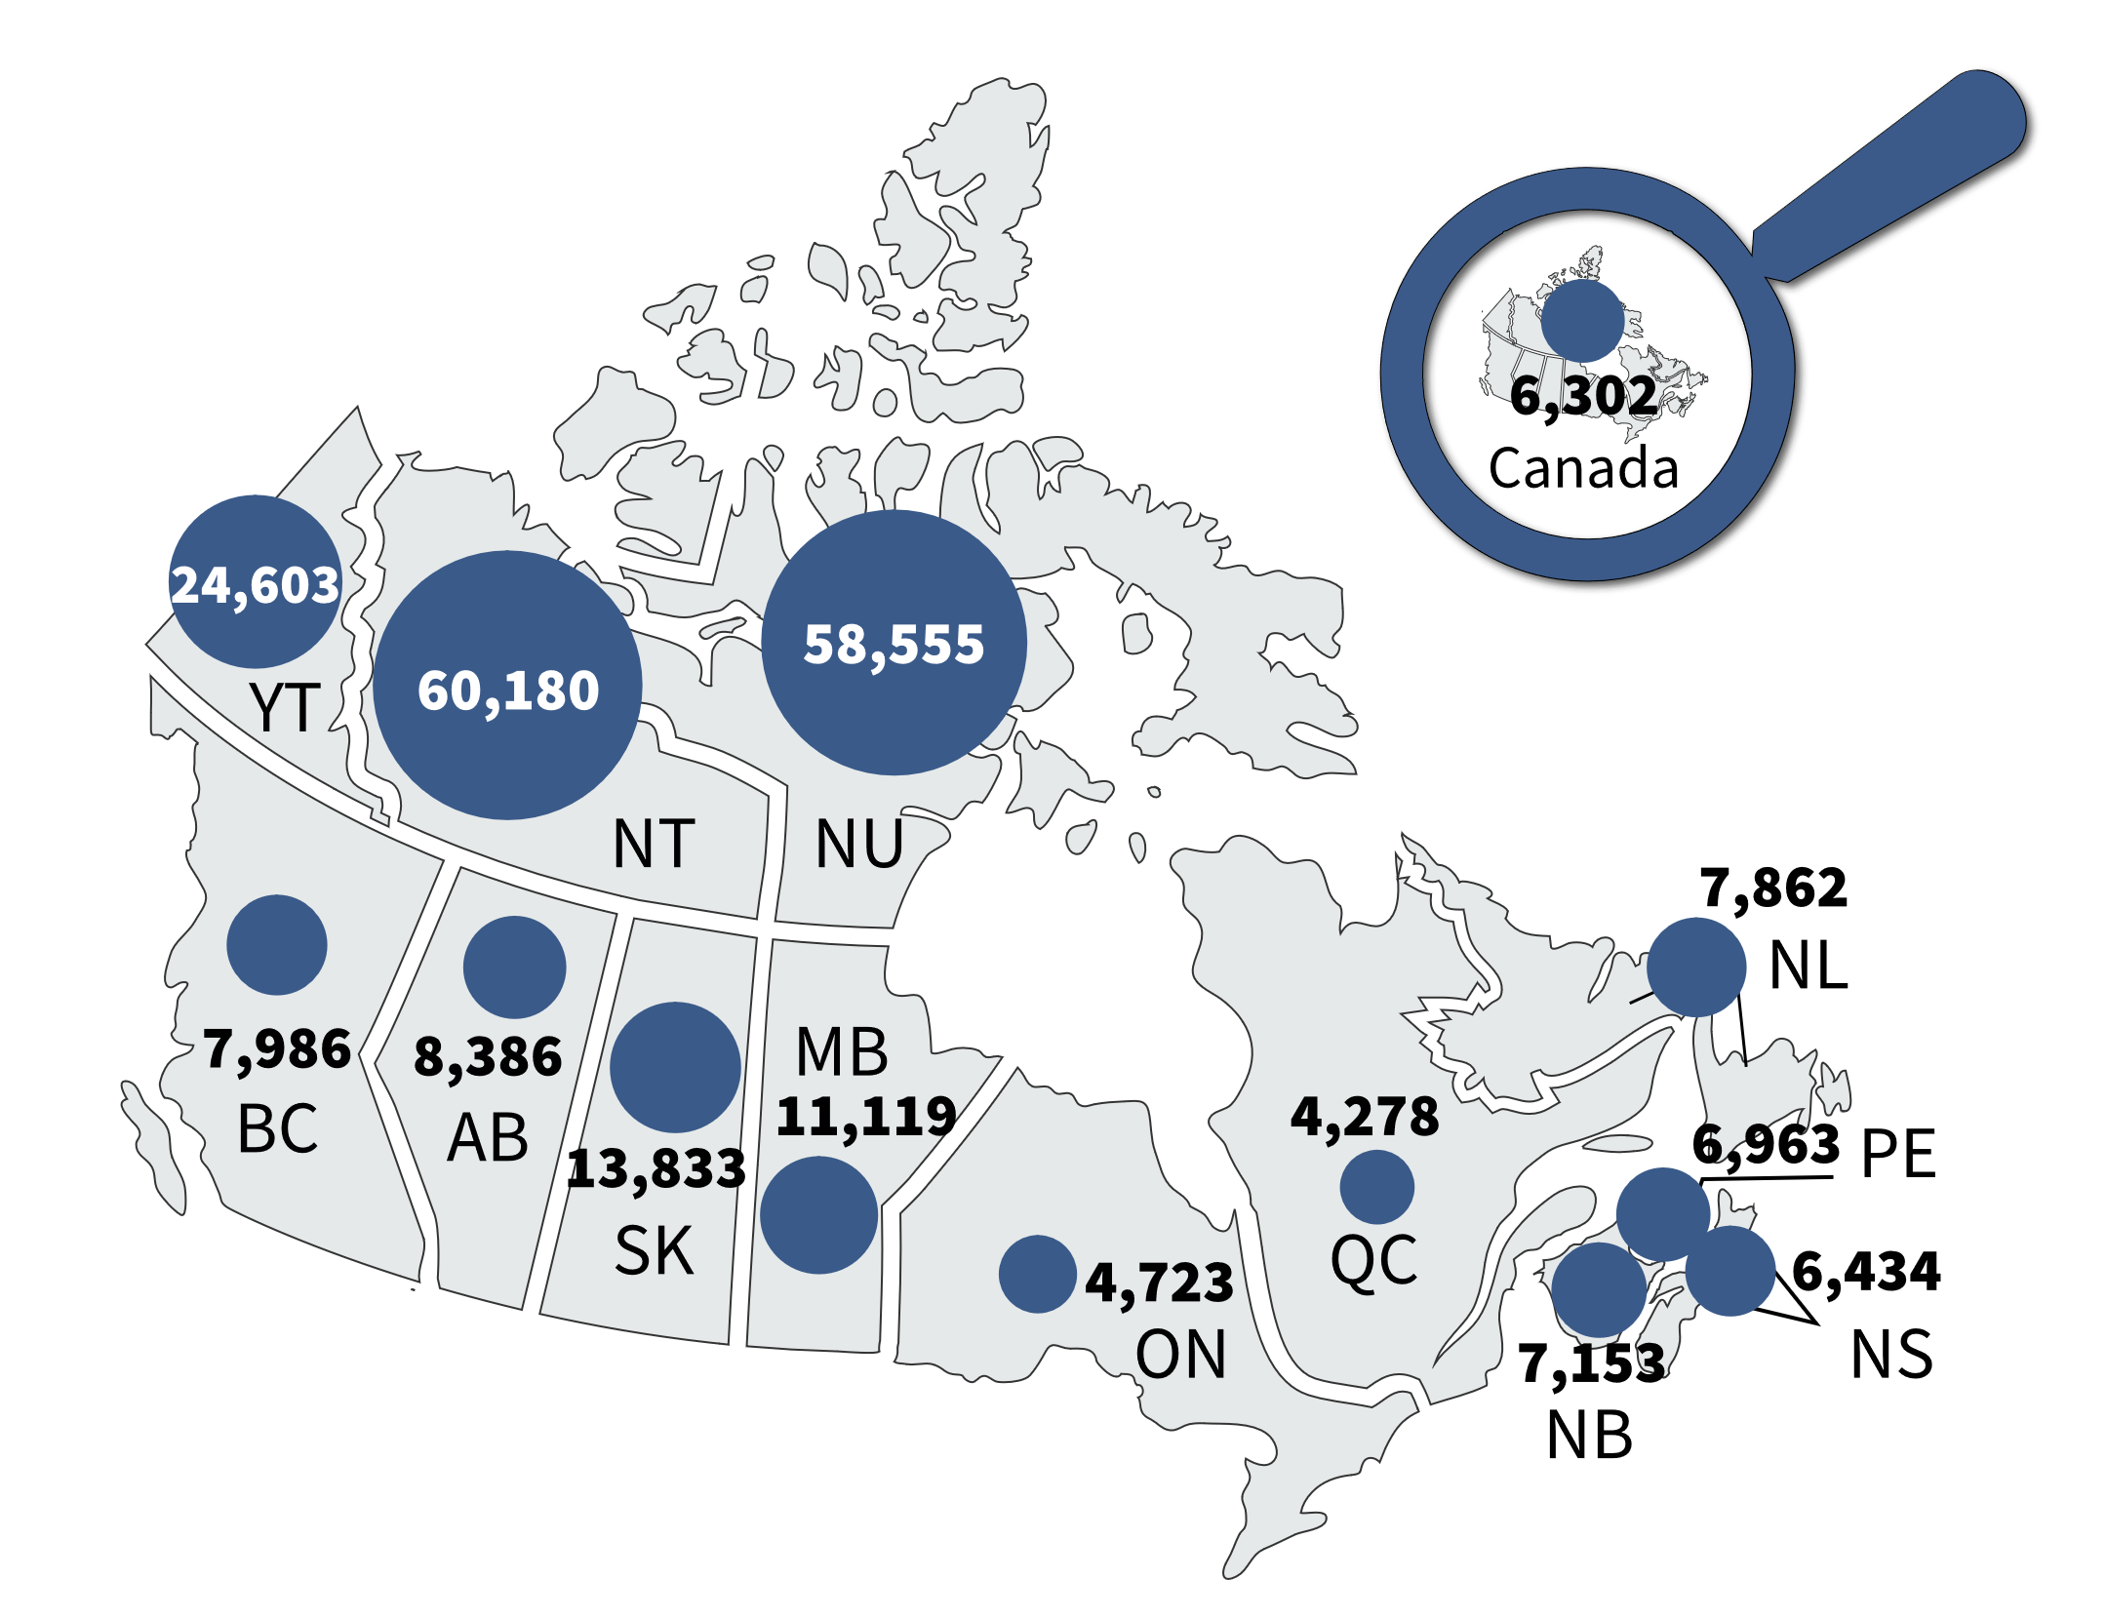
Source: Table 35-10-0177-01, Incident-based crime statistics, by detailed violations, Canada, provinces, territories and Census Metropolitan Areas.
- Crime rates were highest in the territories and elevated in central Canada. This general pattern has been stable over time.
- At the national level, police-reported crime rate decreased 9.1% from 2019 to 2020 and then increased 6.9% from 2020 to 2023.
- In the 5-year period between 2019 and 2023, the crime rate in most provinces and territories increased. The largest increases were 19.8%, 18.5%, and 10.2% in Nunavut, Newfoundland and Labrador, and Nova Scotia, respectively. In contrast, Alberta (-16.5%) and British Columbia (-16.3%) experienced the largest decreases in crime rate over this period.
Notes
These crime statistics are based on crimes that are reported to the police. Since not all crimes are reported to the police, these figures underestimate actual crime statistics. See A6 to A8 for self-reported rates based on General Social Survey (GSS) on Canadians’ Safety surveys (victimization), an alternative method of measuring crime. GSS data is complementary to police-reported crime data, as many individuals who are victimized do not report their victimization to police; therefore, GSS data contributes to a more holistic representation of actual crime statistics.

Table A2. Police-reported crime rate. Rate per 100,000
Province/territory | 2019 | 2020 | 2021 | 2022 | 2023
Newfoundland & Labrador | 6,634 | 6,698 | 7,224 | 7,446 | 7,862
Prince Edward Island | 6,339 | 5,588 | 5,407 | 5,927 | 6,963
Nova Scotia | 5,837 | 5,811 | 6,009 | 6,439 | 6,434
New Brunswick | 6,748 | 6,777 | 7,200 | 7,117 | 7,153
Quebec | 4,075 | 3,607 | 3,770 | 4,302 | 4,278
Ontario | 4,535 | 4,034 | 4,183 | 4,439 | 4,723
Manitoba | 10,860 | 10,148 | 10,001 | 11,203 | 11,119
Saskatchewan | 12,987 | 12,391 | 12,897 | 13,346 | 13,833
Alberta | 10,041 | 8,832 | 8,380 | 8,775 | 8,386
British Columbia | 9,536 | 8,681 | 8,303 | 8,126 | 7,986
Yukon Territories | 26,576 | 25,945 | 25,435 | 23,979 | 24,603
Northwest Territories | 56,201 | 61,383 | 60,013 | 59,288 | 60,180
Nunavut | 48,874 | 53,502 | 54,939 | 53,047 | 58,555
Canada | 6,487 | 5,897 | 5,921 | 6,229 | 6,302
Source: Table 35-10-0177-01, Uniform Crime Reporting Survey, Canadian Centre for Justice and Community Safety Statistics, Statistics Canada.
Notes
These crime statistics are based on crimes that are reported to the police. Since not all crimes are reported to the police, these figures underestimate actual crime statistics. See A6 to A8 for self-reported rates based on General Social Survey (GSS) on Canadians’ Safety surveys (victimization), an alternative method of measuring crime. GSS data is complementary to police-reported crime data, as many individuals who are victimized do not report their victimization to police; therefore, GSS data contributes to a more holistic representation of actual crime statistics.

Police-reported violent victimization: 5-year trend

Figure A3a. Total number of police-reported violent victimizations from 2019 to 2023
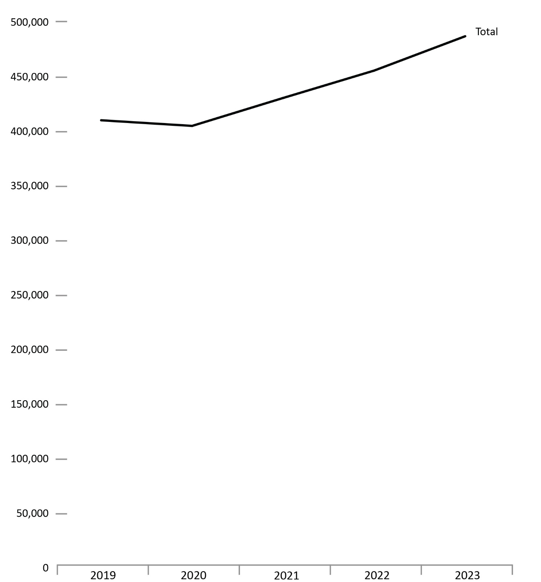

Figure A3b. Number of police-reported violent sexual victimizations from 2019 to 2023
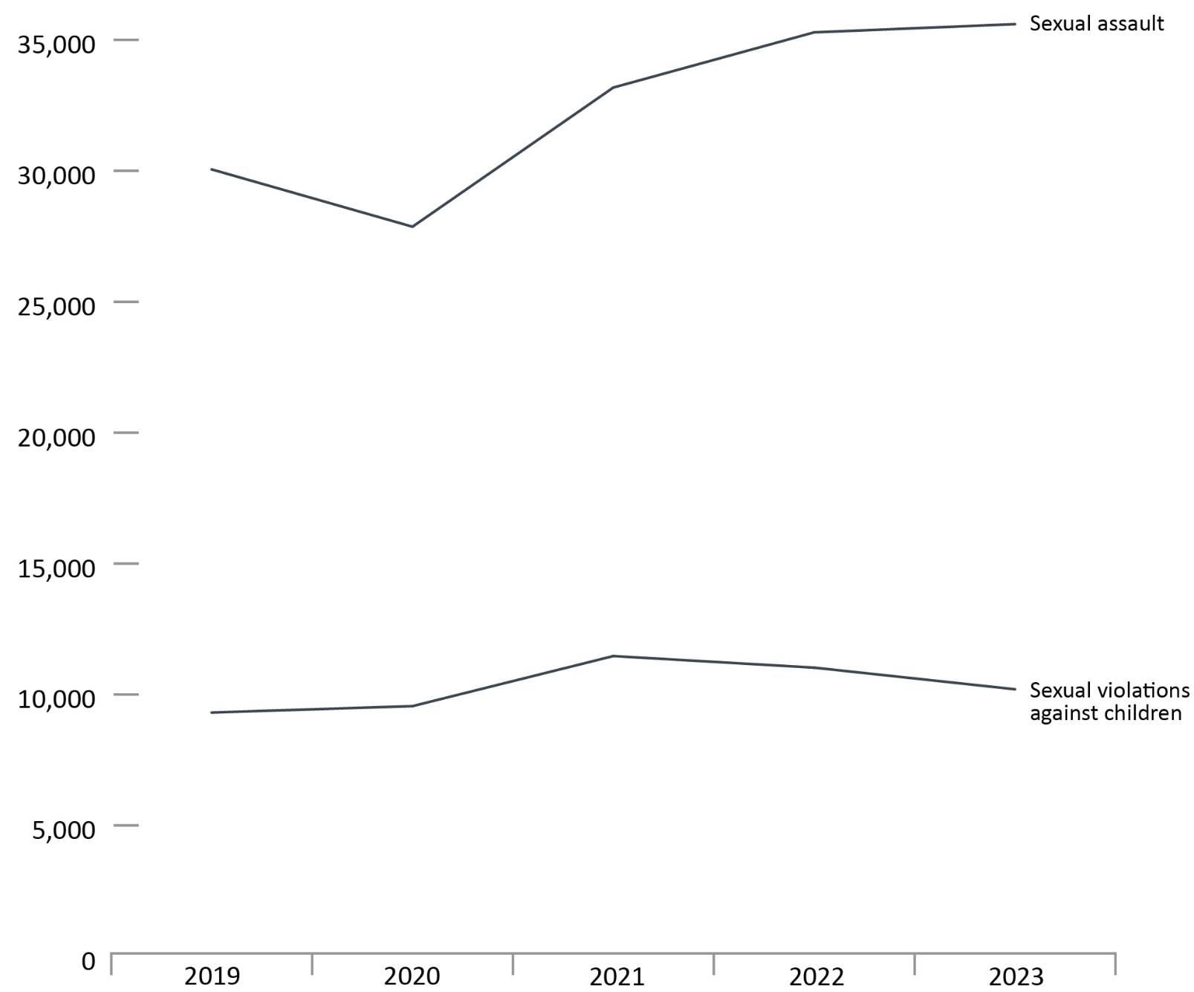
Source: Table 35-10-0049-01, Uniform Crime Reporting Survey, Canadian Centre for Justice and Community Safety Statistics, Statistics Canada.
- Police-reported violent victimization decreased 1.3% from 2019 to 2020 and then increased 12.6% from 2020 to 2022. Fluctuations between 2019 and 2022 may be due to the imposition and cessation of the COVID-19 pandemic lockdown restrictions.
- From 2022 to 2023, police-reported violent victimization increased 7.0%. The offence types that increased over this time period were other violent violations (+9.7%) and physical assaults (+7.3%). The offence types that decreased over this time period were violations causing death and attempted murder (-8.3%) and sexual violations against children (i.e., direct communication and/or contact between the perpetrator and an identifiable victim; -7.5%).
Notes
Sexual violations against children are a set of Criminal Code violations that specifically concern violations involving child and youth victims. These include violations such as sexual interference, invitation to sexual touching and sexual exploitation, but exclude sexual violations not specific to children, as well as accessing/distributing child pornography.
Other violent violations includes robbery, criminal harassment, indecent/harassing communications, uttering threats, kidnapping, forcible confinement, abduction or hostage taking, trafficking in persons and prostitution and other violations.
CC traffic violations causing death or bodily harm include dangerous operation of a motor vehicle, failure to stop and other Criminal Code traffic violations.
These crime statistics are based on crimes that are reported to the police. Since not all crimes are reported to the police, these figures underestimate actual crime statistics. See A6 to A8 for self-reported rates based on General Social Survey (GSS) on Canadians’ Safety surveys (victimization), an alternative method of measuring crime. GSS data is complementary to police-reported crime data, as many individuals who are victimized do not report their victimization to police; therefore, GSS data contributes to a more holistic representation of actual crime statistics.
Excludes victims over 89 years of age.

Table A3. Number of police-reported violent victimizations from 2019 to 2023
Type of crime | 2019 | 2020 | 2021 | 2022 | 2023
Assaults | 258,861 | 255,154 | 267,199 | 285,984 | 306,956
Other violent violations | 103,234 | 103,860 | 110,153 | 114,396 | 125,520
Sexual assault (levels 1, 2, 3) | 30,055 | 27,866 | 33,181 | 35,289 | 35,602
Sexual violations against children | 9,310 | 9,555 | 11,467 | 11,025 | 10,199
Criminal Code traffic violations causing death or bodily harm | 2,839 | 2,654 | 2,740 | 2,953 | 2,975
Violations causing death and attempted murder | 1,623 | 1,685 | 1,616 | 1,787 | 1,639
Total | 405,922 | 400,774 | 426,356 | 451,434 | 482,891
Source: Table 35-10-0049-01, Uniform Crime Reporting Survey, Canadian Centre for Justice and Community Safety Statistics, Statistics Canada.
Notes
Sexual violations against children are a set of Criminal Code violations that specifically concern violations involving child and youth victims. These include violations such as sexual interference, invitation to sexual touching and sexual exploitation, but exclude sexual violations not specific to children, as well as accessing/distributing child pornography.
Other violent violations includes robbery, criminal harassment, indecent/harassing communications, uttering threats, kidnapping, forcible confinement, abduction or hostage taking, trafficking in persons and prostitution and other violations.
CC traffic violations causing death or bodily harm include dangerous operation of a motor vehicle, failure to stop and other Criminal Code traffic violations.
These crime statistics are based on crimes that are reported to the police. Since not all crimes are reported to the police, these figures underestimate actual crime statistics. See A6 to A8 for self-reported rates based on General Social Survey on Canadians’ Safety surveys (victimization), an alternative method of measuring crime.
Excludes victims over 89 years of age.

Police-reported violent victimization of sexual and non-sexual violent offences by age: 5-year trend

Figure A4a. Police-reported victimization of non-sexual violent offences by age. Rate per 100,000
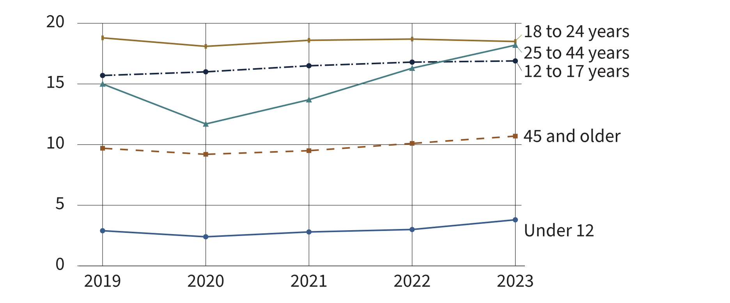
Figure A4b. Police-reported victimization of sexual violent offences by age. Rate per 100,000
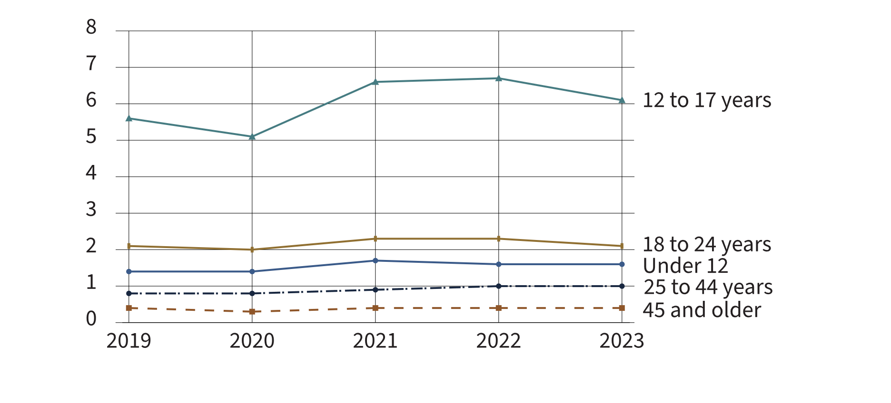
Source: Uniform Crime Reporting Survey, Canadian Centre for Justice and Community Safety Statistics, Statistics Canada.
- Adults aged 18 to 24 years had the highest rate of police-reported non-sexual violent victimization across the past 5 years (2019 to 2023).
- Notably, youth aged 12 to 17 years had the second highest rate of police-reported non-sexual violent victimization in 2023, whereas adults aged 25 to 44 previously had the second highest rate from 2019 to 2022.
- Youth aged 12 to 17 years consistently had the highest rate of police-reported sexual violent victimization in the past 5 years (2019 to 2023).
- From 2022 to 2023, rates of police-reported sexual violent victimization remained relatively stable across all age groups.
Notes
Non-sexual violent offences include 1) violations causing death and attempted murder, 2) assaults, 3) other violent violations (e.g., robbery; criminal harassment; indecent/harassing communications; uttering threats; kidnapping, forcible confinement, abduction or hostage taking; trafficking in persons and prostitution; violent firearm violations; extortion; and other violent violations), and traffic offences causing bodily harm.
Sexual violent offences include 1) sexual assaults and 2) sexual violations against children (e.g., child and youth victims). These include violations such as sexual interference, invitation to sexual touching, and sexual exploitation.
Excludes victims over 89 years of age.

Table A4a. Victims of police-reported non-sexual violent crime by age and gender. Rate per 100,000
Age group | 2019 | 2020 | 2021 | 2022 | 2023
Under 12 total | 2.9 | 2.4 | 2.8 | 3.0 | 3.8
Boys | 3.3 | 2.7 | 3.1 | 3.2 | 3.7
Girls | 2.4 | 2.1 | 2.5 | 2.5 | 2.9
Ages 12 to 17 total | 15.0 | 11.7 | 13.7 | 16.3 | 18.2
Boys | 15.5 | 11.7 | 13.5 | 16.8 | 19.1
Girls | 14.4 | 11.8 | 13.8 | 15.6 | 17.0
Ages 18 to 24 total | 18.8 | 18.1 | 18.6 | 18.7 | 18.5
Men | 17.4 | 16.3 | 16.7 | 17.3 | 17.6
Women | 20.2 | 20.1 | 20.5 | 20.1 | 19.5
Ages 25 to 44 total | 15.7 | 16.0 | 16.5 | 16.8 | 16.9
Men | 14.8 | 14.9 | 15.2 | 15.7 | 15.7
Women | 16.7 | 17.1 | 17.8 | 17.8 | 18.1
Ages 45 and older total | 9.7 | 9.2 | 9.5 | 10.1 | 10.7
Men | 11.1 | 10.9 | 11.2 | 11.9 | 12.5
Women | 8.4 | 7.5 | 7.9 | 8.4 | 9.0
Source: Uniform Crime Reporting Survey, Canadian Centre for Justice and Community Safety Statistics, Statistics Canada.

Table A4b. Victims of police-reported sexual violent crime by age and gender. Rate per 100,000
Age group | 2019 | 2020 | 2021 | 2022 | 2023
Under 12 total | 1.4 | 1.4 | 1.7 | 1.6 | 1.6
Boys | 0.7 | 0.7 | 0.7 | 0.7 | 0.8
Girls | 2.2 | 2.2 | 2.7 | 2.4 | 2.3
Ages 12 to 17 total | 5.6 | 5.1 | 6.6 | 6.7 | 6.1
Boys | 1.1 | 1.0 | 1.2 | 1.4 | 1.4
Girls | 10.4 | 9.4 | 12.2 | 12.4 | 11.1
Ages 18 to 24 total | 2.1 | 2.0 | 2.3 | 2.3 | 2.1
Men | 0.3 | 0.3 | 0.3 | 0.3 | 0.3
Women | 4.1 | 3.9 | 4.3 | 4.4 | 4.1
Ages 25 to 44 total | 0.8 | 0.8 | 0.9 | 1.0 | 1.0
Men | 0.1 | 0.1 | 0.2 | 0.2 | 0.2
Women | 1.6 | 1.5 | 1.7 | 1.8 | 1.8
Ages 45 and older total | 0.4 | 0.3 | 0.4 | 0.4 | 0.4
Men | 0.1 | 0.1 | 0.1 | 0.1 | 0.1
Women | 0.6 | 0.6 | 0.6 | 0.7 | 0.7
Source: Uniform Crime Reporting Survey, Canadian Centre for Justice and Community Safety Statistics, Statistics Canada.
Notes
Non-sexual violent offences include 1) violations causing death and attempted murder, 2) assaults, 3) other violent violations (e.g., robbery; criminal harassment; indecent/harassing communications; uttering threats; kidnapping, forcible confinement, abduction or hostage taking; trafficking in persons and prostitution; violent firearm violations; extortion; and other violent violations), and traffic offences causing bodily harm.
Sexual violent offences include 1) sexual assaults and 2) sexual violations against children (e.g., child and youth victims). These include violations such as sexual interference, invitation to sexual touching, and sexual exploitation.
Excludes victims over 89 years of age.

Police-reported violent crime by type and gender of victim

Figure A5a. Number of victims of police-reported violent crime by type (2023)
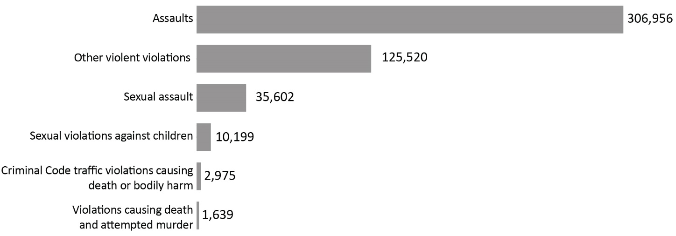
Source: Table 35-10-0049-01, Uniform Crime Reporting Survey, Canadian Centre for Justice and Community Safety Statistics, Statistics Canada.

Figure A5b. Percentage of victims of police-reported violent crime by gender of victim (2023)
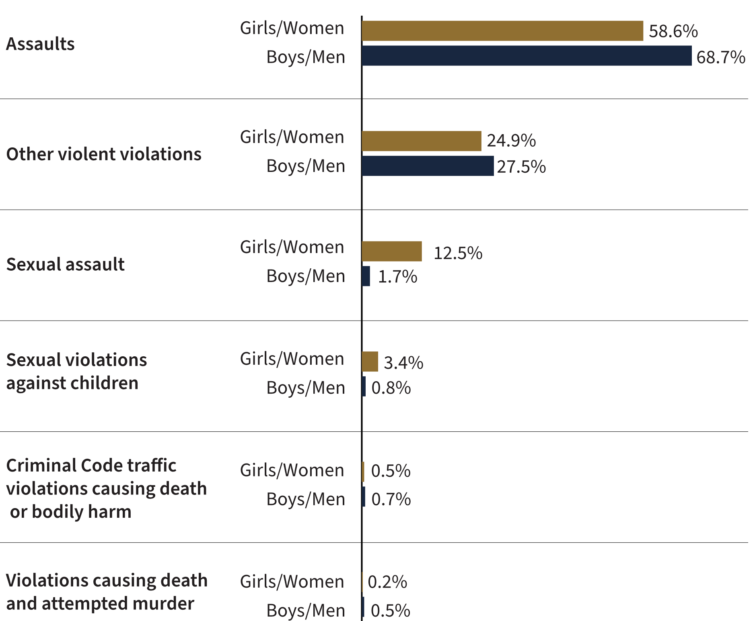
Source: Table 35-10-0049-01, Uniform Crime Reporting Survey, Canadian Centre for Justice and Community Safety Statistics, Statistics Canada.
- Assaults (physical) accounted for nearly two-thirds (63.6%) of all police-reported violent crime.
- Girls/women accounted for slightly more than half (52.0%) of all victims of violent crime.
- Boys/men were more likely than girls/women to be victims of violations causing death. Girls/women were more likely to be victims of sexual assault and sexual violations against children*, relative to boys/men.
Notes
Victims with gender unreported were omitted from Figure A5b.
Other violent violations includes robbery, criminal harassment, indecent/harassing communications, uttering threats, kidnapping, forcible confinement, abduction or hostage taking, trafficking in persons and prostitution and other violations.
*Sexual violations against children are a set of Criminal Code violations that specifically concern violations involving child and youth victims. These include violations such as sexual interference, invitation to sexual touching and sexual exploitation, but exclude sexual violations not specific to children.
Criminal Code traffic violations causing death or bodily harm include dangerous operation of a motor vehicle, failure to stop and other Criminal Code traffic violations.
Excludes victims over 89 years of age.

Table A5a. Police-reported violent crime by type and gender of victim (2023)
Crime type | Girls and women | % | Boys and men | % | Not reported | %
Assaults | 147,194 | 58.6 | 155,917 | 68.7 | 3,845 | 81.3
Other violent violations* | 62,552 | 24.9 | 62,489 | 27.5 | 479 | 10.1
Sexual assault | 31,377 | 12.5 | 3,905 | 1.7 | 320 | 6.8
Sexual violations against children** | 8,428 | 3.4 | 1,718 | 0.8 | 53 | 1.1
Criminal Code traffic violations causing death or bodily harm*** | 1,269 | 0.5 | 1,688 | 0.7 | 18 | 0.4
Violations causing death and attempted murder | 436 | 0.2 | 1,187 | 0.5 | 16 | 0.3
Total | 251,256 | 100.0 | 226,904 | 100.0 | 4,731 | 100.0
Source: Table 35-10-0049-01, Uniform Crime Reporting Survey, Canadian Centre for Justice and Community Safety Statistics, Statistics Canada.

Table A5b. Total police-reported violent crime by type (2023)
Crime type | # | %
Assaults | 306,956 | 63.6
Other violent violations* | 125,520 | 26.0
Sexual assault | 35,602 | 7.4
Sexual violations against children** | 10,199 | 2.1
Criminal Code traffic violations causing death or bodily harm*** | 2,975 | 0.6
Violations causing death and attempted murder | 1,639 | 0.3
Total | 482,891 | 100.0

Source: Table 35-10-0049-01, Uniform Crime Reporting Survey, Canadian Centre for Justice and Community Safety Statistics, Statistics Canada.
Notes
*Other violent violations includes robbery, criminal harassment, indecent/harassing communications, uttering threats, kidnapping, forcible confinement, abduction or hostage taking, trafficking in persons and prostitution and other violations.
**Sexual violations against children are a set of Criminal Code violations that specifically concern violations involving child and youth victims. These include violations such as sexual interference, invitation to sexual touching and sexual exploitation, but exclude sexual violations not specific to children.
***Criminal Code traffic violations causing death or bodily harm include dangerous operation of a motor vehicle, failure to stop and other Criminal Code traffic violations.
Due to rounding, percentages may not add up to 100 percent.
Excludes victims over 89 years of age.

Self-reported victimization rate

Figure A6. Victims of self-reported crime by type (2019). Rate per 100,000
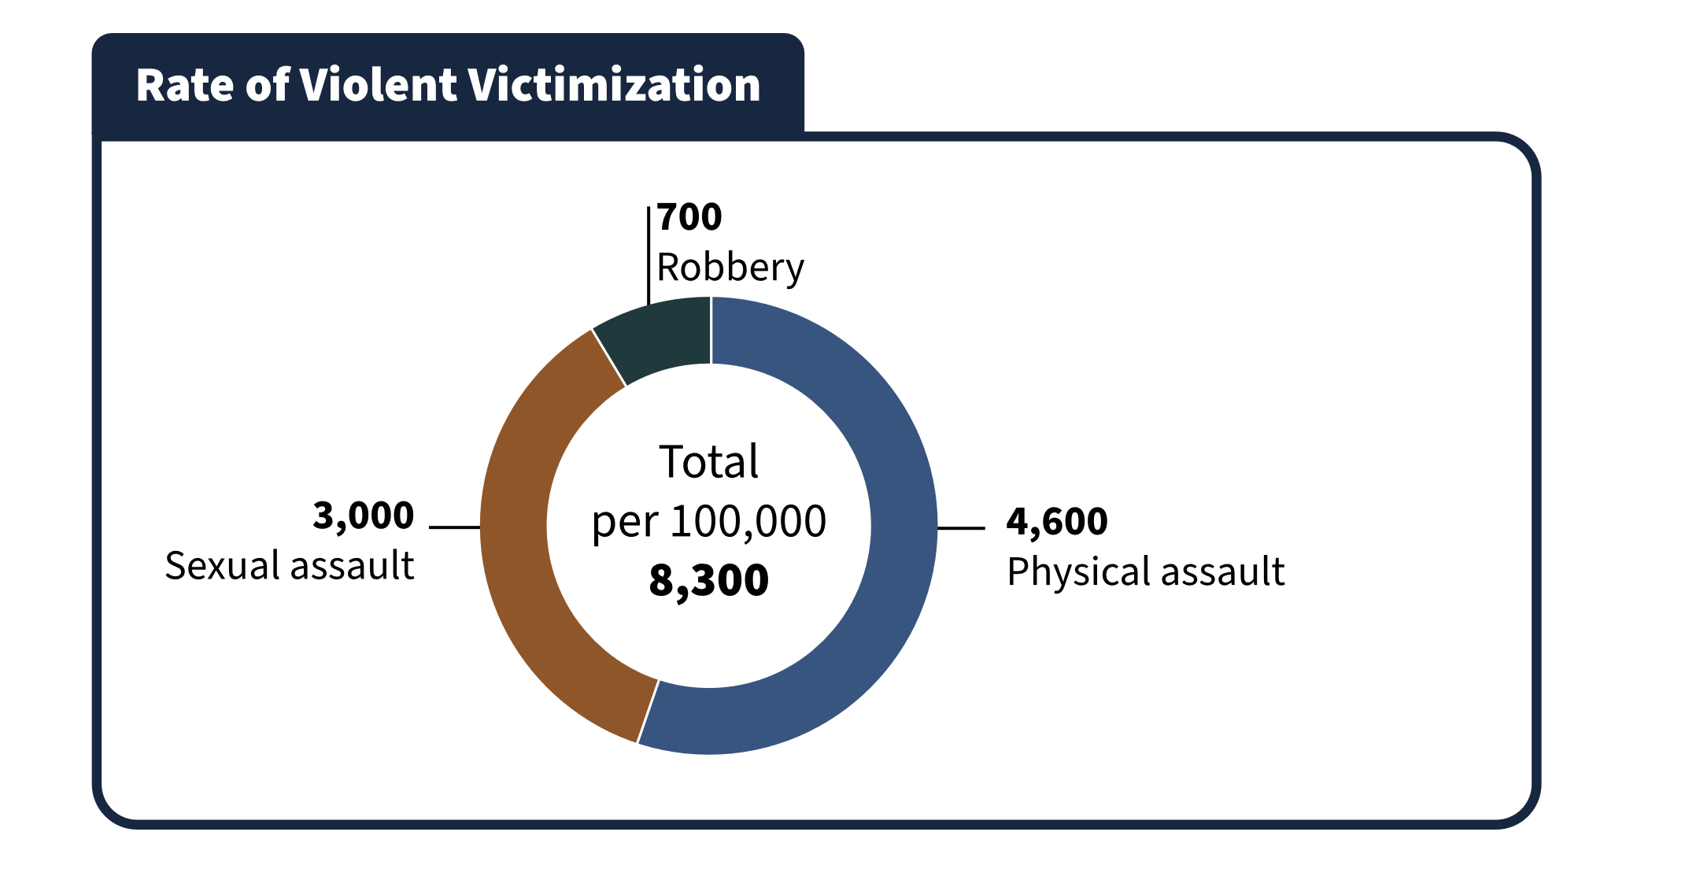
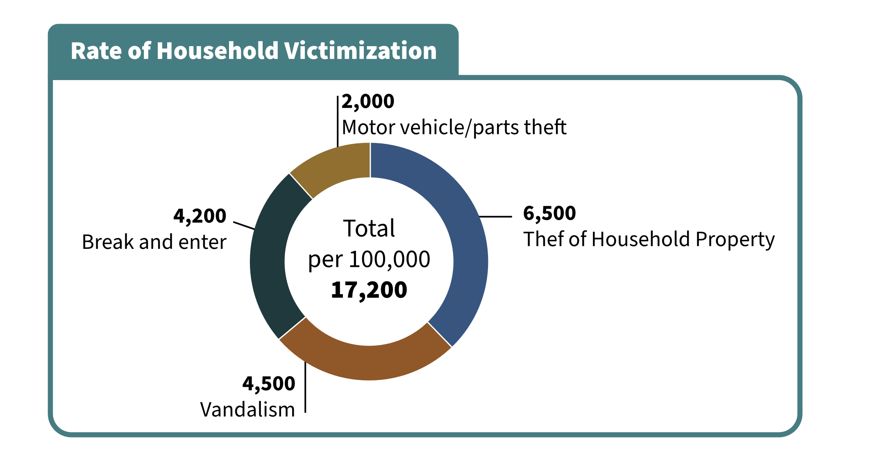
Source: General Social Survey (GSS), Statistics Canada.
- In 2019, theft of personal property was the most common self-reported form of victimization followed by theft of household property.
- Assault was the third most common self-reported crime and the most common form of violent victimization.

Notes
General Social Survey (GSS) Canadians’ Safety data are reported per 1,000 population, which are converted to per 100,000 in the CCRSO for ease of comparison with police-reported rates.
Police-reported rates are based on crimes that are reported to the police. Since not all crimes are reported to the police, these figures underestimate actual crime statistics. GSS data is complementary to police-reported crime data, as many individuals who are victimized do not report their victimization to police; therefore, GSS data contributes to a more holistic representation of actual crime statistics.
Total household victimization includes the following categories contained in the General Social Survey: motor vehicle/parts theft, break and enter, vandalism, theft of household property.
Total violent victimization includes the following categories contained in the General Social Survey: physical assault, sexual assault, and robbery.
The GSS Canadians’ Safety is conducted every 5 years, and the most recent data available are from 2019. The GSS excludes those under age 15.

Table A6. Victims of self-reported crime by type (2019). Rate per 100,000
Type of violent victimization | Rate
Theft of personal property | 9,800
Household victimization total | 17,200
Theft of household property | 6,500
Vandalism | 4,500
Break and enter | 4,200
Motor vehicle/parts theft | 2,000
Violent victimization total | 8,300
Physical assault | 4,600
Sexual assault | 3,000
Robbery | 700
Source: General Social Survey (GSS) Canadians’ Safety, Statistics Canada.
Notes
General Social Survey (GSS) Canadians’ Safety data are reported per 1,000 population, which are converted to per 100,000 in the CCRSO for ease of comparison with police-reported rates.
Police-reported rates are based on crimes that are reported to the police. Since not all crimes are reported to the police, these figures underestimate actual crime statistics. GSS data is complementary to police-reported crime data, as many individuals who are victimized do not report their victimization to police; therefore, GSS data contributes to a more holistic representation of actual crime statistics.
Total household victimization includes the following categories contained in the General Social Survey: motor vehicle/parts theft, break and enter, vandalism, theft of household property.
Total violent victimization includes the following categories contained in the General Social Survey: physical assault, sexual assault, and robbery.
The GSS Canadians’ Safety is conducted every 5 years, and the most recent data available are from 2019. The GSS excludes those under age 15.

Self-reported violent victimization rate by type, gender, and age

Figure A7a. Self-reported violent victimization rate by type and gender (2019). Rate per 100,000
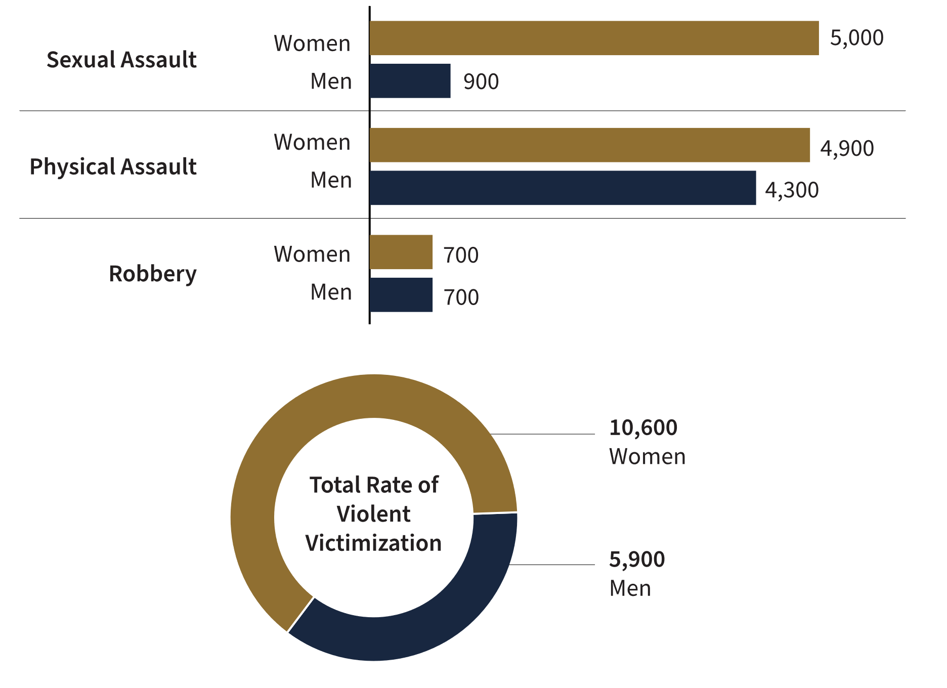
Source: General Social Survey (GSS), Statistics Canada.

Figure A7b. Self-reported violent victimization rate by age (2019). Rate per 100,000
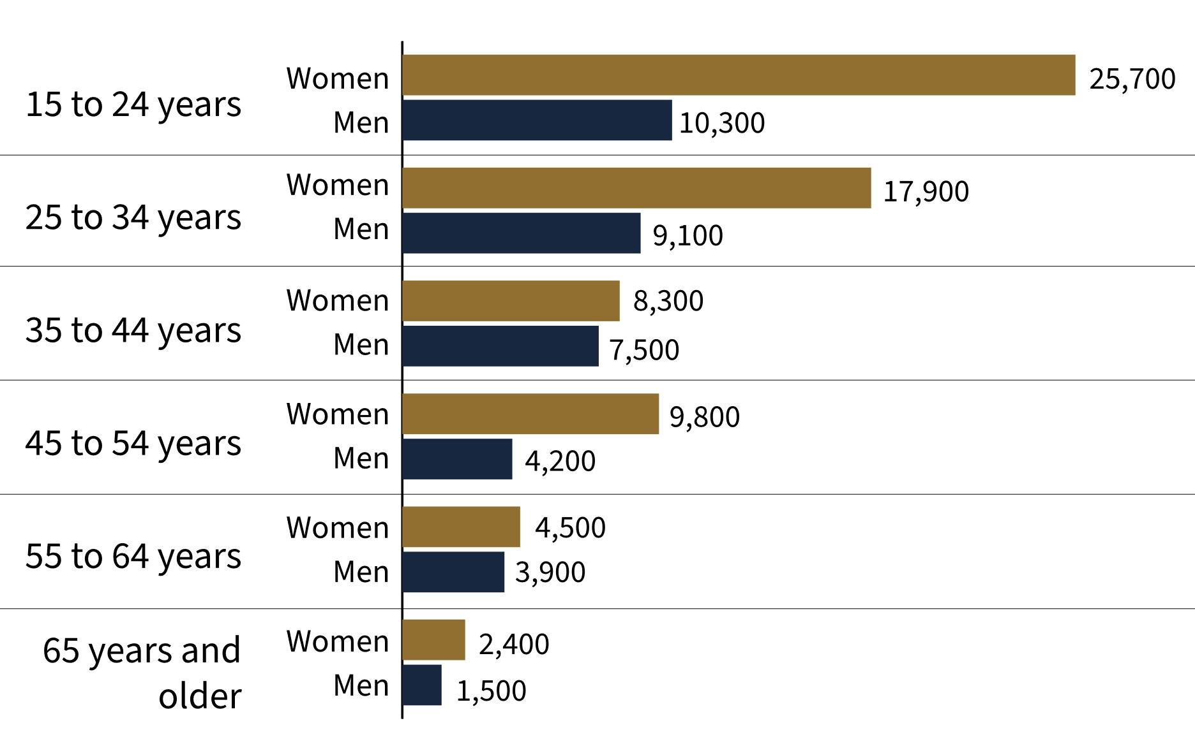
Source: General Social Survey (GSS), Statistics Canada.
- Women were more likely to experience violent victimization than men. When broken down by types of crime, the gender difference is largely due to the substantially higher number of women who self-report sexual assault.
- The gender difference in self-reported crime was greatest at ages 15 to 24 (with a difference of 15,400 per 100,000), followed by ages 25 to 34 (with a difference of 8,800 per 100,000).
Notes
General Social Survey (GSS) Canadians’ Safety data are reported per 1,000 population, which are converted to per 100,000 in the CCRSO for ease of comparison with police-reported rates.
Police-reported rates are based on crimes that are reported to the police. Since not all crimes are reported to the police, these figures underestimate actual crime statistics. GSS data is complementary to police-reported crime data, as many individuals who are victimized do not report their victimization to police; therefore, GSS data contributes to a more holistic representation of actual crime statistics.
Sexual assault remains one of the most underreported crimes, according to 2019 GSS data, with only 6% of those who had been victims of sexual assault reporting the assault to police.
Total household victimization includes the following categories contained in the General Social Survey: motor vehicle/parts theft, break and enter, vandalism, theft of household property.
Total violent victimization includes the following categories contained in the General Social Survey: physical assault, sexual assault, and robbery.
The GSS Canadians’ Safety is conducted every 5 years, and the most recent data available are from 2019. The GSS excludes those under age 15.

Table A7a. Self-reported violent victimization rate by type and gender (2019). Rate per 100,000
Type of violent victimization | Women | Men
Sexual assault | 5,000 | 900
Robbery | 700 | 700
Physical assault | 4,900 | 4,300
Total violent victimization | 10,600 | 5,900

Table A7b. Self-reported violent victimization rate by age (2019). Rate per 100,000
Age group | Women | Men
15 to 24 | 25,700 | 10,300
25 to 34 | 17,900 | 9,100
35 to 44 | 8,300 | 7,500
45 to 54 | 9,800 | 4,200
55 to 64 | 4,500 | 3,900
65 and older | 2,400 | 1,500
Source: General Social Survey (GSS) Canadians’ Safety, Statistics Canada.

Notes
General Social Survey (GSS) Canadians’ Safety data are reported per 1,000 population, which are converted to per 100,000 in the CCRSO for ease of comparison with police-reported rates.
Police-reported rates are based on crimes that are reported to the police. Since not all crimes are reported to the police, these figures underestimate actual crime statistics. GSS data is complementary to police-reported crime data, as many individuals who are victimized do not report their victimization to police; therefore, GSS data contributes to a more holistic representation of actual crime statistics.
Total household victimization includes the following categories contained in the General Social Survey: motor vehicle/parts theft, break and enter, vandalism, theft of household property.
Total violent victimization includes the following categories contained in the General Social Survey: physical assault, sexual assault, and robbery.
The GSS Canadians’ Safety is conducted every 5 years, and the most recent data available are from 2019. The GSS excludes those under age 15.

Self-reported victimization reported to police

Figure A8. Percentage of self-reported victimization reported to police (2019)
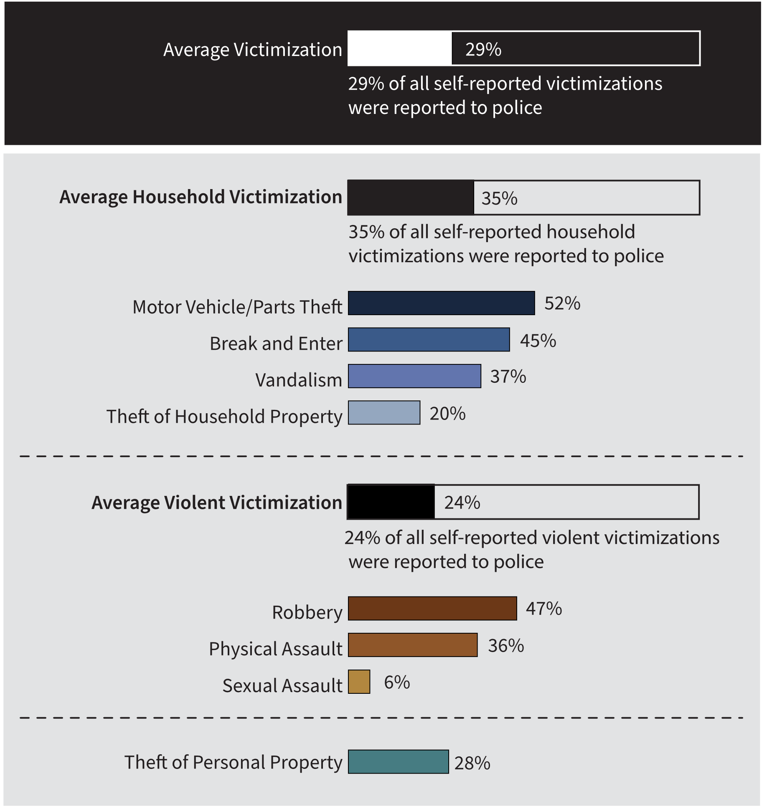
Source: General Social Survey (GSS) Canadians’ Safety, Statistics Canada.
Note: The percentages for each crime category indicate the proportion of that specific type of crime reported to the police, compared to the overall incidence of that type of crime reported under the GSS. For example, out of 100% of the self-reported thefts of personal property, only 28% were reported to police.
- Among all self-reported victims of motor vehicle/parts theft in 2019, 52% of these crimes were reported to police. This was the most frequently self-reported crime type that was reported police. Among all self-reported victims of sexual assault, only 6% were reported to police. This was the least frequently self-reported crime type that was reported to police.
- On average, self-reported household victimization crimes were more commonly reported to police than self-reported violent victimization crimes.
Notes
General Social Survey (GSS) Canadians’ Safety data are reported per 1,000 population, which are converted to per 100,000 in the CCRSO for ease of comparison with police-reported rates.
Police-reported rates are based on crimes that are reported to the police. Since not all crimes are reported to the police, these figures underestimate actual crime statistics. GSS data is complementary to police-reported crime data, as many individuals who are victimized do not report their victimization to police; therefore, GSS data contributes to a more holistic representation of actual crime statistics.
Total household victimization includes the following categories contained in the General Social Survey: motor vehicle/parts theft, break and enter, vandalism, theft of household property.
Total violent victimization includes the following categories contained in the General Social Survey: physical assault, sexual assault, and robbery.
Theft of personal property is not captured under household victimization or violent victimization; it is therefore presented separately. Theft of personal property is included in the total average victimization.
The GSS Canadians’ Safety is conducted every 5 years, and the most recent data available are from 2019. The GSS excludes those under age 15.

Table A8. Percentage of self-reported victimization reported to police (2019)
Type of victimization | Percent reported to police
Theft of personal property | 28
Household victimization average | 35
Motor vehicle/parts theft | 52
Break and enter | 45
Vandalism | 37
Theft of household property | 20
Violent victimization average | 24
Robbery | 47
Physical assault | 36
Sexual assault | 6
Average overall victimization | 29
Source: General Social Survey (GSS) Canadians’ Safety, Statistics Canada.
Notes
General Social Survey (GSS) Canadians’ Safety data are reported per 1,000 population, which are converted to per 100,000 in the CCRSO for ease of comparison with police-reported rates.
Police-reported rates are based on crimes that are reported to the police. Since not all crimes are reported to the police, these figures underestimate actual crime statistics. GSS data is complementary to police-reported crime data, as many individuals who are victimized do not report their victimization to police; therefore, GSS data contributes to a more holistic representation of actual crime statistics.
Total household victimization includes the following categories contained in the General Social Survey: motor vehicle/parts theft, break and enter, vandalism, theft of household property.
Total violent victimization includes the following categories contained in the General Social Survey: physical assault, sexual assault, and robbery.
Theft of personal property is not captured under household victimization or violent victimization; it is therefore presented separately. Theft of personal property is included in the total average victimization.
The GSS Canadians’ Safety is conducted every 5 years, and the most recent data available are from 2019. The GSS excludes those under age 15.

The rate of adults charged

Figure A9. Rate of adults charged. Rate per 100,000
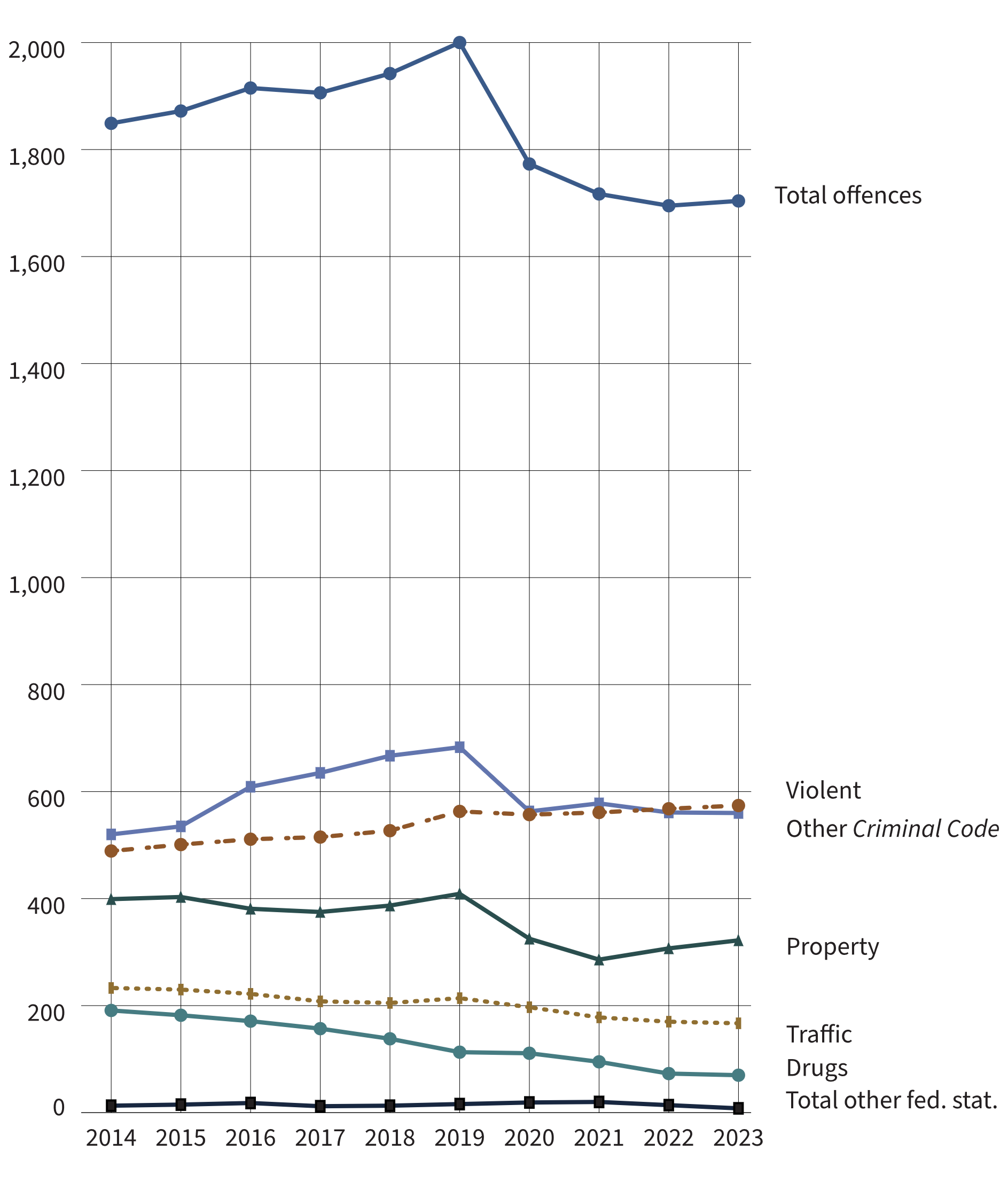
Source: Table 35-10-0177-01, Incident-based crime statistics, by detailed violations, Canada, provinces, territories and Census Metropolitan Areas.
- The overall rate of adults charged in 2023 was 7.9% lower than the rate recorded in 2014. From 2014 to 2019, there was an 8.2% increase, and from 2019 to 2023, there was a 14.8% decrease.
- Notably, the overall rate of adults charged was 23.8% lower in 2023 (1,704) than it was at the inception of the survey in 1998 (2,236).
- The rate of adults charged with violent crimes has remained relatively stable from 2019 to 2023 (+2.0%). The 2023 rate is 17.6% higher than 2014.
- The rate of adults charged with drug offences has consistently decreased, with a total decrease of 63.2% over the 10-year period from 2014 and 2023.
Notes
Other Criminal Code offences includes administration of justice violations; weapons/firearms violations; counterfeit; possession of, accessing, making, or distribution of child pornography; and prostitution.
Other federal statute offences refer to offences against Canadian federal statutes, such as Customs Act, Employment Insurance Act, Firearms Act, Food and Drugs Act (FDA), Income Tax Act, Controlled Drugs and Substances Act (CDSA) and Narcotic Control Act (NCA). This offence category excludes Criminal Code of Canada offences.
Violent crimes include homicide, attempted murder, assault, sexual offences, abduction, extortion, robbery, firearms, and other violent offences such as uttering threats and criminal harassment. Property crimes include break and enter, motor vehicle thefts, other thefts, possession of stolen property, fraud, mischief, and arson.

Table A9. Rate of adults charged. Rate per 100,000
Year | Violent | Property | Traffic | Other CC | Drugs | Total other fed. stat. | Total charged
1998 | 563 | 677 | 374 | 430 | 168 | 12 | 2,236
1999 | 590 | 632 | 371 | 396 | 185 | 18 | 2,203
2000 | 615 | 591 | 349 | 411 | 198 | 16 | 2,190
2001 | 641 | 584 | 349 | 451 | 202 | 18 | 2,256
2002 | 617 | 569 | 336 | 460 | 199 | 18 | 2,211
2003 | 598 | 573 | 326 | 476 | 172 | 15 | 2,168
2004 | 584 | 573 | 314 | 490 | 187 | 22 | 2,180
2005 | 589 | 550 | 299 | 479 | 185 | 22 | 2,131
2006 | 594 | 533 | 300 | 498 | 198 | 20 | 2,150
2007 | 577 | 499 | 298 | 521 | 208 | 20 | 2,132
2008 | 576 | 487 | 307 | 540 | 207 | 22 | 2,149
2009 | 585 | 490 | 311 | 532 | 201 | 20 | 2,152
2010 | 576 | 473 | 295 | 545 | 211 | 22 | 2,132
2011 | 548 | 441 | 271 | 527 | 213 | 23 | 2,034
2012 | 541 | 434 | 269 | 536 | 203 | 25 | 2,020
2013 | 505 | 417 | 242 | 519 | 200 | 18 | 1,910
2014 | 489 | 399 | 233 | 520 | 191 | 13 | 1,849
2015 | 501 | 403 | 230 | 535 | 182 | 15 | 1,872
2016 | 511 | 381 | 222 | 609 | 171 | 18 | 1,915
2017 | 515 | 375 | 208 | 635 | 157 | 12 | 1,906
2018 | 527 | 387 | 205 | 667 | 138 | 13 | 1,942
2019 | 563 | 409 | 214 | 683 | 113 | 16 | 2,000
2020 | 557 | 325 | 197 | 563 | 111 | 19 | 1,773
2021 | 561 | 286 | 178 | 578 | 95 | 20 | 1,717
2022 | 568 | 307 | 170 | 561 | 73 | 14 | 1,695
2023 | 574 | 322 | 167 | 560 | 70 | 8 | 1,704
Source: Table 35-10-0177-01, Incident-based crime statistics, by detailed violations, Canada, provinces, territories and Census Metropolitan Areas.

Notes
Other Criminal Code offences (Other CC) includes administration of justice offences, counterfeit, weapons/firearms violations, possession of, accessing, making or distribution of child pornography and prostitution.
Other federal statute offences refer to offences against Canadian federal statutes, such as Customs Act, Employment Insurance Act, Firearms Act, Food and Drugs Act (FDA), Income Tax Act, Controlled Drugs and Substances Act (CDSA) and Narcotic Control Act (NCA). This offence category excludes Criminal Code of Canada offences.
Violent crimes include homicide, attempted murder, assault, sexual offences, abduction, extortion, robbery, firearms, and other violent offences such as uttering threats and criminal harassment. Property crimes include break and enter, motor vehicle theft, other theft, possession of stolen property, fraud, mischief and arson.
Due to rounding, rates may not add up to totals.

Criminal Code and other Federal Statute charges among adults: 5-year trend

Figure A10. Percentage of All Charges, by Type of Charge
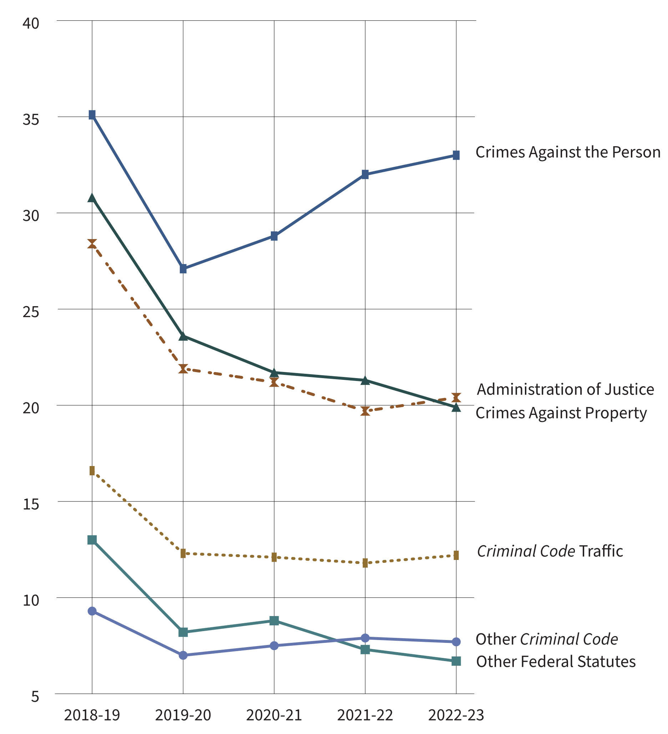
Source: Table 35-10-0027-01, Integrated Criminal Court Survey, Canadian Centre for Justice and Community Safety Statistics, Statistics Canada.
- From 2019-20 to 2022-23, crimes against the person increased from 27.1% to 33.0% of all charges among adults. In the same time period, the proportions of all other categories either decreased or remained stable.
- The most frequent charges in adult courts in 2022-23 were common assault (Level 1) (11.9%), failure to comply with order (10.3%), major assault (Level 2 and 3) (9.2%), and impaired driving (8.9%). These charges are captured in categories “Crimes against the person”, “Administration of justice”, and “Criminal Code traffic”, respectfully.
Notes
Assault is a violent offence classified into 3 levels: level 1 or common assault, the least serious form including behaviours such as pushing, slapping, punching and face-to-face threats; level 2 assault, defined as assault with a weapon or causing bodily harm; and level 3 aggravated assault, defined as assault that wounds, maims, disfigures or endangers the life of the victim.
Administration of justice includes the offences failure to appear, breach of probation, and unlawfully at large.
Other Criminal Code offences (Other CC) includes administration of justice violations; weapons/firearms violations; counterfeit; possession of, accessing, making or distribution of child pornography; and prostitution.
Other federal statute offences refer to offences against Canadian federal statutes, such as Customs Act, Employment Insurance Act, Firearms Act, Food and Drugs Act (FDA), Income Tax Act, Controlled Drugs and Substances Act (CDSA) and Narcotic Control Act (NCA). This offence category excludes Criminal Code of Canada offences.
The concept of a case has changed to more closely reflect court processing. Statistics from the Integrated Criminal Court Survey used in this report should not be compared to editions of the Corrections and Conditional Release Statistical Overview prior to 2007. A case is one or more charges against an accused person or corporation, processed by the courts at the same time, and where all of the charges in the case received a final disposition. Where a case has more than one charge, it is necessary to select a charge to represent the case. An offence is selected by applying two rules. First, the most serious decision rule is applied. In cases where two or more offences have the same decision, the most serious offence rule is applied. All charges are ranked according to an offence seriousness scale. Superior Court data are not reported to the Integrated Criminal Court Survey for Prince Edward Island, Quebec, Ontario, Manitoba, and Saskatchewan. In addition, information from Quebec's municipal courts is not collected.
The Canadian Centre for Justice and Community Safety Statistics continues to make updates to the offence library used to classify offence data sent by the provinces and territories. These improvements have resulted in minor changes in the counts of charges and cases as well as the distributions by type of offence. Data presented have been revised to account for these updates.
Due to rounding, percentages may not add up to 100 percent.
The figure includes data from the most recent year available at the time of publication.
Reported year periods reflect fiscal years. A fiscal year runs from April 1 to March 31 of the following year.

Table A10. Type of charge
Type of charge | 2018-19 | 2019-20 | 2020-21 | 2021-22 | 2022-23
Crimes against the person | 82,921 | 85,828 | 68,110 | 70,864 | 71,049
Homicide and related | 340 | 330 | 311 | 274 | 317
Attempted murder | 215 | 184 | 180 | 169 | 148
Robbery | 3,081 | 3,246 | 2,618 | 2,466 | 2,245
Sexual assault | 3,324 | 3,606 | 2,695 | 3,164 | 3,486
Other sexual offences | 3,995 | 4,084 | 2,883 | 3,378 | 3,731
Major assault (levels 2 & 3) | 19,616 | 20,780 | 17,429 | 18,797 | 19,698
Common assault (level 1) | 32,234 | 32,362 | 24,733 | 26,522 | 25,610
Uttering threats | 12,981 | 13,784 | 11,117 | 10,328 | 9,664
Criminal harassment | 3,347 | 3,693 | 3,065 | 2,720 | 2,821
Other crimes against persons | 3,218 | 3,321 | 2,888 | 2,843 | 3,154
Crimes against property | 72,768 | 74,857 | 51,219 | 47,086 | 42,876
Theft | 27,718 | 28,453 | 16,611 | 13,400 | 12,014
Break and enter | 9,297 | 10,007 | 7,918 | 7,604 | 7,519
Fraud | 10,953 | 11,384 | 7,482 | 6,235 | 5,478
Mischief | 11,997 | 11,899 | 9,493 | 10,940 | 10,097
Possession of stolen property | 10,448 | 10,678 | 7,868 | 7,228 | 6,633
Other property crimes | 2,355 | 2,436 | 1,847 | 1,679 | 1,135
Administration of justice | 67,259 | 69,469 | 50,053 | 43,691 | 43,931
Fail to appear | 4,470 | 4,278 | 3,135 | 3,432 | 4,154
Breach of probation | 26,312 | 28,122 | 18,858 | 12,706 | 12,416
Unlawfully at large | 2,688 | 2,719 | 1,345 | 521 | 457
Fail to comply with order | 26,748 | 27,426 | 21,794 | 22,153 | 22,152
Other admin. justice | 7,041 | 6,924 | 4,921 | 4,879 | 4,752
Other Criminal Code | 22,101 | 22,215 | 17,778 | 17,542 | 16,550
Weapons/firearms | 10,792 | 11,195 | 9,812 | 10,256 | 9,610
Prostitution | 23 | 11 | 32 | 7 | 26
Disturbing the peace | 634 | 634 | 409 | 353 | 333
Residual Criminal Code | 10,652 | 10,375 | 7,525 | 6,926 | 6,581
Criminal Code traffic | 39,321 | 38,892 | 28,610 | 26,082 | 26,297
Impaired driving | 30,700 | 30,423 | 22,095 | 18,589 | 19,080
Other CC traffic | 8,621 | 8,469 | 6,515 | 7,493 | 7,217
Other federal statutes | 30,832 | 26,020 | 20,694 | 16,048 | 14,335
Drug possession | 7,589 | 6,026 | 6,574 | 4,880 | 4,308
Other drug offences | 7,538 | 6,881 | 6,075 | 7,014 | 6,554
Residual federal statutes | 14,954 | 12,447 | 7,665 | 3,937 | 3,337
Total offences | 315,202 | 317,281 | 236,464 | 221,313 | 215,038
Source: Table 35-10-0027-01, Integrated Criminal Court Survey, Canadian Centre for Justice and Community Safety Statistics, Statistics Canada.
Notes
Assault is a violent offence classified into 3 levels: level 1 or common assault, the least serious form including behaviours such as pushing, slapping, punching and face-to-face threats; level 2 assault, defined as assault with a weapon or causing bodily harm; and level 3 aggravated assault, defined as assault that wounds, maims, disfigures or endangers the life of the victim.
Administration of justice includes the offences failure to appear, breach of probation, and unlawfully at large.
Other Criminal Code offences (Other CC) includes administration of justice violations, weapons/firearms violations, counterfeit, possession of, accessing, making or distribution of child pornography and prostitution.
Other federal statute offences refer to offences against Canadian federal statutes, such as Customs Act, Employment Insurance Act, Firearms Act, Food and Drugs Act (FDA), Income Tax Act, Controlled Drugs and Substances Act (CDSA) and Narcotic Control Act (NCA). This offence category excludes Criminal Code of Canada offences.
The concept of a case has changed to more closely reflect court processing. Statistics from the Integrated Criminal Court Survey used in this report should not be compared to editions of the Corrections and Conditional Release Statistical Overview prior to 2007. A case is 1 or more charges against an accused person or corporation, processed by the courts at the same time, and where all of the charges in the case received a final disposition. Where a case has more than 1 charge, it is necessary to select a charge to represent the case. An offence is selected by applying 2 rules. First, the most serious decision rule is applied. In cases where 2 or more offences have the same decision, the most serious offence rule is applied. All charges are ranked according to an offence seriousness scale. Superior Court data are not reported to the Integrated Criminal Court Survey for Prince Edward Island, Quebec, Ontario, Manitoba and Saskatchewan. In addition, information from Quebec's municipal courts is not collected.
The Canadian Centre for Justice and Community Safety Statistics continues to make updates to the offence library used to classify offence data sent by the provinces and territories. These improvements have resulted in minor changes in the counts of charges and cases as well as the distributions by type of offence. Data presented have been revised to account for these updates.
Due to rounding, percentages may not add up to 100 percent.
The table includes data from the most recent year available at the time of preparation.
Reported year periods reflect fiscal years. A fiscal year runs from April 1 to March 31 of the following year.

Decisions in adult criminal court

Figure A11. Number of cases in adult criminal court and admissions to custody (2022-23)
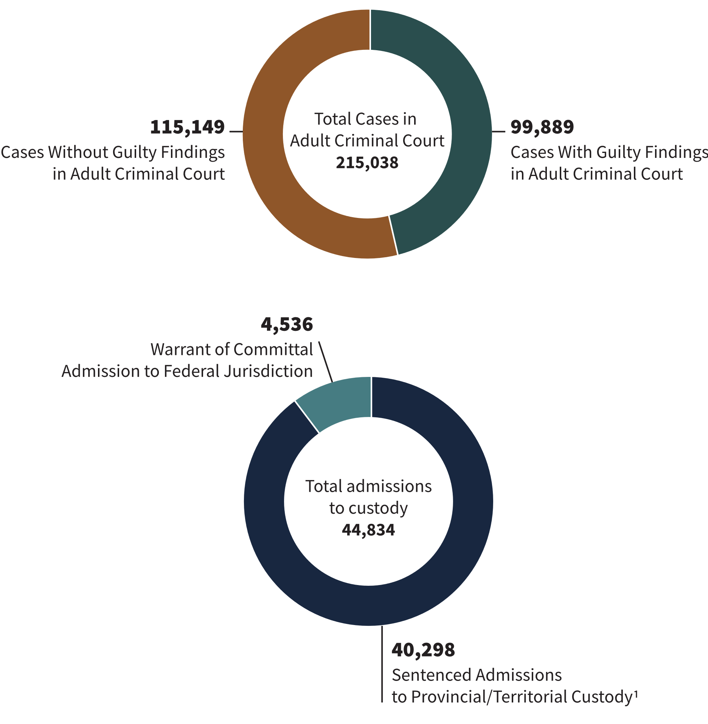
Sources:
Table 35-10-0027-01, Integrated Criminal Court Survey, Canadian Centre for Justice and Community Safety Statistics, Statistics Canada;
Table 35-10-0018-01, Adult Correctional Services, Canadian Centre for Justice and Community Safety Statistics, Statistics Canada;
Correctional Service of Canada.
- In 2022-23, there were 99,889 cases with guilty findings in adult criminal court.
- Between 2018-19 and 2022-23, the total number of cases in adult criminal court decreased 31.8%. Over the same time period, the total number of sentenced admissions to provincial/territorial custody decreased 44.3%.
- In 2022-23, there were 4,536 warrant of committal admissions to a federal institution or Healing Lodge.
- In 2022-23, there were 40,298 sentenced admissions to provincial/territorial custody.
Notes
Warrant of Committal is a new admission to federal jurisdiction from the courts.
The decision type guilty includes guilty of the offence, of an included offence, of an attempt of the offence, or of an attempt of an included offence. This category also includes cases where an absolute or conditional discharge has been imposed.
This figure only includes cases in provincial court and partial data from Superior Court. Superior Court data are not reported to the Integrated Criminal Court Survey for Prince Edward Island, Quebec, Ontario, Manitoba and Saskatchewan. Information from Quebec's municipal courts is not collected.
These numbers refer to the total number of admissions to a federal institution or Healing Lodge during each fiscal year and may be greater than the actual number of offenders admitted, since an individual offender may be admitted more than once in a given year.
Individuals found guilty in adult criminal court in a given year period are not always admitted to custody in the same year period.
The concept of a case has changed to more closely reflect court processing. Statistics from the Integrated Criminal Court Survey used in this report should not be compared to editions of the Corrections and Conditional Release Statistical Overview prior to 2007. A case is one or more charges against an accused person or corporation, processed by the courts at the same time, and where all of the charges in the case received a final disposition.
Court and correctional services data are reported on a fiscal year basis (April 1 through March 31).
There is a lag in the data entry of admissions into CSC's Offender Management System. The admission figures for the most recent year are under-reported by 200-400 admissions at the time of year end data extraction. More accurate figures will be available in the next year's publication of the CCRSO. Please use caution when including the most recent year in any trend analysis.

Table A11. Cases in adult criminal court and admissions to custody
Case type |  | 2018-19 |  | 2019-20 |  | 2020-21 |  | 2021-22 |  | 2022-23
Total cases without guilty findings in criminal court¹ | 121,860 |  | 124,558 |  | 117,722 |  | 116,151 |  | 115,149
Acquitted¹ | 11,339 |  | 9,811 |  | 7,141 |  | 2,011 |  | 2,265
Stayed or withdrawn¹ | 106,465 |  | 111,041 |  | 107,739 |  | 112,343 |  | 110,767
Other decisions¹ | 4,056 |  | 3,706 |  | 2,842 |  | 1,797 |  | 2,117
Total case decisions* in adult criminal court¹ | 315,202 |  | 317,281 |  | 236,464 |  | 221,313 |  | 215,038
Cases with guilty findings in adult criminal court¹ | 193,342 |  | 192,723 |  | 118,742 |  | 105,162 |  | 99,889
Sentenced admissions to provincial/territorial custody² | 72,389 |  | 64,964 |  | 35,566 |  | 37,932 |  | 40,298
Warrant of committal-admission to FED (CSC)³ | 5,005 |  | 4,632 |  | 3,200 |  | 3,954 |  | 4,536
Sources
¹ Table 35-10-0027-01, Integrated Criminal Court Survey, Canadian Centre for Justice and Community Safety Statistics, Statistics Canada;
² Table 35-10-0018-01, Adult Correctional Services, Canadian Centre for Justice and Community Safety Statistics, Statistics Canada;
³ Correctional Service of Canada.
Notes
Warrant of Committal is a new admission to federal jurisdiction from the courts.
*The concept of a case changed to more closely reflect court processing. Statistics from the Integrated Criminal Court Survey used in this report should not be compared to editions of the Corrections and Conditional Release Statistical Overview prior to 2007. A case is one or more charges against an accused person or corporation, processed by the courts at the same time, and where all of the charges in the case received a final disposition.
The decision type guilty includes guilty of the offence, of an included offence, of an attempt of the offence, or of an attempt of an included offence. This category also includes cases where an absolute or conditional discharge has been imposed. This figure only includes cases convicted in provincial court and partial data from Superior Court. Superior Court data are not reported to the Integrated Criminal Court Survey for Prince Edward Island, Quebec, Ontario, Manitoba and Saskatchewan. Information from Quebec's municipal courts is not collected.
Police data are reported on a calendar year basis whereas court and correctional services data are reported on a fiscal year basis (April 1 through March 31).
These numbers refer to the total number of admissions to a federal institution or Healing Lodge during each fiscal year and may be greater than the actual number of offenders admitted, since an individual offender may be admitted more than once in a given year.
Individuals found guilty in adult criminal court in a given year period are not always admitted to custody in the same year period.
There is a lag in the data entry of admissions into CSC's Offender Management System. The admission figures for the most recent year are under-reported by 200-400 admissions at the time of year end data extraction. More accurate figures will be available in the next year's publication. Please use caution when including the most recent year in any trend analysis.

Length of adult custodial sentences

Figure A12. Length of prison sentence ordered by the court (2022-23)
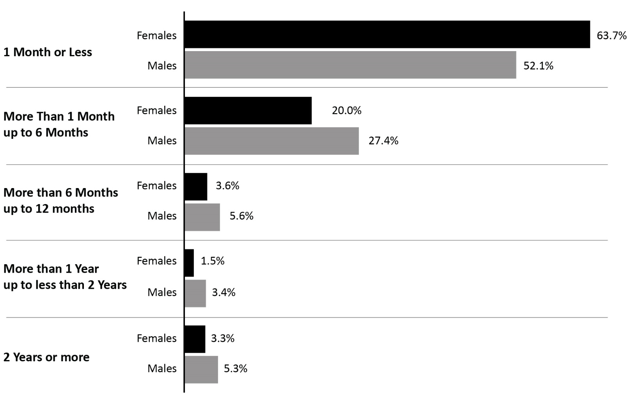
Source: Table 35-10-0032-01, Integrated Criminal Court Survey, Canadian Centre for Justice and Community Safety Statistics, Statistics Canada.
- Just under half (48.4%) of all custodial sentences imposed by adult criminal courts were 1 month or less.
- Prison sentences for males tended to be longer than for females, with the exception of sentences of 1 month or less.
- 63.7% of females and 52.1% of males who were incarcerated following a guilty* finding received a sentence of 1 month or less, and 83.7% of females and 79.5% of males received a sentence of 6 months or less.
Notes
*The decision type guilty includes guilty of the offence, of an included offence, of an attempt of the offence, or of an attempt of an included offence. This category also includes cases where an absolute or conditional discharge has been imposed.
Length unknown includes indeterminate custody sentences. In some provinces/territories, particularly British Columbia, Saskatchewan, Quebec and New Brunswick, the unknown category may include guilty cases with custody where the custodial sentence ordered has already been served and the time remaining is equal to zero.
The concept of a case has changed to more closely reflect court processing. Statistics from the Integrated Criminal Court Survey used in this report should not be compared to editions of the Corrections and Conditional Release Statistical Overview prior to 2007.
Superior Court data are not reported to the Integrated Criminal Court Survey for Prince Edward Island, Quebec, Ontario, Manitoba and Saskatchewan. In addition, information from Quebec's municipal courts is not collected.
The Canadian Centre for Justice and Community Safety Statistics continues to make updates to the offence library used to classify offence data sent by the provinces and territories. These improvements have resulted in minor changes in the counts of charges and cases as well as the distributions by type of offence. Data presented have been revised to account for these updates.
Due to rounding, totals may not add up to 100 percent.
The figure includes data from the most recent year available at the time of preparation.
Reported year periods reflect fiscal years. A fiscal year runs from April 1 to March 31 of the following year.

Table A12. Length of prison sentence ordered by the court

Sentence of 1 month or less (%)
Fiscal year | 2018-19 | 2019-20 | 2020-21 | 2021-22 | 2022-23
Females | 59.4 | 54.8 | 51.9 | 61.9 | 63.7
Males | 49.4 | 46.6 | 43.4 | 51.5 | 52.1
Total | 46.9 | 44.6 | 41.2 | 47.8 | 48.4

Sentence of 1 month up to 6 months (%)
Fiscal year | 2018-19 | 2019-20 | 2020-21 | 2021-22 | 2022-23
Females | 44.8 | 26.0 | 27.1 | 21.9 | 20.0
Males | 29.9 | 31.0 | 31.7 | 28.0 | 27.4
Total | 27.2 | 28.4 | 28.9 | 24.7 | 23.9

Sentence of more than 6 months up to 12 months (%)
Sex | 2018-19 | 2019-20 | 2020-21 | 2021-22 | 2022-23
Females | 6.1 | 3.9 | 4.5 | 3.7 | 3.6
Males | 5.4 | 5.9 | 6.8 | 6.1 | 5.6
Total | 4.9 | 5.3 | 6.1 | 5.3 | 4.9

Sentence of more than 1 year up to less than 2 years (%)
Fiscal year | 2018-19 | 2019-20 | 2020-21 | 2021-22 | 2022-23
Females | 3.4 | 1.9 | 2.2 | 1.5 | 1.5
Males | 3.2 | 3.4 | 3.9 | 3.4 | 3.4
Total | 2.9 | 3.0 | 3.4 | 2.9 | 2.9

Sentence of 2 years or more (%)
Fiscal year | 2018-19 | 2019-20 | 2020-21 | 2021-22 | 2022-23
Females | 3.9 | 1.9 | 2.7 | 3.2 | 3.3
Males | 3.7 | 3.6 | 4.2 | 4.8 | 5.3
Total | 3.3 | 3.2 | 3.8 | 4.2 | 4.6

Sentence length unknown (%)
Fiscal year | 2018-19 | 2019-20 | 2020-21 | 2021-22 | 2022-23
Females | 9.6 | 11.5 | 11.7 | 7.9 | 7.9
Males | 8.4 | 9.6 | 10.1 | 6.2 | 6.2
Total | 14.9 | 15.6 | 16.7 | 15.1 | 15.3
Source: Table 35-10-0032-01, Integrated Criminal Court Survey, Canadian Centre for Justice and Community Safety Statistics, Statistics Canada.
Notes
Total includes the following categories: males, females, sex unknown, and any registered companies.
Length unknown includes indeterminate custody sentences. In some provinces/territories, particularly British Columbia, Saskatchewan, Quebec and New Brunswick, the unknown category may include guilty cases with custody where the custodial sentence ordered has already been served and the time remaining is equal to zero.
The concept of a case has changed to more closely reflect court processing. Statistics from the Integrated Criminal Court Survey used in this report should not be compared to editions of the Corrections and Conditional Release Statistical Overview prior to 2007.
Superior Court data are not reported to the Integrated Criminal Court Survey for Prince Edward Island, Quebec, Ontario, Manitoba and Saskatchewan. In addition, information from Quebec's municipal courts is not collected.
The Canadian Centre for Justice and Community Safety Statistics continues to make updates to the offence library used to classify offence data sent by the provinces and territories. These improvements have resulted in minor changes in the counts of charges and cases as well as the distributions by type of offence. Data presented have been revised to account for these updates.
Due to rounding, totals may not add up to 100 percent.
The table includes data from the most recent year available at the time of preparation.
Reported year periods reflect fiscal years. A fiscal year runs from April 1 to March 31 of the following year.

The rate of youth charged

Figure A13. Rate of youth charged. Rate per 100,000
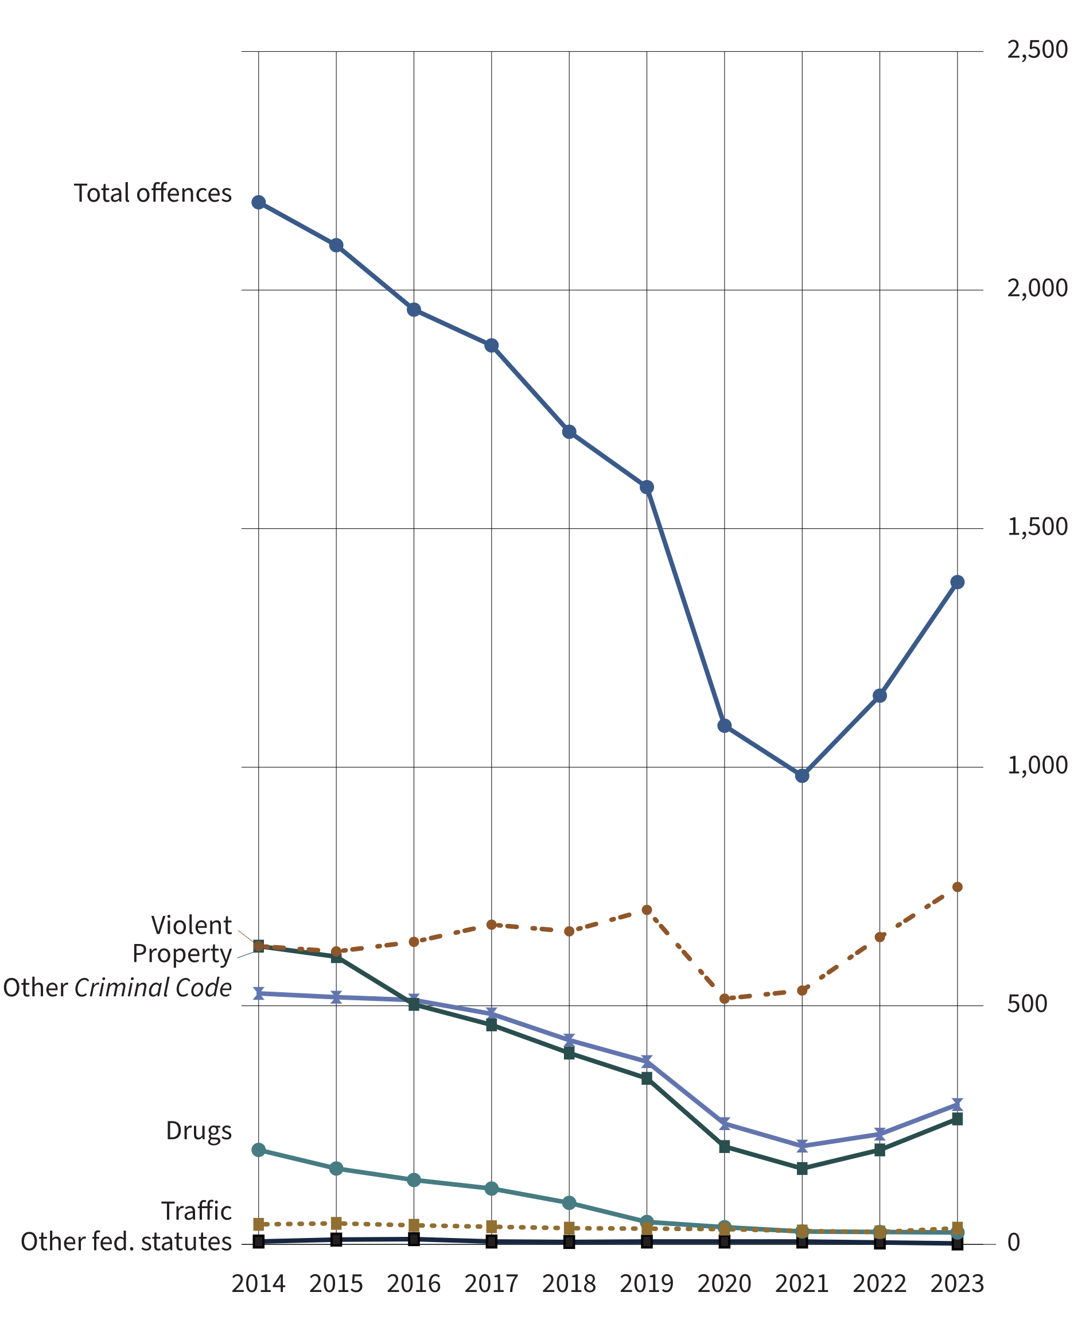
Source: Table 35-10-0177-01, Uniform Crime Reporting Survey, Canadian Centre for Justice and Community Safety Statistics, Statistics Canada.
- From 2014 to 2019, the rate of youth charged decreased substantially (-27.3%). The sharp decrease (-38.1%) seen between 2019 and 2021 may be due to lockdown restrictions resulting from the COVID-19 pandemic. From 2021 to 2023, after most lockdown restrictions had ended, there was an increase of 41.3%.
- Between 2014 to 2019 there was a 12.2% increase in the rate of youth charged with a violent crime, followed by a 24.0% decrease between 2019 to 2021, perhaps due to COVID-19 pandemic lockdown restrictions. The sharp increase (+40.6%) observed between 2021 and 2023 may be due to the lifting of many COVID-19 lockdown restrictions. The rate of youth charged with a violent crime is 6.8% higher in 2023 than in 2019.
- In the 10-year period between 2014 and 2023, the rate of youth charged with drug offences decreased by 87.6%.
Notes
Other Criminal Code offences (Other CC) includes administration of justice violations; weapons/firearms violations; counterfeit; possession of, accessing, making or distribution of child pornography; and prostitution.
Other federal statute offences refer to offences against Canadian federal statutes, such as Customs Act, Employment Insurance Act, Firearms Act, Food and Drugs Act (FDA), Income Tax Act, Controlled Drugs and Substances Act (CDSA) and Narcotic Control Act (NCA). This offence category excludes Criminal Code of Canada offences.
For criminal justice purposes, youth are defined under Canadian law as persons aged 12 to 17.
Rates are based on 100,000 youth population (12 to 17 years old).
Violent crimes include homicide, attempted murder, assault, sexual offences, abduction, extortion, robbery, firearms, and other violent offences such as uttering threats and criminal harassment. Property crimes include break and enter, motor vehicle theft, other theft, possession of stolen property, fraud, mischief and arson.

Table A13. Rate of youth charged. Rate per 100,000
Year | Violent | Property | Traffic | Other CC | Drugs | Total other fed. stat. | Total charged
1998 | 994 | 2,500 | 0 | 870 | 226 | 4 | 4,775
1999 | 1,060 | 2,237 | 0 | 728 | 266 | 2 | 4,500
2000 | 1,136 | 2,177 | 2 | 760 | 317 | 4 | 4,589
2001 | 1,157 | 2,119 | 1 | 840 | 343 | 6 | 4,656
2002 | 1,102 | 2,009 | 0 | 793 | 337 | 6 | 4,476
2003 | 953 | 1,570 | 0 | 726 | 208 | 5 | 3,662
2004 | 918 | 1,395 | 1 | 691 | 230 | 5 | 3,457
2005 | 924 | 1,276 | 0 | 660 | 214 | 10 | 3,287
2006 | 917 | 1,216 | 0 | 680 | 240 | 16 | 3,269
2007 | 943 | 1,211 | 75 | 732 | 260 | 17 | 3,461
2008 | 909 | 1,130 | 74 | 730 | 267 | 19 | 3,369
2009 | 888 | 1,143 | 68 | 698 | 238 | 30 | 3,294
2010 | 860 | 1,035 | 62 | 669 | 255 | 31 | 3,147
2011 | 806 | 904 | 58 | 636 | 263 | 31 | 2,918
2012 | 765 | 842 | 58 | 629 | 240 | 20 | 2,771
2013 | 692 | 722 | 45 | 554 | 229 | 10 | 2,435
2014 | 625 | 625 | 42 | 526 | 198 | 6 | 2,184
2015 | 614 | 603 | 44 | 518 | 159 | 10 | 2,094
2016 | 634 | 503 | 40 | 512 | 135 | 11 | 1,959
2017 | 670 | 460 | 37 | 483 | 117 | 6 | 1,884
2018 | 656 | 401 | 34 | 428 | 87 | 5 | 1,703
2019 | 701 | 348 | 33 | 383 | 47 | 6 | 1,587
2020 | 515 | 205 | 32 | 253 | 36 | 6 | 1,087
2021 | 532 | 159 | 28 | 206 | 27 | 6 | 982
2022 | 644 | 198 | 26 | 231 | 26 | 4 | 1,150
2023 | 749 | 263 | 34 | 293 | 25 | 2 | 1,388
Source: Table 35-10-0177-01, Incident-based crime statistics, by detailed violations, Canada, provinces, territories and Census Metropolitan Areas.
Notes
Other Criminal Code offences (Other CC) includes administration of justice violations; weapons/firearms violations; counterfeit; possession of, accessing, making or distribution of child pornography; and prostitution.
Other federal statute offences refer to offences against Canadian federal statutes, such as Customs Act, Employment Insurance Act, Firearms Act, Food and Drugs Act (FDA), Income Tax Act, Controlled Drugs and Substances Act (CDSA) and Narcotic Control Act (NCA). This offence category excludes Criminal Code of Canada offences.
For criminal justice purposes, youth are defined under Canadian law as persons age 12 to 17.
Rates are based on 100,000 youth population (12 to 17 years old). Violent crimes include homicide, attempted murder, assault, sexual offences, abduction, extortion, robbery, firearms, and other violent offences such as uttering threats and criminal harassment. Property crimes include break and enter, motor vehicle theft, other theft, possession of stolen property, fraud, mischief and arson.

Criminal Code and other Federal Statute charges among youth: 5-year trend

Figure A14. Percentage of all Criminal Code and other federal statute charges among youth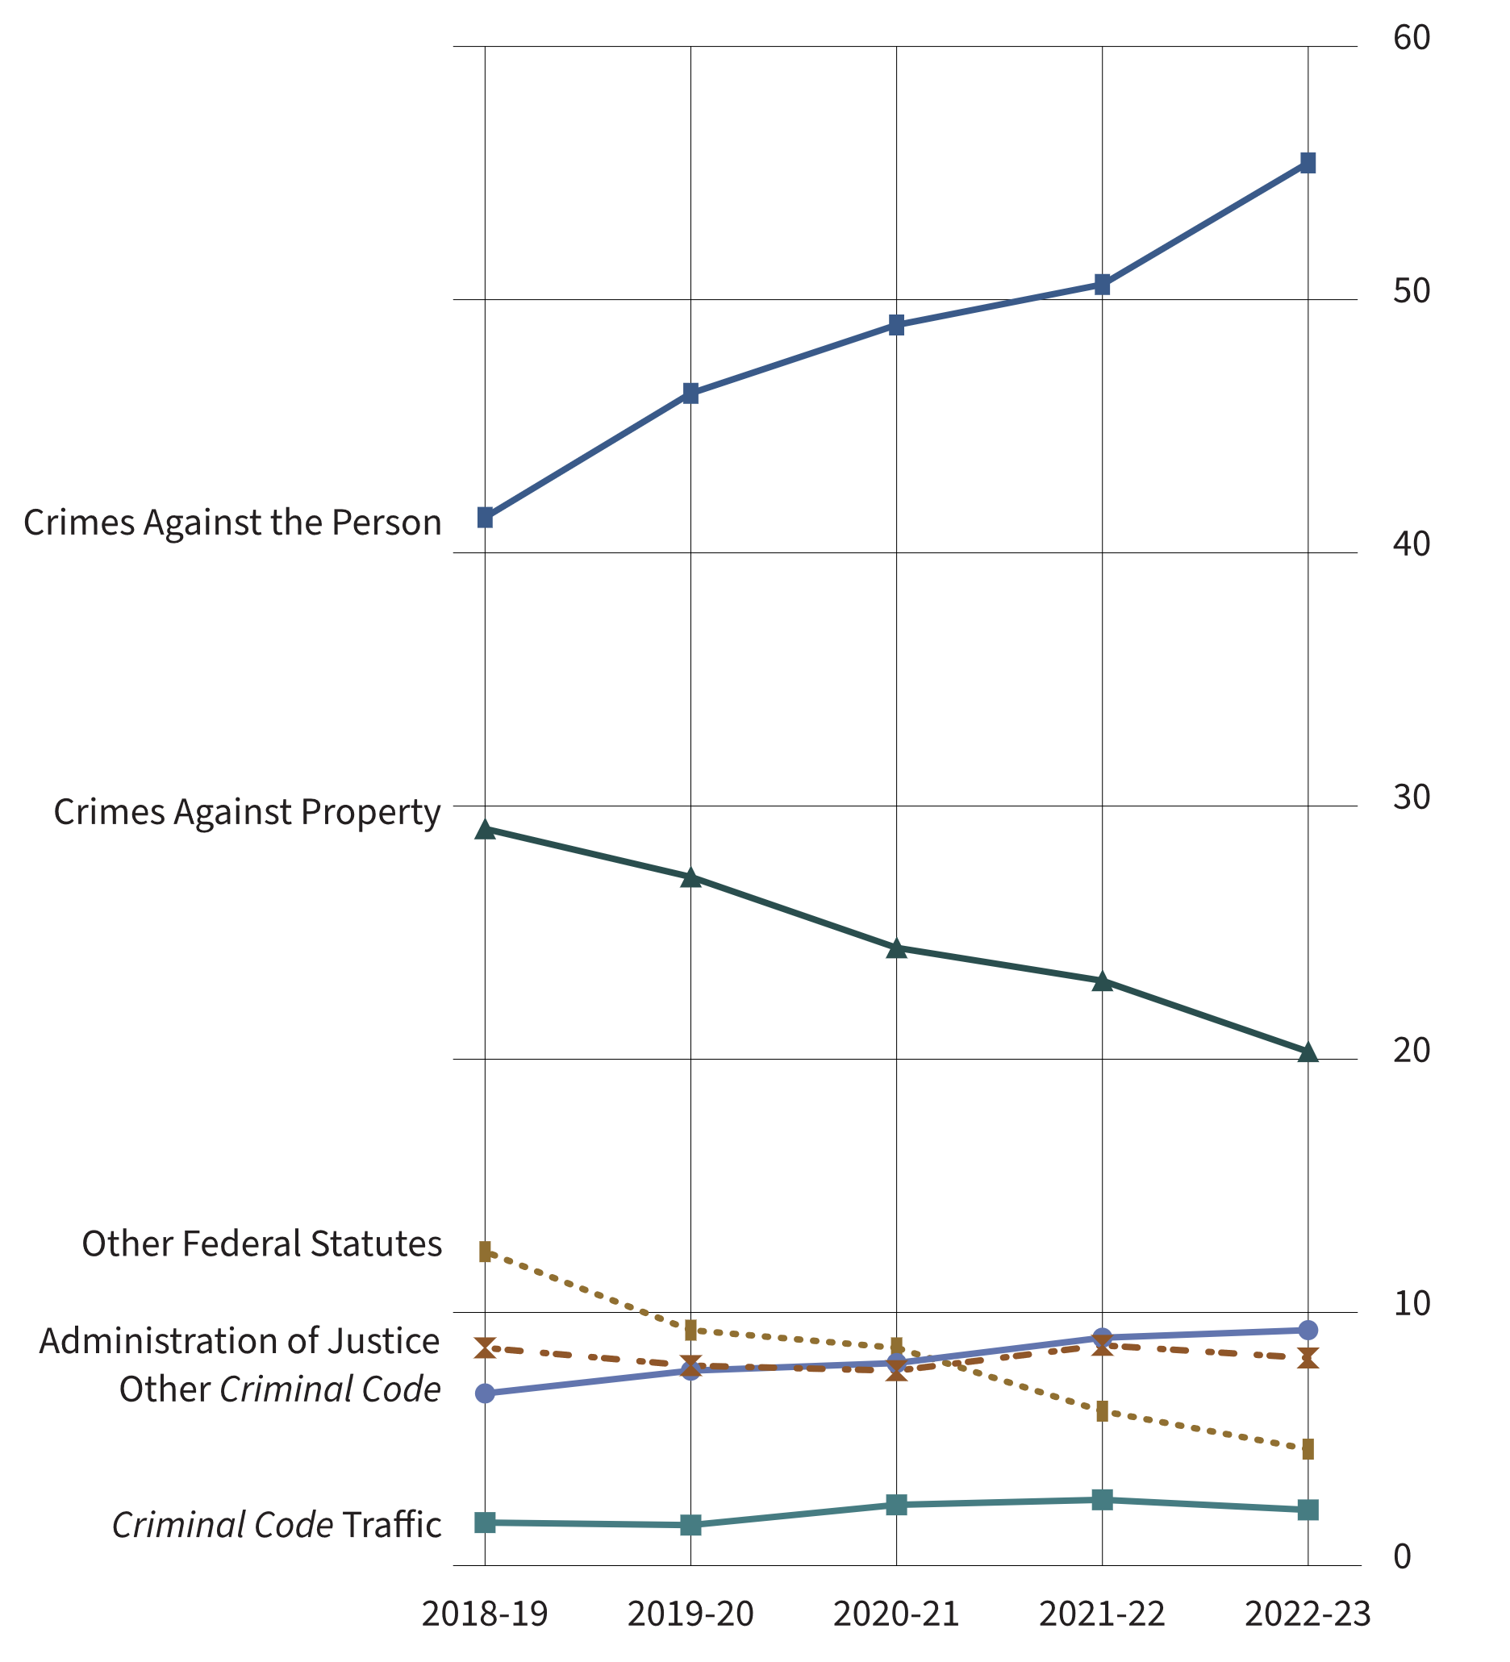
Source: Table 35-10-0038-01, Integrated Criminal Court Survey, Canadian Centre for Justice and Community Safety Statistics, Statistics Canada.
- In 2022-23, crimes against the person accounted for approximately half (55.4%) of all charges among youth (increasing from 41.4% in 2018-19).
- In the 5-year period between 2018-19 and 2022-23, crimes against property and other federal statute charges decreased among youth, while crimes against the person and Other Criminal Code charges increased. Criminal Code traffic and administration of justice charges remained relatively stable.
- Common assault (included in “Crimes against the person”) has consistently been the most frequent charge in youth court in the 5-year period from 2018-19 to 2022-23.
Notes
Administration of justice includes the offences failure to appear, breach of probation, and unlawfully at large.
Other Criminal Code offences (Other CC) includes administration of justice violations; weapons/firearms violations; counterfeit; possession of, accessing, making or distribution of child pornography; and prostitution.
Other federal statute offences refer to offences against Canadian federal statutes, such as Customs Act, Employment Insurance Act, Firearms Act, Food and Drugs Act (FDA), Income Tax Act, Controlled Drugs and Substances Act (CDSA) and Narcotic Control Act (NCA). This offence category excludes Criminal Code of Canada offences.
Youth Criminal Justice Act offences include failure to comply with a disposition or undertaking, contempt against youth court, assisting a youth to leave a place of custody, and harbouring a youth unlawfully at large. Also included are similar offences under the Young Offenders Act, which preceded the Youth Criminal Justice Act.
The concept of a case has changed to more closely reflect court processing. Statistics from the Integrated Criminal Court Survey used in this report should not be compared to editions of the Corrections and Conditional Release Statistical Overview prior to 2007. A case is one or more charges against an accused person or corporation, processed by the courts at the same time, and where all of the charges in the case received a final disposition. Where a case has more than one charge, it is necessary to select a charge to represent the case. An offence is selected by applying two rules. First, the most serious decision rule is applied. In cases where two or more offences have the same decision, the most serious offence rule is applied. All charges are ranked according to an offence seriousness scale.
The Canadian Centre for Justice and Community Safety Statistics continues to make updates to the offence library used to classify offence data sent by the provinces and territories. These improvements have resulted in minor changes in the counts of charges and cases as well as the distributions by type of offence. Data presented have been revised to account for these updates.
The figure includes data from the most recent year available at the time of preparation.
Reported year periods reflect fiscal years. A fiscal year runs from April 1 to March 31 of the following year.

Table A14. Number of all Criminal Code and other federal statute charges among youth
Type of charge | 2018-19 | 2019-20 | 2020-21 | 2021-22 | 2022-23
Crimes against the person | 10,192 | 10,380 | 7,317 | 5,761 | 6,624
Homicide and Attempted Murder | 49 | 42 | 37 | 40 | 39
Robbery | 1,523 | 1,502 | 1,082 | 786 | 670
Sexual Assault/Other Sexual Offences | 1,701 | 1,854 | 1,822 | 1,479 | 1,284
Major Assault | 2,078 | 2,144 | 1,565 | 1,356 | 1,596
Common Assault | 2,651 | 2,828 | 1,819 | 1,522 | 2,040
Other Crimes Against the Person | 2,013 | 2,027 | 1,321 | 737 | 828
Crimes against property | 7,173 | 6,092 | 3,640 | 2,630 | 2,426
Theft | 1,952 | 1,590 | 806 | 427 | 446
Break and Enter | 1,511 | 1,161 | 770 | 618 | 545
Fraud | 380 | 383 | 257 | 122 | 90
Mischief | 1,443 | 1,283 | 889 | 803 | 799
Possession of Stolen Property | 1,172 | 1,061 | 531 | 393 | 306
Other Crimes Against Property | 273 | 240 | 162 | 120 | 91
Administration of justice | 2,108 | 1,775 | 1,151 | 989 | 987
Failure to comply with order | 1,314 | 1,060 | 716 | 651 | 646
Other administration of justice | 648 | 617 | 374 | 289 | 312
Other Criminal Code | 1,664 | 1,732 | 1,188 | 1,020 | 1,115
Weapons/Firearms | 1,304 | 1,381 | 918 | 819 | 940
Prostitution | 0 | 1 | 2 | 1 | 0
Disturbing the Peace | 27 | 33 | 23 | 32 | 27
Residual Criminal Code | 333 | 317 | 245 | 168 | 148
Criminal Code traffic | 424 | 367 | 353 | 296 | 265
Other federal statutes | 3,060 | 2,086 | 1,279 | 697 | 550
Drug Possession | 741 | 269 | 164 | 41 | 64
Other Drug Offences | 461 | 336 | 240 | 182 | 179
Youth Criminal Justice Act | 1,829 | 1,385 | 766 | 455 | 297
Residual Federal Statutes | 29 | 96 | 109 | 19 | 10
Total | 24,621 | 22,432 | 14,928 | 11,393 | 11,967
Source: Table 35-10-0038-01, Integrated Criminal Court Survey, Canadian Centre for Justice and Community Safety Statistics, Statistics Canada.
Notes
Administration of justice includes the offences failure to appear, breach of probation, and unlawfully at large.
Other Criminal Code (Other CC) offences includes administration of justice violations, weapons/firearms violations, counterfeit, possession of, accessing, making or distribution of child pornography and prostitution.
Other federal statute offences refer to offences against Canadian federal statutes, such as Customs Act, Employment Insurance Act, Firearms Act, Food and Drugs Act (FDA), Income Tax Act, Controlled Drugs and Substances Act (CDSA) and Narcotic Control Act (NCA). This offence category excludes Criminal Code of Canada offences.
Youth Criminal Justice Act offences include failure to comply with a disposition or undertaking, contempt against youth court, assisting a youth to leave a place of custody and harbouring a youth unlawfully at large. Also included are similar offences under the Young Offenders Act, which preceded the Youth Criminal Justice Act.
The concept of a case has changed to more closely reflect court processing. Statistics from the Integrated Criminal Court Survey used in this report should not be compared to editions of the Corrections and Conditional Release Statistical Overview prior to 2007. A case is 1 or more charges against an accused person or corporation, processed by the courts at the same time, and where all of the charges in the case received a final disposition. Where a case has more than 1 charge, it is necessary to select a charge to represent the case. An offence is selected by applying 2 rules. First, the most serious decision rule is applied. In cases where 2 or more offences have the same decision, the most serious offence rule is applied. All charges are ranked according to an offence seriousness scale.
The Canadian Centre for Justice and Community Safety Statistics continues to make updates to the offence library used to classify offence data sent by the provinces and territories. These improvements have resulted in minor changes in the counts of charges and cases as well as the distributions by type of offence. Data presented have been revised to account for these updates.
The table includes data from the most recent year available at the time of preparation.
Reported year periods reflect fiscal years. A fiscal year runs from April 1 to March 31 of the following year.

Youth criminal court sentences: 5-year trend

Figure A15. Percentage of sentence type received in youth criminal court
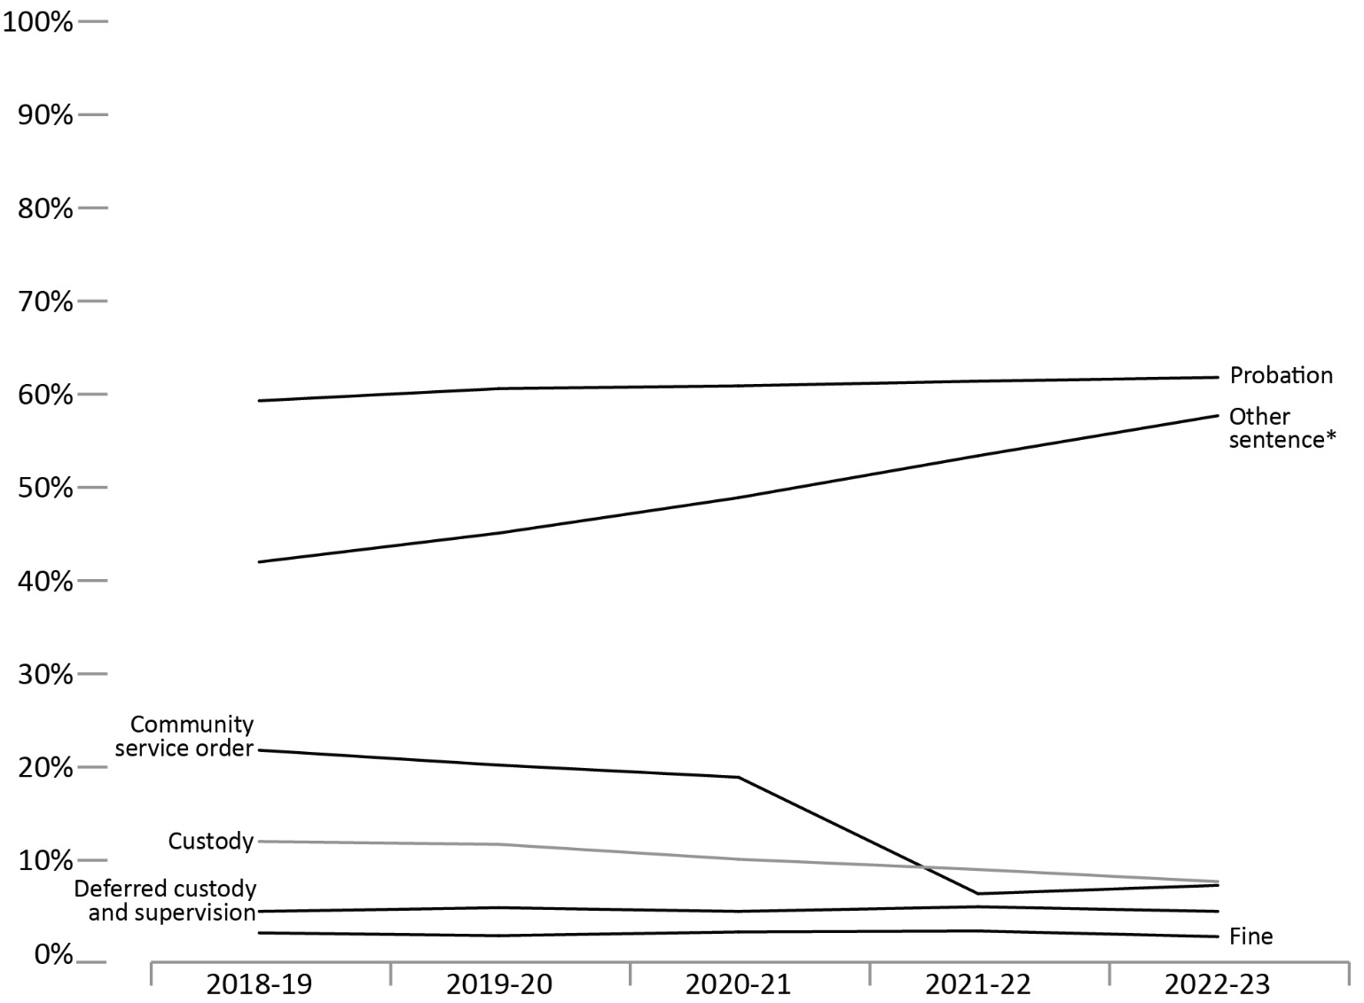
Source: Table 35-10-0041-01, Integrated Criminal Court Survey, Canadian Centre for Justice and Community Safety Statistics, Statistics Canada.
- Probation has consistently been the most common sentence in youth criminal court. In fiscal year 2022-23, 61.8% of all youth found guilty were sentenced to probation. By sex, 56.9% of females and 62.3% of males were sentenced to probation in 2022-23.
- Community service orders steadily declined from 2018-19 to 2020-21, then had a sharp decline between 2020-21 and 2022-23 (from 18.9% to 7.3%). Fluctuations between 2019 and 2022 may be due to the imposition and cessation of the COVID-19 pandemic lockdown restrictions.
- In the 5-year period from 2018-19 to 2022-23, other sentences* increased from 42.0% to 57.7%.
Notes
*Other sentence includes absolute discharge, restitution, prohibition, seizure, forfeiture, compensation, pay purchaser, essays, apologies, counselling programs and conditional discharge, conditional sentence, intensive support and supervision, attendance at non-residential program(s), and reprimand. This category also includes intensive support and supervision, attendance at non-residential program(s) and reprimand where sentencing data under the Youth Criminal Justice Act are not available.
Cases can have more than one sentence. Therefore, sanctions are not mutually exclusive and will not add to 100%. For all sentencing tables, data are for cases with a guilty finding only. Sentencing information is not available for a small proportion of guilty cases (i.e., approximately 3%, overall). For all sentencing tables, data are for cases with a guilty finding only and for which sentencing information is reported.
The concept of a case has changed to more closely reflect court processing. Statistics from the Integrated Criminal Court Survey used in this report should not be compared to editions of the Corrections and Conditional Release Statistical Overview prior to 2007.
The table includes data from the most recent year available at the time of preparation.
Reported year periods reflect fiscal years. A fiscal year runs from April 1 to March 31 of the following year.
Table A15. Percentage of sentence type received in youth criminal court

Probation (%)
Fiscal year | 2018-19 | 2019-20 | 2020-21 | 2021-22 | 2022-23
Female | 53.4 | 53.9 | 51.9 | 55.3 | 56.9
Male | 60.8 | 62.2 | 63.3 | 62.7 | 62.3
Total | 59.3 | 60.6 | 60.9 | 61.4 | 61.8

Custody (%)
Fiscal year | 2018-19 | 2019-20 | 2020-21 | 2021-22 | 2022-23
Female | 6.3 | 4.7 | 4.4 | 4.6 | 3.0
Male | 13.4 | 12.8 | 10.9 | 9.7 | 8.4
Total | 12.0 | 11.7 | 10.1 | 9.0 | 7.7

Community service order (%)
Fiscal year | 2018-19 | 2019-20 | 2020-21 | 2021-22 | 2022-23
Female | 21.4 | 18.9 | 19.0 | 6.5 | 6.7
Male | 22.8 | 21.8 | 20.5 | 5.8 | 7.3
Total | 21.8 | 20.2 | 18.9 | 6.4 | 7.3

Deferred custody and supervision (%)
Fiscal year | 2018-19 | 2019-20 | 2020-21 | 2021-22 | 2022-23
Female | 3.2 | 3.7 | 3.4 | 3.9 | 3.8
Male | 4.9 | 5.3 | 4.7 | 5.3 | 5.0
Total | 4.5 | 4.9 | 4.5 | 5.0 | 4.5

Fine (%)
Fiscal year | 2018-19 | 2019-20 | 2020-21 | 2021-22 | 2022-23
Female | 2.4 | 1.6 | 2.0 | 1.7 | 0.8
Male | 2.1 | 1.9 | 2.2 | 2.5 | 1.9
Total | 2.2 | 1.9 | 2.3 | 2.4 | 1.8

Other sentence* (%)
Fiscal year | 2018-19 | 2019-20 | 2020-21 | 2021-22 | 2022-23
Female | 41.4 | 43.7 | 49.9 | 52.5 | 55.5
Male | 43.0 | 46.4 | 48.7 | 54.5 | 59.2
Total | 42.0 | 45.1 | 48.9 | 53.4 | 57.7
Source: Table 35-10-0041-01, Integrated Criminal Court Survey, Canadian Centre for Justice and Community Safety Statistics, Statistics Canada.
Notes
*Other sentence includes absolute discharge, restitution, prohibition, seizure, forfeiture, compensation, pay purchaser, essays, apologies, counselling programs and conditional discharge, conditional sentence, intensive support and supervision, attendance at non-residential program(s), and reprimand. This category also includes intensive support and supervision, attendance at non-residential program(s) and reprimand where sentencing data under the Youth Criminal Justice Act are not available.
Cases can have more than one sentence. Therefore, sanctions are not mutually exclusive and will not add to 100%. For all sentencing tables, data are for cases with a guilty finding only. Sentencing information is not available for a small proportion of guilty cases (i.e., approximately 3%, overall). For all sentencing tables, data are for cases with a guilty finding only and for which sentencing information is reported.
The concept of a case has changed to more closely reflect court processing. Statistics from the Integrated Criminal Court Survey used in this report should not be compared to editions of the Corrections and Conditional Release Statistical Overview prior to 2007.
The table includes data from the most recent year available at the time of preparation.
Reported year periods reflect fiscal years. A fiscal year runs from April 1 to March 31 of the following year.

Youth criminal court sentences for most serious sentence: 5-year trend

Figure A16. Percentage of youth criminal court sentence for most serious sentence
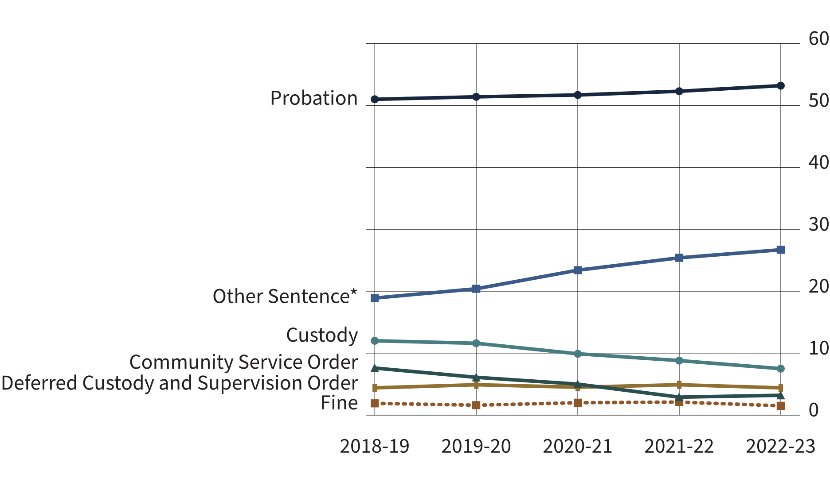
Source: Table 35-10-0042-01, Integrated Criminal Court Survey, Canadian Centre for Justice and Community Safety Statistics, Statistics Canada.
- In 2022-23, 53.2% of youth found guilty were given probation as the most serious sentence. This rate has remained relatively stable since the implementation of the Youth Criminal Justice Act in April 2003.
- Of the Youth Criminal Justice Act sentences in 2022-23, fine orders were the least frequent sentences (1.5%), followed by community service orders (3.2%).
Notes
It is possible to receive more than one sentence type in relation to a guilty charge in a case. For the current figure, when a youth received multiple sentences, only the most serious sentence is represented. Sentence types are ranked from most to least serious as follows: Intensive rehabilitative custody and supervision; custody and supervision - presumptive, murder; custody and supervision - presumptive, excluding murder; custody and supervision; custody (supervision type) not specified, youth custodial sentence under the Young Offenders Act, or adult custody; conditional sentence, deferred custody and supervision; Intensive support and supervision; probation; prohibition, seizure, forfeiture; community service; personal service/compensation in kind; pay purchaser; restitution; compensation; fine; conditional discharge; absolute discharge; reprimand; and other.
*Other sentence includes absolute discharge, restitution, prohibition, seizure, forfeiture, compensation, pay purchaser, essays, apologies, counselling programs and conditional discharge, conditional sentence, intensive support and supervision, attendance at non-residential program(s), and reprimand. This category also includes intensive support and supervision, attendance at non-residential program(s) and reprimand where sentencing data under the Youth Criminal Justice Act are not available.
The concept of a case has changed to more closely reflect court processing. Statistics from the Integrated Criminal Court Survey used in this report should not be compared to editions of the Corrections and Conditional Release Statistical Overview prior to 2007.
The figure includes data from the most recent year available at the time of preparation.
Reported year periods reflect fiscal years. A fiscal year runs from April 1 to March 31 of the following year.

Table A16. Percentage of youth criminal court sentence for most serious sentence

Probation (%)
Fiscal year | 2018-19 | 2019-20 | 2020-21 | 2021-22 | 2022-23
Female | 49.3 | 49.2 | 47.1 | 49.9 | 52.9
Male | 51.3 | 51.6 | 53.2 | 52.6 | 52.3
Total | 51.0 | 51.4 | 51.7 | 52.3 | 53.2

Custody (%)
Fiscal year | 2018-19 | 2019-20 | 2020-21 | 2021-22 | 2022-23
Female | 6.3 | 4.7 | 4.3 | 4.2 | 2.9
Male | 13.3 | 12.8 | 10.6 | 9.5 | 8.2
Total | 12.0 | 11.6 | 9.9 | 8.8 | 7.5

Community service order (%)
Fiscal year | 2018-19 | 2019-20 | 2020-21 | 2021-22 | 2022-23
Female | 8.4 | 7.5 | 6.9 | 3.8 | 3.6
Male | 6.5 | 5.3 | 4.7 | 1.9 | 2.6
Total | 7.6 | 6.1 | 5.0 | 2.9 | 3.2

Deferred custody and supervision (%)
Fiscal year | 2018-19 | 2019-20 | 2020-21 | 2021-22 | 2022-23
Female | 3.2 | 3.7 | 3.4 | 3.9 | 3.8
Male | 4.8 | 5.3 | 4.7 | 5.2 | 4.9
Total | 4.4 | 4.9 | 4.5 | 4.9 | 4.4

Fine (%)
Fiscal year | 2018-19 | 2019-20 | 2020-21 | 2021-22 | 2022-23
Female | 2.1 | 1.3 | 2.0 | 1.4 | 0.5
Male | 1.8 | 1.6 | 1.9 | 2.2 | 1.7
Total | 1.9 | 1.6 | 2.0 | 2.1 | 1.5

Other sentence* (%)
Fiscal year | 2018-19 | 2019-20 | 2020-21 | 2021-22 | 2022-23
Female | 24.1 | 27.3 | 31.2 | 31.1 | 32.0
Male | 18.4 | 19.6 | 21.6 | 25.3 | 26.6
Total | 18.9 | 20.4 | 23.4 | 25.4 | 26.7
Source: Table 35-10-0042-01, Integrated Criminal Court Survey, Canadian Centre for Justice and Community Safety Statistics, Statistics Canada.
Notes
It is possible to receive more than one sentence type in relation to a guilty charge in a case. For the current figure, when a youth received multiple sentences, only the most serious sentence is represented. Sentence types are ranked from most to least serious as follows: Intensive rehabilitative custody and supervision; custody and supervision - presumptive, murder; custody and supervision - presumptive, excluding murder; custody and supervision; custody (supervision type) not specified, youth custodial sentence under the Young Offenders Act, or adult custody; conditional sentence, deferred custody and supervision; Intensive support and supervision; probation; prohibition, seizure, forfeiture; community service; personal service/compensation in kind; pay purchaser; restitution; compensation; fine; conditional discharge; absolute discharge; reprimand; and other.
*Other sentence includes absolute discharge, restitution, prohibition, seizure, forfeiture, compensation, pay purchaser, essays, apologies, counselling programs and conditional discharge, conditional sentence, intensive support and supervision, attendance at non-residential program(s), and reprimand. This category also includes intensive support and supervision, attendance at non-residential program(s) and reprimand where sentencing data under the Youth Criminal Justice Act are not available.
The concept of a case has changed to more closely reflect court processing. Statistics from the Integrated Criminal Court Survey used in this report should not be compared to editions of the Corrections and Conditional Release Statistical Overview prior to 2007.
The table includes data from the most recent year available at the time of preparation.
Reported year periods reflect fiscal years. A fiscal year runs from April 1 to March 31 of the following year.

International incarceration rates

Figure A17. Prison population (2023). Rate per 100,000
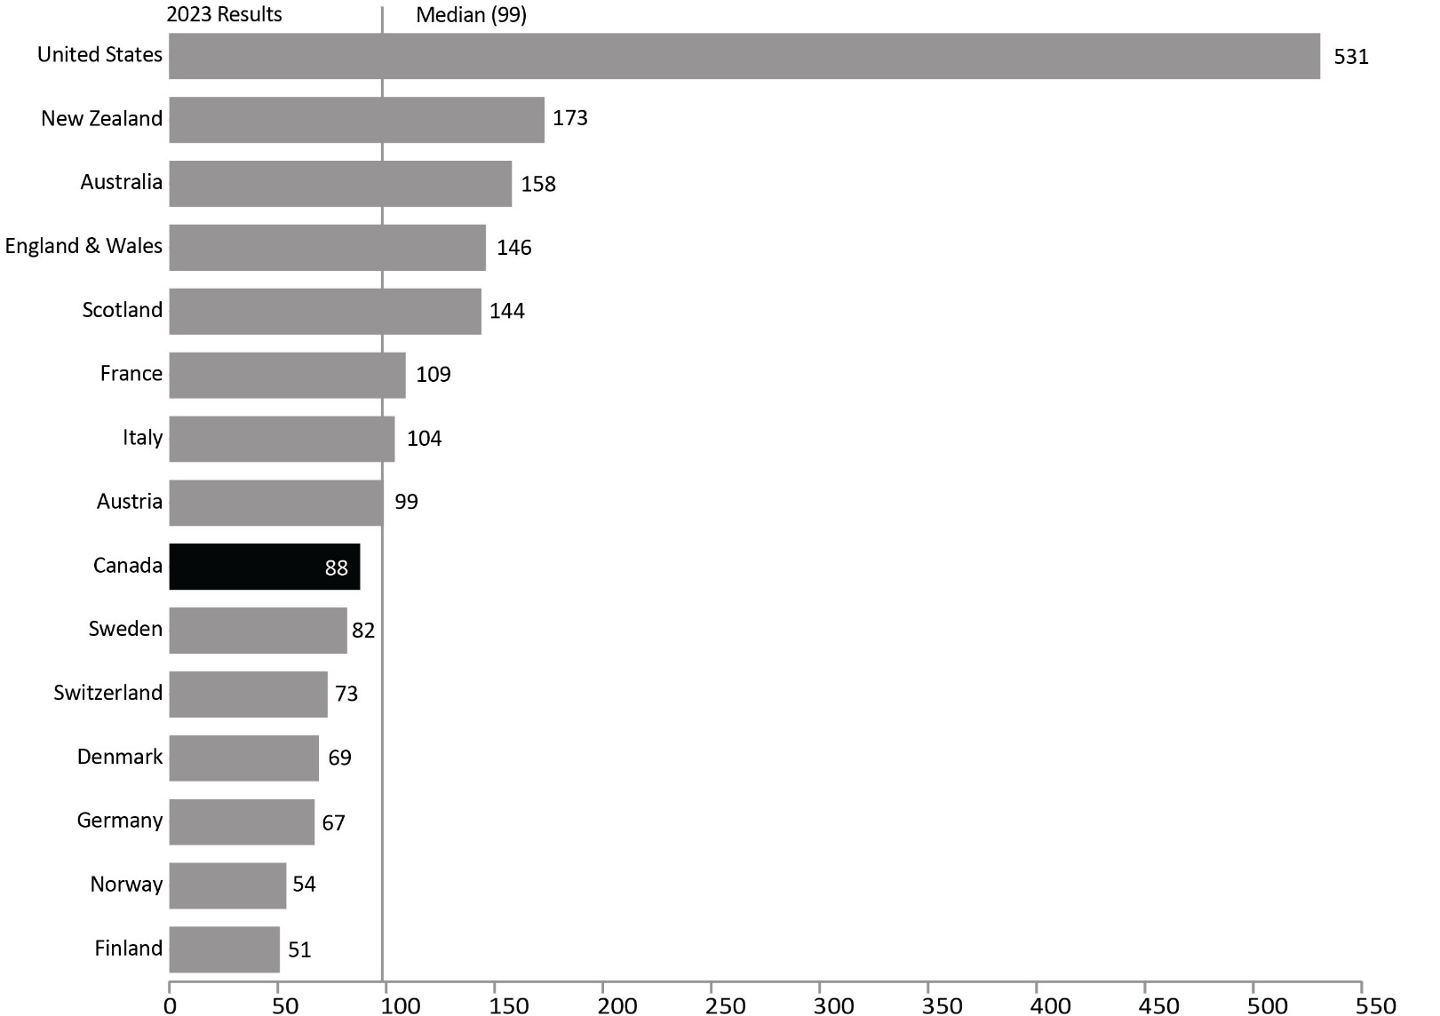
Source: World Prison Brief, Institute for Crime & Justice Policy Research (ICPR) (www.prisonstudies.org/highest-to-lowest/prison-population-total).
- In 2023, Canada's incarceration rate was 88 per 100,000. When ranked from highest incarceration rate (i.e., 1) to lowest (i.e., 223), Canada's prison population rate was ranked 164 of 223 countries. Canada's incarceration rate is lower than the median of Western and European countries, and much lower than the United States where the incarceration rate was 531 per 100,000 in 2023.
- Finland’s incarceration rate was 51 per 100,000, the lowest incarceration rate among western European countries.

Notes
The median is the middle value where half the values fall below the median and the other half above. The median is the preferred way to measure the average when there is an extreme outlier in the data.
The incarceration rate presented here is a measure of the number of people (i.e., adults and youth) in custody per 100,000 people in the general population. Incarceration rates from the World Prison Brief hosted by the Institute for Crime & Justice Policy Research (ICPR) are based on the most recently available data at the time the list was compiled. The data were retrieved online on March 21st, 2024 from http://www.prisonstudies.org, which contains the most up-to-date information available. Additionally, different practices and variations in measurement in different countries limit the comparability of these figures.

Table A17. Prison population. Rate per 100,000
Country | 2014 | 2015 | 2016 | 2017 | 2018 | 2019 | 2020 | 2021 | 2022 | 2023
United States | 707 | 698 | 693 | 666 | 655 | 655 | 639 | 629 | 505 | 531
New Zealand | 190 | 190 | 203 | 214 | 214 | 201 | 188 | 150 | 157 | 173
Australia | 143 | 151 | 152 | 168 | 172 | 170 | 160 | 165 | 165 | 158
England & Wales | 149 | 148 | 147 | 146 | 140 | 140 | 131 | 132 | 139 | 146
Scotland | 144 | 144 | 142 | 138 | 143 | 149 | 136 | 138 | 136 | 144
France | 102 | 100 | 103 | 103 | 100 | 105 | 90 | 103 | 106 | 109
Italy | 88 | 86 | 90 | 95 | 98 | 101 | 89 | 92 | 96 | 104
Austria | 99 | 95 | 93 | 94 | 98 | 98 | 95 | 90 | 97 | 99
Canada | 118 | 106 | 114 | 114 | 114 | 107 | 104 | 104 | 85 | 88
Sweden | 57 | 60 | 53 | 57 | 59 | 61 | 68 | 73 | 74 | 82
Switzerland | 87 | 84 | 83 | 82 | 81 | 81 | 80 | 73 | 72 | 73
Denmark | 67 | 61 | 58 | 59 | 63 | 63 | 68 | 72 | 72 | 69
Germany | 81 | 78 | 78 | 77 | 75 | 77 | 69 | 71 | 67 | 67
Norway | 75 | 71 | 74 | 74 | 63 | 60 | 49 | 57 | 56 | 54
Finland | 55 | 57 | 55 | 57 | 51 | 53 | 53 | 50 | 51 | 51
Source: World Prison Brief, Institute for Crime & Justice Policy Research (ICPR) (www.prisonstudies.org/highest-to-lowest/prison-population-total ).
Notes
Table A17 and A18 display the same data for ease of reference and accessibility purposes.
The incarceration rate presented here is a measure of the number of people (i.e., adults and youth) in custody per 100,000 people in the general population. Incarceration rates from the World Prison Brief hosted by the Institute for Crime & Justice Policy Research (ICPR) are based on the most recently available data at the time the list was compiled. The data were retrieved online on March 21st, 2024 from http://www.prisonstudies.org, which contains the most up-to-date information available. Additionally, different practices and variations in measurement in different countries limit the comparability of these figures.

International incarceration rates: 10-year trend

Figure A18. Prison population. Rate per 100,000
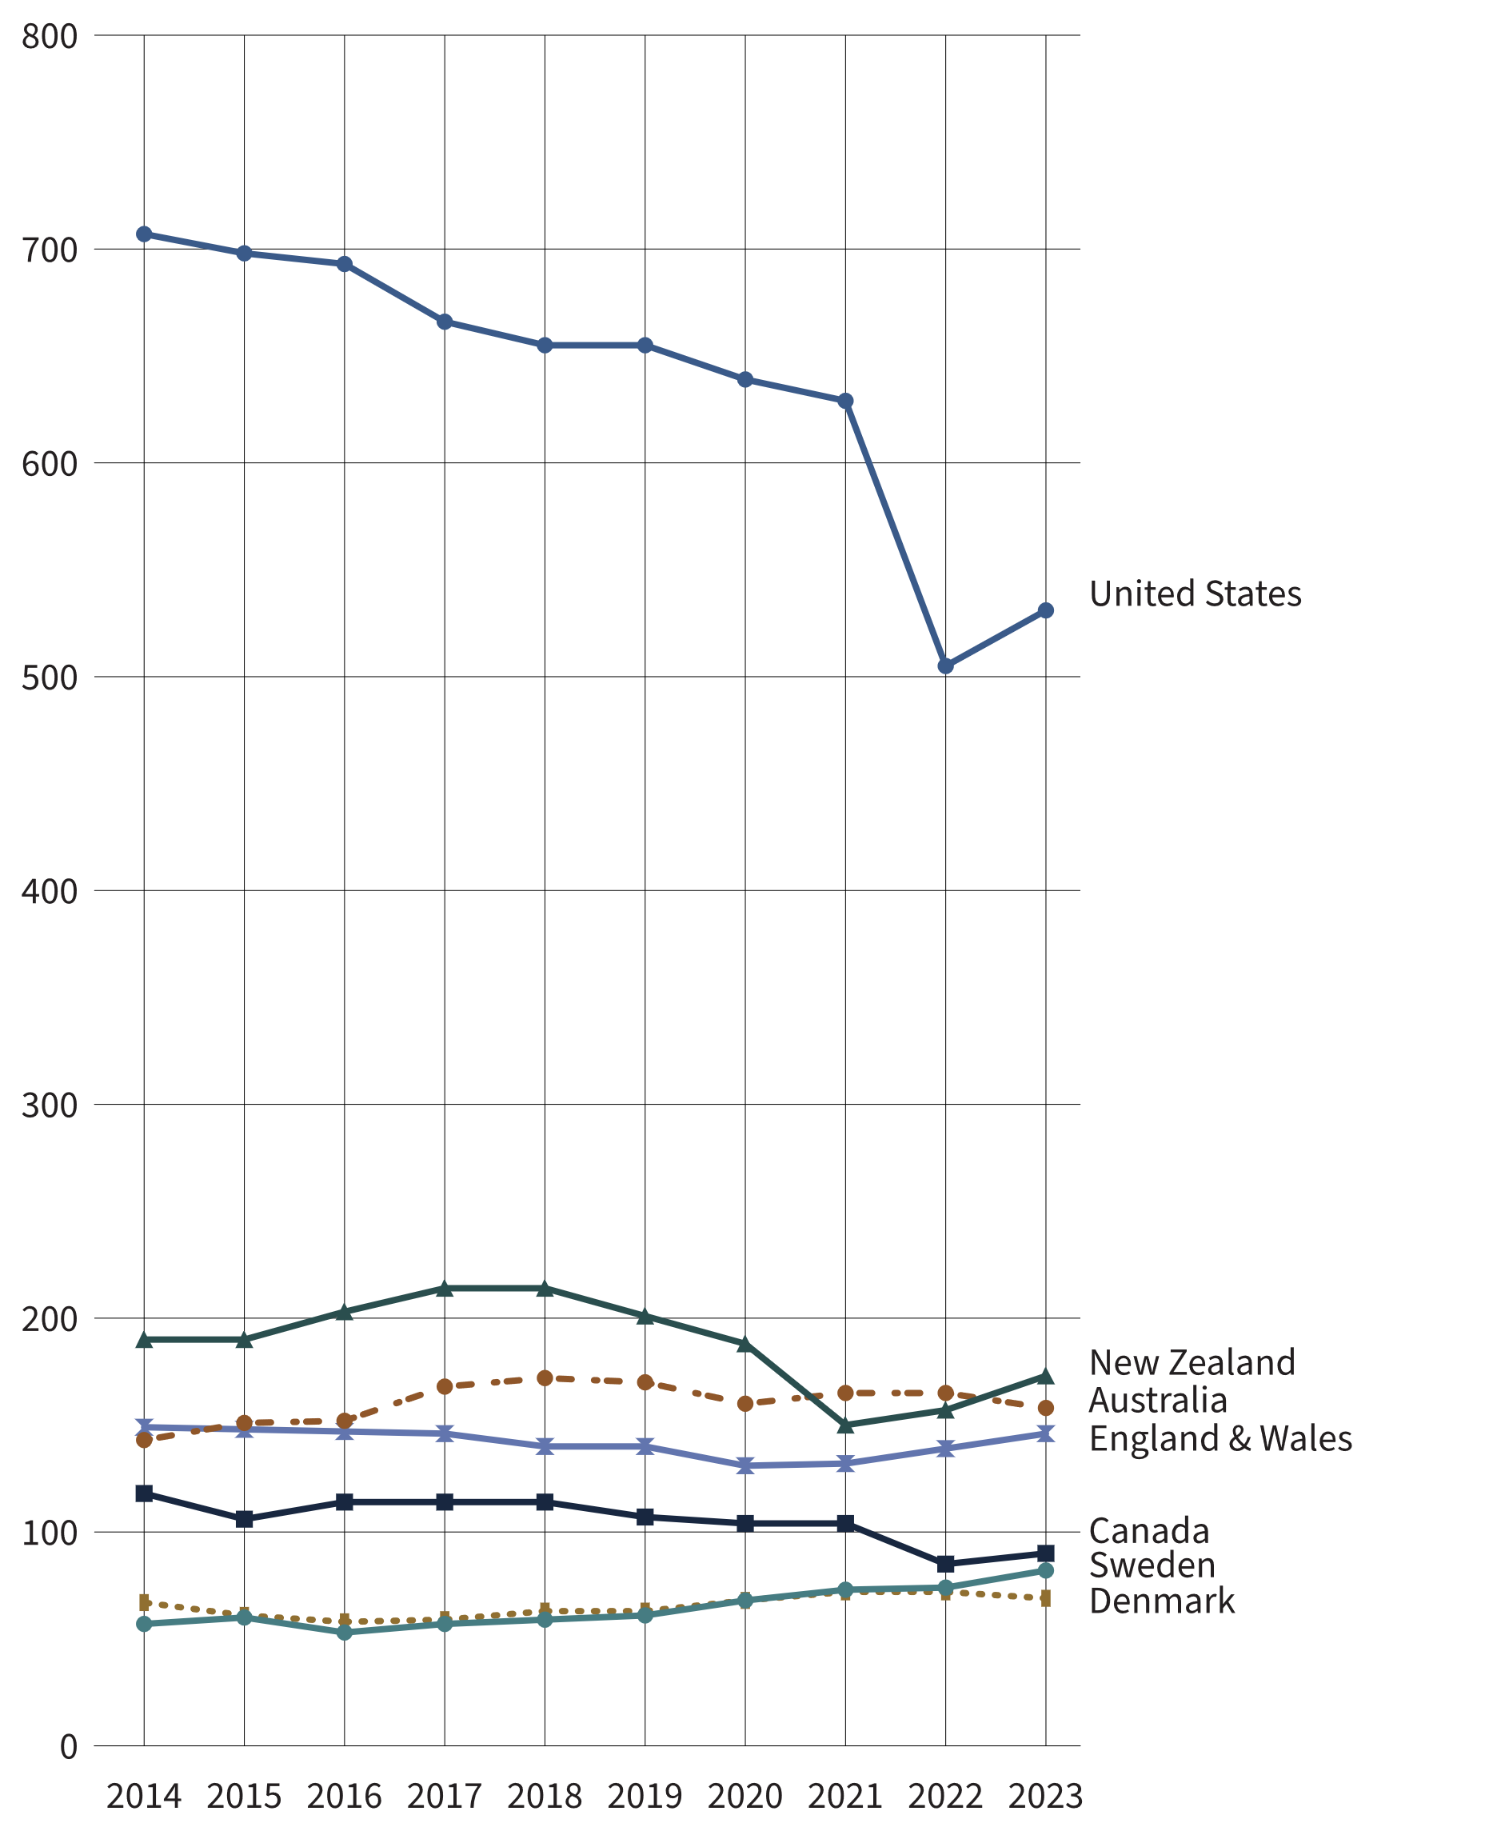
Source: World Prison Brief, Institute for Crime & Justice Policy Research (ICPR) (www.prisonstudies.org/highest-to-lowest/prison-population-total ).
- In the past 10 years (from 2014 to 2023), Canada’s incarceration rate declined 25.4%.
- From 2014 to 2022, incarceration rates declined in most countries. Notable exceptions are Sweden and Australia, with an increase of 29.8% and 15.4%, respectively, in the incarceration rate over the same time period.
- From 2022 to 2023, incarceration rates either remained stable or increased. The greatest increases were in Sweden (+10.8%) and New Zealand (+10.2%). The only countries with decreases in incarceration rates between 2022 to 2023 were Australia (-4.2%), Denmark (-4.2%), and Norway (-3.6%).
Notes
The incarceration rate presented here is a measure of the number of people (i.e., adults and youth) in custody per 100,000 people in the general population. Incarceration rates from the World Prison Brief hosted by the Institute for Crime & Justice Policy Research (ICPR) are based on the most recently available data at the time the list was compiled. The data were retrieved online on March 21st 2024, from http://www.prisonstudies.org, which contains the most up to-date information available. Different practices and variations in measurement in different countries limit the comparability of these figures.

Table A18. Prison population. Rate per 100,000
Country | 2014 | 2015 | 2016 | 2017 | 2018 | 2019 | 2020 | 2021 | 2022 | 2023
United States | 707 | 698 | 693 | 666 | 655 | 655 | 639 | 629 | 505 | 531
New Zealand | 190 | 190 | 203 | 214 | 214 | 201 | 188 | 150 | 157 | 173
Australia | 143 | 151 | 152 | 168 | 172 | 170 | 160 | 165 | 165 | 158
England & Wales | 149 | 148 | 147 | 146 | 140 | 140 | 131 | 132 | 139 | 146
Scotland | 144 | 144 | 142 | 138 | 143 | 149 | 136 | 138 | 136 | 144
France | 102 | 100 | 103 | 103 | 100 | 105 | 90 | 103 | 106 | 109
Italy | 88 | 86 | 90 | 95 | 98 | 101 | 89 | 92 | 96 | 104
Austria | 99 | 95 | 93 | 94 | 98 | 98 | 95 | 90 | 97 | 99
Canada | 118 | 106 | 114 | 114 | 114 | 107 | 104 | 104 | 85 | 88
Sweden | 57 | 60 | 53 | 57 | 59 | 61 | 68 | 73 | 74 | 82
Switzerland | 87 | 84 | 83 | 82 | 81 | 81 | 80 | 73 | 72 | 73
Denmark | 67 | 61 | 58 | 59 | 63 | 63 | 68 | 72 | 72 | 69
Germany | 81 | 78 | 78 | 77 | 75 | 77 | 69 | 71 | 67 | 67
Norway | 75 | 71 | 74 | 74 | 63 | 60 | 49 | 57 | 56 | 54
Finland | 55 | 57 | 55 | 57 | 51 | 53 | 53 | 50 | 51 | 51
Source: World Prison Brief, Institute for Crime & Justice Policy Research (ICPR) (www.prisonstudies.org/highest-to-lowest/prison-population-total ).
Notes
Table A17 and A18 display the same data for ease of reference and accessibility purposes.
The incarceration rate presented here is a measure of the number of people (i.e., adults and youth) in custody per 100,000 people in the general population. Incarceration rates from the World Prison Brief are based on the most recently available data at the time the list was compiled. The data were retrieved online on March 21st, 2024 at www.prisonstudies.org, which contains the most up to date information available. Additionally, different practices and variations in measurement in different countries limit the comparability of these figures.

Section B:
Corrections Administration



Corrections costs federally and provincially/territorially

Figure B1a. Costs of federal corrections
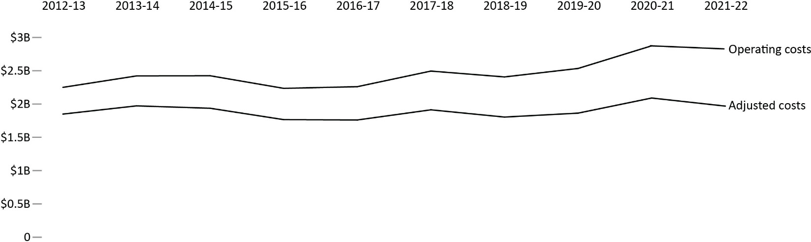

Figure B1b. Costs of provincial/territorial corrections
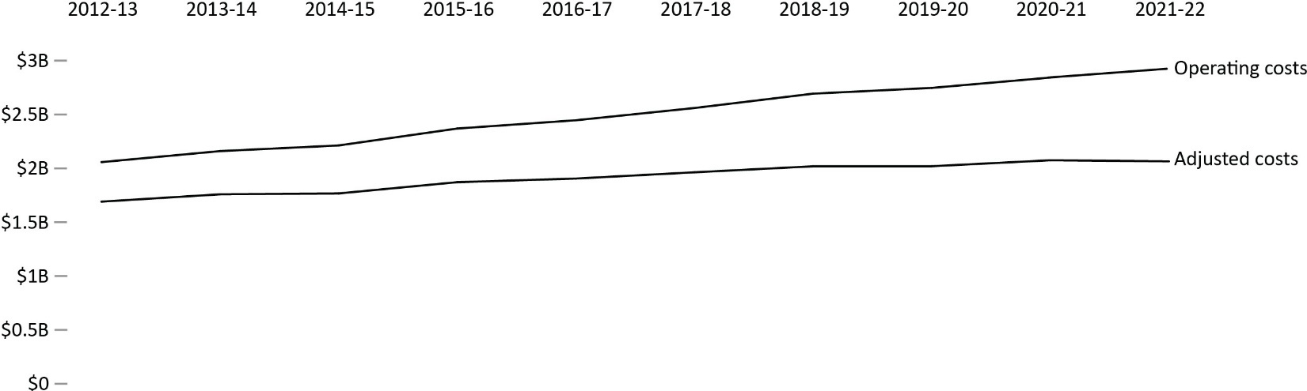
Sources: Federal costs are from Correctional Service Canada; Office of the Correctional Investigator; Parole Board of Canada. Provincial/Territorial costs are from Table 35-10-0013-01, Adult Correctional Services, Canadian Centre for Justice and Community Safety Statistics, Statistics Canada.
- Costs of federal corrections were about $2.8 billion in 2021-22. This was a 1.6% decrease compared to the prior year and 25.4% higher than 2012-13. When considering adjusted costs, there was a 5.7% decrease in spending between 2012-13 to 2021-22.
- Costs of provincial/territorial corrections were about $2.9 billion in 2021-22. This represented a 2.9% increase from 2020-21, and a 42.1% increase since 2012-13. When considering adjusted costs, there was a 22.1% increase in spending between 2012-13 to 2021-22.
Notes
Total expenditures represent gross expenditures and exclude revenues (i.e., Foreign Exchange Gains and refund of previous year revenue). Operating costs include Employee Benefit Plan expenditures. CSC expenditures exclude CORCAN (a Special Operating Agency that conducts industrial operations within penitentiaries), remissions on service fees as well as spending of amounts equivalent to the proceeds from disposal of surplus moveable Crown assets.
Adjusted costs adjust for the impact of inflation by reporting in constant dollars. Constant dollars (2002) represent dollar amounts calculated on a 1-year base that adjusts for inflation, allowing the yearly amounts to be directly comparable. Changes in the Consumer Price Index were used to calculate constant dollars.
Federal expenditures on corrections include spending by Correctional Service Canada (CSC), the Parole Board of Canada (PBC), and the Office of the Correctional Investigator (OCI).
The table includes data from the most recent year available at the time of preparation.
Reported year periods reflect fiscal years. A fiscal year runs from April 1 to March 31 of the following year.

Table B1a. Federal corrections costs in current dollars

Fiscal year 2017-18
Organization | Operating ($’000) | Capital ($’000) | Total ($’000) | Per capita* ($)
CSC | 2,442,488 | 185,624 | 2,628,112 | 71.91
PBC | 47,730 | NA | 47,730 | 1.31
OCI | 4,616 | NA | 4,616 | 0.13
Total | 2,494,849 | 185,624 | 2,680,473 | 73.35

Fiscal year 2018-19
Organization | Operating ($’000) | Capital ($’000) | Total ($’000) | Per capita* ($)
CSC | 2,352,556 | 227,793 | 2,580,349 | 69.62
PBC | 49,754 | NA | 49,754 | 1.34
OCI | 4,631 | NA | 4,631 | 0.12
Total | 2,406,941 | 227,793 | 2,634,734 | 71.08

Fiscal year 2019-20
Organization | Operating ($’000) | Capital ($’000) | Total ($’000) | Per capita* ($)
CSC | 2,477,237 | 164,643 | 2,641,879 | 70.28
PBC | 51,489 | NA | 51,489 | 1.37
OCI | 5,441 | NA | 5,441 | 0.14
Total | 2,534,167 | 164,643 | 2,698,809 | 71.79

Fiscal year 2020-21
Organization | Operating ($’000) | Capital ($’000) | Total ($’000) | Per capita* ($)
CSC | 2,811,113 | 121,987 | 2,933,100 | 77.17
PBC | 57,745 | NA | 57,745 | 1.52
OCI | 5,304 | NA | 5,304 | 0.14
Total | 2,874,162 | 121,987 | 2,996,149 | 78.83

Fiscal year 2021-22
Organization | Operating ($’000) | Capital ($’000) | Total ($’000) | Per capita* ($)
CSC | 2,764,000 | 146,976 | 2,910,977 | 76.12
PBC | 58,753 | NA | 58,753 | 1.54
OCI | 5,467 | NA | 5,467 | 0.14
Total | 2,828,220 | 146,976 | 2,975,197 | 77.80
Sources: Federal costs are from Correctional Service Canada; Office of the Correctional Investigator; Parole Board of Canada.

Table B1b. Federal corrections costs in constant 2002 dollars

Fiscal year 2017-18
Organization | Operating ($’000) | Capital ($’000) | Total ($’000) | Per capita* ($)
CSC | 1,873,074 | 142,350 | 2,015,423 | 55.15
PBC | 36,603 | NA | 36,603 | 1.00
OCI | 3,551 | NA | 3,551 | 0.10
Total | 1,913,228 | 142,350 | 2,055,577 | 56.25

Fiscal year 2018-19
Organization | Operating ($’000) | Capital ($’000) | Total ($’000) | Per capita* ($)
CSC | 1,763,535 | 170,759 | 1,934,295 | 52.19
PBC | 37,297 | NA | 37,297 | 1.01
OCI | 3,472 | NA | 3,472 | 0.09
Total | 1,804,304 | 170,759 | 1,975,063 | 53.29

Fiscal year 2019-20
Organization | Operating ($’000) | Capital ($’000) | Total ($’000) | Per capita* ($)
CSC | 1,821,498 | 121,061 | 1,942,558 | 51.67
PBC | 37,860 | NA | 37,860 | 1.01
OCI | 4,001 | NA | 4,001 | 0.11
Total | 1,863,358 | 121,061 | 1,984,418 | 52.79

Fiscal year 2020-21
Organization | Operating ($’000) | Capital ($’000) | Total ($’000) | Per capita* ($)
CSC | 2,044,446 | 88,718 | 2,133,164 | 56.13
PBC | 41,996 | NA | 41,996 | 1.10
OCI | 3,857 | NA | 3,857 | 0.10
Total | 2,090,300 | 88,718 | 2,179,017 | 57.33

Fiscal year 2021-22
Organization | Operating ($’000) | Capital ($’000) | Total ($’000) | Per capita* ($)
CSC | 1,924,344 | 102,327 | 2,026,672 | 53.00
PBC | 40,905 | NA | 40,905 | 1.07
OCI | 3,806 | NA | 3,806 | 0.10
Total | 1,969,055 | 102,327 | 2,071,383 | 54.17
Sources: Federal costs are from Correctional Service Canada; Office of the Correctional Investigator; Parole Board of Canada.
Notes
“Not applicable” is abbreviated to “NA” in this table due to formatting.
Total expenditures represent gross expenditures and exclude revenues (i.e., Foreign Exchange Gains and refund of previous year revenue). Operating costs include Employee Benefit Plan expenditures. CSC expenditures exclude CORCAN (a Special Operating Agency that conducts industrial operations within penitentiaries), remissions on service fees as well as spending of amounts equivalent to the proceeds from disposal of surplus moveable Crown assets.
*Per capita cost is calculated by dividing the total expenditures by the total Canadian population and represents the cost per Canadian for federal correctional services. The 2022 CCRSO used population estimates from July within the fiscal year. For example, the 2020-21 fiscal year used July 2020. This change was implemented in the 2020 CCRSO, and therefore, some values might vary from prior reports.
Due to rounding, constant dollar amounts may not add up to Total.
Constant dollars represent dollar amounts calculated on a 1-year base (2002) that adjusts for inflation allowing the yearly amounts to be directly comparable. Changes in the Consumer Price Index (CPI) were used to calculate constant dollars. Beginning in the 2020 CCRSO, the CPI rate is based on an average of the monthly CPI for the fiscal year rather than calendar year. This limits comparability of the current data to that reported prior to the 2020 CCRSO.
Federal expenditures on corrections include spending by Correctional Service Canada (CSC), the Parole Board of Canada (PBC), and the Office of the Correctional Investigator (OCI).
Costs are rounded to the thousands. Therefore, the per capita rate needs to be multiplied by 1,000.
The table includes data from the most recent year available at the time of preparation.
Reported year periods reflect fiscal years. A fiscal year runs from April 1 to March 31 of the following year.

Number of CSC employees by location

Figure B2. CSC employees at the end of fiscal year (2022-23)
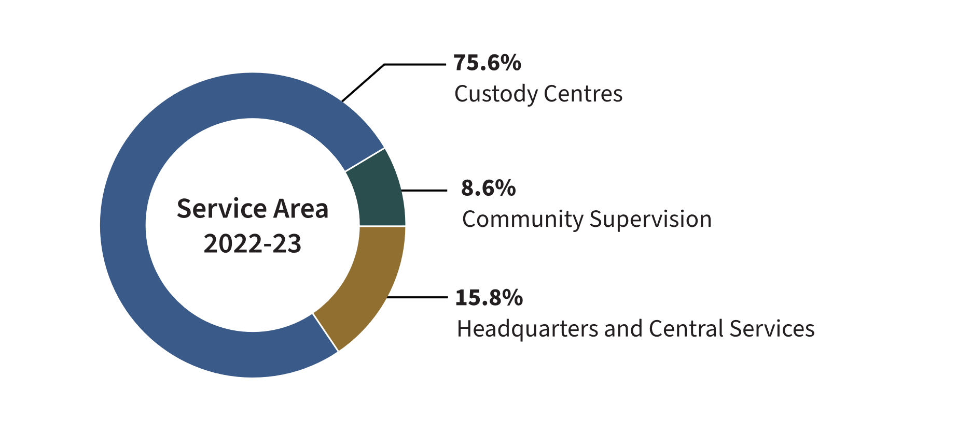
Source: Correctional Service of Canada.
- The Correctional Service of Canada (CSC) has a total staff of 18,149.
- 75.6% of CSC staff work in institutions.
- Staff employed in community supervision account for 8.6% of the total number of CSC employees.
Notes
Due to changes in policy, Correctional Officers no longer occupy positions in the community.
These numbers represent indeterminate and terms equal to or more than 3 months substantive employment; and employee status of active and paid leave current up to March 31, 2023.
Due to rounding, percentage may not add to 100.
Reported year periods reflect fiscal years. A fiscal year runs from April 1 to March 31 of the following year.

Table B2. CSC employees at the end of fiscal year
Service area | March 31, 2014 | % | March 31, 2023 | %
Headquarters and central services total | 2,752 | 15.3 | 2,867 | 15.8
Administration | 2,378 | 13.2 | 2,198 | 12.1
Health care | 96 | 0.5 | 86 | 0.5
Program staff | 71 | 0.4 | 63 | 0.3
Correctional officers | 13 | 0.1 | 44 | 0.2
Instructors/supervisors | 10 | 0.1 | 11 | 0.1
Parole officers/parole supervisors* | 2 | 0.0 | 1 | 0.0
Other** | 182 | 1.0 | 464 | 2.6
Custody centres total | 13,783 | 76.5 | 13,716 | 75.6
Administration | 1,918 | 10.6 | 1,851 | 10.2
Health care | 991 | 5.5 | 1,088 | 6.0
Program staff | 936 | 5.2 | 1,042 | 5.7
Correctional officers | 7,654 | 42.5 | 7,227 | 39.8
Instructors/supervisors | 422 | 2.3 | 422 | 2.3
Parole officers/parole supervisors* | 705 | 3.9 | 583 | 3.2
Other** | 1,157 | 6.4 | 1,503 | 8.3
Community supervision total | 1,477 | 8.2 | 1,566 | 8.6
Administration | 373 | 2.1 | 358 | 2.0
Health care | 84 | 0.5 | 90 | 0.5
Program staff | 281 | 1.6 | 266 | 1.5
Parole officers/parole supervisors* | 728 | 4.0 | 827 | 4.6
Correctional officers | 10 | 0.1 | NA | NA
Other** | 1 | 0.0 | 25 | 0.1
Total | 18,012 | 100.0 | 18,149 | 100.0
Source: Correctional Service of Canada.

Notes
Due to changes in policy, Correctional Officers no longer occupy positions in the community.
*These parole officers work within institutions, with the responsibility of preparing offenders for release.
** The "Other" category represents job classifications such as trades and food services.
These numbers represent indeterminate and terms equal to or more than 3 months substantive employment; and employee status of active and paid leave current up to March 31, 2023.
Due to rounding, percentage may not add to 100.
Reported year periods reflect fiscal years. A fiscal year runs from April 1 to March 31 of the following year.

Cost of incarceration in a federal institution: 5-year trend

Figure B3. Federal average daily inmate cost (current $)
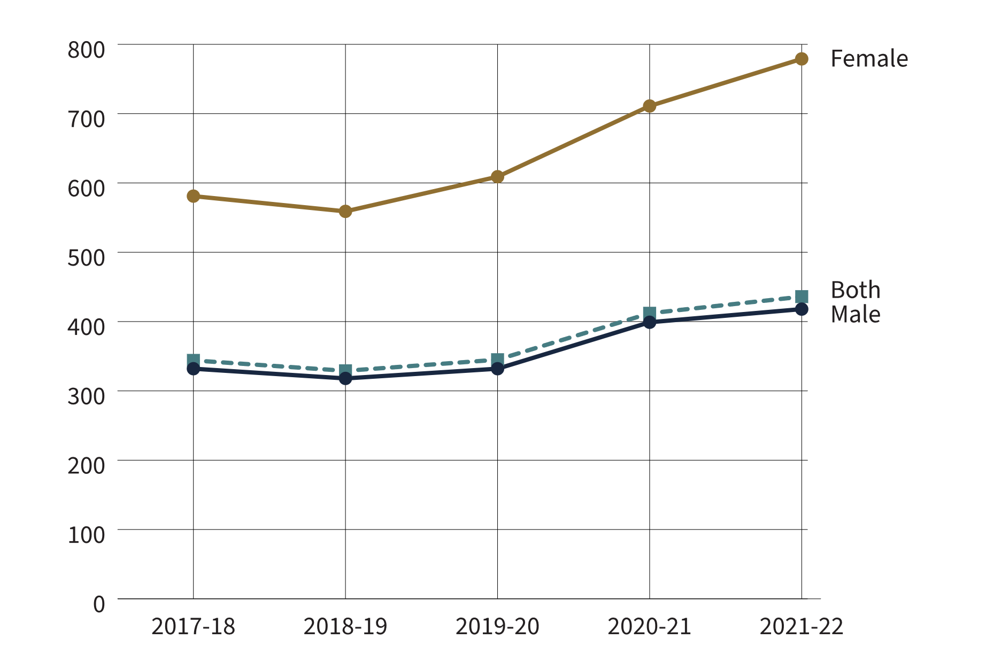
Source: Correctional Service of Canada.
- The federal average daily inmate cost has increased from $344 in 2017-18 to $436 in 2021-22. In 2021-22, the annual average cost of keeping an inmate incarcerated was $159,115 per year, an increase from $125,466 per year in 2017-18. In 2021-22, the annual average cost of keeping a male incarcerated was $152,704 per year, whereas the annual average cost for incarcerating a female was $284,157.
- The cost associated with maintaining an offender in the community is 73.9% less than what it costs to maintain an offender in custody ($41,519 per year versus $159,115 per year).
Notes
In 2018-19, the methodology of presentation for certain indirect costs was changed to better reflect the direct costs of maintaining an offender.
The average daily inmate cost includes those costs associated with the operation of the institutions such as salaries and employee benefit plan contributions, but excludes capital expenditures and expenditures related to CORCAN (a Special Operating Agency that conducts industrial operations within federal institutions).
Total incarcerated and community includes additional NHQ & RHQ administrative costs, which are not part of the Institutional and/or Community calculations.
Offenders in the Community include: Offenders under CSC’s supervision on conditional release, statutory release, or with Long-Term Supervision Order. Figures may not add due to rounding.
Reported year periods reflect fiscal years. A fiscal year runs from April 1 to March 31 of the following year.

Table B3. Annual average cost per offender (current $)
Categories | 2017-18 | 2018-19 | 2019-20 | 2020-21 | 2021-22
Maximum security (men’s facilities) | 169,367 | 163,642 | 174,939 | 204,048 | 221,993
Medium security (men’s facilities) | 115,263 | 109,660 | 111,243 | 131,533 | 135,676
Minimum security (men’s facilities) | 86,603 | 83,900 | 92,877 | 121,898 | 128,889
Women’s facilities | 212,005 | 204,474 | 222,942 | 259,654 | 284,157
Exchange of services agreements* (males and females) | 114,188 | 122,269 | 131,322 | 130,729 | 174,218
Incarcerated average | 125,466 | 120,589 | 126,253 | 150,505 | 159,115
Offenders in the community | 32,327 | 32,037 | 34,214 | 38,418 | 41,519
Total incarcerated and in community | 100,425 | 99,185 | 104,963 | 119,735 | 128,478
Source: Correctional Service of Canada.
Notes
In 2018-19, the methodology of presentation for certain indirect costs was changed to better reflect the direct costs of maintaining an offender.
The average daily inmate cost includes those costs associated with the operation of the institutions such as salaries and employee benefit plan contributions, but excludes capital expenditures and expenditures related to CORCAN (a Special Operating Agency that conducts industrial operations within federal institutions).
*The intent of an Exchange of Service Agreement is to detail the roles and responsibilities of each jurisdiction and include specific protocols regarding per diem rates, offender information sharing, and invoicing pertaining to the reciprocal exchange of offenders between jurisdictions.
Total incarcerated and community includes additional NHQ & RHQ administrative costs which are not part of the Institutional and/or Community calculations.
Offenders in the Community include: Offenders under CSC’s supervision on conditional release, statutory release, or with Long-Term Supervision Order.
Figures may not add due to rounding.
Reported year periods reflect fiscal years. A fiscal year runs from April 1 to March 31 of the following year.

The number of Parole Board of Canada employees

Figure B4. Full-time equivalents – 10-year trend
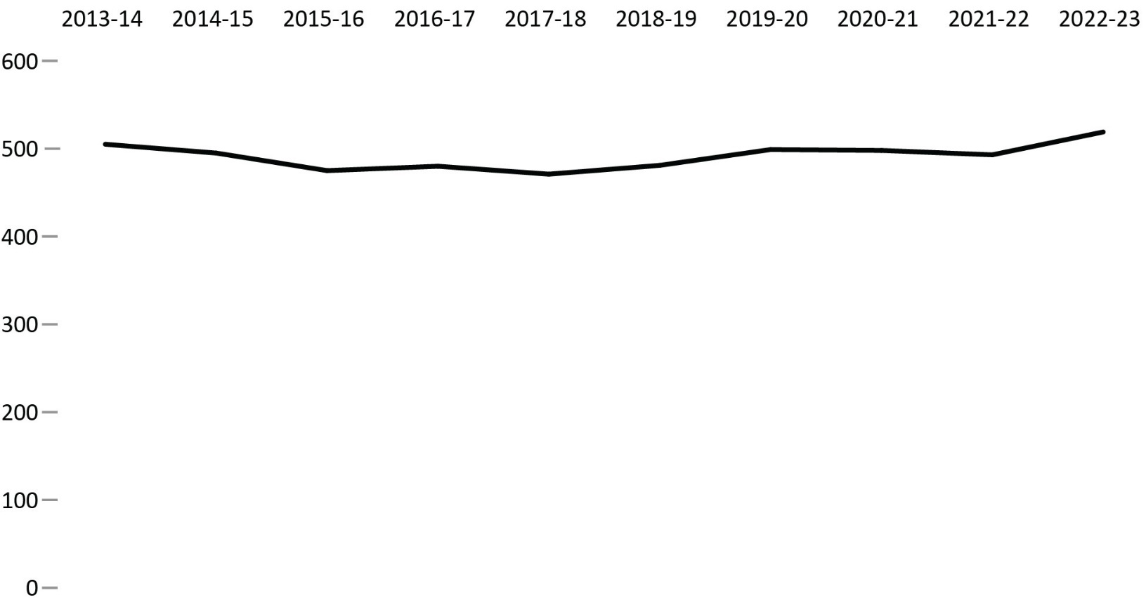
Source: Parole Board of Canada.
- In 2022-23, the full-time equivalents employed by the Parole Board of Canada increased by 5.6% to 519 (26 more) compared to 2021-22.
- In the past 10 fiscal years (from 2013-14 to 2022-23), there was a 2.8% increase (from 505 to 519) in the number of full-time equivalents employed by the Parole Board of Canada.
Notes
A full-time equivalent is a measure of the extent to which an employee represents a full person-year charge against a departmental budget. Section 103 of the Corrections and Conditional Release Act limits the Parole Board of Canada to 60 full-time members.
Reported year periods reflect fiscal years. A fiscal year runs from April 1 to March 31 of the following year.

Table B4. Full-time equivalents
Parole Board of Canada employees | 2018-19 | 2019-20 | 2020-21 | 2021-22 | 2022-23
Total program activity | 481 | 499 | 498 | 493 | 519
Conditional release decisions | 317 | 320 | 323 | 320 | 329
Conditional release openness and accountability | 43 | 45 | 45 | 49 | 49
Record suspension and clemency recommendations | 58 | 72 | 62 | 57 | 65
Internal services | 63 | 62 | 68 | 67 | 76
Total types of employees | 481 | 499 | 498 | 493 | 519
Full-time board members | 41 | 40 | 36 | 40 | 39
Part-time board members | 19 | 20 | 20 | 19 | 18
Staff | 421 | 439 | 442 | 434 | 462
Source: Parole Board of Canada.
Notes
A full-time equivalent is a measure of the extent to which an employee represents a full person-year charge against a departmental budget. Section 103 of the Corrections and Conditional Release Act limits the Parole Board of Canada to 60 full-time members.
Reported year periods reflect fiscal years. A fiscal year runs from April 1 to March 31 of the following year.

The number of employees in the Office of the Correctional Investigator

Figure B5. Full-time equivalents
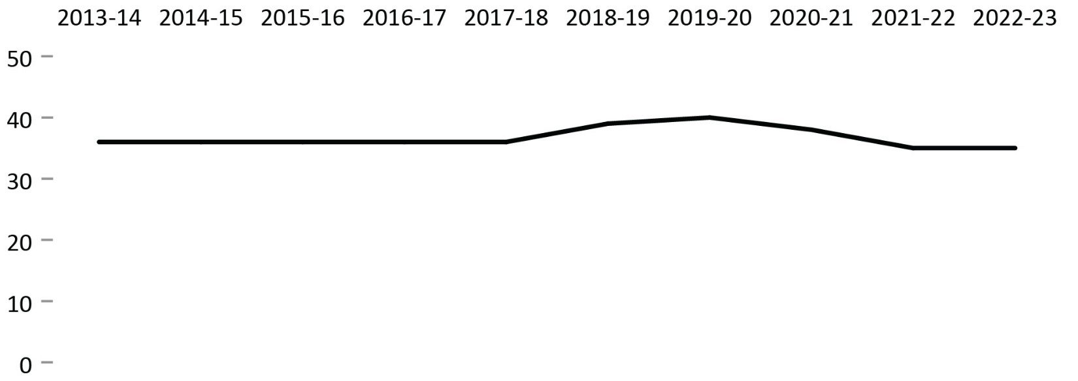
Source: Office of the Correctional Investigator.
- In 2022-23, the total number of full-time equivalents at the Office of the Correctional Investigator was 35, which is consistent with the year prior.
- In the past 10 years (from 2013-14 to 2022-23), the total number of full-time equivalents at the Office of the Correctional Investigator has remained relatively stable.
Notes
The Office of the Correctional Investigator (OCI) may commence an investigation on receipt of a complaint by or on behalf of an offender or on its own initiative. Complaints are made by telephone, letter and during interviews with the OCI's investigative staff at federal correctional facilities. The dispositions in response to complaints involve a combination of internal responses (where the information or assistance sought by the offender can generally be provided by the OCI's investigative staff) and investigations (where, further to a review/analysis of law, policies and documentation, OCI investigative staff make an inquiry or several interventions with Correctional Service Canada and submit recommendations to address the complaint). Investigations vary considerably in terms of scope, complexity, duration, and resources required.
Reported year periods reflect fiscal years. A fiscal year runs from April 1 to March 31 of the following year.

Table B5. Full time equivalents
Types of employees | 2018-19 | 2019-20 | 2020-21 | 2021-22 | 2022-23
Correctional investigator | 1 | 1 | 1 | 1 | 1
Senior management and investigative services | 27 | 28 | 26 | 24 | 22
Internal services | 6 | 5 | 5 | 5 | 8
Legal counsel, policy and research | 5 | 6 | 6 | 5 | 4
Total | 39 | 40 | 38 | 35 | 35
Source: Office of the Correctional Investigator.
Notes
The Office of the Correctional Investigator (OCI) may commence an investigation on receipt of a complaint by or on behalf of an offender or on its own initiative. Complaints are made by telephone, letter and during interviews with the OCI's investigative staff at federal correctional facilities. The dispositions in response to complaints involve a combination of internal responses (where the information or assistance sought by the offender can generally be provided by the OCI's investigative staff) and investigations (where, further to a review/analysis of law, policies and documentation, OCI investigative staff make an inquiry or several interventions with Correctional Service Canada and submit recommendations to address the complaint). Investigations vary considerably in terms of scope, complexity, duration, and resources required.
Reported year periods reflect fiscal years. A fiscal year runs from April 1 to March 31 of the following year.

Most common offender complaints to the Office of the Correctional Investigator

Figure B6. Top 10 offender complaints at the end of fiscal year 2022-23
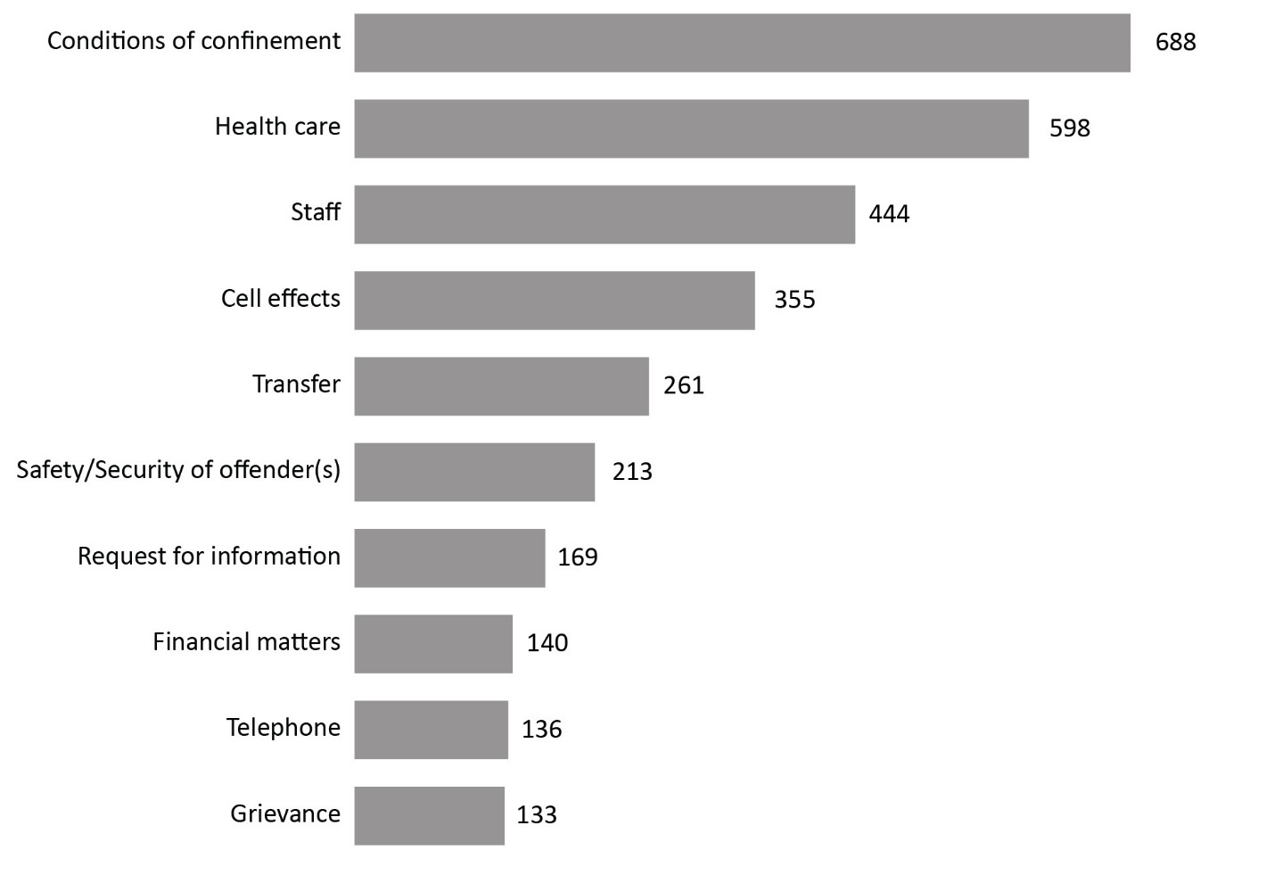
Source: Office of the Correctional Investigator.
- There were 4,740 complaints/enquiries received at the Office of the Correctional Investigator (OCI) in 2022-23, an increase of 4.3% since 2021-22.
- Conditions of confinement (14.5%), health care (12.6%), staff (9.4%), and cell effects (7.5%), accounted for 44% of all complaints.
- Conditions of confinement remain the most common offender complaint in 2022. From 2018-19 to 2019-20, the most common complaint was health care.
Notes
The Office of the Correctional Investigator (OCI) may commence an investigation on receipt of a complaint by or on behalf of an offender or on its own initiative. Complaints are made by telephone, letter and during interviews with the OCI's investigative staff at federal correctional facilities. The dispositions in response to complaints involve a combination of internal responses (where the information or assistance sought by the offender can generally be provided by the OCI's investigative staff) and investigations (where, further to a review/analysis of law, policies and documentation, OCI investigative staff make an inquiry or several interventions with Correctional Service Canada and submit recommendations to address the complaint). Investigations vary considerably in terms of scope, complexity, duration, and resources required.
Due to ongoing efforts at the OCI to streamline the administrative database and ensure accuracy in reporting, the numbers in this table will not always match those of past Corrections and Conditional Release Statistical Overviews, or OCI Annual Reports.
Reported year periods reflect fiscal years. A fiscal year runs from April 1 to March 31 of the following year.

Table B6. Top 20 offender complaint categories* across the past 5 fiscal years
Category of complaint* | 2018-19 | 2019-20 | 2020-21 | 2021-22 | 2022-23
Conditions of confinement | 608 | 502 | 863 | 765 | 688
Health Care | 693 | 688 | 516 | 522 | 598
Staff | 501 | 560 | 515 | 477 | 444
Cell Effects | 407 | 388 | 244 | 287 | 355
Transfer | 334 | 368 | 201 | 175 | 261
Safety/Security of Offender(s) | 177 | 230 | 183 | 165 | 213
Request for Information | 159 | 245 | 204 | 139 | 169
Visits | 192 | 209 | 123 | 140 | 125
Telephone | 183 | 185 | 133 | 127 | 136
Financial Matters | 111 | 119 | 112 | 149 | 140
Grievance | 127 | 129 | 106 | 92 | 133
Case Preparation | 73 | 96 | 149 | 166 | 38
Outside OCI Jurisdiction | 128 | 133 | 65 | 71 | 119
Correspondence | 84 | 130 | 103 | 84 | 87
Security Classification | 102 | 136 | 61 | 81 | 95
Operation/Decisions of the OCI | 39 | 57 | 80 | 40 | 35
Programs | 112 | 112 | 71 | 73 | 93
Legal Counsel | 20 | 63 | 69 | 128 | 107
Mental Health | 59 | 100 | 49 | 66 | 103
Conditional Release | 30 | 60 | 62 | 77 | 109
Total of all categories** | 5,113 | 5,566 | 4,507 | 4,536 | 4,740
Source: Office of the Correctional Investigator.
Notes
The Office of the Correctional Investigator (OCI) may commence an investigation on receipt of a complaint by or on behalf of an offender or on its own initiative. Complaints are made by telephone, letter and during interviews with the OCI's investigative staff at federal correctional facilities. The dispositions in response to complaints involve a combination of internal responses (where the information or assistance sought by the offender can generally be provided by the OCI's investigative staff) and investigations (where, further to a review/analysis of law, policies and documentation, OCI investigative staff make an inquiry or several interventions with Correctional Service Canada and submit recommendations to address the complaint). Investigations vary considerably in terms of scope, complexity, duration, and resources required.
*These top 20 categories of complaints are based on the sum totals for the 5 reported fiscal years between 2018-19 and 2022-23. A fiscal year runs from April 1 to March 31 of the following year.
**These totals represent all complaint categories.
Due to ongoing efforts at the OCI (Office of the Correctional Investigator) to streamline the administrative database and ensure accuracy in reporting, the numbers in this table will not always match those of past Corrections and Conditional Release Statistical Overviews, or OCI Annual Reports.
Reported year periods reflect fiscal years. A fiscal year runs from April 1 to March 31 of the following year.

Section C:
Federal Offender and Registered Victims Populations



Offenders under the responsibility of CSC

Figure C1. Total offender population (2022-23) *
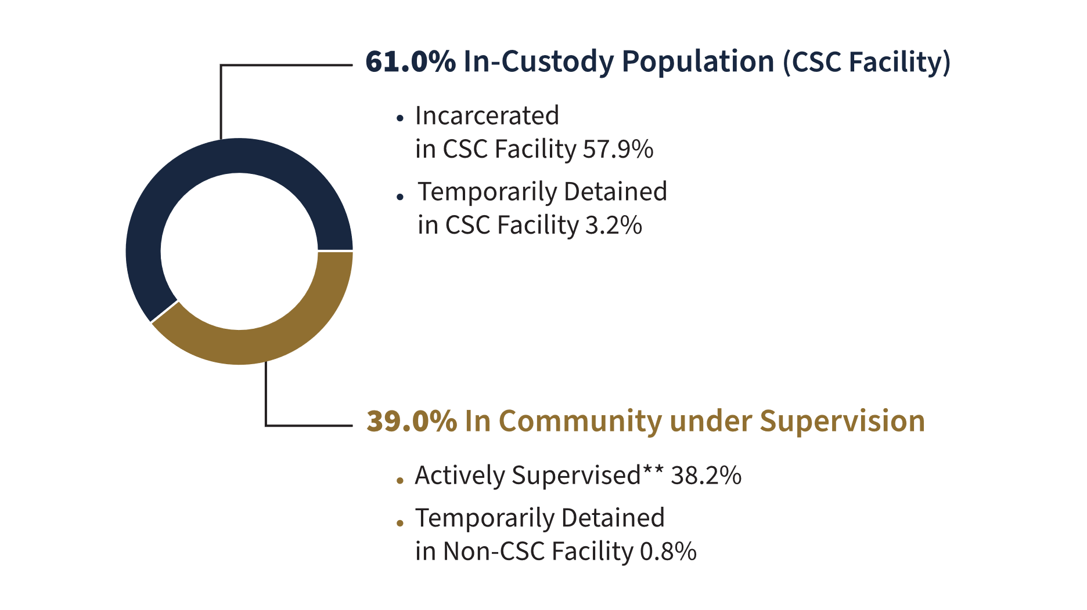
Source: Correctional Service of Canada.
- After a consistent yearly decrease in the in-custody population between 2013-14 and 2021-22, the in-custody population has seen a noticeable increase of 5.9% from 12,328 in 2021-22 to 13,054 in 2022-23.
Definitions C1:
Total Offender Population includes all active offenders who are incarcerated in a CSC facility, offenders on temporary absence from a CSC facility, offenders who are temporarily detained, offenders who are actively supervised, and offenders who are unlawfully at large for less than 90 days.
CSC Facilities include all federal institutions and federally funded Healing Lodges.
In Custody includes all active offenders incarcerated in a CSC facility, offenders on temporary absence from a CSC facility, offenders who are temporarily detained in a CSC facility and offenders on remand in a CSC facility.
In Community Under Supervision includes all active offenders on day parole, full parole, statutory release, in the community supervised on a long-term supervision order, offenders who are temporarily detained in a non-CSC facility, offenders who are unlawfully at large for less than 90 days, offenders on remand in a non-CSC facility, and offenders supervised and subject to an immigration hold by Canada Border Services Agency.
**Actively Supervised includes all active offenders on day parole, full parole or statutory release, as well as those who are in the community on long-term supervision orders.
Temporarily Detained includes offenders who are physically held in a CSC facility or a non-CSC facility after being suspended for a breach of a parole condition or to prevent a breach of parole conditions.
In addition to the total offender population, there are excluded groups such as:
Federal jurisdiction offenders incarcerated in a Community Correctional Centre or in a non-CSC facility.
Federal jurisdiction offenders deported /extradited including offenders for whom a deportation order has been enforced by Canada Border Services Agency.
Federal offenders on bail which includes offenders on a judicial interim release; they have appealed their conviction or sentence and have been released to await the results of a new trial.
Escaped includes offenders who have absconded from either a correctional facility or while on a temporary absence and whose whereabouts are unknown.
Unlawfully at Large for 90 days or more. This includes offenders who have been released to the community on day parole, full parole, statutory release or a long-term supervision order for whom a warrant for suspension has been issued at least 90 days ago, but has not yet been executed.
Notes
*In addition to this total offender population, 282 offenders were on bail, 118 offenders were escapees, 290 offenders serving a federal sentence were in custody in a non-CSC facility, 327 offenders were unlawfully at large for 90 days or more, and 374 offenders were deported.
The definition of "Offender Population" changed from previous editions of the Corrections and Conditional Release Statistical Overview (CCRSO). Previously, CSC counted the number of federal offenders; the definition has now changed to counting the number of offenders in federal facilities. As such, comparisons to editions of the CCRSO prior to 2016 should be done with caution.
Reported year periods reflect fiscal years. A fiscal year runs from April 1 to March 31 of the following year.

Table C1. Total offender population (2022-23)*
Status | Offenders under the responsibility of CSC | %
In-custody population (CSC facility) | 13,054 | 61.0
Incarcerated in CSC facility | 12,374 | 57.9
Temporarily detained in CSC facility | 680 | 3.2
In community under supervision | 8,330 | 39.0
Temporarily detained in non-CSC facility | 167 | 0.8
Actively supervised | 8,163 | 38.2
Day parole | 1,472 | 6.9
Full parole | 4,011 | 18.8
Statutory release | 2,216 | 10.4
Long-term supervision order | 464 | 2.2
Total | 21,384 | 100.0
Source: Correctional Service of Canada.
Notes
*In addition to this total offender population, 282 offenders were on bail, 118 offenders were escapees, 290 offenders serving a federal sentence were in custody in a non-CSC facility, 327 offenders were unlawfully at large for 90 days or more, and 374 offenders were deported.
The definition of "Offender Population" changed from previous editions of the Corrections and Conditional Release Statistical Overview (CCRSO). Previously, CSC counted the number of federal offenders; the definition has now changed to counting the number of offenders in federal facilities. As such, comparisons to editions of the CCRSO prior to 2016 should be done with caution.
Reported year periods reflect fiscal years. A fiscal year runs from April 1 to March 31 of the following year.

Number of registered victims and number of offenders with a registered victim: 5-year trend

Figure C2. Number of registered victims and number of offenders with a registered victim
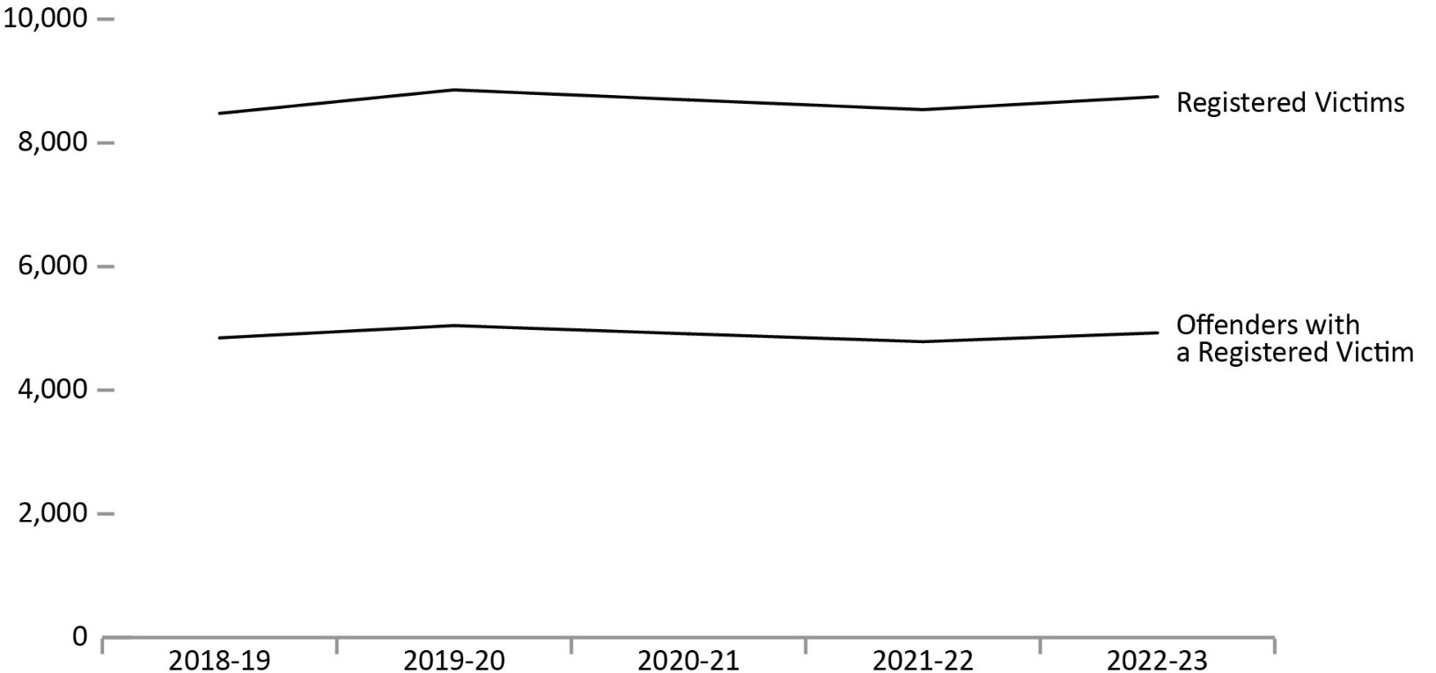
Source: Correctional Service of Canada.
- In order to register to receive information, a victim must meet the definition of a victim under the Corrections and Conditional Release Act (CCRA). Victims of federal offenders must be at least 18 years old or legally emancipated or demonstrate they can act for themselves. Victims can register with the Correctional Service of Canada or the Parole Board of Canada.
- Although the number of victims registered with the federal correctional system has fluctuated over the past 5 fiscal years, it has increased by 3.2%, from 8,477 in 2018-19 to 8,747 in 2022-23.
- Although the number of offenders with registered victims has fluctuated over the past 5 fiscal years, there was a slight increase of 1.7% from 4,847 in 2018-19 to 4,928 in 2022-23.
Notes
The Canadian Victims Bill of Rights defines a victim as any individual who has suffered physical or emotional harm, property damage, or economic loss as the result of the commission of an offence. The law also allows a spouse, a relative or dependent, an individual who is responsible for the care or support of the victim or the care or support of a dependent of the victim, to act on behalf of a victim, if the victim cannot act on their own behalf. Victims include persons harmed by the offender regardless of whether the offender has been prosecuted or not, as long as an official complaint has been made to the police or to the Crown.
Victims do not automatically receive information about the offender who harmed them. If they have been harmed by an offender serving a sentence of 2 years or more, victims must register with the Correctional Service of Canada (CSC) or the Parole Board of Canada to receive information or access services. Registration allows CSC to verify that the individual meets the definition of victim, which is required by law before sharing protected offender information. https://www.csc-scc.gc.ca/victims/003006-7001-en.shtml
Reported data is current up to the end of each fiscal year. A fiscal year runs from April 1 to March 31 of the following year.

Table C2. Number of registered victims and number of offenders with a registered victim
Fiscal year | Number of registered victims | Number of offenders with a registered victim
2018-19 | 8,477 | 4,847
2019-20 | 8,857 | 5,045
2020-21 | 8,695 | 4,912
2021-22 | 8,537 | 4,785
2022-23 | 8,747 | 4,928
Source: Correctional Service of Canada.
Notes
The Canadian Victims Bill of Rights defines a victim as any individual who has suffered physical or emotional harm, property damage, or economic loss as the result of the commission of an offence. The law also allows a spouse, a relative or dependent, an individual who is responsible for the care or support of the victim or the care or support of a dependent of the victim, to act on behalf of a victim, if the victim cannot act on their own behalf. Victims include persons harmed by the offender regardless of whether the offender has been prosecuted or not, as long as an official complaint has been made to the police or to the Crown.
Victims do not automatically receive information about the offender who harmed them. If they have been harmed by an offender serving a sentence of 2 years or more, victims must register with the Correctional Service of Canada (CSC) or the Parole Board of Canada to receive information or access services. Registration allows CSC to verify that the individual meets the definition of victim, which is required by law before sharing protected offender information. https://www.csc-scc.gc.ca/victims/003006-7001-en.shtml
Reported data is current up to the end of each fiscal year. A fiscal year runs from April 1 to March 31 of the following year.

The number of in-custody offenders: 10-year trend

Figure C3a. Number of in-custody offenders in a CSC facility at fiscal year* end
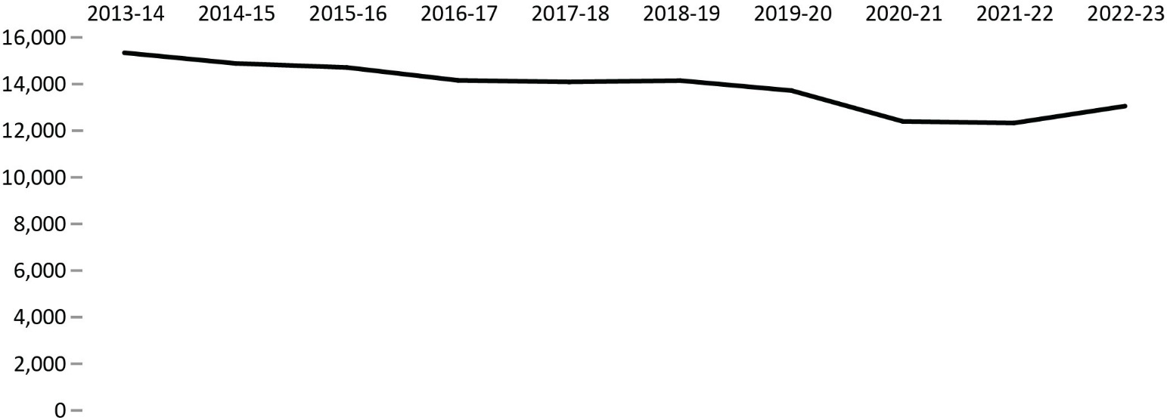
Source: Correctional Service of Canada.

Figure C3b. Number of in-custody offenders in a provincial/territorial facility fiscal year* end
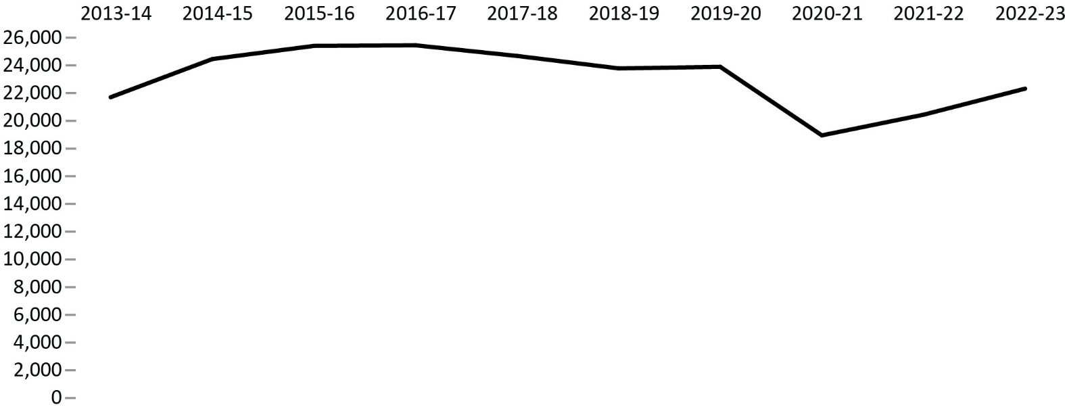
Source: Table: 35-10-0154-01, Corrections Key Indicator Report for Adults and Youth, Canadian Centre for Justice and Community Safety Statistics, Statistics Canada.
- After a consistent yearly decrease in the in-custody population between 2013-14 and 2021-22, the in-custody population increased 5.9% from 12,328 in 2021-22 to 13,054 in 2022-23. Despite this increase, the in-custody population has not returned to pre-COVID-19 pandemic levels.
- From 2016-17 to 2020-21, the in-custody population in a provincial/territorial facility decreased by 25.5%, followed by a 7.9% increase from 2020-21 to 2021-22 and a further 9.2% increase from 2021-22 to 2022-23. Despite this increase, the in-custody population in a provincial/territorial facility has not returned to pre-COVID-19 pandemic levels.
Notes
*The data reflect the number of offenders in custody at the end of each fiscal year. A fiscal year runs from April 1 to March 31 of the following year.
Provincial/territorial data points in Figure C3b reflect the average daily count of adult offenders in custody over the 12-month fiscal year period.
The term "In custody in a CSC facility" includes all active offenders incarcerated in a CSC facility, offenders on temporary absence from a CSC facility, offenders who are temporarily detained in a CSC facility and offenders on remand in a CSC facility.

Table C3. In-custody offenders
Fiscal Year |  | In custody in a CSC¹ facility* |  | Sentenced in a prov./terr.² facility | On remand in a prov./terr.² facility | Other/ temporary detention in a prov./terr.² facility |  | Total in a prov./terr.² facility | Total CSC¹ and prov./terr.²
2013-14 | 15,342 |  | 9,888 |  | 11,494 | 322 | 21,704 |  | 37,046
2014-15 | 14,886 |  | 10,364 |  | 13,650 | 441 | 24,455 |  | 39,341
2015-16 | 14,712 |  | 10,091 |  | 14,899 | 415 | 25,405 |  | 40,117
2016-17 | 14,159 |  | 9,710 |  | 15,417 | 321 | 25,448 |  | 39,607
2017-18 | 14,092 |  | 9,545 |  | 14,833 | 303 | 24,681 |  | 38,773
2018-19 | 14,149 |  | 8,708 |  | 14,778 | 297 | 23,783 |  | 37,932
2019-20 | 13,720 |  | 7,947 |  | 15,505 | 442 | 23,894 |  | 37,614
2020-21 | 12,399 |  | 5,881 |  | 12,753 | 317 | 18,950 |  | 31,349
2021-22 | 12,328 |  | 5,798 |  | 14,415 | 226 | 20,439 |  | 32,767
2022-23 | 13,054 |  | 5,916 |  | 16,194 | 209 | 22,319 |  | 35,373
Sources: ¹Correctional Service of Canada. ²Table 35-10-0154-01, Corrections Key Indicator Report for Adults and Youth, Canadian Centre for Justice and Community Safety Statistics, Statistics Canada.
Notes
*The data reflect the number of offenders in custody at the end of each fiscal year. A fiscal year runs from April 1 to March 31 of the following year.
Provincial/territorial data points in Figure C3b reflect the average daily count of adult offenders in custody over the 12-month fiscal year period.
The term "In custody in a CSC facility" includes all active offenders incarcerated in a CSC facility, offenders on temporary absence from a CSC facility, offenders who are temporarily detained in a CSC facility and offenders on remand in a CSC facility.

Number of admissions to CSC facilities

Figure C4. Number of admissions to CSC facilities
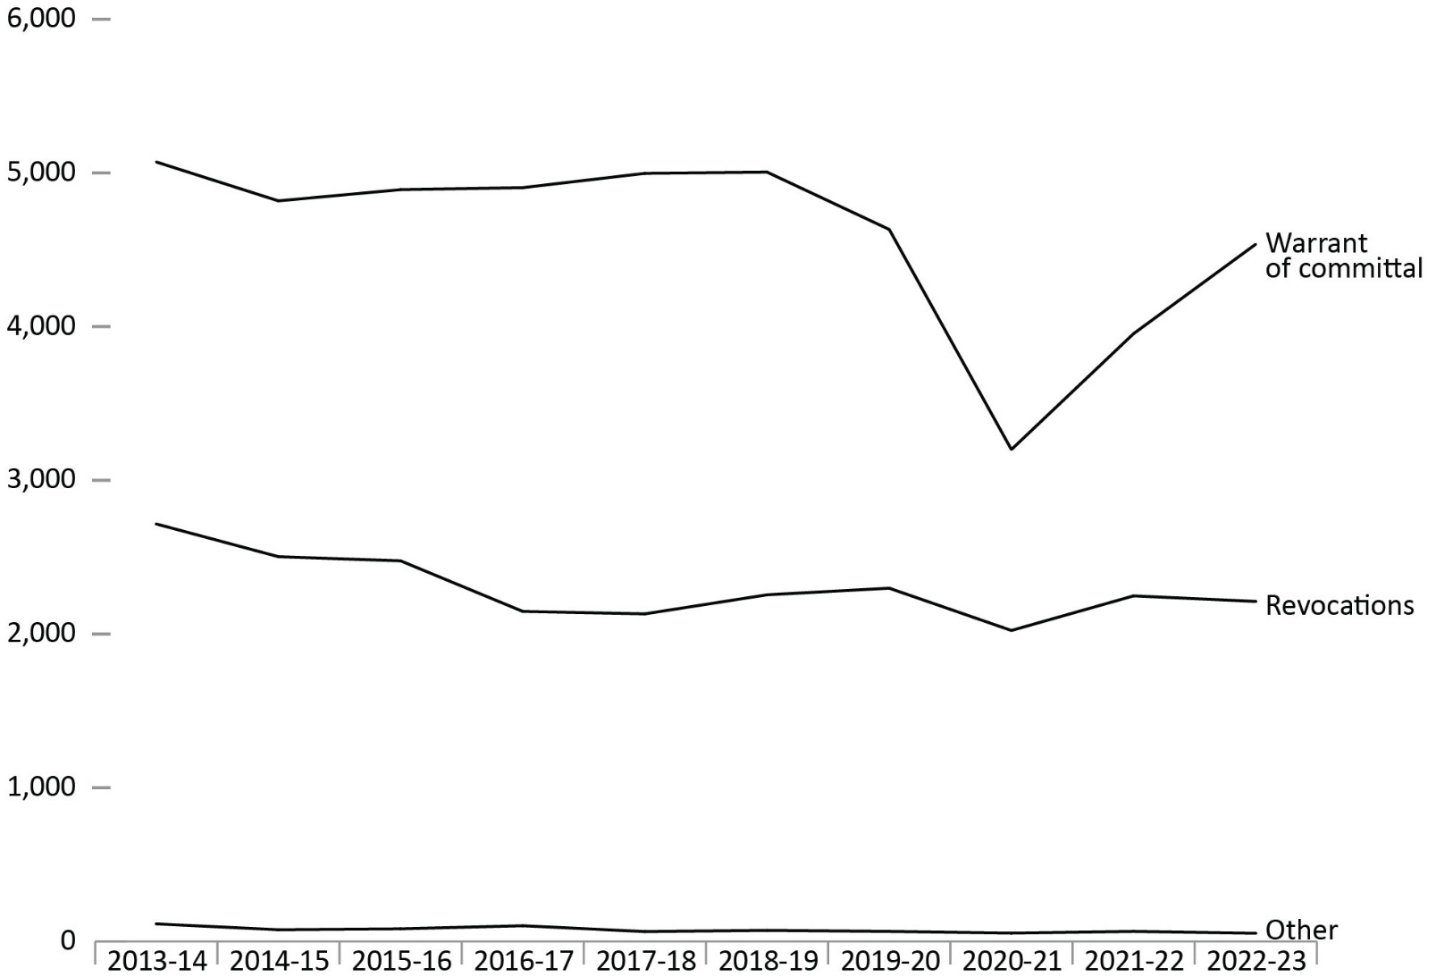
Source: Correctional Service of Canada.
- After peaking at 7,901 in 2013-14, the total number of admissions has decreased by 13.9% to 6,801 in 2022-23.
- The number of warrant of committal admissions has fluctuated over the past 10 fiscal years (from 2013-14 to 2022-23) but has declined by 10.6% when comparing 2022-23 data (4,536 admissions) to the highest point which occurred in fiscal year 2013-14 (5,071 admissions).
- There was a sharp decrease of 30.9% between 2019-20 to 2020-21 in the warrant of committal admissions followed by an increase of 41.8% in 2022-23.

Notes
Warrant of Committal is a new admission to federal jurisdiction from the courts.
Revocation is when an offender is admitted to federal custody after conditional release and before reaching warrant expiry.
“Other” includes transfers from other jurisdictions (exchange of services), terminations, transfers from foreign countries, and admissions where a release is interrupted as a consequence of a new conviction.
These numbers refer to the total number of admissions to a federal institution or Healing Lodge during each fiscal year and may be greater than the actual number of offenders admitted, since an individual offender may be admitted more than once in a given year.
There is a lag in the data entry of admissions into CSC’s Offender Management System. The admission figures for the most recent year are under-reported by 200-400 admissions at the time of year end data extraction. More accurate figures will be available in the next year’s publication. Please use caution when including the most recent year in any trend analysis.
Reported year periods reflect fiscal years. A fiscal year runs from April 1 to March 31 of the following year.

Table C4a. Number of female admissions to CSC facilities
Admission type | 2018-19 | 2019-20 | 2020-21 | 2021-22 | 2022-23
Total warrant of committal | 383 | 354 | 267 | 287 | 337
1st federal sentence | 347 | 323 | 244 | 247 | 290
Subsequent federal sentence | 36 | 30 | 23 | 39 | 46
Provincial sentence | 0 | 1 | 0 | 1 | 1
Revocations | 145 | 177 | 144 | 141 | 138
Other | 5 | 4 | 8 | 1 | 1
Total female admissions | 533 | 535 | 419 | 429 | 476
Source: Correctional Service of Canada.

Table C4b. Number of male admissions to CSC facilities
Admission type | 2018-19 | 2019-20 | 2020-21 | 2021-22 | 2022-23
Total warrant of committal | 4,622 | 4,278 | 2,933 | 3,667 | 4,198
1st federal sentence | 3,447 | 3,163 | 2,135 | 2,730 | 3,200
Subsequent federal sentence | 1,164 | 1,101 | 782 | 926 | 997
Provincial sentence | 11 | 14 | 16 | 11 | 1
Revocations | 2,110 | 2,121 | 1,879 | 2,107 | 2,074
Other | 67 | 61 | 46 | 64 | 52
Total male admissions | 6,799 | 6,460 | 4,858 | 5,838 | 6,324
Source: Correctional Service of Canada.

Table C4c. Total number of admissions to CSC facilities
Admission type | 2018-19 | 2019-20 | 2020-21 | 2021-22 | 2022-23
Warrant of committal | 5,005 | 4,632 | 3,200 | 3,954 | 4,536
1st federal sentence | 3,794 | 3,486 | 2,379 | 2,977 | 3,490
Subsequent federal sentence | 1,200 | 1,131 | 805 | 965 | 1,043
Provincial sentence | 11 | 15 | 16 | 12 | 2
Revocations | 2,255 | 2,298 | 2,023 | 2,248 | 2,212
Other | 72 | 65 | 54 | 65 | 53
Total admissions | 7,332 | 6,995 | 5,277 | 6,267 | 6,801*
Source: Correctional Service of Canada.
Notes
*In addition to females and males, 1 intersex offender was admitted to CSC facilities in 2022-23 and is therefore included in the total.
On November 28, 2019, the new choice “Another sex” was added as a choice in the sex field of the Offender Management System. On September 24, 2022, “Another sex” was changed to “Intersex” to use an appropriate term based on the definition of sex. Per Commissioner's Directive 100, an offender’s current “sex” is determined solely by their current genitalia and must not be changed unless there is a change to the offender’s genitalia following gender-affirming surgery.
Warrant of Committal is a new admission to federal jurisdiction from the courts.
Revocation is when an offender is admitted to federal custody after conditional release and before reaching warrant expiry.
“Other” includes transfers from other jurisdictions (exchange of services), terminations, transfers from foreign countries, and admissions where a release is interrupted as a consequence of a new conviction.
These numbers refer to the total number of admissions to a federal institution or Healing Lodge during each fiscal year and may be greater than the actual number of offenders admitted, since an individual offender may be admitted more than once in a given year.
There is a lag in the data entry of admissions into CSC’s Offender Management System. The admission figures for the most recent year are under-reported by 200-400 admissions at the time of year end data extraction. More accurate figures will be available in the next year’s publication. Please use caution when including the most recent year in any trend analysis.
Reported year periods reflect fiscal years. A fiscal year runs from April 1 to March 31 of the following year.

Warrant of committal admissions to CSC facilities by sex: 10-year trend

Figure C5. Warrant of committal admissions for females and males
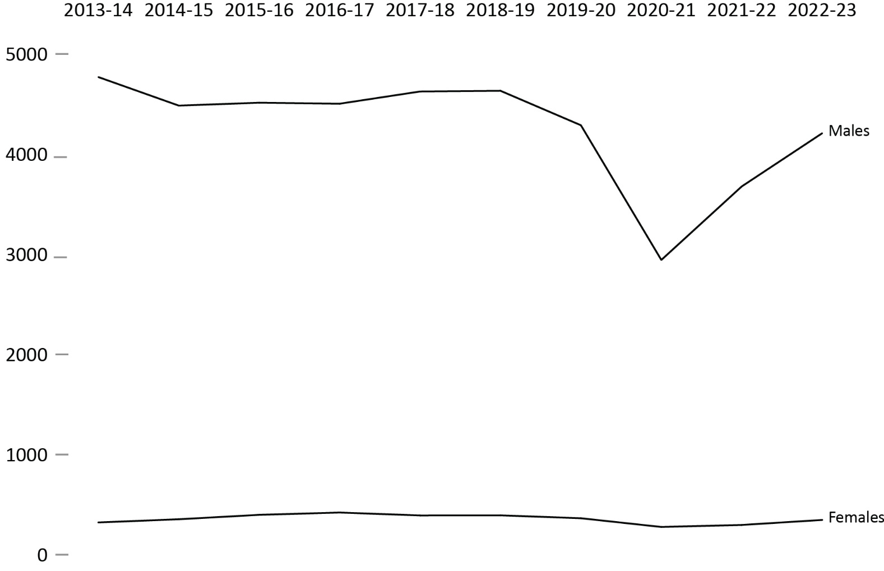
Source: Correctional Service of Canada.
- In the past 5 years, the number of females admitted to CSC facilities on a warrant of committal decreased by 12.0% from 383 in 2018-19 to 337 in 2022-23. During the same time period, there was a 9.2% decrease in the number of males admitted to CSC facilities on a warrant of committal from 4,622 in 2018-19 to 4,198 in 2022-23.
- Overall, females continue to represent a small proportion of the total number of warrant of committal admissions (i.e., 7.4% in 2022-23).
- At the end of fiscal year 2022-23, there were 645 females and 12,407 males offenders in custody within Correctional Service Canada facilities.
Notes
Two intersex offenders were also in custody within Correctional Service Canada facilities at the end of fiscal year 2022-23.
On November 28, 2019, the new choice “Another sex” was added as a choice in the sex field of the Offender Management System. On September 24, 2022, “Another sex” was changed to “Intersex” to use an appropriate term based on the definition of sex. Per Commissioner's Directive 100, an offender’s current “sex” is determined solely by their current genitalia and must not be changed unless there is a change to the offender’s genitalia following gender-affirming surgery.
A warrant of committal is a new admission to federal jurisdiction from the courts.
These numbers refer to the total number of admissions to a federal institution or Healing Lodge during each fiscal year and may be greater than the actual number of offenders admitted, since an individual offender may be admitted more than once in a given year.
There is a lag in the data entry of admissions into CSC’s Offender Management System. The admission figures for the most recent year are under-reported by 200-400 admissions at the time of year end data extraction. More accurate figures will be available in the next year’s publication. Please use caution when including the most recent year in any trend analysis.
Reported year periods reflect fiscal years. A fiscal year runs from April 1 to March 31 of the following year.

Table C5. Warrant of committal admissions for females and males
Fiscal year | Females | % | Males | % | Total
2013-14 | 312 | 6.2 | 4,759 | 93.8 | 5,071
2014-15 | 344 | 7.1 | 4,474 | 92.9 | 4,818
2015-16 | 388 | 7.9 | 4,503 | 92.1 | 4,891
2016-17 | 411 | 8.4 | 4,493 | 91.6 | 4,904
2017-18 | 382 | 7.6 | 4,615 | 92.4 | 4,997
2018-19 | 383 | 7.7 | 4,622 | 92.3 | 5,005
2019-20 | 354 | 7.6 | 4,278 | 92.4 | 4,632
2020-21 | 267 | 8.3 | 2,933 | 91.7 | 3,200
2021-22 | 287 | 7.3 | 3,667 | 92.7 | 3,954
2022-23 | 337 | 7.4 | 4,198 | 92.5 | 4,536
Source: Correctional Service of Canada.
Notes
Two intersex offenders were also in custody within Correctional Service Canada facilities at the end of fiscal year 2022-23.
On November 28, 2019, the new choice “Another sex” was added as a choice in the sex field of the Offender Management System. On September 24, 2022, “Another sex” was changed to “Intersex” to use an appropriate term based on the definition of sex. Per Commissioner's Directive 100, an offender’s current “sex” is determined solely by their current genitalia and must not be changed unless there is a change to the offender’s genitalia following gender-affirming surgery.
A warrant of committal is a new admission to federal jurisdiction from the courts.
These numbers refer to the total number of admissions to a federal institution or Healing Lodge during each fiscal year and may be greater than the actual number of offenders admitted, since an individual offender may be admitted more than once in a given year.
There is a lag in the data entry of admissions into CSC’s Offender Management System. The admission figures for the most recent year are under-reported by 200-400 admissions at the time of year end data extraction. More accurate figures will be available in the next year’s publication. Please use caution when including the most recent year in any trend analysis.
Reported year periods reflect fiscal years. A fiscal year runs from April 1 to March 31 of the following year.

Number of registered victims by gender: 5-year trend

Figure C6. Number of registered victims by gender*
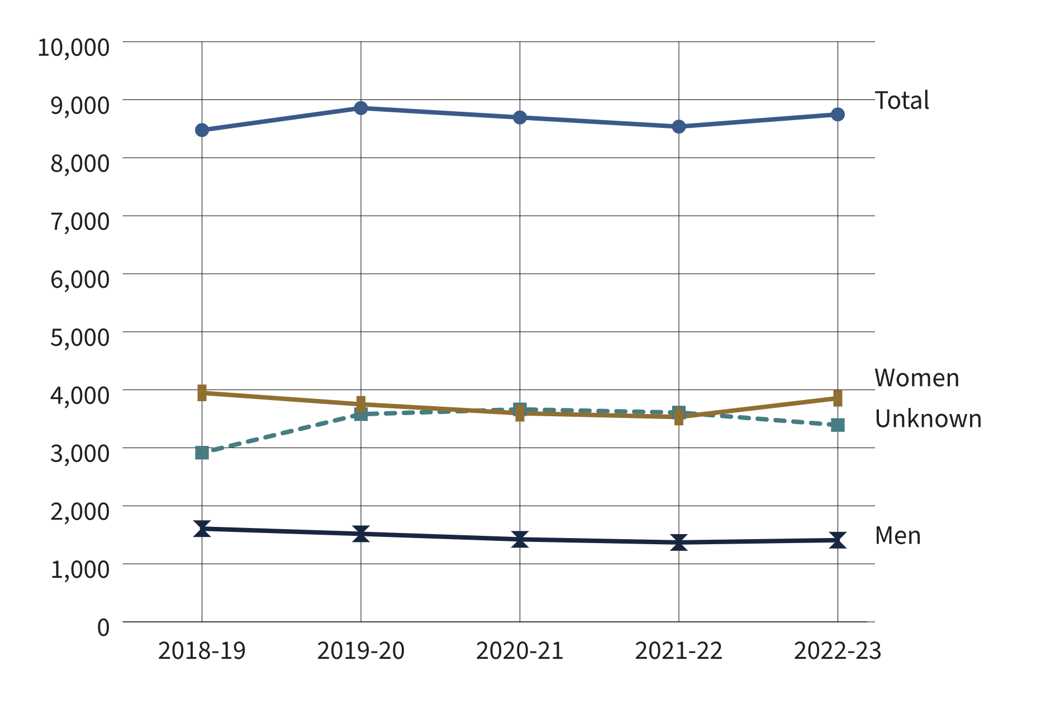
Source: Correctional Service of Canada.
- Most registered victims were of unknown gender (38.8%), or identified as women (44.1%).
- Although not displayed, 4 registered victims identified as another gender** and 87 registered victims did not want to provide a gender at the end of fiscal year 2022-23.
Notes
The Canadian Victims Bill of Rights defines a victim as any individual who has suffered physical or emotional harm, property damage, or economic loss as the result of the commission of an offence. The law also allows a spouse, a relative or dependent, an individual who is responsible for the care or support of the victim or the care or support of a dependent of the victim, to act on behalf of a victim, if the victim cannot act on their own behalf. Victims include persons harmed by the offender regardless of whether the offender has been prosecuted or not, as long as an official complaint has been made to the police or to the Crown.
Victims do not automatically receive information about the offender who harmed them. If they have been harmed by an offender serving a sentence of 2 years or more, victims must register with the Correctional Service of Canada (CSC) or the Parole Board of Canada to receive information or access services. Registration allows CSC to verify that the individual meets the definition of victim, which is required by law before sharing protected offender information. https://www.canada.ca/en/correctional-service/services/you-csc/victims/register.html
Demographic information is voluntarily self-reported by victims who have registered with CSC to receive information about the offender who harmed them. The information does not represent victims who have not been in contact with CSC or those who choose not to register.
The difference between the total number of registered victims and the number of victims who voluntarily self-reported their gender is the result of victims choosing not to report their gender, or their gender is unknown to CSC. Some victims choose to not provide this information to CSC, and the number of victims choosing to provide information varies from year to year. The response rate for victim gender has remained stable for the past 3 fiscal years.
*Note that information provided by victims is based on gender, as opposed to information collected from offenders, which is based on biological sex.
**This option became available in VAM in November 2019.
Reported data is current up to the end of each fiscal year. A fiscal year runs from April 1 to March 31 of the following year.

Table C6. Number of registered victims by gender*
Gender | 2018-19 | 2019-20 | 2020-21 | 2021-22 | 2022-23
Men | 1,606 | 1,517 | 1,422 | 1,369 | 1,408
Women | 3,947 | 3,750 | 3,596 | 3,531 | 3,855
Another gender** | NR | 0 | 0 | 2 | 4
Does not want to provide | 8 | 10 | 14 | 27 | 87
Unknown | 2,916 | 3,580 | 3,663 | 3,608 | 3,393
Total | 8,477 | 8,857 | 8,695 | 8,537 | 8,747
Source: Correctional Service of Canada.
Notes
The Canadian Victims Bill of Rights defines a victim as any individual who has suffered physical or emotional harm, property damage, or economic loss as the result of the commission of an offence. The law also allows a spouse, a relative or dependent, an individual who is responsible for the care or support of the victim or the care or support of a dependent of the victim, to act on behalf of a victim, if the victim cannot act on their own behalf. Victims include persons harmed by the offender regardless of whether the offender has been prosecuted or not, as long as an official complaint has been made to the police or to the Crown.
Victims do not automatically receive information about the offender who harmed them. If they have been harmed by an offender serving a sentence of 2 years or more, victims must register with the Correctional Service of Canada (CSC) or the Parole Board of Canada to receive information or access services. Registration allows CSC to verify that the individual meets the definition of victim, which is required by law before sharing protected offender information. https://www.canada.ca/en/correctional-service/services/you-csc/victims/register.html
Demographic information is voluntarily self-reported by victims who have registered with CSC to receive information about the offender who harmed them. The information does not represent victims who have not been in contact with CSC or those who choose not to register.
The difference between the total number of registered victims and the number of victims who voluntarily self-reported their gender is the result of victims choosing not to report their gender, or their gender is unknown to CSC. Some victims choose to not provide this information to CSC, and the number of victims choosing to provide information varies from year to year. The response rate for victim gender has remained stable for the past 3 fiscal years.
*Note that information provided by victims is based on gender, as opposed to information collected from offenders, which is based on biological sex.
**This option became available in VAM in November 2019.
Reported data is current up to the end of each fiscal year. A fiscal year runs from April 1 to March 31 of the following year.

CSC total offender population by sentence length

Figure C7. Sentence length of total offender population (2022-23)
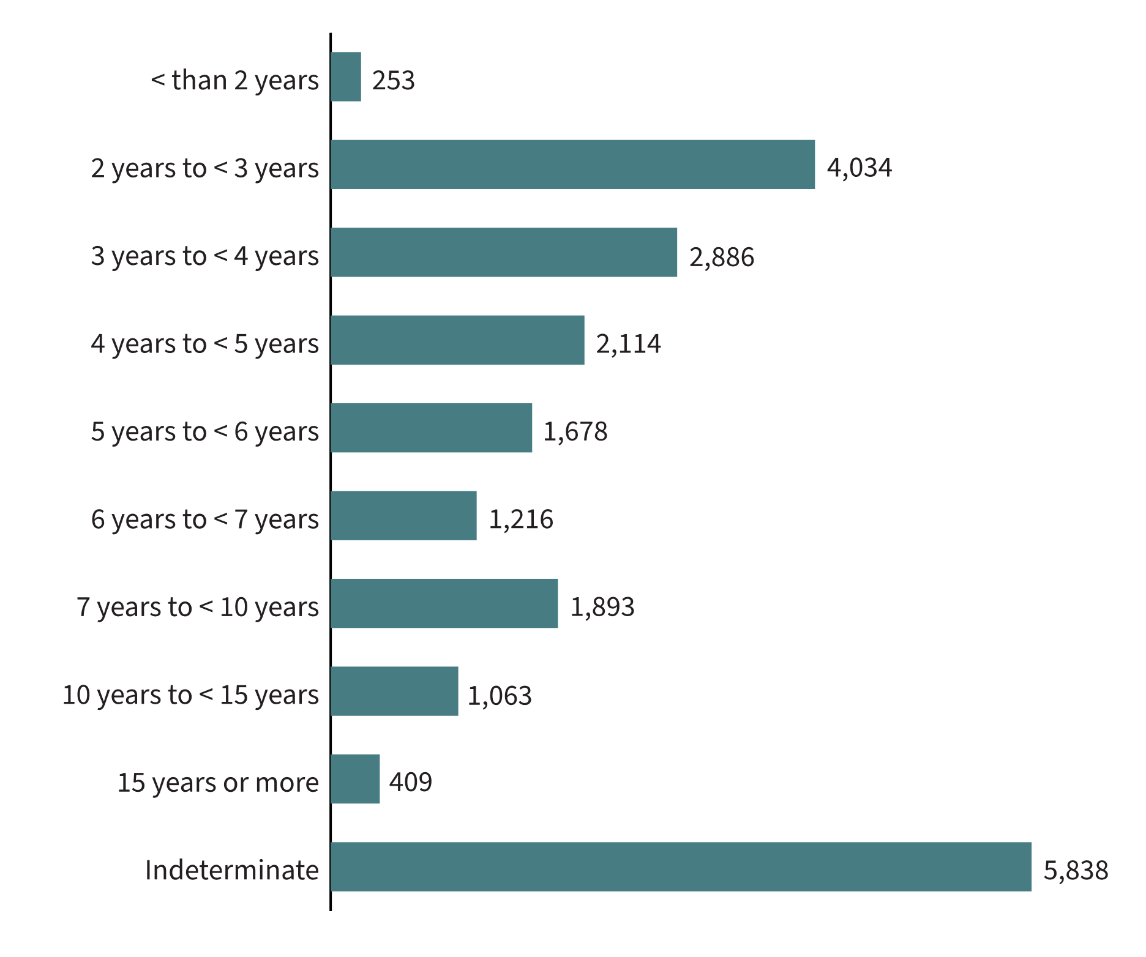
Source: Correctional Service of Canada.
- In 2022-23, almost half (43.4%) of the total offender population was serving a sentence of less than 5 years with 18.9% serving a sentence between 2 years and less than 3 years.
- 5,838 offenders were serving an indeterminate sentence representing 27.3% of the total offender population. The total number of offenders with indeterminate sentences has increased 2.2% since 2018-19 from 5,713 to 5,838 in 2022-23.
Notes
Total Offender Population includes all active offenders, who are incarcerated in a CSC facility, offenders on temporary absence from a CSC facility, offenders who are temporarily detained, offenders who are actively supervised, and offenders who are unlawfully at large for less than 90 days.
The group of offenders serving a sentence less than 2 years includes offenders transferred from foreign countries or offenders under a long-term supervision order who received a new sentence of less than 2 years.
Indeterminate means that the offender’s term of imprisonment does not have an end date. The Parole Board of Canada reviews the cases after the number of years prescribed by legislation and sentencing.
Reported year periods reflect fiscal years. A fiscal year runs from April 1 to March 31 of the following year.

Table C7. Sentence length of total offender population
Sentence length |  | 2018-19 | % | 2019-20 | % | 2020-21 | % | 2021-22 | % |  | 2022-23 | %
< than 2 years |  | 307 | 1.3 | 307 | 1.3 | 293 | 1.4 | 267 | 1.3 |  | 253 | 1.2
2 years to < 3 years |  | 5,457 | 23.3 | 5,149 | 22.3 | 4,321 | 20.1 | 3,814 | 18.3 |  | 4,034 | 18.9
3 years to < 4 years |  | 3,436 | 14.6 | 3,389 | 14.7 | 3,060 | 14.2 | 2,917 | 14.0 |  | 2,886 | 13.5
4 years to < 5 years |  | 2,368 | 10.1 | 2,371 | 10.3 | 2,157 | 10.0 | 2,070 | 9.9 |  | 2,114 | 9.9
5 years to < 6 years |  | 1,711 | 7.3 | 1,692 | 7.3 | 1,598 | 7.4 | 1,605 | 7.7 |  | 1,678 | 7.8
6 years to < 7 years |  | 1,172 | 5.0 | 1,153 | 5.0 | 1,130 | 5.3 | 1,152 | 5.5 |  | 1,216 | 5.7
7 years to < 10 years |  | 1,857 | 7.9 | 1,841 | 8.0 | 1,795 | 8.3 | 1,795 | 8.6 |  | 1,893 | 8.9
10 years to < 15 years |  | 998 | 4.3 | 1,010 | 4.4 | 999 | 4.6 | 991 | 4.8 |  | 1,063 | 5.0
15 years or more |  | 445 | 1.9 | 426 | 1.8 | 404 | 1.9 | 403 | 1.9 |  | 409 | 1.9
Indeterminate |  | 5,713 | 24.3 | 5,764 | 25.0 | 5,755 | 26.8 | 5,792 | 27.8 |  | 5,838 | 27.3
Total | 23,464 |  | 100.0 | 23,102 | 100.0 | 21,512 | 100.0 | 20,806* | 100.0 | 21,384 |  | 100.0
Source: Correctional Service of Canada.
Notes
*As a result of a data quality issue, sentence length information on one offender was not available at the time of the data extraction; therefore, the total of the sentence length grouping will not add up to the offender population results for 2021-22.
Total Offender Population includes all active offenders, who are incarcerated in a CSC facility, offenders on temporary absence from a CSC facility, offenders who are temporarily detained, offenders who are actively supervised, and offenders who are unlawfully at large for less than 90 days.
The group of offenders serving a sentence less than 2 years includes offenders transferred from foreign countries or offenders under a long-term supervision order who received a new sentence of less than 2 years.
Indeterminate means that the offender’s term of imprisonment does not have an end date. The Parole Board of Canada reviews the cases after the number of years prescribed by legislation and sentencing.
Reported year periods reflect fiscal years. A fiscal year runs from April 1 to March 31 of the following year.

Offences of victimization among registered victims

Figure C8. Offences of victimization (2022-23)
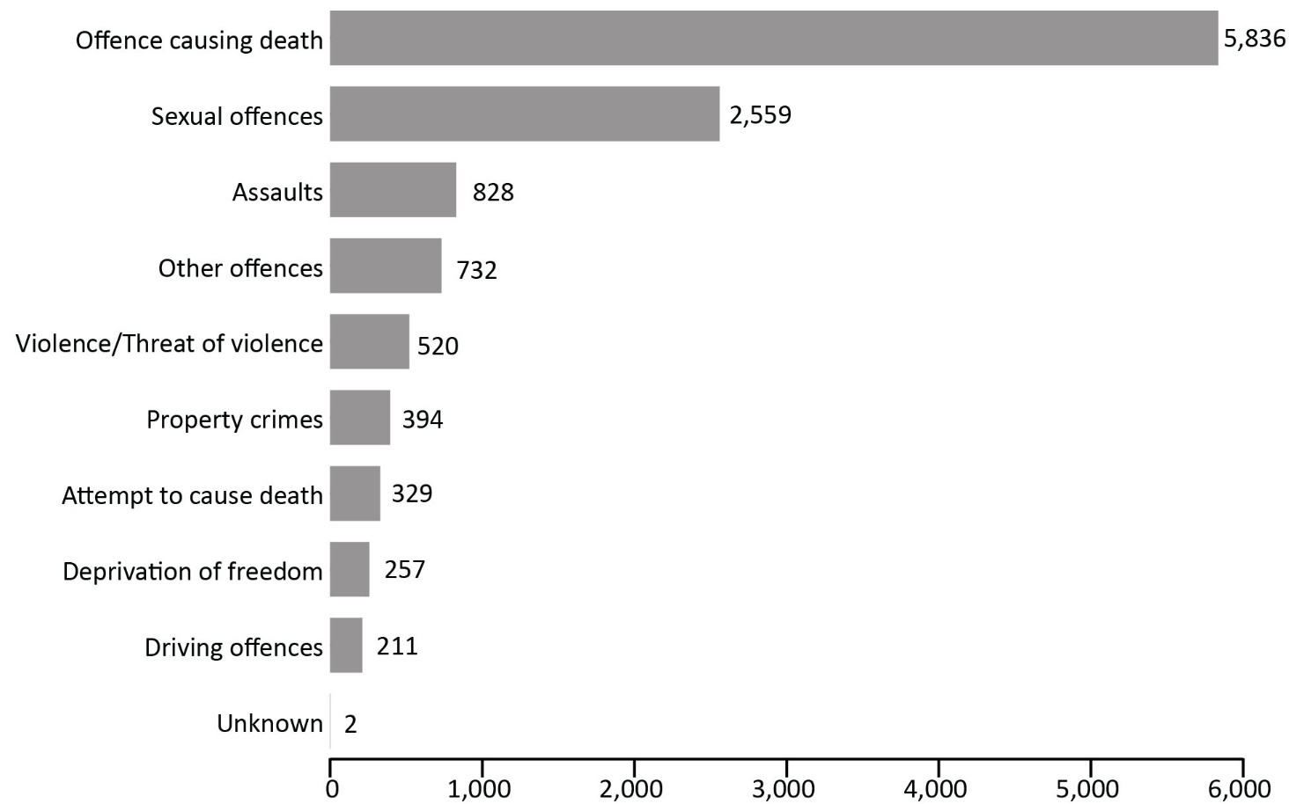
Source: Correctional Service of Canada.
- Offences causing death accounted for half of all offences of victimization (50.0%).
- Sexual offences were the second most common offence of victimization (21.9%).
Notes
The Canadian Victims Bill of Rights defines a victim as any individual who has suffered physical or emotional harm, property damage, or economic loss as the result of the commission of an offence. The law also allows a spouse, a relative or dependent, an individual who is responsible for the care or support of the victim or the care or support of a dependent of the victim, to act on behalf of a victim, if the victim cannot act on their own behalf. Victims include persons harmed by the offender regardless of whether the offender has been prosecuted or not, as long as an official complaint has been made to the police or to the Crown.
Victims do not automatically receive information about the offender who harmed them. If they have been harmed by an offender serving a sentence of 2 years or more, victims must register with the Correctional Service of Canada (CSC) or the Parole Board of Canada to receive information or access services. Registration allows CSC to verify that the individual meets the definition of victim, which is required by law before sharing protected offender information. https://www.canada.ca/en/correctional-service/services/you-csc/victims/register.html
Offences of victimization are acts the offender committed that harmed the victim, and have been confirmed using police reports or judge's comments. The offender may not have been convicted of each act or may be serving a federal sentence for different offences. This could be a result of plea deals, because charges were not pursued by the Crown, or the offence may be from a previous sentence or a provincial sentence. Offences of victimization are limited to victims registered with CSC.
More than one offence of victimization may be recorded for each victim.
"Deprivation of freedom" offences are offences such as kidnapping, forcible confinement, hostage taking, or abduction.
Reported year periods reflect fiscal years. A fiscal year runs from April 1 to March 31 of the following year.

Table C8. Offences of victimization
Offence type | 2018-19 | % | 2019-20 | % | 2020-21 | % | 2021-22 | % | 2022-23 | %
Offence causing death | 5,398 | 48.5 | 5,629 | 47.8 | 5,597 | 48.5 | 5,653 | 49.5 | 5,836 | 50.0
Sexual offences | 2,366 | 21.3 | 2,517 | 21.4 | 2,483 | 21.5 | 2,464 | 21.6 | 2,559 | 21.9
Assaults | 876 | 7.9 | 932 | 7.9 | 903 | 7.8 | 828 | 7.3 | 828 | 7.1
Other offences | 683 | 6.1 | 762 | 6.5 | 696 | 6.0 | 689 | 6.0 | 732 | 6.3
Violence/ threat of violence | 502 | 4.5 | 540 | 4.6 | 555 | 4.8 | 555 | 4.9 | 520 | 4.5
Property crimes | 508 | 4.6 | 540 | 4.6 | 501 | 4.3 | 438 | 3.8 | 394 | 3.4
Attempt to cause death | 317 | 2.8 | 338 | 2.9 | 341 | 3.0 | 325 | 2.8 | 329 | 2.8
Deprivation of freedom | 263 | 2.4 | 279 | 2.4 | 260 | 2.3 | 260 | 2.3 | 257 | 2.2
Driving offences | 210 | 1.9 | 229 | 1.9 | 198 | 1.7 | 204 | 1.8 | 211 | 1.8
Unknown | 4 | 0.0 | 4 | 0.0 | 3 | 0.0 | 2 | 0.0 | 2 | 0.0
Total number of offences | 11,127 | 100.0 | 11,770 | 100.0 | 11,537 | 100.0 | 11,418 | 100.0 | 11,668 | 100.0
Source: Correctional Service of Canada.
Notes
The Canadian Victims Bill of Rights defines a victim as any individual who has suffered physical or emotional harm, property damage, or economic loss as the result of the commission of an offence. The law also allows a spouse, a relative or dependent, an individual who is responsible for the care or support of the victim or the care or support of a dependent of the victim, to act on behalf of a victim, if the victim cannot act on their own behalf. Victims include persons harmed by the offender regardless of whether the offender has been prosecuted or not, as long as an official complaint has been made to the police or to the Crown.
Victims do not automatically receive information about the offender who harmed them. If they have been harmed by an offender serving a sentence of 2 years or more, victims must register with the Correctional Service of Canada (CSC) or the Parole Board of Canada to receive information or access services. Registration allows CSC to verify that the individual meets the definition of victim, which is required by law before sharing protected offender information. https://www.canada.ca/en/correctional-service/services/you-csc/victims/register.html
Offences of victimization are acts the offender committed that harmed the victim, and have been confirmed using police reports or judge's comments. The offender may not have been convicted of each act or may be serving a federal sentence for different offences. This could be a result of plea deals, because charges were not pursued by the Crown, or the offence may be from a previous sentence or a provincial sentence. Offences of victimization are limited to victims registered with CSC.
More than one offence of victimization may be recorded for each victim.
"Deprivation of freedom" offences are offences such as kidnapping, forcible confinement, hostage taking, or abduction.
Reported year periods reflect fiscal years. A fiscal year runs from April 1 to March 31 of the following year.

Warrant of committal admissions to a CSC facility by age

Figure C9. Percentage of warrant of committal admissions by age: 10-year trend
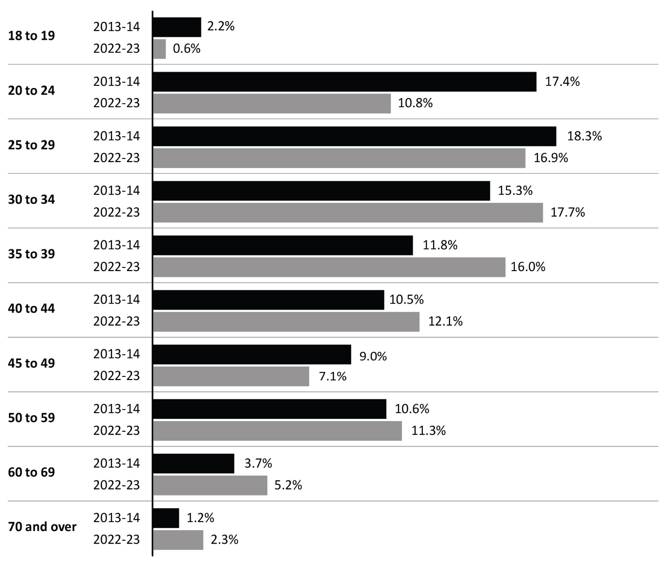
Source: Correctional Service of Canada.
- In 2022-23, 27.7% of offenders admitted on a warrant of committal to CSC facilities were between the ages of 20 and 29, and 33.6% were between 30 and 39 years of age.
- In 2022-23, most warrant of committal admissions were among those ages 30 to 34, while in 2013-14 it was among those ages 25 to 29.
- The median age of the population upon warrant of committal admission in 2022-23 was 36, compared to a median age of 33 in 2013-14.
- The number of offenders between the ages of 18 and 19 at admission decreased from 112 in 2013-14 to 28 in 2022-23, representing a 75.0% decrease.
- The number of offenders between the ages of 40 and 49 at admission decreased from 990 in 2013-14 to 872 in 2022-23, representing a 11.9% decrease.
- The number of offenders between the ages of 50 and 59 at admission decreased from 540 in 2013-14 to 511 in 2022-23, representing a 5.4% decrease.
- The number of offenders aged 70 and over at admission increased from 60 in 2013-14 to 106 in 2022-23, representing a 76.7% increase.
Notes
A warrant of committal is a new admission to federal jurisdiction from the courts.
Although not illustrated in the figure, the distribution of age upon admission is similar for both males and females.
These numbers refer to the total number of admissions to a federal institution or Healing Lodge during each fiscal year and may be greater than the actual number of offenders admitted, since an individual offender may be admitted more than once in a given year.
There is a lag in the data entry of admissions into CSC’s Offender Management System. The admission figures for the most recent year are under-reported by 200-400 admissions at the time of year end data extraction. More accurate figures will be available in the next year’s publication. Please use caution when including the most recent year in any trend analysis.
Due to rounding, percentages may not add to 100 percent.
Reported year periods reflect fiscal years. A fiscal year runs from April 1 to March 31 of the following year.

Table C9. Warrant of committal admissions by age and sex: 10-year trend

Fiscal year 2013-14
Age at admission | Females | % | Males | % | Total | %
18 to 19 | 5 | 1.6 | 107 | 2.2 | 112 | 2.2
20 to 24 | 56 | 17.9 | 828 | 17.4 | 884 | 17.4
25 to 29 | 54 | 17.3 | 873 | 18.3 | 927 | 18.3
30 to 34 | 51 | 16.3 | 723 | 15.2 | 774 | 15.3
35 to 39 | 41 | 13.1 | 556 | 11.7 | 597 | 11.8
40 to 44 | 44 | 14.1 | 489 | 10.3 | 533 | 10.5
45 to 49 | 22 | 7.1 | 435 | 9.1 | 457 | 9.0
50 to 59 | 25 | 8.0 | 515 | 10.8 | 540 | 10.6
60 to 69 | 10 | 3.2 | 177 | 3.7 | 187 | 3.7
70 and over | 4 | 1.3 | 56 | 1.2 | 60 | 1.2
Total | 312 | 100.0 | 4,759 | 100.0 | 5,071 | 100.0

Fiscal year 2022-23
Age at admission | Females | % | Males | % | Intersex | % | Total | %
18 to 19 | 5 | 1.5 | 23 | 0.5 | 0 | 0.0 | 28 | 0.6
20 to 24 | 23 | 6.8 | 467 | 11.1 | 0 | 0.0 | 490 | 10.8
25 to 29 | 57 | 16.9 | 711 | 16.9 | 0 | 0.0 | 768 | 16.9
30 to 34 | 65 | 19.3 | 735 | 17.5 | 1 | 100.0 | 801 | 17.7
35 to 39 | 67 | 19.9 | 658 | 15.7 | 0 | 0.0 | 725 | 16.0
40 to 44 | 51 | 15.1 | 499 | 11.9 | 0 | 0.0 | 550 | 12.1
45 to 49 | 18 | 5.3 | 304 | 7.2 | 0 | 0.0 | 322 | 7.1
50 to 59 | 36 | 10.7 | 475 | 11.3 | 0 | 0.0 | 511 | 11.3
60 to 69 | 10 | 3.0 | 225 | 5.4 | 0 | 0.0 | 235 | 5.2
70 and over | 5 | 1.5 | 101 | 2.4 | 0 | 0.0 | 106 | 2.3
Total | 337 | 100.0 | 4,198 | 100.0 | 1 | 100.0 | 4,536 | 100.0
Source: Correctional Service of Canada.
Notes
On November 28, 2019, the new choice “Another sex” was added as a choice in the sex field of the Offender Management System. On September 24, 2022, “Another sex” was changed to “Intersex” to use an appropriate term based on the definition of sex. Per Commissioner's Directive 100, an offender’s current “sex” is determined solely by their current genitalia and must not be changed unless there is a change to the offender’s genitalia following gender-affirming surgery.
A warrant of committal is a new admission to federal jurisdiction from the courts.
These numbers refer to the total number of admissions to a federal institution or Healing Lodge during each fiscal year and may be greater than the actual number of offenders admitted, since an individual offender may be admitted more than once in a given year.
There is a lag in the data entry of admissions into CSC’s Offender Management System. The admission figures for the most recent year are under-reported by 200-400 admissions at the time of year end data extraction. More accurate figures will be available in the next year’s publication. Please use caution when including the most recent year in any trend analysis.
Due to rounding, percentages may not add to 100 percent.
Reported year periods reflect fiscal years. A fiscal year runs from April 1 to March 31 of the following year.

Number of registered victims by age

Figure C10. Number of registered victims by age (2022-23)
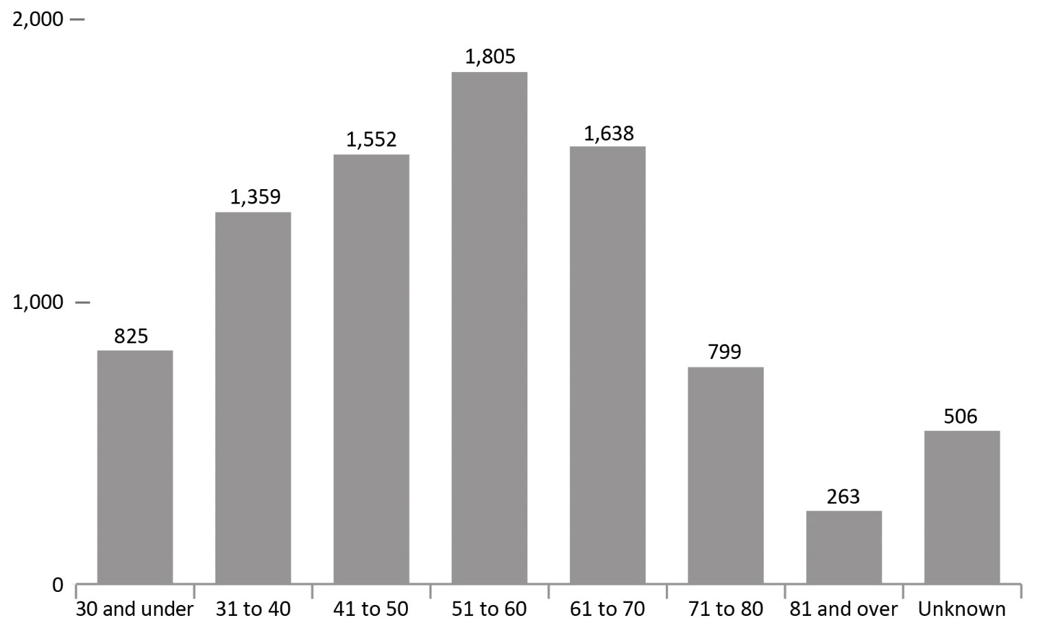
Source: Correctional Service of Canada.
- In 2022-23, 57.1% of registered victims were aged 41 to 70. The greatest proportion of victims was in the 51-60 age group (20.6%). This pattern has remained consistent over the past 5 fiscal years (from 2018-19 to 2022-23).
Notes
The Canadian Victims Bill of Rights defines a victim as any individual who has suffered physical or emotional harm, property damage, or economic loss as the result of the commission of an offence. The law also allows a spouse, a relative or dependent, an individual who is responsible for the care or support of the victim or the care or support of a dependent of the victim, to act on behalf of a victim, if the victim cannot act on their own behalf. Victims include persons harmed by the offender regardless of whether the offender has been prosecuted or not, as long as an official complaint has been made to the police or to the Crown.
Victims do not automatically receive information about the offender who harmed them. If they have been harmed by an offender serving a sentence of 2 years or more, victims must register with the Correctional Service of Canada (CSC) or the Parole Board of Canada to receive information or access services. Registration allows CSC to verify that the individual meets the definition of victim, which is required by law before sharing protected offender information. https://www.canada.ca/en/correctional-service/services/you-csc/victims/register.html
Reporting rates ranged from 91.5% in 2018-19 to 94.2% in 2022-23. The difference between the total number of registered victims and the number of victims who reported their age is the result of victims choosing not to report their age during registration, or their age is unknown to CSC. The information does not represent victims who have not been in contact with CSC or those who choose not to register.
Note that all registered victims are 18 years of age or older except for exceptional circumstances (i.e. emancipations).
Reported year periods reflect fiscal years. A fiscal year runs from April 1 to March 31 of the following year.

Table C10. Number of registered victims by age
Age group | 2018-19 | % | 2019-20 | % | 2020-21 | % | 2021-22 | % | 2022-23 | %
30 and under | 890 | 10.5 | 957 | 10.8 | 881 | 10.1 | 788 | 9.2 | 825 | 9.4
31 to 40 | 1,225 | 14.5 | 1,274 | 14.4 | 1,288 | 14.8 | 1,313 | 15.4 | 1,359 | 15.5
41 to 50 | 1,521 | 17.9 | 1,598 | 18.0 | 1,585 | 18.2 | 1,517 | 17.8 | 1,552 | 17.7
51 to 60 | 1,882 | 22.0 | 1,928 | 21.8 | 1,852 | 21.3 | 1,808 | 21.2 | 1,805 | 20.6
61 to 70 | 1,373 | 16.2 | 1,455 | 16.4 | 1,504 | 17.3 | 1,546 | 18.1 | 1,638 | 18.7
71 to 80 | 651 | 7.7 | 715 | 8.1 | 748 | 8.6 | 766 | 9.0 | 799 | 9.1
81 and older | 214 | 2.5 | 246 | 2.8 | 252 | 2.9 | 258 | 3.0 | 263 | 3.0
Unknown | 721 | 8.5 | 684 | 7.7 | 585 | 6.7 | 541 | 6.3 | 506 | 5.8
Total | 8,477 | 100.0 | 8,857 | 100.0 | 8,695 | 100.0 | 8,537 | 100.0 | 8,747 | 100.0
Source: Correctional Service of Canada.

Notes
The Canadian Victims Bill of Rights defines a victim as any individual who has suffered physical or emotional harm, property damage, or economic loss as the result of the commission of an offence. The law also allows a spouse, a relative or dependent, an individual who is responsible for the care or support of the victim or the care or support of a dependent of the victim, to act on behalf of a victim, if the victim cannot act on their own behalf. Victims include persons harmed by the offender regardless of whether the offender has been prosecuted or not, as long as an official complaint has been made to the police or to the Crown.
Victims do not automatically receive information about the offender who harmed them. If they have been harmed by an offender serving a sentence of 2 years or more, victims must register with the Correctional Service of Canada (CSC) or the Parole Board of Canada to receive information or access services. Registration allows CSC to verify that the individual meets the definition of victim, which is required by law before sharing protected offender information. https://www.canada.ca/en/correctional-service/services/you-csc/victims/register.html
Reporting rates ranged from 91.5% in 2018-19 to 94.2% in 2022-23. The difference between the total number of registered victims and the number of victims who reported their age is the result of victims choosing not to report their age during registration, or their age is unknown to CSC. The information does not represent victims who have not been in contact with CSC or those who choose not to register.
Note that all registered victims are 18 years of age or older except for exceptional circumstances (i.e., emancipations).
Due to rounding, percentages may not add to 100 percent.
Reported year periods reflect fiscal years. A fiscal year runs from April 1 to March 31 of the following year.

Warrant of committal admissions to a CSC facility for Indigenous and non-Indigenous offenders by age

Figure C11. Percentage of warrant of committal admissions for Indigenous and non-Indigenous offenders by age (2022-23)
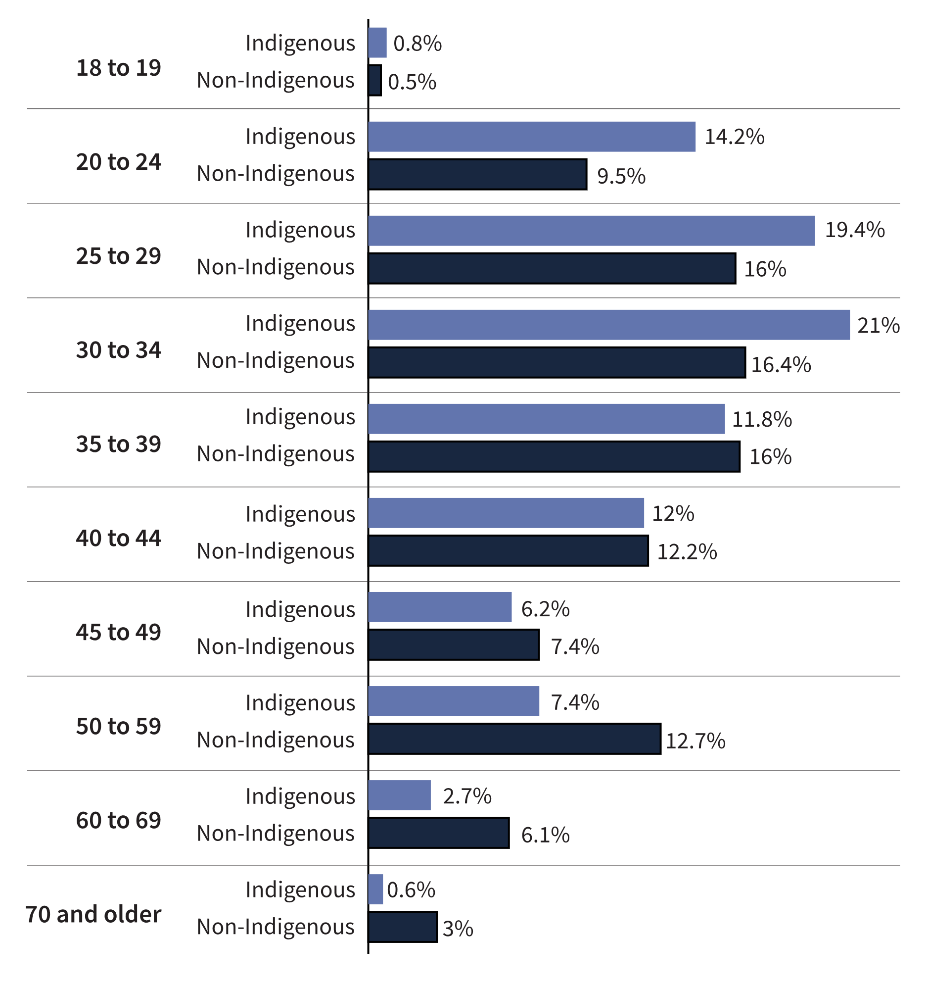
Source: Correctional Service of Canada.
- Of those offenders admitted on a warrant of committal to CSC facilities in 2022-23, 34.5% of Indigenous offenders were under the age of 30, compared to 26.0% of non-Indigenous offenders.
- The number of Indigenous offenders between the ages of 18 and 19 at admission decreased from 45 in 2013-14 to 10 in 2022-23, representing a 77.8% decrease.
- The number of Indigenous offenders aged 70 and over at admission increased from 4 in 2013-2014 to 8 in 2022-23, representing a 100.0% increase.
- The median age of Indigenous offenders at admission was 33, compared to a median age of 37 for non-Indigenous offenders.
- The median age of Indigenous female offenders at admission was 33, compared to a median age of 38 for non-Indigenous female offenders.
Notes
A warrant of committal is a new admission to federal jurisdiction from the courts.
These numbers refer to the total number of admissions to a federal institution or Healing Lodge during each fiscal year and may be greater than the actual number of offenders admitted, since an individual offender may be admitted more than once in a given year.
There is a lag in the data entry of admissions into CSC’s Offender Management System. The admission figures for the most recent year are under-reported by 200-400 admissions at the time of year end data extraction. More accurate figures will be available in the next year’s publication. Please use caution when including the most recent year in any trend analysis.
Due to rounding, percentages may not add to 100 percent.
Reported year periods reflect fiscal years. A fiscal year runs from April 1 to March 31 of the following year.

Table C11. Warrant of committal admissions for Indigenous and non-Indigenous offenders by age

Fiscal year 2013-14
Age at admission | Indigenous | % | Non- Indigenous | % | Total | %
18 to 19 | 45 | 3.6 | 67 | 1.8 | 112 | 2.2
20 to 24 | 307 | 24.7 | 577 | 15.1 | 884 | 17.4
25 to 29 | 257 | 20.6 | 670 | 17.5 | 927 | 18.3
30 to 34 | 176 | 14.1 | 598 | 15.6 | 774 | 15.3
35 to 39 | 133 | 10.7 | 464 | 12.1 | 597 | 11.8
40 to 44 | 122 | 9.8 | 411 | 10.7 | 533 | 10.5
45 to 49 | 95 | 7.6 | 362 | 9.5 | 457 | 9.0
50 to 59 | 90 | 7.2 | 450 | 11.8 | 540 | 10.6
60 to 69 | 16 | 1.3 | 171 | 4.5 | 187 | 3.7
70 and over | 4 | 0.3 | 56 | 1.5 | 60 | 1.2
Total | 1,245 | 100.0 | 3,826 | 100.0 | 5,071 | 100.0

Fiscal year 2022-23
Age at admission | Indigenous | % | Non- Indigenous | % | Total | %
18 to 19 | 10 | 0.8 | 18 | 0.5 | 28 | 0.6
20 to 24 | 178 | 14.2 | 312 | 9.5 | 490 | 10.8
25 to 29 | 243 | 19.4 | 525 | 16.0 | 768 | 16.9
30 to 34 | 262 | 21.0 | 539 | 16.4 | 801 | 17.7
35 to 39 | 194 | 15.5 | 531 | 16.2 | 725 | 16.0
40 to 44 | 150 | 12.0 | 400 | 12.2 | 550 | 12.1
45 to 49 | 78 | 6.2 | 244 | 7.4 | 322 | 7.1
50 to 59 | 93 | 7.4 | 418 | 12.7 | 511 | 11.3
60 to 69 | 34 | 2.7 | 201 | 6.1 | 235 | 5.2
70 and over | 8 | 0.6 | 98 | 3.0 | 106 | 2.3
Total | 1,250 | 100.0 | 3,286 | 100.0 | 4,536 | 100.0
Source: Correctional Service of Canada.
Notes
A warrant of committal is a new admission to federal jurisdiction from the courts.
These numbers refer to the total number of admissions to a federal institution or Healing Lodge during each fiscal year and may be greater than the actual number of offenders admitted, since an individual offender may be admitted more than once in a given year.
There is a lag in the data entry of admissions into CSC’s Offender Management System. The admission figures for the most recent year are under-reported by 200-400 admissions at the time of year end data extraction. More accurate figures will be available in the next year’s publication. Please use caution when including the most recent year in any trend analysis.
Due to rounding, percentages may not add to 100 percent.
Reported year periods reflect fiscal years. A fiscal year runs from April 1 to March 31 of the following year.

Age distribution of the CSC offender population

Figure C12. Percentage of in-custody offender population (2022-23) vs. in community under supervision (2022-23)
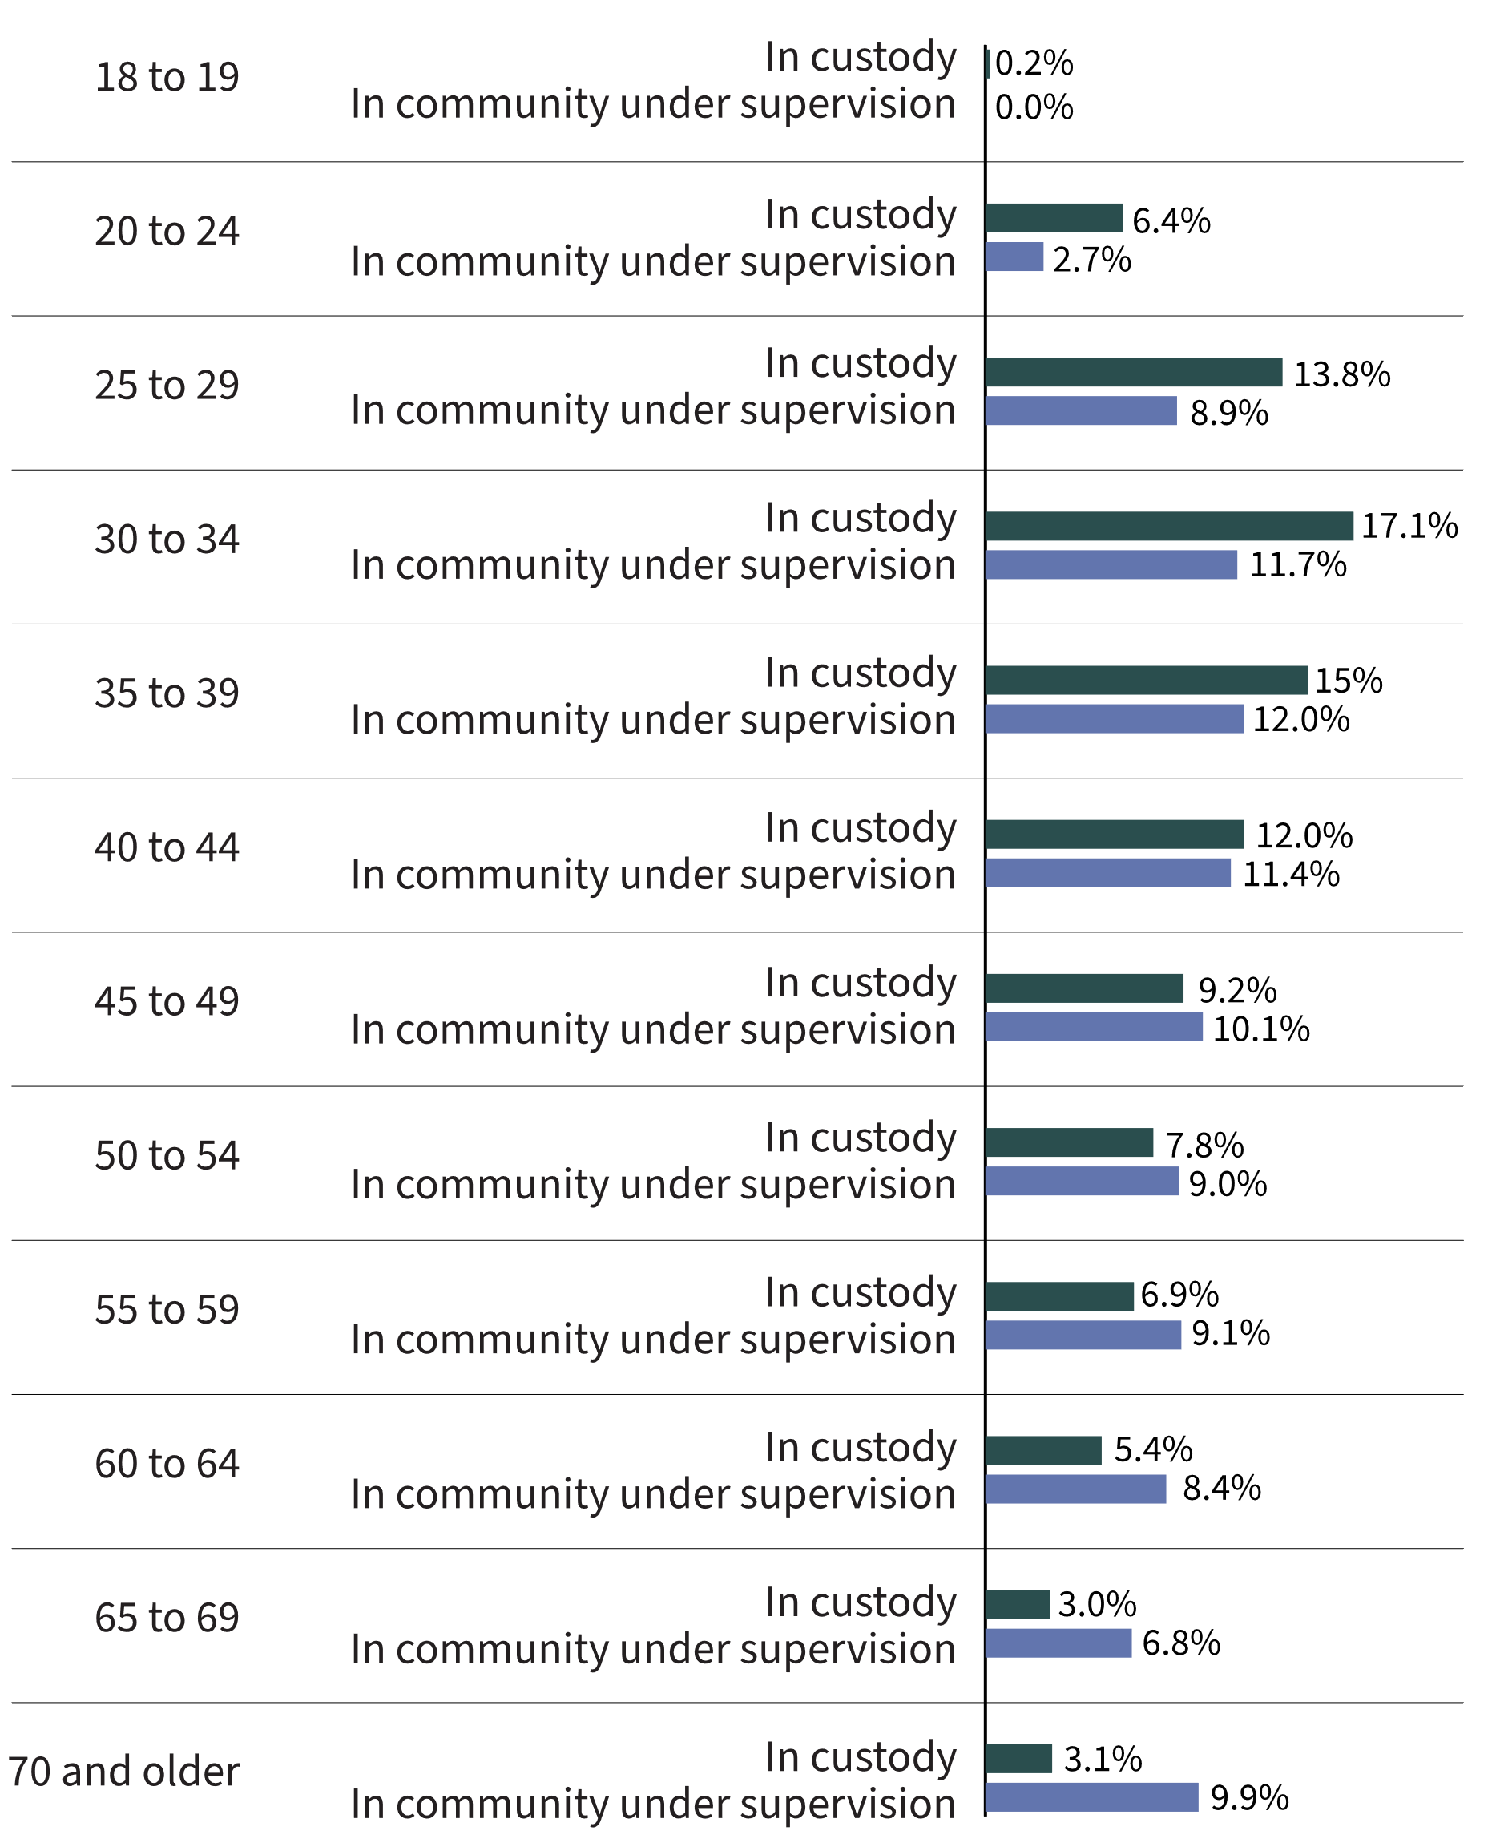
Source: Correctional Service of Canada.
- In 2022-23, 52.5% of in-custody offenders were under the age of 40, compared with 36.7% of the Canadian adult population in the same age range.
- In 2022-23, 26.3% of the in-custody offender population was aged 50 and over, compared with 47.5% of the Canadian adult population in the same age range.
- In 2022-23, the community offender population was older than the in-custody population; 43.1% of offenders in the community were aged 50 and over, compared to 26.3% of the in-custody offenders in this age group.
- As of 2022-23, 0.04% of the Canadian adult population are in-custody offenders, and 0.03% of the Canadian adult population are offenders in the community under supervision. Taken together, the total federal offender population represents 0.07% of the Canadian adult population.
Notes
In-custody population includes all active offenders incarcerated in a CSC facility, offenders on temporary absence from a CSC facility, offenders who are temporarily detained in a CSC facility, and offenders on remand in a CSC facility.
In community under supervision includes all active offenders on day parole, full parole, statutory release, or in the community supervised on a long-term supervision order, offenders who are temporarily detained in a non-CSC facility, offenders who are unlawfully at large for less than 90 days, offenders on remand in a non-CSC facility, and offenders supervised and subject to an immigration hold by Canada Border Services Agency.
Due to rounding, percentage may not add to 100 percent.
For offender population data, the reported year period (2022-23) reflects a fiscal year. A fiscal year runs from April 1 to March 31 of the following year.

Table C12. Percentage of in-custody offender population (2022-23) vs. in community under supervision (2022-23) vs. overall distribution of the Canadian adult population (2022)
Age | In custody¹ | %¹ | In community under supervision¹ | %¹ | Total¹ | %¹ | % of Canadian adult population²
18 to 19 | 25 | 0.2 | 1 | 0.0 | 26 | 0.1 |  | 2.8
20 to 24 | 838 | 6.4 | 228 | 2.7 | 1,066 | 5.0 |  | 7.9
25 to 29 | 1,798 | 13.8 | 741 | 8.9 | 2,539 | 11.9 |  | 8.7
30 to 34 | 2,238 | 17.1 | 978 | 11.7 | 3,216 | 15.0 |  | 8.9
35 to 39 | 1,957 | 15.0 | 999 | 12.0 | 2,956 | 13.8 |  | 8.5
40 to 44 | 1,568 | 12.0 | 953 | 11.4 | 2,521 | 11.8 |  | 8.1
45 to 49 | 1,203 | 9.2 | 843 | 10.1 | 2,046 | 9.6 |  | 7.6
50 to 54 | 1,017 | 7.8 | 750 | 9.0 | 1,767 | 8.3 |  | 7.7
55 to 59 | 903 | 6.9 | 754 | 9.1 | 1,657 | 7.7 |  | 8.3
60 to 64 | 711 | 5.4 | 696 | 8.4 | 1,407 | 6.6 |  | 8.4
65 to 69 | 387 | 3.0 | 563 | 6.8 | 950 | 4.4 |  | 7.3
70 and over | 409 | 3.1 | 824 | 9.9 | 1,233 | 5.8 |  | 15.8
Total | 13,054 | 100.0 | 8,330 | 100.0 | 21,384 | 100.0 |  | 100.0
Sources: Correctional Service of Canada¹; Table 17-10-0005-01, Annual Demographic Estimates: Canada, Provinces, and Territories, Centre for Demography, Statistics Canada².
Notes
In-custody population includes all active offenders incarcerated in a CSC facility, offenders on temporary absence from a CSC facility, offenders who are temporarily detained in a CSC facility and offenders on remand in a CSC facility.
In community under supervision includes all active offenders on day parole, full parole, statutory release, or in the community supervised on a long-term supervision order, offenders who are temporarily detained in a non-CSC facility, offenders who are unlawfully at large for less than 90 days, offenders on remand in a non-CSC facility, and offenders supervised and subject to an immigration hold by Canada Border Services Agency.
Due to rounding, percentage may not add to 100 percent.
For offender population data, the reported year period (2022-23) reflects a fiscal year. A fiscal year runs from April 1 to March 31 of the following year.

CSC offender population by self-reported race

Figure C13. Percentage of total offender population by self-reported race*
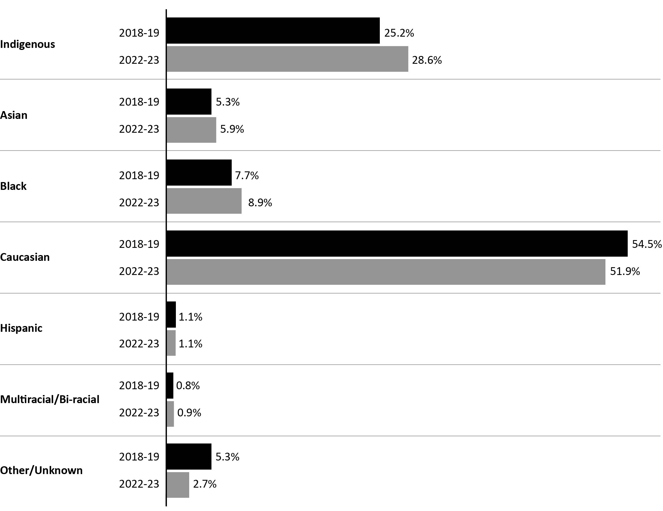
Source: Correctional Service of Canada.
- The CSC offender population is becoming more diverse, as evidenced by the decrease in the proportion of Caucasian offenders (from 54.5% in 2018-19 to 51.9% in 2022-23). Between 2018-19 and 2022-23, the Indigenous population increased by 3.5% (from 5,914 to 6,120).
- Indigenous offenders represented 28.6% of the 2022-23 total CSC offender population and 27.6% of 2022-23 warrant of committal admissions to CSC facilities.
Notes
*The offenders self-report race. The list of categories may not fully account for all races and the race grouping information has changed starting in 2022-23; therefore, the comparison of the information before and after 2022-23 should be done with caution.
"Indigenous" includes offenders who identify as Inuit, Innu, Métis, or First Nations.
"Asian" includes offenders who identify as Arab, Arab/West Asian, Asian-East and Southeast, Asian-South, Asian West, Asiatic, Chinese, East Indian, Filipino, Japanese, Korean, South Asian, or South East Asian.
"Hispanic" includes offenders who identify as Hispanic, or Latin American.
“Multiracial/Bi-Racial” includes offenders who identify as Multiracial/Ethnic.
"Black" includes offenders who identify as Black, Caribbean, or Sub-Sahara African.
“Caucasian” includes offenders who identify as British Isles, European French, European-Eastern, European-Northern, European-Southern, European-Western, or White.
"Other/Unknown" includes offenders who identify as Oceania, offenders unable to identify to one race, other, and unknown.
Asiatic includes Asian-East and Southeast, Asian South, Asian West, and Asiatic.
The data reflect all active offenders, who are incarcerated in a CSC facility, offenders on temporary absence from a CSC facility, offenders who are temporarily detained, offenders who are actively supervised, and offenders who are unlawfully at large for less than 90 days.
Due to rounding, percentages may not add to 100 percent.
The data reflect the number of offenders active at the end of each fiscal year. A fiscal year runs from April 1 to March 31 of the following year.

Table C13. Total offender population by self-reported race*
Self-reported race* | 2018-19 | % | 2022-23 | %
Caucasian | 12,798 | 54.5 | 11,102 | 51.9
Indigenous | 5,914 | 25.2 | 6,120 | 28.6
First Nations | 3,993 | 17.0 | 4,244 | 19.8
Métis | 1,723 | 7.3 | 1,696 | 7.9
Inuit | 198 | 0.8 | 180 | 0.8
Black | 1,802 | 7.7 | 1,894 | 8.9
Black | 1,692 | 7.2 | 1,714 | 8.0
Caribbean | 73 | 0.3 | 113 | 0.5
Sub-Saharan African | 37 | 0.2 | 67 | 0.3
Asian | 1,250 | 5.3 | 1,262 | 5.9
Asiatic | 377 | 1.6 | 386 | 1.8
Arab | 179 | 0.8 | 219 | 1.0
Arab/West Asian | 176 | 0.8 | 144 | 0.7
Southeast Asian | 184 | 0.8 | 167 | 0.8
South Asian | 121 | 0.5 | 157 | 0.7
Chinese | 95 | 0.4 | 87 | 0.4
Filipino | 85 | 0.4 | 70 | 0.3
East Indian | 13 | 0.1 | 14 | 0.1
Korean | 12 | 0.1 | 13 | 0.1
Japanese | 8 | 0.0 | 5 | 0.0
Hispanic | 267 | 1.1 | 236 | 1.1
Latin American | 260 | 1.1 | 231 | 1.1
Hispanic | 7 | 0.0 | 5 | 0.0
Multiracial/Bi-Racial | 191 | 0.8 | 183 | 0.9
Other/Unknown | 1,242 | 5.3 | 587 | 2.7
Total | 23,464 | 100.0 | 21,384 | 100.0
Source: Correctional Service of Canada.
Notes
*The offenders self-report race. The list of categories may not fully account for all races and the race grouping information has changed starting in 2022-23; therefore, the comparison of the information before and after 2022-23 should be done with caution.
"Indigenous" includes offenders who identify as Inuit, Innu, Métis and First Nations.
"Asian" includes offenders who identify as Arab, Arab/West Asian, Asian-East and Southeast, Asian-South, Asian West, Asiatic, Chinese, East Indian, Filipino, Japanese, Korean, South Asian and South East Asian.
"Hispanic" includes offenders who identify as Hispanic and Latin American.
“Multiracial/Bi-Racial” includes offenders who identify as Multiracial/Ethnic.
"Black" includes offenders who identify as Black, Caribbean, or Sub-Sahara African.
“Caucasian” includes offenders who identify as British Isles, European French, European-Eastern, European-Northern, European-Southern, European-Western, or White.
"Other/Unknown" includes offenders who identify as Oceania, offenders unable to identify to one race, other, and unknown.
Asiatic includes Asian-East and Southeast, Asian South, Asian West, and Asiatic.
The data reflect all active offenders, who are incarcerated in a CSC facility, offenders on temporary absence from a CSC facility, offenders who are temporarily detained, offenders who are actively supervised, and offenders who are unlawfully at large for less than 90 days.
Due to rounding, percentages may not add to 100 percent.
The data reflect the number of offenders active at the end of each fiscal year. A fiscal year runs from April 1 to March 31 of the following year.

Number of registered victims by race

Figure C14. Number of registered victims by race (2022-23)
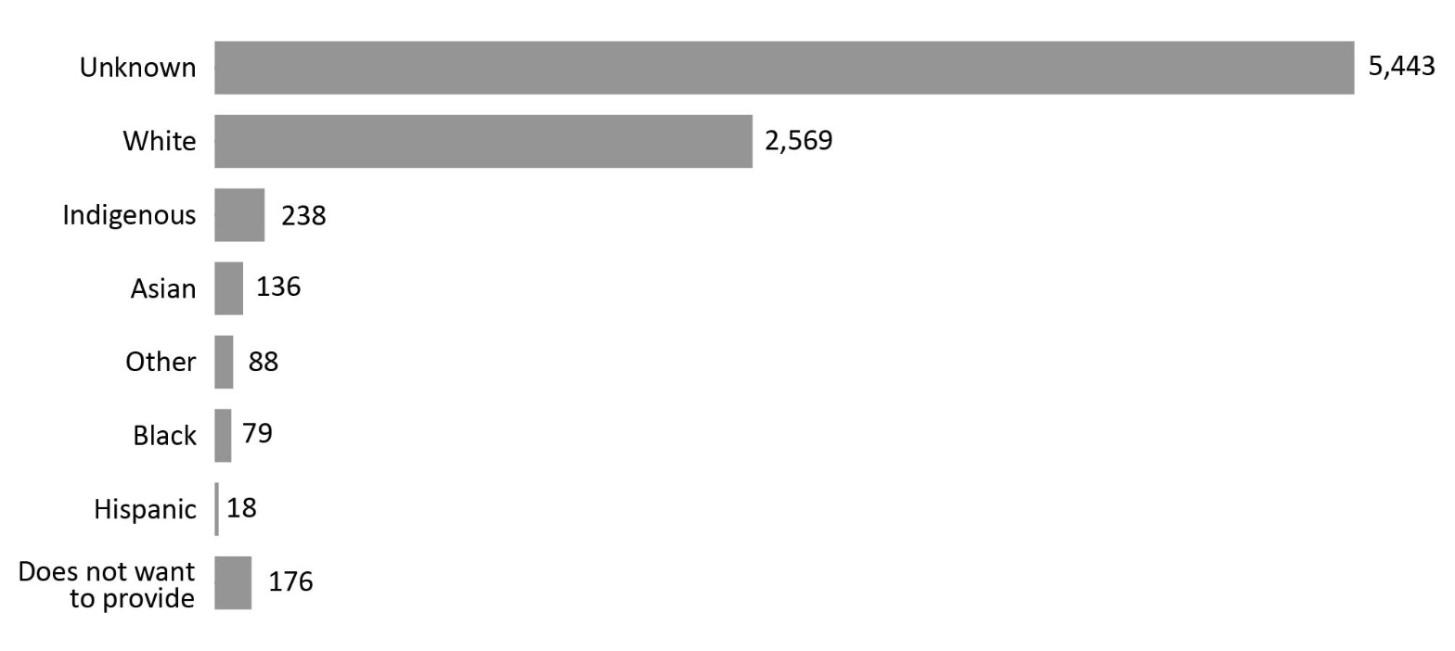
Source: Correctional Service of Canada.
- Most registered victims (62.2%) were of unknown race. More than a quarter of registered victims (29.4%) identified as White.
Notes
The Canadian Victims Bill of Rights defines a victim as any individual who has suffered physical or emotional harm, property damage, or economic loss as the result of the commission of an offence. The law also allows a spouse, a relative or dependent, an individual who is responsible for the care or support of the victim or the care or support of a dependent of the victim, to act on behalf of a victim, if the victim cannot act on their own behalf. Victims include persons harmed by the offender regardless of whether the offender has been prosecuted or not, as long as an official complaint has been made to the police or to the Crown.
Victims do not automatically receive information about the offender who harmed them. If they have been harmed by an offender serving a sentence of 2 years or more, victims must register with the Correctional Service of Canada (CSC) or the Parole Board of Canada to receive information or access services. Registration allows CSC to verify that the individual meets the definition of victim, which is required by law before sharing protected offender information. https://www.canada.ca/en/correctional-service/services/you-csc/victims/register.html
Demographic information is voluntarily self-reported by victims who have registered with CSC to receive information about the offender who harmed them. The information does not represent victims who have not been in contact with CSC or those who choose not to register.
The difference between the total number of registered victims and the number of victims who voluntarily self-reported their race is the result of victims choosing not to report their race or their race is unknown to CSC. The response rate for victim race has remained stable for the past three fiscal years.
The total number of victims for whom CSC has reported race data for 2022-23 is 3,304 whereby it is 5,443 for unknown, which means CSC has self-reported race data for approximately one third of registered victims. Therefore, these statistics do not represent the entirety of registered victims.
Reported year periods reflect fiscal years. A fiscal year runs from April 1 to March 31 of the following year.

Table C14. Number of registered victims by race
Race | 2018-19 | % | 2019-20 | % | 2020-21 | % | 2021-22 | % | 2022-23 | %
White | 2,487 | 29.3 | 2,382 | 26.9 | 2,241 | 25.8 | 2,255 | 26.4 | 2,569 | 29.4
Indigenous | 182 | 2.1 | 181 | 2.0 | 180 | 2.1 | 187 | 2.2 | 238 | 2.7
First Nations | 128 | 1.5 | 122 | 1.4 | 115 | 1.3 | 118 | 1.4 | 153 | 1.7
Métis | 30 | 0.4 | 34 | 0.4 | 38 | 0.4 | 43 | 0.5 | 62 | 0.7
Inuit | 24 | 0.3 | 25 | 0.3 | 27 | 0.3 | 26 | 0.3 | 23 | 0.3
Black | 75 | 0.9 | 77 | 0.9 | 72 | 0.8 | 67 | 0.8 | 79 | 0.9
Asian | 109 | 1.3 | 107 | 1.2 | 110 | 1.3 | 119 | 1.4 | 136 | 1.6
Arab | 0 | 0.0 | 0 | 0.0 | 0 | 0.0 | 0 | 0.0 | 2 | 0.0
Arab/West Asian | 16 | 0.2 | 14 | 0.2 | 13 | 0.1 | 14 | 0.2 | 16 | 0.2
East/Southeast Asian | 26 | 0.3 | 30 | 0.3 | 33 | 0.4 | 35 | 0.4 | 38 | 0.4
South Asian | 24 | 0.3 | 22 | 0.2 | 21 | 0.2 | 25 | 0.3 | 29 | 0.3
Chinese | 34 | 0.4 | 34 | 0.4 | 35 | 0.4 | 36 | 0.4 | 36 | 0.4
Filipino | 7 | 0.1 | 5 | 0.1 | 4 | 0.0 | 4 | 0.0 | 8 | 0.1
Japanese | 1 | 0.0 | 1 | 0.0 | 3 | 0.0 | 4 | 0.0 | 4 | 0.0
Korean | 1 | 0.0 | 1 | 0.0 | 1 | 0.0 | 1 | 0.0 | 3 | 0.0
Hispanic | 16 | 0.2 | 14 | 0.2 | 14 | 0.2 | 12 | 0.1 | 18 | 0.2
Other | 65 | 0.8 | 68 | 0.8 | 71 | 0.8 | 81 | 0.9 | 88 | 1.0
Does not want to provide | 42 | 0.5 | 45 | 0.5 | 51 | 0.6 | 102 | 1.2 | 176 | 2.0
Unknown | 5,501 | 64.9 | 5,983 | 67.6 | 5,956 | 68.5 | 5,714 | 66.9 | 5,443 | 62.2
Total | 8,477 | 100.0 | 8,857 | 100.0 | 8,965 | 100.0 | 8,537 | 100.0 | 8,747 | 100.0
Source: Correctional Service of Canada.
Notes
The Canadian Victims Bill of Rights defines a victim as any individual who has suffered physical or emotional harm, property damage, or economic loss as the result of the commission of an offence. The law also allows a spouse, a relative or dependent, an individual who is responsible for the care or support of the victim or the care or support of a dependent of the victim, to act on behalf of a victim, if the victim cannot act on their own behalf. Victims include persons harmed by the offender regardless of whether the offender has been prosecuted or not, as long as an official complaint has been made to the police or to the Crown.
Victims do not automatically receive information about the offender who harmed them. If they have been harmed by an offender serving a sentence of 2 years or more, victims must register with the Correctional Service of Canada (CSC) or the Parole Board of Canada to receive information or access services. Registration allows CSC to verify that the individual meets the definition of victim, which is required by law before sharing protected offender information. https://www.canada.ca/en/correctional-service/services/you-csc/victims/register.html
Demographic information is voluntarily self-reported by victims who have registered with CSC to receive information about the offender who harmed them. The information does not represent victims who have not been in contact with CSC or those who choose not to register.
The difference between the total number of registered victims and the number of victims who voluntarily self-reported their race is the result of victims choosing not to report their race or their race is unknown to CSC. The response rate for victim race has remained stable for the past three fiscal years.
The total number of victims for whom CSC has reported race data for 2022-23 is 3,304 whereby it is 5,443 for unknown, which means CSC has self-reported race data for approximately one third of registered victims. Therefore, these statistics do not represent the entirety of registered victims.
Reported year periods reflect fiscal years. A fiscal year runs from April 1 to March 31 of the following year.

CSC offender population by religion

Figure C15. Percentage of total offender population by religious identification (2022-23)
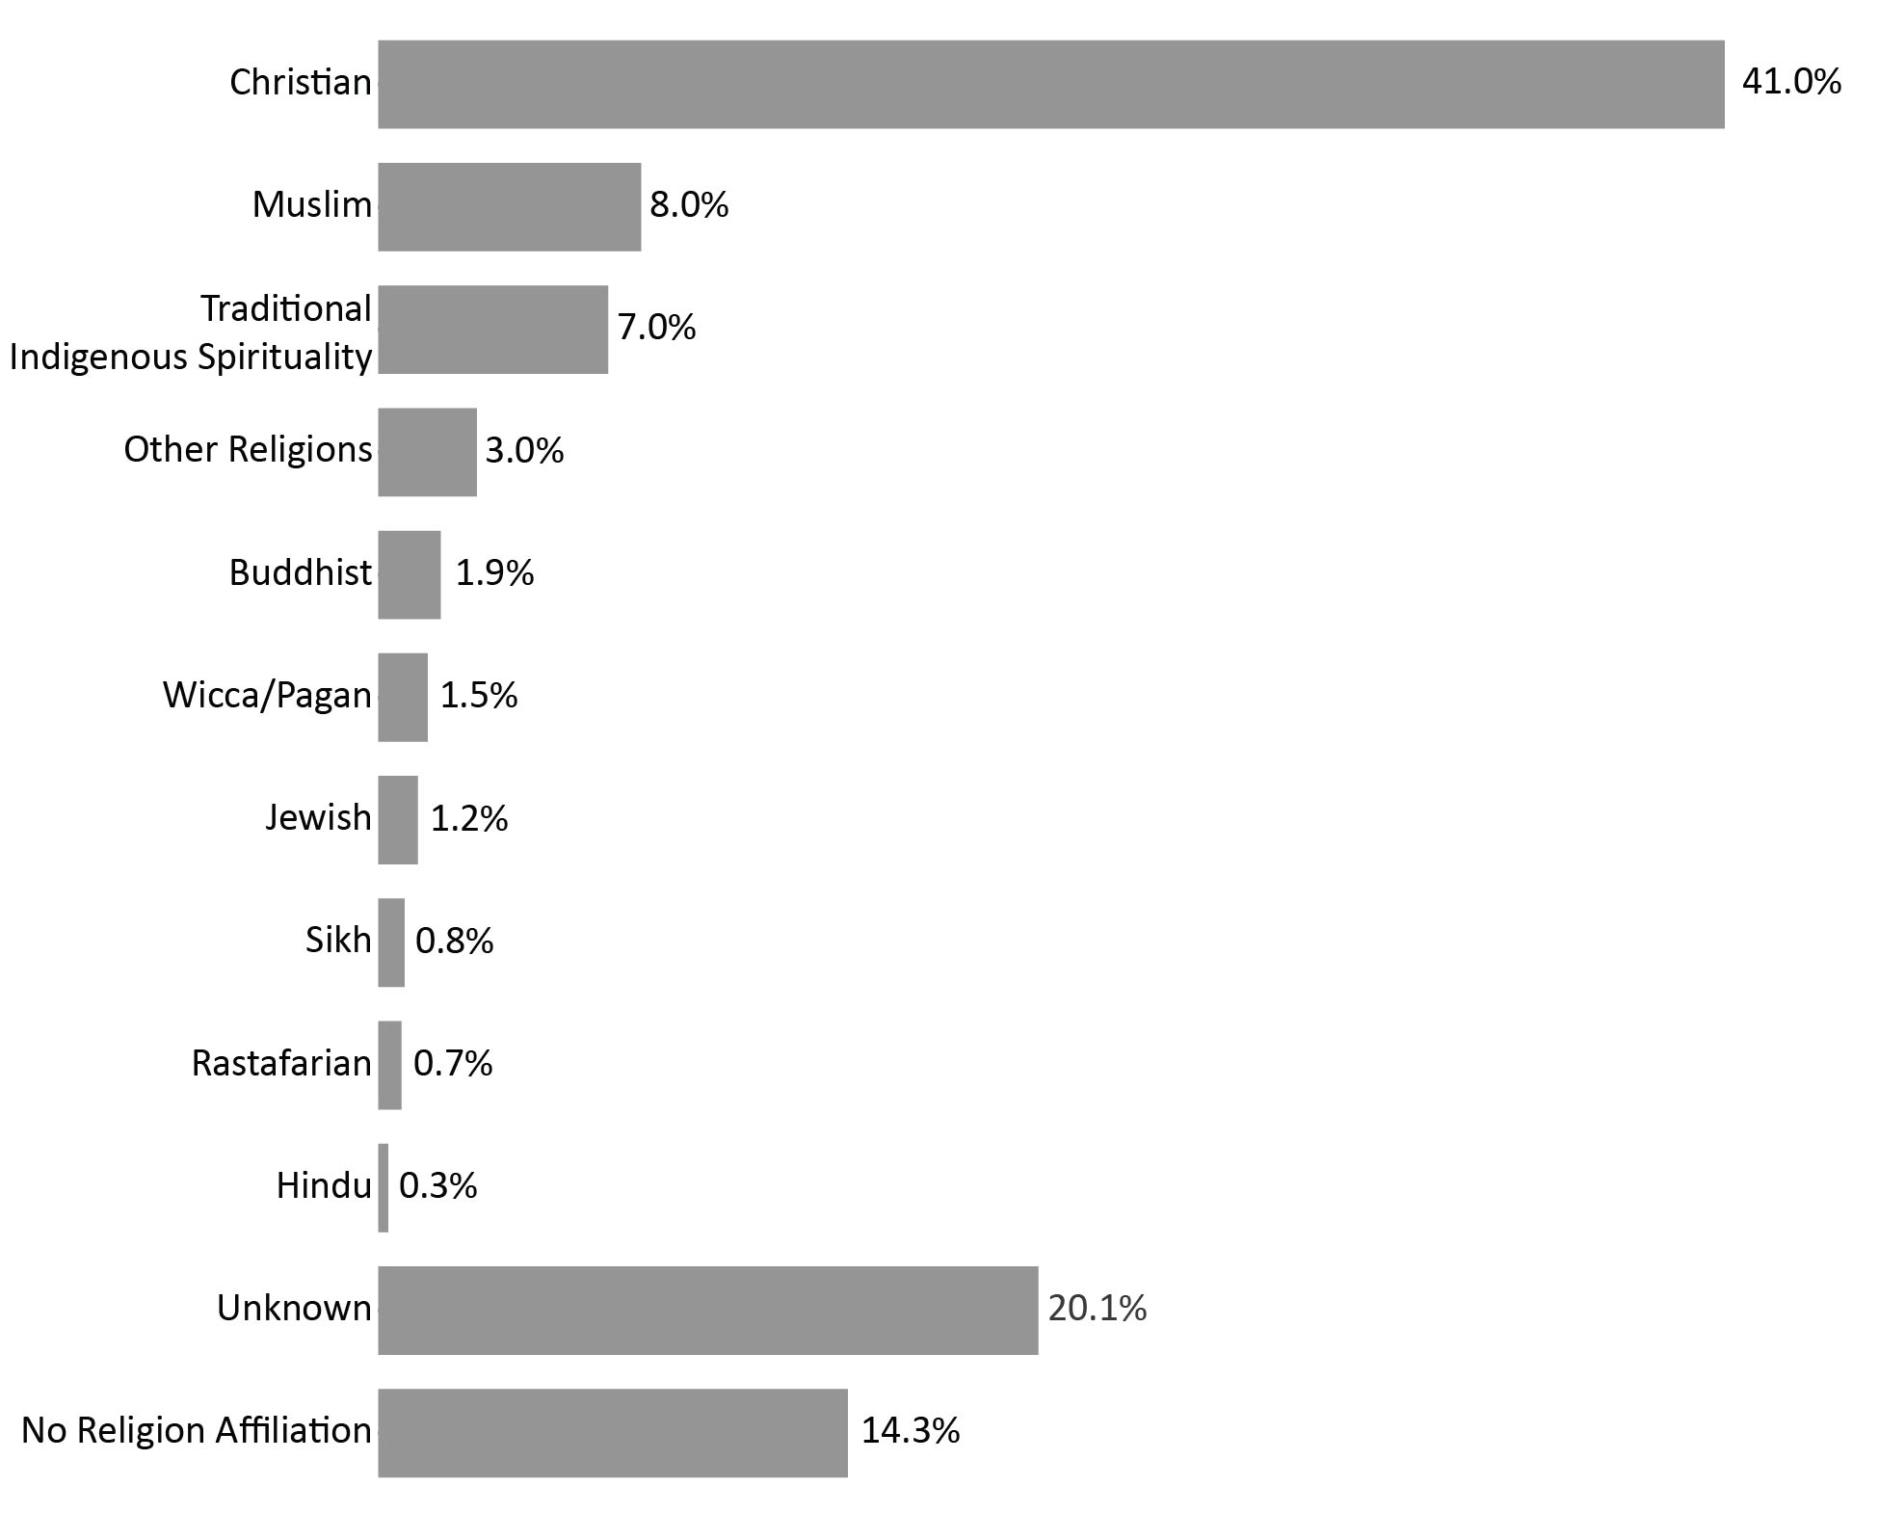
Source: Correctional Service of Canada.
- The religious identification of the CSC offender population is diverse. While the proportion of offenders who identified as Christian still represented the majority, their proportions decreased from 47.8% in 2018-19 to 41.0% in 2022-23.
- Religious identification was unknown for 20.1% of offenders, whereas 14.3% stated they had no religion affiliation.
Notes
The religion groupings were changed starting in the 2018 CCRSO publication to reflect the same groupings as Statistics Canada
Religious identification is self-reported by offenders while they are incarcerated, and the categories are not comprehensive; therefore, the reader should interpret these data with caution.
Buddhist includes offenders who belong to the following group: Buddhist, Mahayana Buddhist, Theravadan Buddhist and Vajrayana Buddhist.
Christian includes offenders who belong to the following group: Amish, Anglican (Episcopal Church of England), Antiochian Orthodox, Apostolic Christian Church, Armenian Orthodox/Apostolic, Associated Gospel, Assyrian Chaldean Catholic, Baptist, Brethren In Christ, Bulgarian Orthodox, Canadian Reformed Church, Catholic- Greek, Catholic-Roman, Catholic-Ukrainian, Catholic Non-Specific, Churches of Christ/Christian Churches, Charismatic, Christadelphian, Christian & Missionary Alliance, Christian Congregational, Christian Non Specific, Christian Or Plymouth Brethren, Christian Orthodox, Christian Reformed, Christian Reformed Church, Christian Science, Church of Christ Scientist, Church of God, Church of Jesus Christ of Latter-Day Saint, Community of Christ, Coptic Orthodox, Doukhobor, Dutch Reformed Church, Ethiopian Orthodox, Evangelical, Evangelical Free Church , Evangelical Missionary Church, Free Methodist, Free Reformed Church, Grace Communion International, Greek Orthodox, Hutterite, Iglesia Ni Cristo, Jehovah's Witnesses, Lutheran, Macedonian Orthodox, Maronite, Melkite, Mennonite, Messianic Jew, Methodist Christian, Metropolitan Community Church, Mission de l'Esprit Saint, Moravian, Mormon (Latter Day Saints), Nazarene Christian, Netherlands Reformed, New Apostolic, Pentecostal (4-Square), Pentecostal Assembly of God, Pentecôtiste, Philadelphia Church of God, Presbyterian, Protestant Non-Specific, Quaker (Society of Friends), Reformed Christian, Romanian Orthodox, Russian Orthodox, Salvation Army, Serbian Orthodox, Seventh Day Adventist, Shaker, Swedenborgian (New Church), Syrian/Syriac Orthodox, Ukrainian Catholic, Ukrainian Orthodox, United Church, United Reformed Church, Vineyard Christian Fellowship, Wesleyan Christian and Worldwide Church of God.
Hindu includes offenders who belong to the following group: Hindu and Siddha Yoga.
Jewish includes offenders who belong to the following group: Jewish Orthodox, Jewish Reformed and Judaism.
Muslim includes offenders who belong to the following group: Muslim and Sufism.
Rastafarian includes offenders who belong to the following group: Rastafarian.
Sikh includes offenders who belong to the following group: Sikh.
Traditional Indigenous Spirituality includes offenders who belong to the following group: Indigenous Spirituality Catholic, Traditional Indigenous Protestant, Traditional Indigenous Catholic, Native Spirituality, Catholic - Native Spirituality, Native Spirituality Protestant and Indigenous Spirituality.
Wiccan/Pagan includes offenders who belong to the following group: Asatru Paganism, Druidry Paganism, Pagan and Wicca.
Other Religion includes offenders who belong to the following group: Baha'i, Eckankar, Independent Spirituality, Jain, Krishna, New Age, New Thought-Unity-Religious Science, Other, Pantheist, Rosicrucian, Satanist, Scientology, Shintoïste, Spiritualist, Taoism, Transcendental Meditation, Unification Church, Unitarian, Visnabha and Zoroastrian.
No religion Affiliation includes offenders who belong to the following group: Agnostic, Atheist, Gnostic, Humanist and offenders who have no religion affiliation.
Unknown includes offenders who belong to the following group: Unknown, not stated as well as those offenders who have no religion specified.
The data reflect all active offenders, who are incarcerated in a CSC facility, offenders on temporary absence from a CSC facility, offenders who are temporarily detained, offenders who are actively supervised, and offenders who are unlawfully at large for less than 90 days.
The data reflect the number of offenders active at the end of each fiscal year.
A fiscal year runs from April 1 to March 31 of the following year.
Due to rounding, percentages may not add to 100 percent.

Table C15. Total offender population by religious identification
Religious identification | 2018-19 | % | 2022-23 | %
Buddhist | 519 | 2.2 | 416 | 1.9
Christian | 11,219 | 47.8 | 8,775 | 41.0
Hindu | 64 | 0.3 | 63 | 0.3
Jewish | 244 | 1.0 | 264 | 1.2
Muslim | 1,695 | 7.2 | 1,709 | 8.0
Rastafarian | 181 | 0.8 | 160 | 0.7
Sikh | 183 | 0.8 | 174 | 0.8
Traditional Aboriginal spirituality | 1,591 | 6.8 | 1,497 | 7.0
Wicca/Pagan | 352 | 1.5 | 323 | 1.5
Other religions | 579 | 2.5 | 642 | 3.0
No religion affiliation | 3,695 | 15.7 | 3,053 | 14.3
Unknown | 3,142 | 13.4 | 4,308 | 20.1
Total | 23,464 | 100.0 | 21,384 | 100.0
Source: Correctional Service of Canada.
Notes
The religion groupings were changed starting in the 2018 CCRSO publication to reflect the same groupings as Statistics Canada
Religious identification is self-reported by offenders while they are incarcerated, and the categories are not comprehensive; therefore, the reader should interpret these data with caution.
Buddhist includes offenders who belong to the following group: Buddhist, Mahayana Buddhist, Theravadan Buddhist and Vajrayana Buddhist.
Christian includes offenders who belong to the following group: Amish, Anglican (Episcopal Church of England), Antiochian Orthodox, Apostolic Christian Church, Armenian Orthodox/Apostolic, Associated Gospel, Assyrian Chaldean Catholic, Baptist, Brethren In Christ, Bulgarian Orthodox, Canadian Reformed Church, Catholic- Greek, Catholic-Roman, Catholic-Ukrainian, Catholic Non-Specific, Churches of Christ/Christian Churches, Charismatic, Christadelphian, Christian & Missionary Alliance, Christian Congregational, Christian Non Specific, Christian Or Plymouth Brethren, Christian Orthodox, Christian Reformed, Christian Reformed Church, Christian Science, Church of Christ Scientist, Church of God, Church of Jesus Christ of Latter-Day Saint, Community of Christ, Coptic Orthodox, Doukhobor, Dutch Reformed Church, Ethiopian Orthodox, Evangelical, Evangelical Free Church , Evangelical Missionary Church, Free Methodist, Free Reformed Church, Grace Communion International, Greek Orthodox, Hutterite, Iglesia Ni Cristo, Jehovah's Witnesses, Lutheran, Macedonian Orthodox, Maronite, Melkite, Mennonite, Messianic Jew, Methodist Christian, Metropolitan Community Church, Mission de l'Esprit Saint, Moravian, Mormon (Latter Day Saints), Nazarene Christian, Netherlands Reformed, New Apostolic, Pentecostal (4-Square), Pentecostal Assembly of God, Pentecôtiste, Philadelphia Church of God, Presbyterian, Protestant Non-Specific, Quaker (Society of Friends), Reformed Christian, Romanian Orthodox, Russian Orthodox, Salvation Army, Serbian Orthodox, Seventh Day Adventist, Shaker, Swedenborgian (New Church), Syrian/Syriac Orthodox, Ukrainian Catholic, Ukrainian Orthodox, United Church, United Reformed Church, Vineyard Christian Fellowship, Wesleyan Christian and Worldwide Church of God.
Hindu includes offenders who belong to the following group: Hindu and Siddha Yoga.
Jewish includes offenders who belong to the following group: Jewish Orthodox, Jewish Reformed and Judaism.
Muslim includes offenders who belong to the following group: Muslim and Sufism.
Rastafarian includes offenders who belong to the following group: Rastafarian.
Sikh includes offenders who belong to the following group: Sikh.
Traditional Indigenous Spirituality includes offenders who belong to the following group: Indigenous Spirituality Catholic, Traditional Indigenous Protestant, Traditional Indigenous Catholic, Native Spirituality, Catholic - Native Spirituality, Native Spirituality Protestant and Indigenous Spirituality.
Wiccan/Pagan includes offenders who belong to the following group: Asatru Paganism, Druidry Paganism, Pagan and Wicca.
Other Religion includes offenders who belong to the following group: Baha'i, Eckankar, Independent Spirituality, Jain, Krishna, New Age, New Thought-Unity-Religious Science, Other, Pantheist, Rosicrucian, Satanist, Scientology, Shintoïste, Spiritualist, Taoism, Transcendental Meditation, Unification Church, Unitarian, Visnabha and Zoroastrian.
No religion Affiliation includes offenders who belong to the following group: Agnostic, Atheist, Gnostic, Humanist and offenders who have no religion affiliation.
Unknown includes offenders who belong to the following group: Unknown, not stated as well as those offenders who have no religion specified.
The data reflect all active offenders, who are incarcerated in a CSC facility, offenders on temporary absence from a CSC facility, offenders who are temporarily detained, offenders who are actively supervised, and offenders who are unlawfully at large for less than 90 days.
The data reflect the number of offenders active at the end of each fiscal year.
A fiscal year runs from April 1 to March 31 of the following year.
Due to rounding, percentages may not add to 100 percent.

CSC offenders by Indigenous and non-Indigenous self-identification

Figure C16. Percentage of Indigenous and non-Indigenous offenders in custody
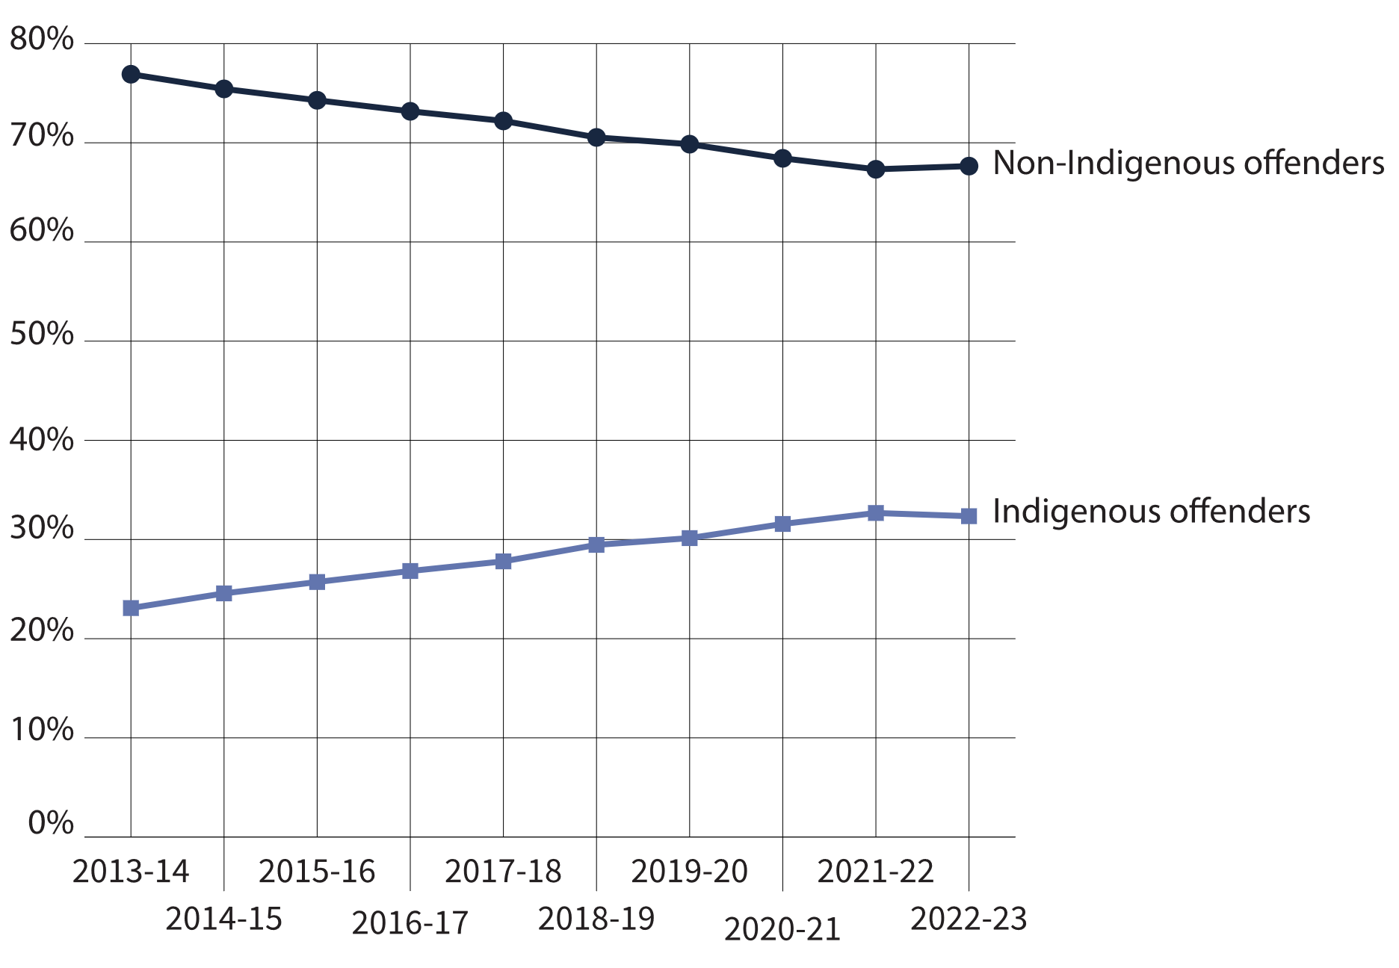
Source: Correctional Service of Canada.
- At the end of fiscal year 2022-23, Indigenous offenders accounted for 32.4% of the in-custody population and 22.8% of the in-community under supervision population, while non-Indigenous offenders accounted for 67.6% of the in-custody population and 77.2% of the in-community under supervision population.
- In 2022-23, Indigenous females represented 47.9% of all in-custody females while Indigenous males represented 31.5% of all males in custody.
- In 2022-23, Indigenous offenders represented 28.6% of the total offender population.
Notes
Total Offender Population includes all active offenders, who are incarcerated in a CSC facility, offenders on temporary absence from a CSC facility, offenders who are temporarily detained, offenders who are actively supervised, and offenders who are unlawfully at large for less than 90 days.
In Custody includes all active offenders incarcerated in a CSC facility, offenders on temporary absence from a CSC facility, offenders who are temporarily detained in a CSC facility and offenders on remand in a CSC facility.
In Community Under Supervision includes all active offenders on day parole, full parole, statutory release, in the community supervised on a long-term supervision order, offenders who are temporarily detained in a non-CSC facility, offenders who are unlawfully at large for less than 90 days, offenders on remand in a non-CSC facility, and offenders supervised and subject to an immigration hold by Canada Border Services Agency.
Indigenous identity is self-reported. Non-indigenous offenders includes offenders who do not identify as Indigenous. See Table C9 for the ethnic diversity of CSC’s offender population.
The data reflect the number of offenders active at the end of each fiscal year. A fiscal year runs from April 1 to March 31 of the following year.

Table C16. Indigenous and non-Indigenous offenders in custody vs. in the community under supervision

Fiscal year 2018-19
 | In-custody | % | In community under supervision | % | Total
Female total | 701 | 49.0 | 731 | 51.0 | 1,432
Indigenous | 291 | 59.5 | 198 | 40.5 | 489
Non-Indigenous | 410 | 43.5 | 533 | 56.5 | 943
Male total | 13,448 | 61.0 | 8,584 | 39.0 | 22,032
Indigenous | 3,877 | 71.5 | 1,548 | 28.5 | 5,425
Non-Indigenous | 9,571 | 57.6 | 7,036 | 42.4 | 16,607

Fiscal year 2019-20
 | In-custody | % | In community under supervision | % | Total
Female total | 685 | 48.4 | 731 | 51.6 | 1,416
Indigenous | 279 | 57.3 | 208 | 42.7 | 487
Non-Indigenous | 406 | 43.7 | 523 | 56.3 | 929
Male total | 13,032 | 60.1 | 8,650 | 39.9 | 21,682
Indigenous | 3,855 | 69.6 | 1,684 | 30.4 | 5,539
Non-Indigenous | 9,177 | 56.8 | 6,966 | 43.2 | 16,143
Intersex total | 3 | 75.0 | 1 | 25.0 | 4
Indigenous | 1 | 100.0 | 0 | 0.0 | 1
Non-Indigenous | 2 | 66.7 | 1 | 33.3 | 3

Fiscal year 2020-21
 | In-custody | % | In community under supervision | % | Total
Female total | 618 | 46.3 | 717 | 53.7 | 1,335
Indigenous | 267 | 55.2 | 217 | 44.8 | 484
Non-Indigenous | 351 | 41.2 | 500 | 58.8 | 851
Male total | 11,778 | 58.4 | 8,396 | 41.6 | 20,174
Indigenous | 3,646 | 68.5 | 1,678 | 31.5 | 5,324
Non-Indigenous | 8,132 | 54.8 | 6,718 | 45.2 | 14,850
Intersex total | 3 | 100.0 | 0 | 0.0 | 3
Indigenous | 1 | 100.0 | 0 | 0.0 | 1
Non-Indigenous | 2 | 100.0 | 0 | 0.0 | 2

Fiscal year 2021-22
 | In-custody | % | In community under supervision | % | Total
Female total | 588 | 47.8 | 643 | 52.2 | 1,231
Indigenous | 291 | 59.4 | 199 | 40.6 | 490
Non-Indigenous | 297 | 40.1 | 444 | 59.9 | 741
Male total | 11,740 | 60.0 | 7,836 | 40.0 | 19,576
Indigenous | 3,737 | 69.9 | 1,613 | 30.1 | 5,350
Non-Indigenous | 8,003 | 56.3 | 6,223 | 43.7 | 14,226
Intersex total | 0 | 0.0 | 0 | 0.0 | 0
Indigenous | 0 | 0.0 | 0 | 0.0 | 0
Non-Indigenous | 0 | 0.0 | 0 | 0.0 | 0

Fiscal year 2022-23
 | In-custody | % | In community under supervision | % | Total
Female total | 645 | 49.5 | 659 | 50.5 | 1,304
Indigenous | 309 | 55.8 | 245 | 44.2 | 554
Non-Indigenous | 336 | 44.8 | 414 | 55.2 | 750
Male total | 12,407 | 61.8 | 7,671 | 38.2 | 20,078
Indigenous | 3,914 | 70.3 | 1,652 | 29.7 | 5,566
Non-Indigenous | 8,493 | 58.5 | 6,019 | 41.5 | 14,512
Intersex total | 2 | 100.0 | 0 | 0.0 | 2
Indigenous | 0 | 0.0 | 0 | 0.0 | 0
Non-Indigenous | 2 | 100.0 | 0 | 0.0 | 2
Source: Correctional Service of Canada.
Notes
On November 28, 2019, the new choice “Another sex” was added as a choice in the sex field of the Offender Management System. On September 24, 2022, “Another sex” was changed to “Intersex” to use an appropriate term based on the definition of sex. Per Commissioner's Directive 100, an offender’s current “sex” is determined solely by their current genitalia and must not be changed unless there is a change to the offender’s genitalia following gender-affirming surgery.
Total Offender Population includes all active offenders, who are incarcerated in a CSC facility, offenders on temporary absence from a CSC facility, offenders who are temporarily detained, offenders who are actively supervised, and offenders who are unlawfully at large for less than 90 days.
In Custody includes all active offenders incarcerated in a CSC facility, offenders on temporary absence from a CSC facility, offenders who are temporarily detained in a CSC facility, and offenders on remand in a CSC facility.
In Community Under Supervision includes all active offenders on day parole, full parole, statutory release, in the community supervised on a long-term supervision order, offenders who are temporarily detained in a non-CSC facility, offenders who are unlawfully at large for less than 90 days, offenders on remand in a non-CSC facility, and offenders supervised and subject to an immigration hold by Canada Border Services Agency.
Indigenous identity is self-reported. Non-indigenous offenders includes offenders who do not identify as Indigenous. See Table C9 for the ethnic diversity of CSC’s offender population.
The data reflect the number of offenders active at the end of each fiscal year. A fiscal year runs from April 1 to March 31 of the following year.

Offenders in custody at a CSC facility by security risk classification
Figure C17. Percentage of classified in-custody offenders (2022-23)
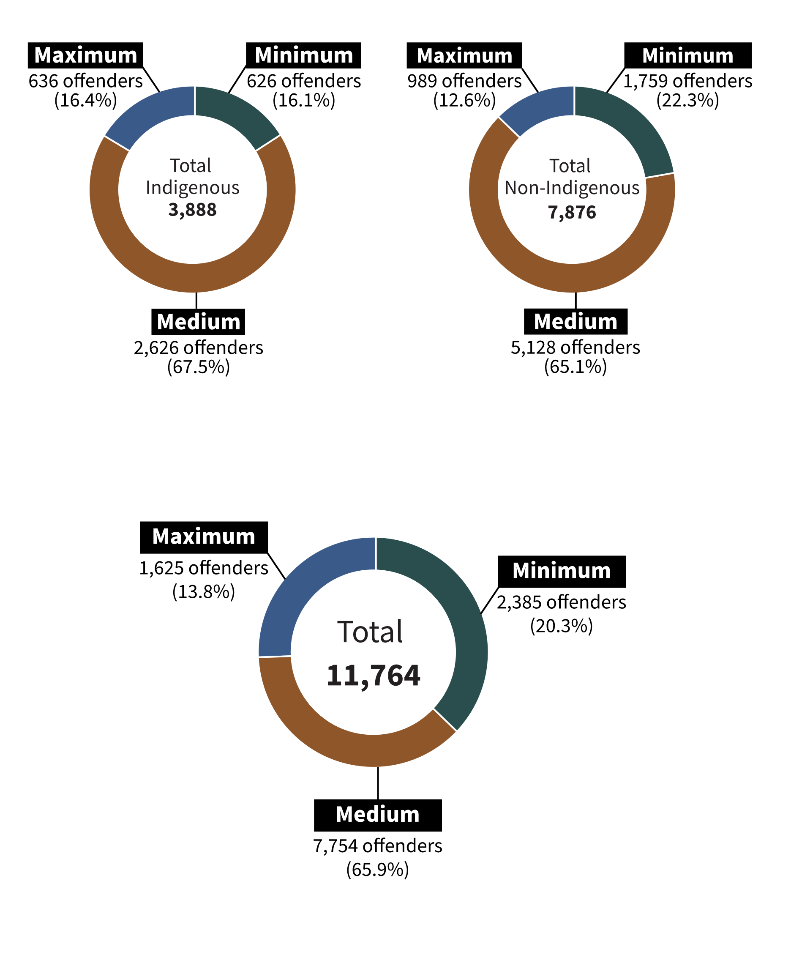
Source: Correctional Service of Canada.
- In 2022-23, approximately two-thirds (65.9%) of offenders were classified as medium security risk. Indigenous offenders were more likely to be classified to a medium or maximum security risk compared to non-Indigenous.
- Compared to non-Indigenous offenders, a lower percentage of Indigenous offenders were classified as minimum security risk (16.1% vs. 22.3%) and a higher percentage were classified as medium (67.5% vs. 65.1%) and maximum (16.4% vs. 12.6%) security risk.
Notes
In Custody includes all active offenders incarcerated in a CSC facility, offenders on temporary absence from a CSC facility, offenders who are temporarily detained in a CSC facility, and offenders on remand in a CSC facility.
The data represent the offender security level decision as of end of fiscal year 2022-23. A fiscal year runs from April 1 to March 31 of the following year.

Table C17. Total of classified in-custody offenders (2022-23)
Security risk level | Indigenous | % | Non-Indigenous | % | Total | %
Total security level | 3,888 | 100.0 | 7,876 | 100.0 | 11,764 | 100.0
Minimum | 626 | 16.1 | 1,759 | 22.3 | 2,385 | 20.3
Medium | 2,626 | 67.5 | 5,128 | 65.1 | 7,754 | 65.9
Maximum | 636 | 16.4 | 989 | 12.6 | 1,625 | 13.8
Not yet determined | 335 | 100.0 | 955 | 100.0 | 1,290 | 100.0
Total | 4,223 | 100.0 | 8,831 | 100.0 | 13,054 | 100.0
Source: Correctional Service of Canada.
Notes
The "Not yet determined" category includes offenders who have not yet been classified.
In-Custody includes all active offenders incarcerated in a CSC facility, offenders on temporary absence from a CSC facility, offenders who are temporarily detained in a CSC facility and offenders on remand in a CSC facility.
The data represent the offender security level decision as of end of fiscal year 2022-23. A fiscal year runs from April 1 to March 31 of the following year.

Admissions to federal jurisdiction with a life and/or indeterminate sentence*: 10-year trend

Figure C18. Number of warrant of committal admissions for life and/or indeterminate sentences*
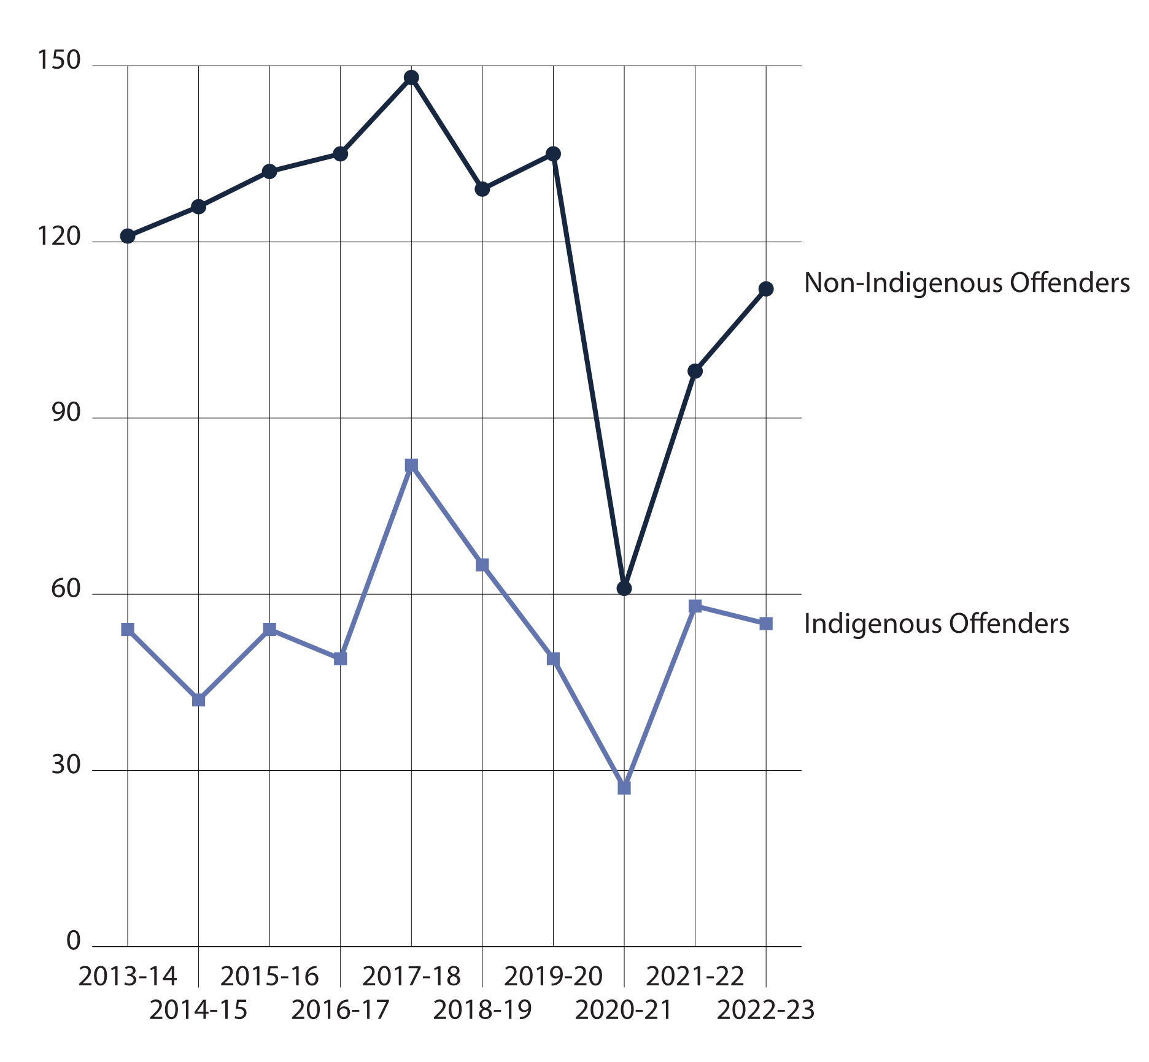
Source: Correctional Service of Canada.
- From 2013-14 to 2022-23, there was a decrease of 4.6% in the number of warrant of committal admissions to CSC facilities with a life and/or indeterminate* sentence from 175 to 167.
- At the end of fiscal year 2022-23, there were a total of 3,594 offenders in custody with a life and/or indeterminate sentence. Of these, 3,465 (96.4%) were male, 129 (3.6%) were female; 1,069 (29.7%) were Indigenous and 2,525 (70.3%) were non-Indigenous.
- At the end of fiscal year 2022-23, 27.3% of the total population was serving a life and/or indeterminate sentence. Of these offenders, 61.6% were in custody and 38.4% were in the community under supervision.
Notes
*Although life sentences and indeterminate sentences both may result in imprisonment for life, they are different. A life sentence is a sentence of life imprisonment, imposed by a judge at the time of sentencing, for example murder. An indeterminate sentence is a result of a designation, where an application is made to the court to declare an offender a Dangerous Offender, and the consequence of this designation is imprisonment for an indeterminate period.
A warrant of committal is a new admission to federal jurisdiction from the courts.
These numbers refer to the total number of admissions to a federal institution or Healing Lodge during each fiscal year and may be greater than the actual number of offenders admitted, since an individual offender may be admitted more than once in a given year.
There is a lag in the data entry of admissions into CSC’s Offender Management System. The admission figures for the most recent year are under-reported by 200-400 admissions at the time of year end data extraction. More accurate figures will be available in the next year’s publication. Please use caution when including the most recent year in any trend analysis.
Total Offender Population includes all active offenders, who are incarcerated in a CSC facility, offenders on temporary absence from a CSC facility, offenders who are temporarily detained, offenders who are actively supervised, and offenders who are unlawfully at large for less than 90 days.
In-Custody includes all active offenders incarcerated in a CSC facility, offenders on temporary absence from a CSC facility, offenders who are temporarily detained in a CSC facility, and offenders on remand in a CSC facility.
In Community Under Supervision includes all active offenders on day parole, full parole, statutory release, in the community supervised on a long-term supervision order, offenders who are temporarily detained in a non-CSC facility, offenders who are unlawfully at large for less than 90 days, offenders on remand in a non-CSC facility, and offenders supervised and subject to an immigration hold by Canada Border Services Agency.
This table combines offenders serving life sentences and offenders serving indeterminate sentences.
Reported year periods reflect fiscal years. A fiscal year runs from April 1 to March 31 of the following year.

Table C18a. Number of warrant of committal admissions for life and/or indeterminate sentences* by Indigenous offenders
Fiscal year | Indigenous females | Indigenous males | Indigenous total
2013-14 | 7 | 47 | 54
2014-15 | 2 | 40 | 42
2015-16 | 5 | 49 | 54
2016-17 | 2 | 47 | 49
2017-18 | 6 | 76 | 82
2018-19 | 7 | 58 | 65
2019-20 | 1 | 48 | 49
2020-21 | 2 | 25 | 27
2021-22 | 4 | 54 | 58
2022-23 | 8 | 47 | 55
Source: Correctional Service of Canada.

Table C18b. Number of warrant of committal admissions for life and/or indeterminate sentences* by non-Indigenous offenders
Fiscal year | Non-Indigenous females | Non-Indigenous males | Non-Indigenous total
2013-14 | 7 | 114 | 121
2014-15 | 8 | 118 | 126
2015-16 | 6 | 126 | 132
2016-17 | 11 | 124 | 135
2017-18 | 12 | 136 | 148
2018-19 | 3 | 126 | 129
2019-20 | 8 | 127 | 135
2020-21 | 0 | 61 | 61
2021-22 | 4 | 94 | 98
2022-23 | 4 | 108 | 112
Source: Correctional Service of Canada.

Table C18c. Total number of warrant of committal admissions for life and/or indeterminate sentences* by sex
Fiscal year | Females | Males | Total
2013-14 | 14 | 161 | 175
2014-15 | 10 | 158 | 168
2015-16 | 11 | 175 | 186
2016-17 | 13 | 171 | 184
2017-18 | 18 | 212 | 230
2018-19 | 10 | 184 | 194
2019-20 | 9 | 175 | 184
2020-21 | 2 | 86 | 88
2021-22 | 8 | 148 | 156
2022-23 | 12 | 155 | 167
Source: Correctional Service of Canada.
Notes
*Although life sentences and indeterminate sentences both may result in imprisonment for life, they are different. A life sentence is a sentence of life imprisonment, imposed by a judge at the time of sentencing, for example murder. An indeterminate sentence is a result of a designation, where an application is made to the court to declare an offender a Dangerous Offender, and the consequence of this designation is imprisonment for an indeterminate period.
A warrant of committal is a new admission to federal jurisdiction from the courts.
These numbers refer to the total number of admissions to a federal institution or Healing Lodge during each fiscal year and may be greater than the actual number of offenders admitted, since an individual offender may be admitted more than once in a given year.
There is a lag in the data entry of admissions into CSC’s Offender Management System. The admission figures for the most recent year are under-reported by 200-400 admissions at the time of year end data extraction. More accurate figures will be available in the next year’s publication. Please use caution when including the most recent year in any trend analysis.
Total Offender Population includes all active offenders, who are incarcerated in a CSC facility, offenders on temporary absence from a CSC facility, offenders who are temporarily detained, offenders who are actively supervised, and offenders who are unlawfully at large for less than 90 days.
In-Custody includes all active offenders incarcerated in a CSC facility, offenders on temporary absence from a CSC facility, offenders who are temporarily detained in a CSC facility, and offenders on remand in a CSC facility.
In Community Under Supervision includes all active offenders on day parole, full parole, statutory release, in the community supervised on a long-term supervision order, offenders who are temporarily detained in a non-CSC facility, offenders who are unlawfully at large for less than 90 days, offenders on remand in a non-CSC facility, and offenders supervised and subject to an immigration hold by Canada Border Services Agency.
This table combines offenders serving life sentences and offenders serving indeterminate sentences.
Reported year periods reflect fiscal years. A fiscal year runs from April 1 to March 31 of the following year.

Proportion of offenders with life and/or indeterminate sentences

Figure C19. Sentence imposed for the total offender population (2022-23)
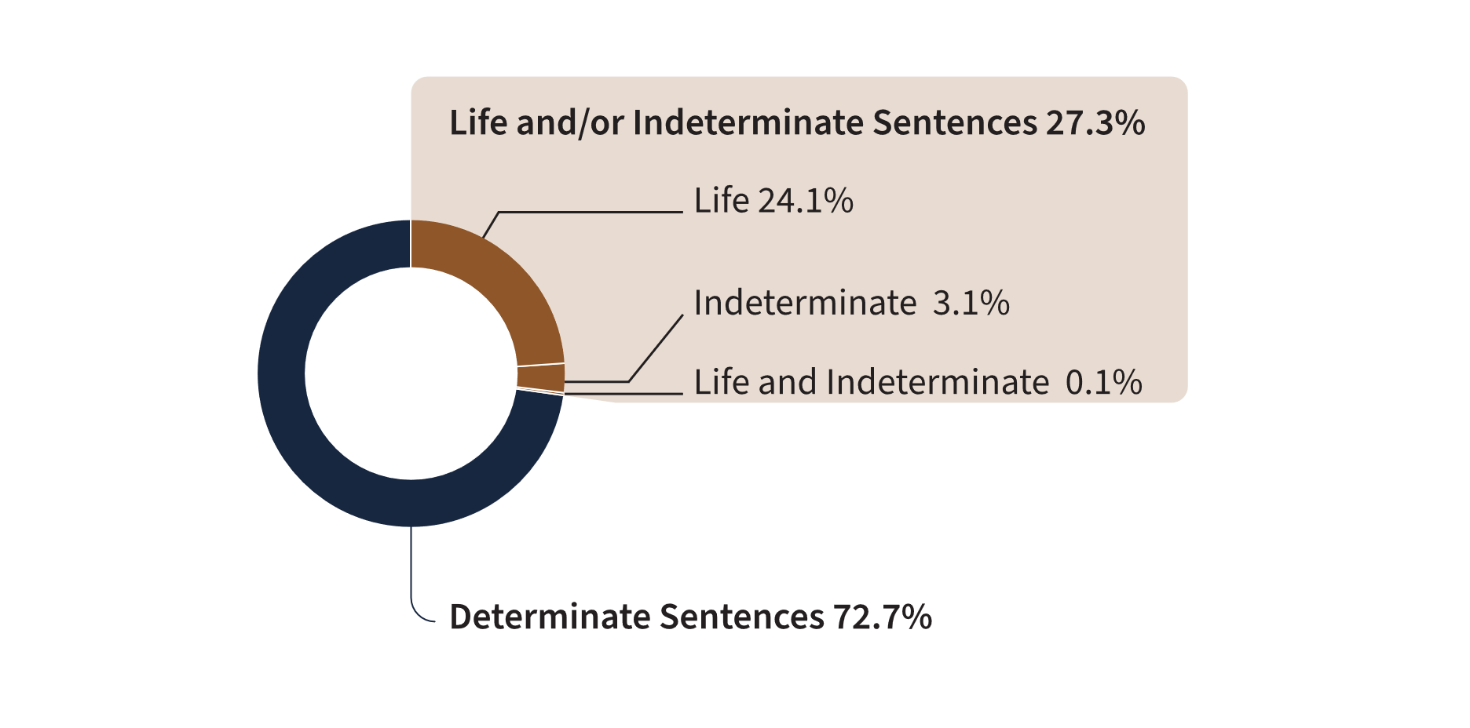
Source: Correctional Service of Canada.
- At the end of fiscal year 2022-23, there were 5,838 offenders serving a life sentence and/or an indeterminate sentence. This represents 27.3% of the total offender population. The majority (61.6%) of these offenders were in custody. Of the 2,244 offenders serving a life and/or an indeterminate sentence who were in the community under supervision, the majority (78.9%) were serving a life sentence for 2nd Degree Murder.
- There were 21 offenders who were serving both a life sentence and an indeterminate sentence.
- There were 667 offenders who were serving an indeterminate sentence as a result of a special designation. The remaining 5,150 offenders did not receive a special designation, but were serving a life sentence.
- 92.4% of the 659 Dangerous Offenders with indeterminate sentences were in custody and 7.6% were in the community under supervision.
- In contrast, 28.6% of the 7 Dangerous Sexual Offenders were in custody and the offender with an Habitual Offender designation was in the community under supervision.
Notes
Although life sentences and indeterminate sentences both may result in imprisonment for life, they are different. A life sentence is a sentence of life imprisonment, imposed by a judge at the time of sentencing, for example murder. An indeterminate sentence is a result of a designation, where an application is made to the court to declare an offender a Dangerous Offender, and the consequence of this designation is imprisonment for an indeterminate period. The Dangerous Sexual Offender and Habitual Offender designations were replaced with Dangerous Offender legislation in 1977.
As per the Criminal Code of Canada under Section 231: Murder I (first degree) occurs when: (1) it is planned and deliberate; or (2) the victim is a person employed and acting in the course of his/her work for the preservation and maintenance of the public peace (e.g. police officer, correctional worker); or (3) the death is caused by a person committing or attempting to commit certain serious offences (e.g. treason, kidnapping, hijacking, sexual assault, robbery and arson). Murder II (second degree) is all murder that is not Murder I.
Total Offender Population includes all active offenders, who are incarcerated in a CSC facility, offenders on temporary absence from a CSC facility, offenders who are temporarily detained, offenders who are actively supervised, and offenders who are unlawfully at large for less than 90 days.
In Custody includes all active offenders incarcerated in a CSC facility, offenders on temporary absence from a CSC facility, offenders who are temporarily detained in a CSC facility and offenders on remand in a CSC facility.
In Community Under Supervision includes all active offenders on day parole, full parole, statutory release, in the community supervised on a long-term supervision order, offenders who are temporarily detained in a non-CSC facility, offenders who are unlawfully at large for less than 90 days, offenders on remand in a non-CSC facility, and offenders supervised and subject to an immigration hold by Canada Border Services Agency.
Reported year periods reflect fiscal years. A fiscal year runs from April 1 to March 31 of the following year.

Table C19a. Total offender population by location (2022-23)
Offender population | In custody in a CSC facility:  Incarcerated | In community under supervision:  Day parole | In community under supervision:  Full parole | In community under supervision:  Other***
Total offenders with a life sentence | 2,965 | 327 | 1,858 | 0
1st degree murder | 988 | 79 | 255 | 0
2nd degree murder | 1,870 | 239 | 1,531 | 0
Other offences* | 107 | 9 | 72 | 0
Total offenders with indeterminate sentences resulting from the special designation | 611 | 21 | 35 | 0
Dangerous Offender | 609 | 20**** | 30**** | 0
Dangerous Sexual Offender | 2 | 1**** | 4**** | 0
Habitual Offender | 0 | 0 | 1 | 0
Offenders serving an indeterminate sentence (due to a special designation) and a life sentence (due to an offence) | 18 | 0 | 3 | 0
Total offenders with life and/or indeterminate sentence | 3,594 | 348 | 1,896 | 0
Offenders serving determinate sentences** | 9,460 | 1,157 | 2,135 | 2,794
Total | 13,054 | 1,505 | 4,031 | 2,794
Source: Correctional Service of Canada.

Table C19b. Total offender population (2022-23)
Offender population | Total population | %
Total offenders with a life sentence | 5,150 | 24.1
1st degree murder | 1,322 | 6.2
2nd degree murder | 3,640 | 17.0
Other offences* | 188 | 0.9
Total offenders with indeterminate sentences resulting from the special designation | 667 | 3.1
Dangerous Offender | 659 | 3.1
Dangerous Sexual Offender | 7 | 0.0
Habitual Offender | 1 | 0.0
Offenders serving an indeterminate sentence (due to a special designation) and a life sentence (due to an offence) | 21 | 0.1
Total offenders with life and/or indeterminate sentence | 5,838 | 27.3
Offenders serving determinate sentences** | 15,546 | 72.7
Total | 21,384 | 100.0
Source: Correctional Service of Canada.
Notes
* Other offences include Schedule 1, Schedule 2 and Non-Schedule types of offences.
** This includes 231 offenders designated as Dangerous Offenders who were serving determinate sentences.
*** Other in the community under supervision population includes federal offenders on statutory release and on a long-term supervision order.
**** As with all parole reviews, when determining whether to grant parole, the Parole Board of Canada (PBC) will review all relevant available information to determine whether the individual presents an undue risk to society, and whether their release will contribute to the protection of society by facilitating their reintegration into society as a law-abiding citizen. The protection of society is the paramount consideration in all PBC decisions.
There is 1 offender with an Habitual Offender designation included in the Designation and Life grouping, this offender was in the community under supervision as well.
Although life sentences and indeterminate sentences both may result in imprisonment for life, they are different. A life sentence is a sentence of life imprisonment, imposed by a judge at the time of sentence, for example for murder. An indeterminate sentence is a result of a designation, where an application is made to the court to declare an offender a Dangerous Offender, and the consequence of this designation is imprisonment for an indeterminate period. The Dangerous Sexual Offender and Habitual Offender designations were replaced with Dangerous Offender legislation in 1977.
As per the Criminal Code of Canada under Section 231: Murder I (first degree) occurs when: (1) it is planned and deliberate; or (2) the victim is a person employed and acting in the course of his/her work for the preservation and maintenance of the public peace (e.g. police officer, correctional worker); or (3) the death is caused by a person committing or attempting to commit certain serious offences (e.g. treason, kidnapping, hijacking, sexual assault, robbery and arson). Murder II (second degree) is all murder that is not Murder I.
Total Offender Population includes all active offenders, who are incarcerated in a CSC facility, offenders on temporary absence from a CSC facility, offenders who are temporarily detained, offenders who are actively supervised, and offenders who are unlawfully at large for less than 90 days.
In Custody includes all active offenders incarcerated in a CSC facility, offenders on temporary absence from a CSC facility, offenders who are temporarily detained in a CSC facility, and offenders on remand in a CSC facility.
In Community Under Supervision includes all active offenders on day parole, full parole, statutory release, in the community supervised on a long-term supervision order, offenders who are temporarily detained in a non-CSC facility, offenders who are unlawfully at large for less than 90 days, offenders on remand in a non-CSC facility, and offenders supervised and subject to an immigration hold by Canada Border Services Agency.
Reported year periods reflect fiscal years. A fiscal year runs from April 1 to March 31 of the following year.

Percentage of total offender population serving a sentence for a violent offence

Figure C20. Percentage of total offender population serving a sentence for a violent offence (2022-23)
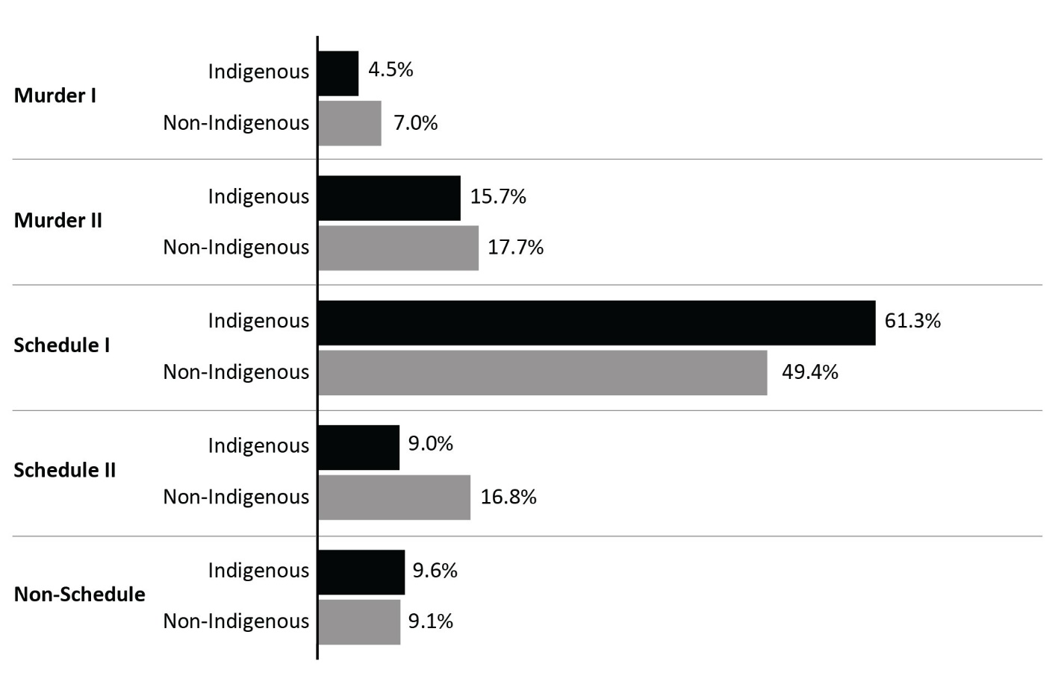
Source: Correctional Service of Canada.
- At the end of fiscal year 2022-23, Indigenous offenders were more likely to be serving a sentence for a violent offence (81.5% for Indigenous versus 74.1% for non-Indigenous).
- 70.4% of Indigenous female offenders were serving a sentence for a violent offence compared to 53.9% of non-Indigenous female offenders.
- Of the total number of offenders serving a sentence for Murder, 4.9% were female and 24.7% were Indigenous.
- A greater proportion of Indigenous offenders than non-Indigenous offenders were serving a sentence for a Schedule I offence (61.3% versus 49.4%, respectively).
- 9.0% of Indigenous offenders were serving a sentence for a Schedule II offence compared to 16.8% of non-Indigenous offenders.
- 25.2% of females were serving a sentence for a Schedule II offence compared to 13.9% for male.
Notes
Violent offences include first degree murder, second degree murder, and Schedule I offences.
Schedule I is comprised of sexual offences and other violent crimes excluding first and second degree murder (see the Corrections and Conditional Release Act).
Schedule II is comprised of serious drug offences or conspiracy to commit serious drug offences (see the Corrections and Conditional Release Act).
In cases where the offender is serving a sentence for more than 1 offence, the data reflect the most serious offence.
As per the Criminal Code of Canada under Section 231: Murder I (first degree) occurs when: (1) it is planned and deliberate; or (2) the victim is a person employed and acting in the course of his/her work for the preservation and maintenance of the public peace (e.g. police officer, correctional worker); or (3) the death is caused by a person committing or attempting to commit certain serious offences (e.g. treason, kidnapping, hijacking, sexual assault, robbery and arson). Murder II (second degree) is all murder that is not Murder I.
Total Offender Population includes all active offenders, who are incarcerated in a CSC facility, offenders on temporary absence from a CSC facility, offenders who are temporarily detained, offenders who are actively supervised, and offenders who are unlawfully at large for less than 90 days.
Reported year periods reflect fiscal years. A fiscal year runs from April 1 to March 31 of the following year.

Table C20a. Indigenous offender population serving a sentence for a violent offence (2022-23)
Offence category | Indigenous Female | % | Indigenous Male | % | Indigenous Intersex | % | Indigenous Total
Murder I | 12 | 2.2 | 263 | 4.7 | 0 | 0.0 | 275
Murder II | 75 | 13.5 | 885 | 15.9 | 0 | 0.0 | 960
Schedule I | 303 | 54.7 | 3,449 | 62.0 | 0 | 0.0 | 3752
Schedule II | 105 | 19.0 | 443 | 8.0 | 0 | 0.0 | 548
Non-schedule | 59 | 10.6 | 526 | 9.5 | 0 | 0.0 | 585
Total | 554 | 100.0 | 5,566 | 100.0 | 0 | 100.0 | 6,120
Source: Correctional Service of Canada.

Table C20b. Non-Indigenous offender population serving a sentence for a violent offence (2022-23)
Offence category | Non- Indigenous Female | % | Non- Indigenous Male | % | Non- Indigenous Intersex | % | Non- Indigenous Total
Murder I | 42 | 5.6 | 1,019 | 7.0 | 0 | 0.0 | 1,061
Murder II | 115 | 15.3 | 2,589 | 17.8 | 0 | 0.0 | 2,704
Schedule I | 247 | 32.9 | 7,296 | 50.3 | 1 | 50.0 | 7,544
Schedule II | 223 | 29.7 | 2,343 | 16.1 | 0 | 0.0 | 2,566
Non-schedule | 123 | 16.4 | 1,265 | 8.7 | 1 | 50.0 | 1,389
Total | 750 | 100.0 | 14,512 | 100.0 | 2 | 100.0 | 15,264
Source: Correctional Service of Canada.

Table C20c. Total offender population serving a sentence for a violent offence (2022-23)
Offence category | Female | % | Male | % | Intersex | % | Total
Murder I | 54 | 4.1 | 1,282 | 6.4 | 0 | 0.0 | 1,336
Murder II | 190 | 14.6 | 3,474 | 17.3 | 0 | 0.0 | 3,664
Schedule I | 550 | 42.2 | 10,745 | 53.5 | 1 | 50.0 | 11,296
Schedule II | 328 | 25.2 | 2,786 | 13.9 | 0 | 0.0 | 3,114
Non-schedule | 182 | 14.0 | 1,791 | 8.9 | 1 | 50.0 | 1,974
Total | 1,304 | 100.0 | 20,078 | 100.0 | 2 | 100.0 | 21,384
Source: Correctional Service of Canada.
Notes
On November 28, 2019, the new choice “Another sex” was added as a choice in the sex field of the Offender Management System. On September 24, 2022, “Another sex” was changed to “Intersex” to use an appropriate term based on the definition of sex. Per Commissioner's Directive 100, an offender’s current “sex” is determined solely by their current genitalia and must not be changed unless there is a change to the offender’s genitalia following gender-affirming surgery.
Violent offences include first degree murder, second degree murder, and Schedule I offences.
Schedule I is comprised of sexual offences and other violent crimes excluding first and second degree murder (see the Corrections and Conditional Release Act).
Schedule II is comprised of serious drug offences or conspiracy to commit serious drug offences (see the Corrections and Conditional Release Act).
In cases where the offender is serving a sentence for more than one offence, the data reflect the most serious offence.
As per the Criminal Code of Canada under Section 231: Murder I (first degree) occurs when: (1) it is planned and deliberate; or (2) the victim is a person employed and acting in the course of his/her work for the preservation and maintenance of the public peace (e.g. police officer, correctional worker); or (3) the death is caused by a person committing or attempting to commit certain serious offences (e.g., treason, kidnapping, hijacking, sexual assault, robbery and arson). Murder II (second degree) is all murder that is not Murder I.
Total Offender Population includes all active offenders, who are incarcerated in a CSC facility, offenders on temporary absence from a CSC facility, offenders who are temporarily detained, offenders who are actively supervised, and offenders who are unlawfully at large for less than 90 days.
Due to rounding, percentages may not add up to 100 percent.
Reported year periods reflect fiscal years. A fiscal year runs from April 1 to March 31 of the following year.

Indigenous offenders under the responsibility of CSC

Figure C21. Indigenous offender population
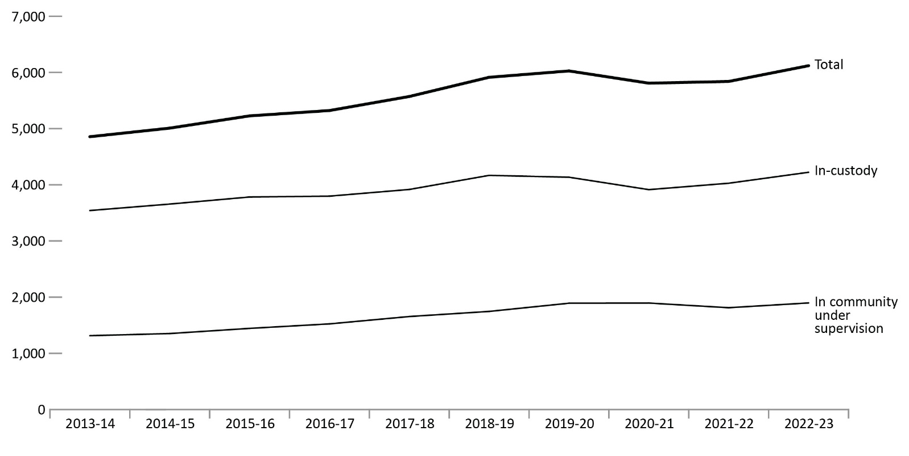
Source: Correctional Service of Canada.
- From 2013-14 to 2022-23, the in-custody Indigenous offender population increased by 19.2%, while the total Indigenous offender population increased 26.0% over the same period of time.
- The number of in-custody Indigenous female offenders increased steadily from 213 in 2013-14 to 309 in 2022-23, representing an increase of 45.1%. The increase for in-custody Indigenous male offenders was 17.6% for the same period, increasing from 3,329 to 3,914.
- From 2013-14 to 2022-23 the number of Indigenous offenders on community supervision increased 44.4%, from 1,314 to 1,897. The Indigenous community population accounted for 22.8% of the total community population in 2022-23.
Notes
Total Offender Population includes all active offenders who are incarcerated in a CSC facility, offenders on temporary absence from a CSC facility, offenders who are temporarily detained, offenders who are actively supervised, and offenders who are unlawfully at large for less than 90 days.
In Custody includes all active offenders incarcerated in a CSC facility, offenders on temporary absence from a CSC facility, offenders who are temporarily detained in a CSC facility, and offenders on remand in a CSC facility.
In Community Under Supervision includes all active offenders on day parole, full parole, statutory release, or in the community supervised on a long-term supervision order, offenders who are temporarily detained in a non-CSC facility, offenders who are unlawfully at large for less than 90 days, offenders on remand in a non-CSC facility, and offenders supervised and subject to an immigration hold by Canada Border Services Agency.
Regional statistics for the Correctional Service of Canada account for data relating to the northern territories in the following manner: data for Nunavut are reported in the Ontario Region, data for the Northwest Territories are reported in the Prairies Region, and data for the Yukon Territories are reported in the Pacific Region.
Reported year periods reflect fiscal years. A fiscal year runs from April 1 to March 31 of the following year.

Table C21a. Indigenous offender population in custody
Region | 2018-19 | 2019-20 | 2020-21 | 2021-22 | 2022-23
Atlantic region total | 243 | 252 | 236 | 227 | 231
Male | 224 | 234 | 211 | 208 | 211
Female | 19 | 18 | 25 | 19 | 20
Intersex | NR | 0 | 0 | 0 | 0
Quebec region total | 465 | 383 | 366 | 408 | 437
Male | 449 | 370 | 352 | 389 | 422
Female | 16 | 13 | 14 | 19 | 15
Intersex | NR | 0 | 0 | 0 | 0
Ontario region total | 608 | 661 | 581 | 666 | 759
Male | 558 | 612 | 528 | 606 | 697
Female | 50 | 49 | 53 | 60 | 62
Intersex | NR | 0 | 0 | 0 | 0
Prairie region total | 2,113 | 2,120 | 2,052 | 2,099 | 2,139
Male | 1,955 | 1,968 | 1,925 | 1,943 | 1,972
Female | 158 | 152 | 127 | 156 | 167
Intersex | NR | 0 | 0 | 0 | 0
Pacific region total | 739 | 719 | 679 | 628 | 657
Male | 691 | 671 | 630 | 591 | 612
Female | 48 | 47 | 48 | 37 | 45
Intersex | NR | 1 | 1 | 0 | 0
National total | 4,168 | 4,135 | 3,914 | 4,028 | 4,223
Male | 3,877 | 3,855 | 3,646 | 3,737 | 3,914
Female | 291 | 279 | 267 | 291 | 309
Intersex | NR | 1 | 1 | 0 | 0
Source: Correctional Service of Canada.

Table C21b. Indigenous offender population in community under supervision
Region | 2018-19 | 2019-20 | 2020-21 | 2021-22 | 2022-23
Atlantic region total | 93 | 119 | 110 | 109 | 120
Male | 83 | 106 | 97 | 99 | 105
Female | 10 | 13 | 13 | 10 | 15
Intersex | NR | 0 | 0 | 0 | 0
Quebec region total | 171 | 190 | 191 | 156 | 187
Male | 162 | 182 | 182 | 150 | 179
Female | 9 | 8 | 9 | 6 | 8
Intersex | NR | 0 | 0 | 0 | 0
Ontario region total | 270 | 305 | 325 | 343 | 354
Male | 239 | 277 | 291 | 304 | 302
Female | 31 | 28 | 34 | 39 | 52
Intersex | NR | 0 | 0 | 0 | 0
Prairie region total | 833 | 869 | 879 | 790 | 845
Male | 720 | 750 | 756 | 687 | 713
Female | 113 | 119 | 123 | 103 | 132
Intersex | NR | 0 | 0 | 0 | 0
Pacific region total | 379 | 409 | 390 | 414 | 391
Male | 344 | 369 | 352 | 373 | 353
Female | 35 | 40 | 38 | 41 | 38
Intersex | NR | 0 | 0 | 0 | 0
National total | 1,746 | 1,892 | 1,895 | 1,812 | 1,897
Male | 1,548 | 1,684 | 1,678 | 1,613 | 1,652
Female | 198 | 208 | 217 | 199 | 245
Intersex | NR | 0 | 0 | 0 | 0
Source: Correctional Service of Canada.
Notes
On November 28, 2019, the new choice “Another sex” was added as a choice in the sex field of the Offender Management System. On September 24, 2022, “Another sex” was changed to “Intersex” to use an appropriate term based on the definition of sex. Per Commissioner's Directive 100, an offender’s current “sex” is determined solely by their current genitalia and must not be changed unless there is a change to the offender’s genitalia following gender-affirming surgery.
Total Offender Population includes all active offenders who are incarcerated in a CSC facility, offenders on temporary absence from a CSC facility, offenders who are temporarily detained, offenders who are actively supervised, and offenders who are unlawfully at large for less than 90 days.
In Custody includes all active offenders incarcerated in a CSC facility, offenders on temporary absence from a CSC facility, offenders who are temporarily detained in a CSC facility, and offenders on remand in a CSC facility.
In Community Under Supervision includes all active offenders on day parole, full parole, statutory release, or in the community supervised on a long-term supervision order, offenders who are temporarily detained in a non-CSC facility, offenders who are unlawfully at large for less than 90 days, offenders on remand in a non-CSC facility, and offenders supervised and subject to an immigration hold by Canada Border Services Agency.
Regional statistics for the Correctional Service of Canada account for data relating to the northern territories in the following manner: data for Nunavut are reported in the Ontario Region, data for the Northwest Territories are reported in the Prairies Region, and data for the Yukon Territories are reported in the Pacific Region.
Reported year periods reflect fiscal years. A fiscal year runs from April 1 to March 31 of the following year.

Number of authorizations for transfer to Structured Intervention Units in federal institutions

Figure C22. Number of authorizations for transfer to Structured Intervention Units in federal institutions
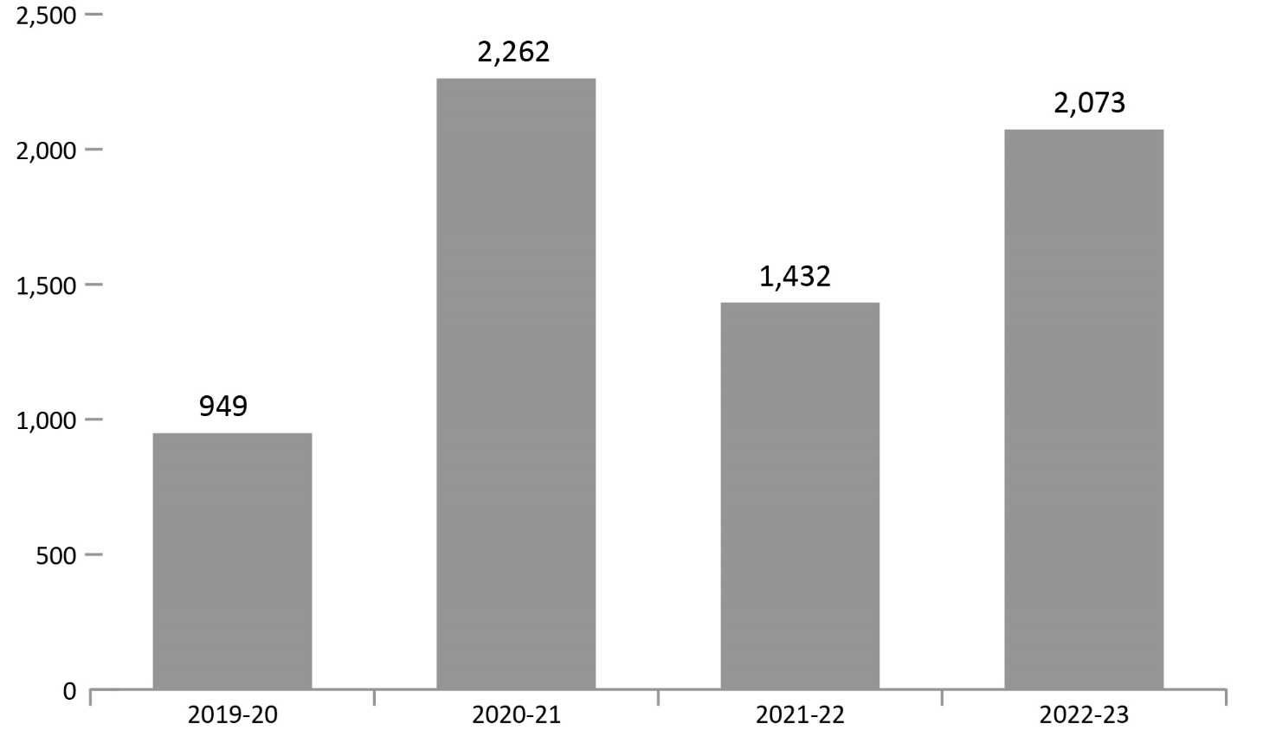
Source: Correctional Service of Canada.
- The number of authorizations for transfer to Structured Intervention Units in federal institutions has fluctuated over the past 4 fiscal years. In fiscal year 2022-23, there were 2,073 authorizations for transfer to a Structured Intervention Unit, which is a 44.8% increase (from 1,432 to 2,073) compared to the previous fiscal year.
Notes
The result represents authorizations for transfer to a Structured Intervention Unit (SIU) where the start date was between the implementation on November 30, 2019 and March 31, 2023.
Reported year periods reflect fiscal years. A fiscal year runs from April 1 to March 31 of the following year.

Table C22. Number of authorizations for transfer to Structured Intervention Units in federal institutions
Fiscal year | Total
2019-20 | 949
2020-21 | 2,262
2021-22 | 1,432
2022-23 | 2,073
Source: Correctional Service of Canada.
Notes
The result represents authorizations for transfer to a Structured Intervention Unit (SIU) where the start date was between the implementation on November 30, 2019 and March 31, 2023.
Reported year periods reflect fiscal years. A fiscal year runs from April 1 to March 31 of the following year.

Percentage of successful transfers out of Structured Intervention Units in federal institutions

Figure C23. Percentage of successful transfers out of Structured Intervention Units
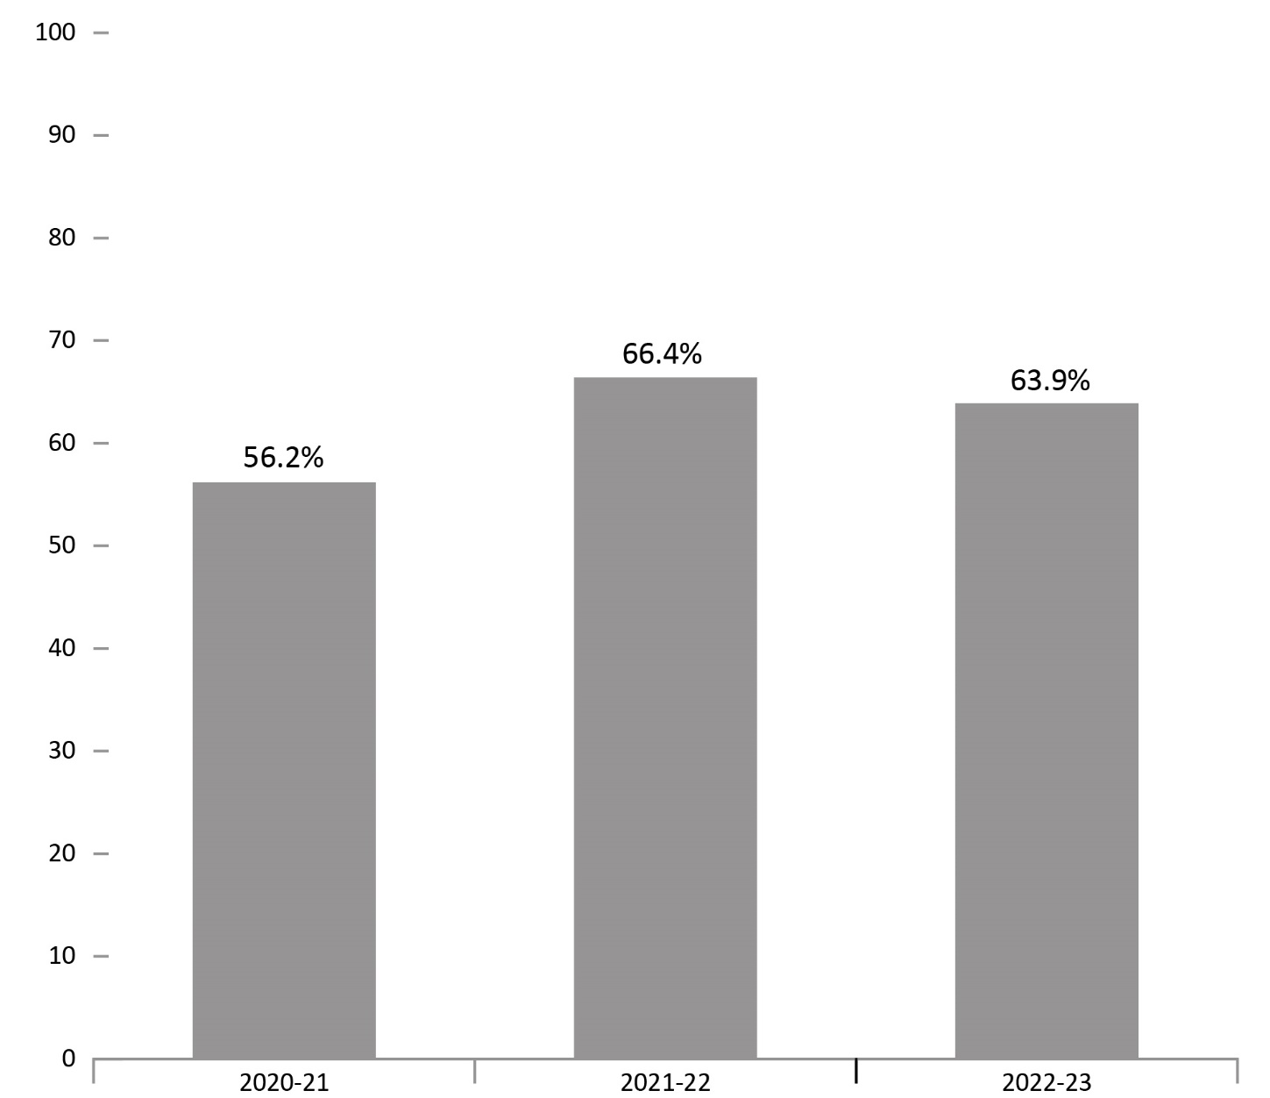
Source: Correctional Service of Canada.
- Of the 1,703 transfers out of a Structured Intervention Unit in 2022-23, 63.9% were successful.
Notes
A transfer out of Structured Intervention Units is successful if the inmate remains in mainstream population for a period of 120 days.
Reported year periods reflect a fiscal year. A fiscal year runs from April 1 to March 31 of the following year.

Table C23. Percentage of successful transfers out of Structured Intervention Units
Fiscal year | Successful transfer count | % | Unsuccessful transfer count | % | Total transfer count | %
2020-21 | 1,286 | 56.2 | 1,004 | 43.8 | 2,290 | 100.0
2021-22 | 1,150 | 66.4 | 582 | 33.6 | 1,732 | 100.0
2022-23 | 1,088 | 63.9 | 615 | 36.1 | 1,703 | 100.0
Source: Correctional Service of Canada.
Notes
A transfer out of Structured Intervention Units is successful if the inmate remains in mainstream population for a period of 120 days.
Reported year periods reflect a fiscal year. A fiscal year runs from April 1 to March 31 of the following year.

Structured Intervention Units: Time Outside of Cell

Figure C24a. Number of days offenders housed in SIUs were offered time out of their cell
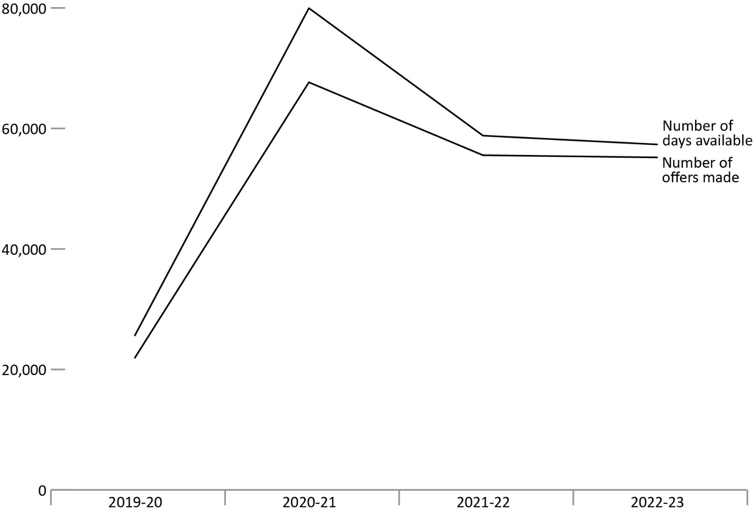
Source: Correctional Service of Canada.

Figure C24b. Percentage of offers accepted for offenders housed in SIUs for time out of their cell
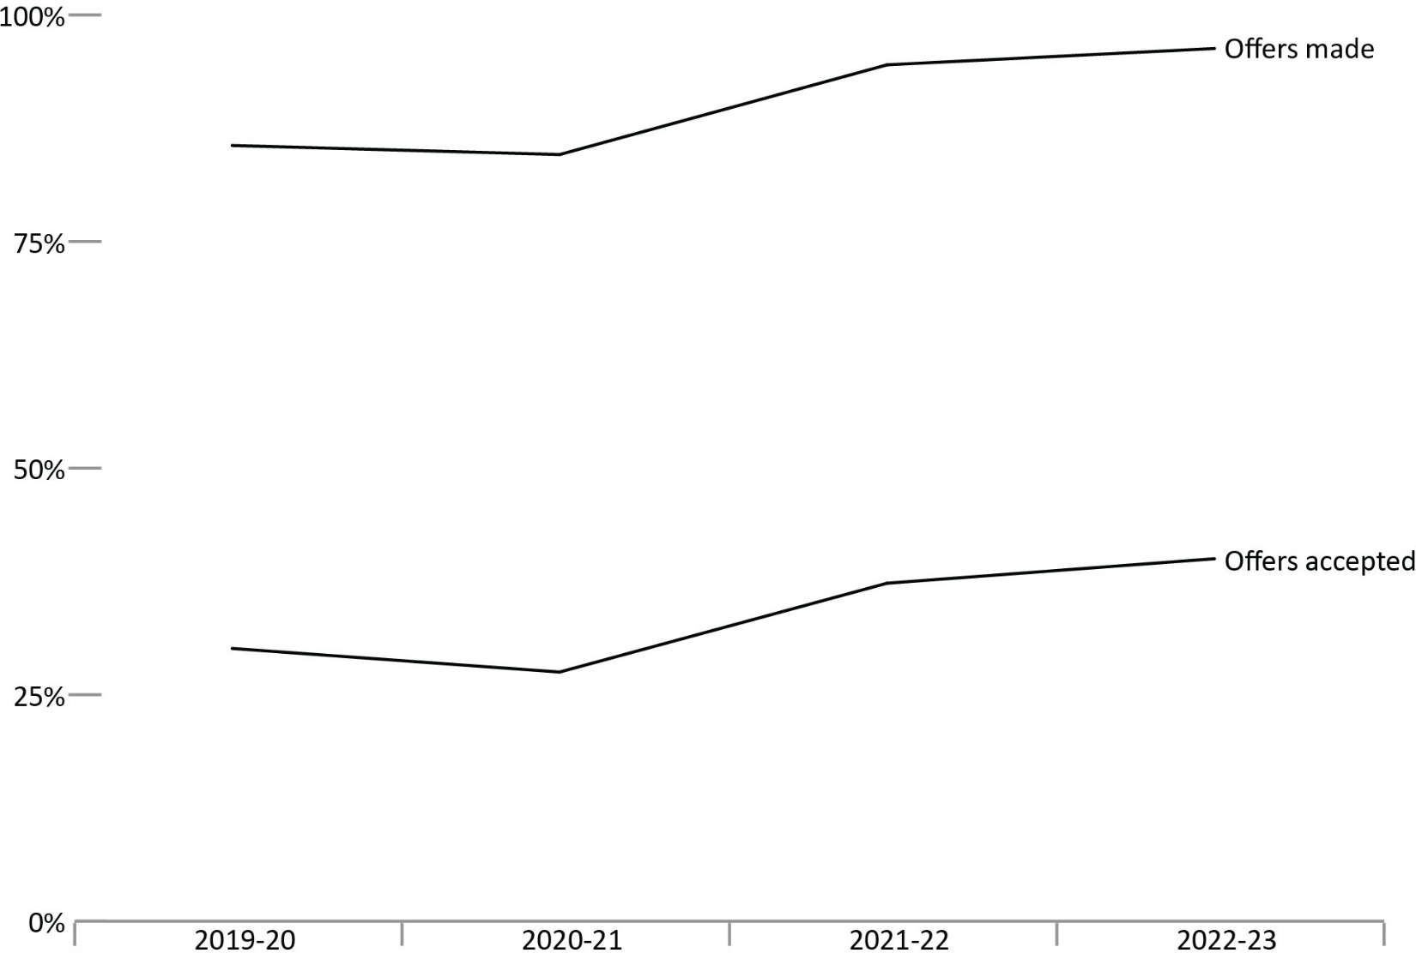
Source: Correctional Service of Canada.
- In 2022-23, the offenders were offered time out of their cell 96% of days where they were available in SIU; 40% of those offers were accepted.
Notes
The results represent the total number of days offenders housed in Structured Intervention Units were out of their cell per the total number of days offenders were available to be out of their cell (based on four hours out of cell per day).
The data is constrained to days where offenders were present in the Structured Intervention Unit for a minimum of four hours, with offers and accepted offers limited to those that occurred between 7am and 10pm.
A fiscal year runs from April 1 to March 31 of the following year.

Table C24. Percentage of days offenders housed in SIUs were offered time out of their cell
Fiscal Year | Days Available | Offers Made | % | Offers Accepted | %
2019-20 | 25,620 | 21,920 | 85.6 | 6,588 | 30.1
2020-21 | 79,969 | 67,661 | 84.6 | 18,609 | 27.5
2021-22 | 58,806 | 55,555 | 94.5 | 20,736 | 37.3
2022-23 | 57,346 | 55,197 | 96.3 | 22,057 | 40.0
Source: Correctional Service of Canada.
Notes
The results represent the total number of days offenders housed in Structured Intervention Units were out of their cell per the total number of days offenders were available to be out of their cell (based on four hours out of cell per day).
The data is constrained to days where offenders were present in the Structured Intervention Unit for a minimum of four hours, with offers and accepted offers limited to those that occurred between 7am and 10pm.
A fiscal year runs from April 1 to March 31 of the following year.

Structured Intervention Units: Duration of Stay

Figure C25. Median number of days offenders spent in Structured Intervention Units
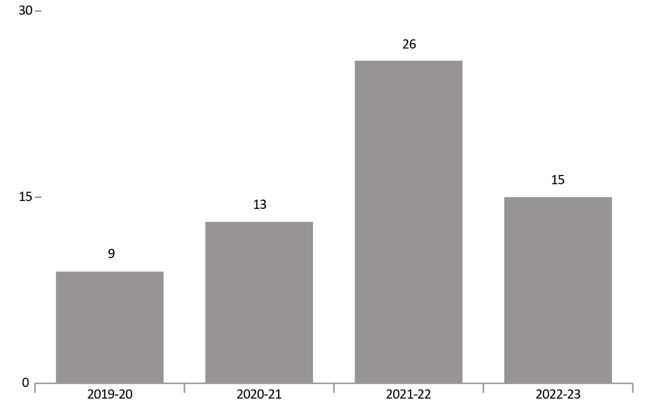
Source: Correctional Service of Canada.
- In 2022-23, the median number of days an offender spent in a Structured Intervention Unit per transfers was 15 days.
Notes
The result represents the median duration in days of the SIU stays that ended in each fiscal year, between the implementation on November 30, 2019 and March 31, 2023.
A fiscal year runs from April 1 to March 31 of the following year.

Table C25. Median number of days offenders spent in Structured Intervention Units
Fiscal year | Median number of days
2019-20 | 9
2020-21 | 13
2021-22 | 26
2022-23 | 15
Source: Correctional Service of Canada.
Notes
The result represents the median duration in days of the SIU stays that ended in each fiscal year, between the implementation on November 30, 2019 and March 31, 2023.
A fiscal year runs from April 1 to March 31 of the following year.

Characteristics of Offenders in Structured Intervention Unit Cells by Indigenous and non-Indigenous

Figure C26. Characteristics of offenders in SIU cells by Indigenous and non-Indigenous
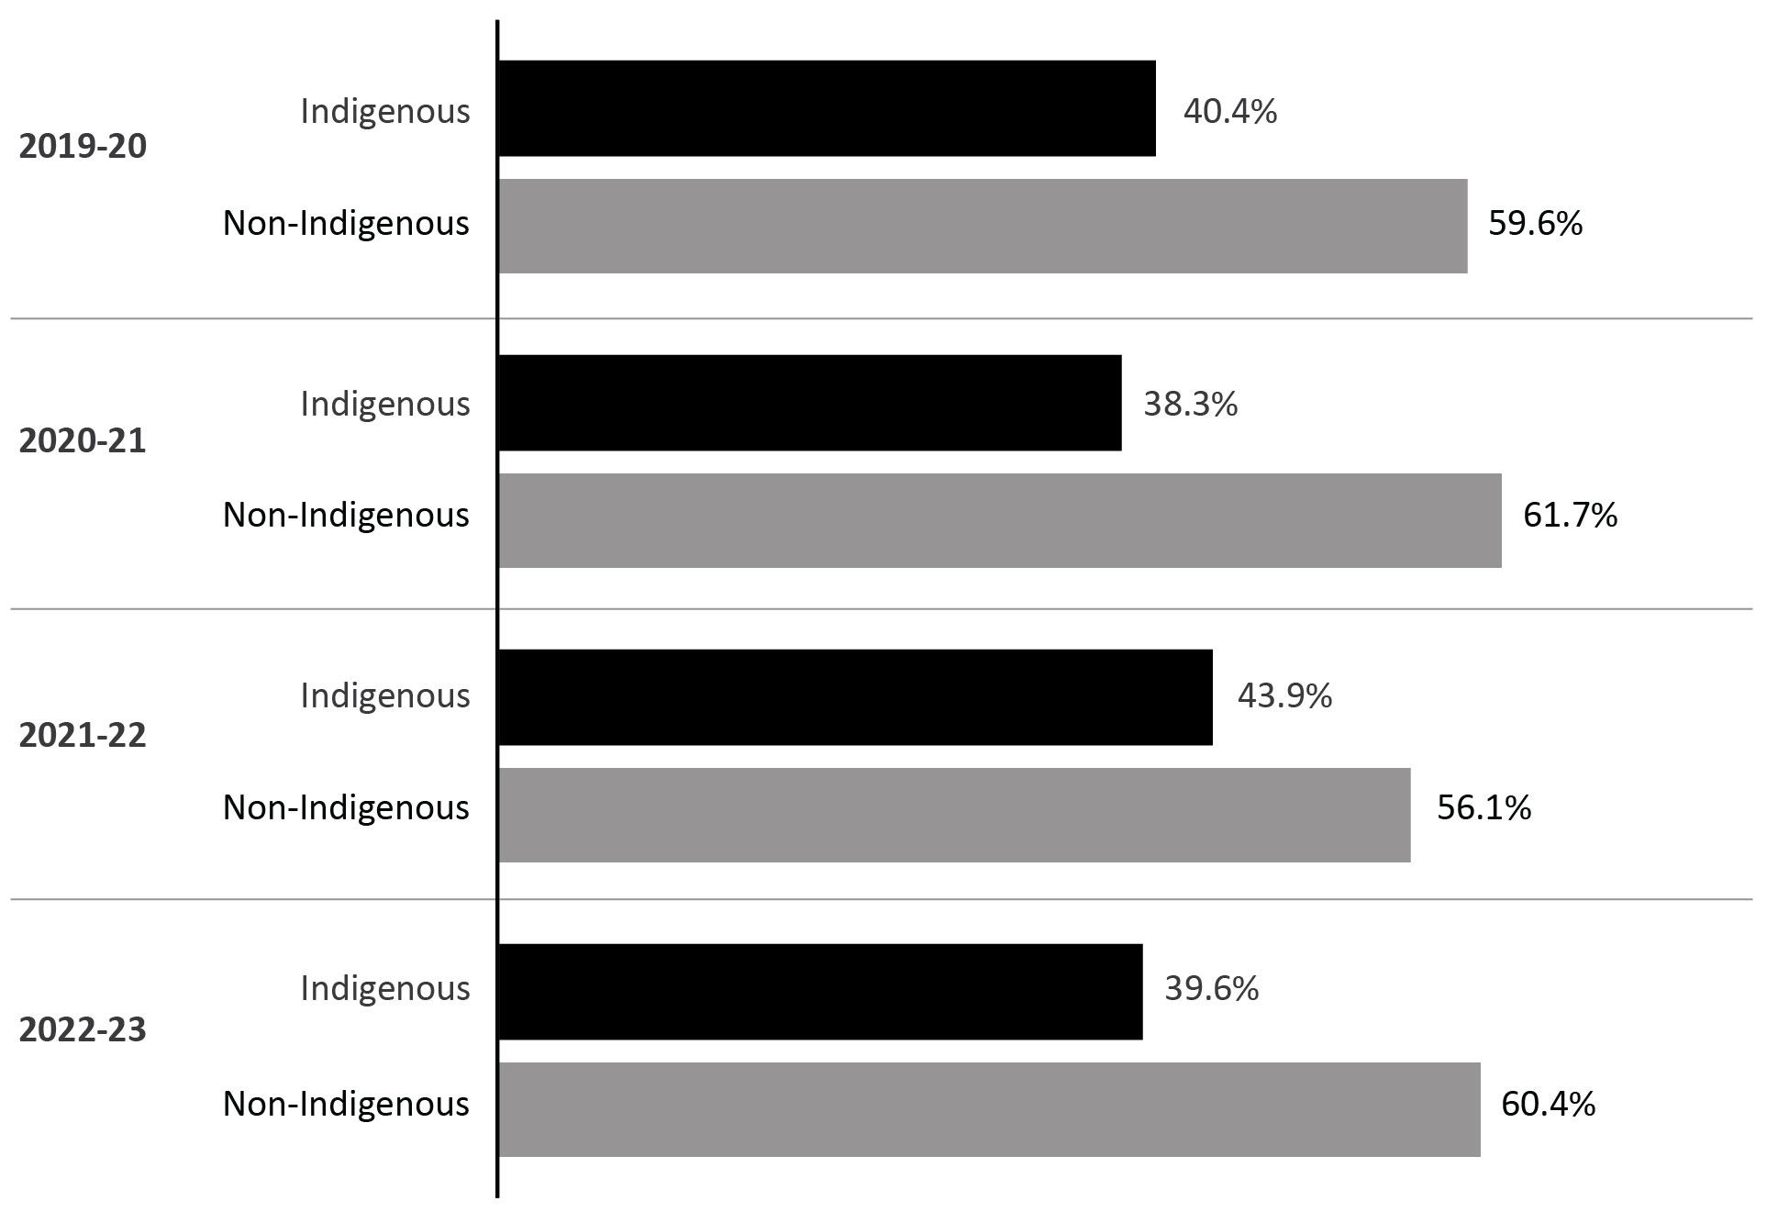
Source: Correctional Service of Canada.
- In 2022-23, 39.6% of the population in SIU were Indigenous. The majority of the population (97.6%) in 2022-23 was male.
Notes
The result represents authorizations for transfer to a Structured Intervention Unit (SIU) where the start date was between the implementation on November 30, 2019 and March 31, 2023.
Note that race is self-identified by offenders.
A fiscal year runs from April 1 to March 31 of the following year.

Table C26a. Characteristics of offenders in SIU cells by sex and Indigenous and non-Indigenous
Fiscal year | Indigenous females | Indigenous males | Indigenous total | Non- Indigenous females | Non- Indigenous males | Non- Indigenous total
2019-20 | 14 | 369 | 383 | 2 | 564 | 566
2020-21 | 58 | 808 | 866 | 18 | 1,378 | 1,396
2021-22 | 31 | 598 | 629 | 11 | 792 | 803
2022-23 | 45 | 776 | 821 | 5 | 1,247 | 1,252
Source: Correctional Service of Canada.

Table C26b. Characteristics of offenders in SIU cells by sex
Fiscal year | Females | Males | Total
2019-20 | 16 | 933 | 949
2020-21 | 76 | 2,186 | 2,262
2021-22 | 42 | 1,390 | 1,432
2022-23 | 50 | 2,023 | 2,073
Source: Correctional Service of Canada.
Notes
The result represents authorizations for transfer to a Structured Intervention Unit (SIU) where the start date was between the implementation on November 30, 2019 and March 31, 2023.
Note that race is self-identified by offenders.
The sex corresponds to the biological sex of the offender entered in the Offender Management System at the date of extraction.
A fiscal year runs from April 1 to March 31 of the following year.

Reasons for Transfer to Structured Intervention Units

Figure C27. Reasons for transfers to SIUs based on all transfers into an SIU
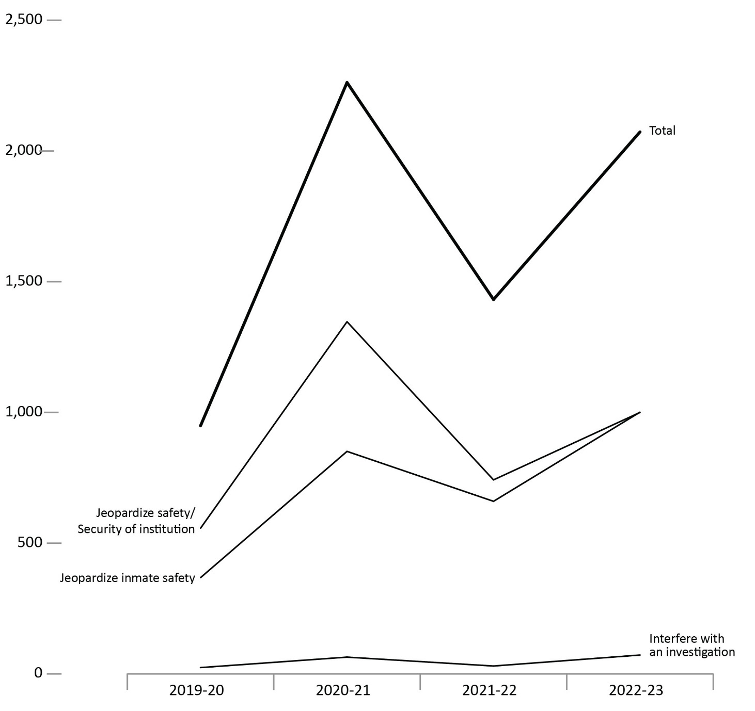
Source: Correctional Service of Canada.
- In 2022-23, from the 2,073 transfers to SIU, 1,001 were completed under the reason of jeopardizing inmate safety (CCRA 34.1B), 1,000 under the reason of jeopardizing the safety/security of institution (CCRA 34.1A) and 72 under the reason of interfering with an investigation (CCRA 34.1C).

Notes
The result represents authorizations for transfer to a Structured Intervention Unit (SIU) where the start date was between the implementation on November 30, 2019 and March 31, 2023. The information is broken down to transfer presented in the Corrections and Conditional Release Act (CCRA).
CCRA 34.1A Jeopardize Safety/Security of Institution: the inmate has acted, has attempted to act or intends to act in a manner that jeopardizes the safety of any person or the security of a penitentiary and allowing the inmate to be in the mainstream inmate population would jeopardize the safety of any person or the security of the penitentiary.
CCRA 34.1B Jeopardize Inmate Safety: allowing the inmate to be in the mainstream inmate population would jeopardize the inmate’s safety.
CCRA 34.1C Interfere with an Investigation: allowing the inmate to be in the mainstream inmate population would interfere with an investigation that could lead to a criminal charge or a charge under subsection 41(2) of a serious disciplinary offence.
A fiscal year runs from April 1 to March 31 of the following year.

Table C27. Reasons for transfers to SIUs based on all transfers into an SIU
Reason of transfers | 2019-20 | 2020-21 | 2021-22 | 2022-23
CCRA 34.1A Jeopardize safety/security of institution | 557 | 1,347 | 742 | 1,000
CCRA 34.1B Jeopardize inmate safety | 368 | 851 | 660 | 1,001
CCRA 34.1C Interfere with an investigation | 24 | 64 | 30 | 72
Total | 949 | 2,262 | 1,432 | 2,073
Source: Correctional Service of Canada.
Notes
The result represents authorizations for transfer to a Structured Intervention Unit (SIU) where the start date was between the implementation on November 30, 2019 and March 31, 2023. The information is broken down to transfer presented in the Corrections and Conditional Release Act (CCRA).
CCRA 34.1A Jeopardize Safety/Security of Institution: the inmate has acted, has attempted to act or intends to act in a manner that jeopardizes the safety of any person or the security of a penitentiary and allowing the inmate to be in the mainstream inmate population would jeopardize the safety of any person or the security of the penitentiary.
CCRA 34.1B Jeopardize Inmate Safety: allowing the inmate to be in the mainstream inmate population would jeopardize the inmate’s safety.
CCRA 34.1C Interfere with an Investigation: allowing the inmate to be in the mainstream inmate population would interfere with an investigation that could lead to a criminal charge or a charge under subsection 41(2) of a serious disciplinary offence.
A fiscal year runs from April 1 to March 31 of the following year.

Number of offender deaths while in custody: 10-year trend

Figure C28a. Number of deaths in federal custody by cause of death
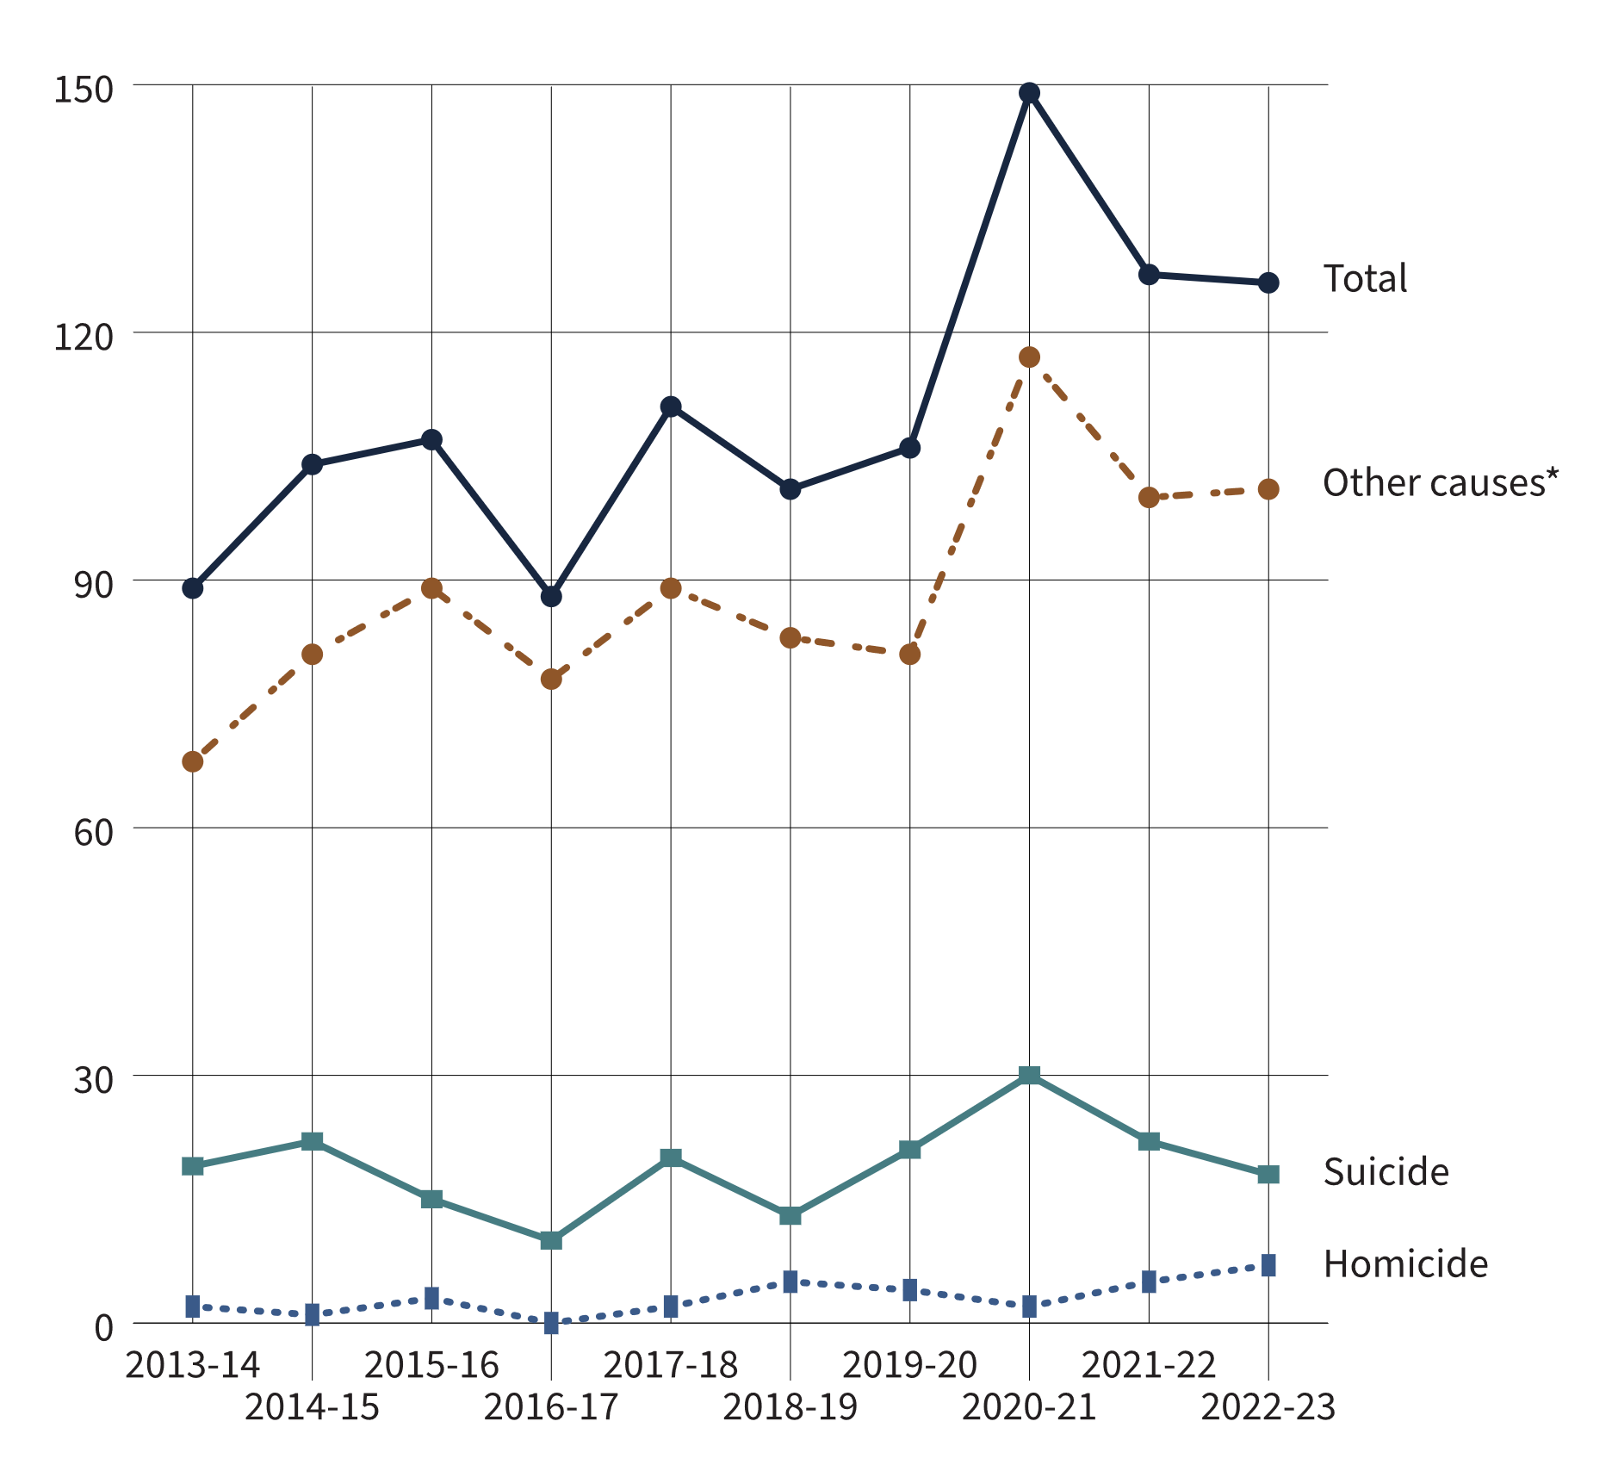
Source: Statistics Canada, Canadian Centre for Justice and Community Safety Statistics, Adult Correctional Services Survey.

Figure C28b. Number of deaths in provincial/territorial custody by cause of death
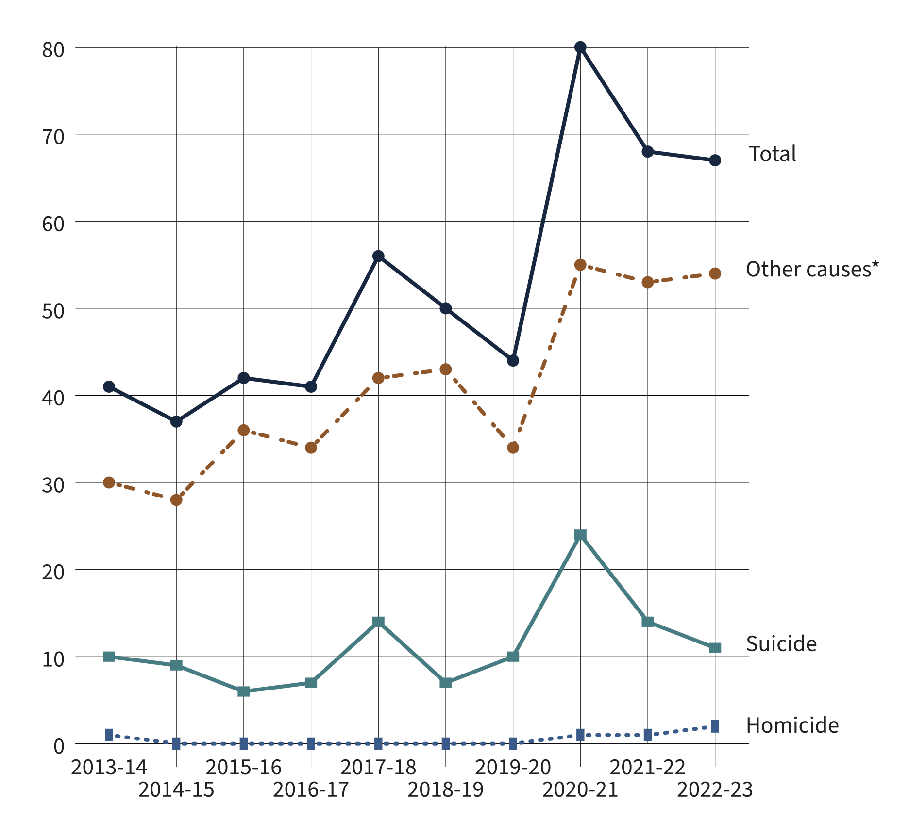
Source: Statistics Canada, Canadian Centre for Justice and Community Safety Statistics, Adult Correctional Services Survey.
- In the 10-year period from 2013-14 to 2022-23, a total of 582 federal offenders and 526 provincial/territorial offenders died while in custody. During this time period, suicides accounted for 13.4% of federal offender deaths and 21.3% of provincial offender deaths. The suicide rate* was approximately 56 per 100,000 for incarcerated federal offenders, and approximately 48 per 100,000 for incarcerated provincial offenders.
- Between 2013-14 and 2022-23, 4.5% of federal offender deaths and 1.0% of provincial offender deaths were due to homicide. The homicide rate for incarcerated federal offenders was approximately 19 per 100,000 and 2 per 100,000 for incarcerated provincial offenders.
Notes
*Other causes of death includes death from natural causes, accidental deaths, death as a result of legal intervention, unknown cause of death, and other.
For the calculation of rates, the total actual in-count numbers between 2013-14 and 2022-23 was used as the denominator.
The data on cause of death are subject to change following an official review or investigation, and should be used/interpreted with caution. The data presented were provided by the Canadian Centre for Justice and Community Safety Statistics at Statistics Canada, and may not reflect the outcome of recent reviews or investigations on cause of death.
The figure includes data from the most recent year available at the time of preparation.
Figure C28 in the 2023 CCRSO corresponds to Figure C24 in the 2022 CCRSO.
Reported year periods reflect a fiscal year. A fiscal year runs from April 1 to March 31 of the following year.

Table C28. Deaths in federal and provincial/territorial custody by cause of death
Fiscal year | Homicide | % | Suicide | % | Other causes* | % | Total
Federal total | 26 | 4.5 | 78 | 13.4 | 478 | 82.1 | 582
2013-14 | 1 | 2.1 | 9 | 18.8 | 38 | 79.2 | 48
2014-15 | 1 | 1.5 | 13 | 19.4 | 53 | 79.1 | 67
2015-16 | 3 | 4.6 | 9 | 13.8 | 53 | 81.5 | 65
2016-17 | 0 | 0.0 | 3 | 6.4 | 44 | 93.6 | 47
2017-18 | 2 | 3.6 | 6 | 10.9 | 47 | 85.5 | 55
2018-19 | 5 | 9.8 | 6 | 11.8 | 40 | 78.4 | 51
2019-20 | 4 | 6.5 | 11 | 17.7 | 47 | 75.8 | 62
2020-21 | 1 | 1.4 | 6 | 8.7 | 62 | 89.9 | 69
2021-22 | 4 | 6.8 | 8 | 13.6 | 47 | 79.7 | 59
2022-23 | 5 | 8.5 | 7 | 11.9 | 47 | 79.7 | 59
Provincial and territorial total | 5 | 1.0 | 112 | 21.3 | 409 | 77.8 | 526
2013-14 | 1 | 2.4 | 10 | 24.4 | 30 | 73.2 | 41
2014-15 | 0 | 0.0 | 9 | 24.3 | 28 | 75.7 | 37
2015-16 | 0 | 0.0 | 6 | 14.3 | 36 | 85.7 | 42
2016-17 | 0 | 0.0 | 7 | 17.1 | 34 | 82.9 | 41
2017-18 | 0 | 0.0 | 14 | 25.0 | 42 | 75.0 | 56
2018-19 | 0 | 0.0 | 7 | 14.0 | 43 | 86.0 | 50
2019-20 | 0 | 0.0 | 10 | 22.7 | 34 | 77.3 | 44
2020-21 | 1 | 1.3 | 24 | 30.0 | 55 | 68.8 | 80
2021-22 | 1 | 1.5 | 14 | 20.6 | 53 | 77.9 | 68
2022-23 | 2 | 3.0 | 11 | 16.4 | 54 | 80.6 | 67
Total federal and provincial/ territorial offender deaths | 31 | 2.8 | 190 | 17.1 | 887 | 80.1 | 1,108
Source: Statistics Canada, Canadian Centre for Justice and Community Safety Statistics, Adult Correctional Services Survey.
Notes
*Other causes of death includes death from natural causes, accidental deaths, death as a result of legal intervention, unknown cause of death, and other.
For the calculation of rates, the total actual in-count numbers between 2013-14 and 2022-23 was used as the denominator.
The data on cause of death are subject to change following an official review or investigation, and should be used/interpreted with caution. The data presented were provided by the Canadian Centre for Justice and Community Safety Statistics at Statistics Canada, and may not reflect the outcome of recent reviews or investigations on cause of death.
The figure includes data from the most recent year available at the time of preparation.
Figure C28 in the 2023 CCRSO corresponds to Figure C24 in the 2022 CCRSO.
Reported year periods reflect a fiscal year. A fiscal year runs from April 1 to March 31 of the following year.

The number of escapees from federal institutions: 10-year trend

Figure C29. Number of escapees from federal institutions
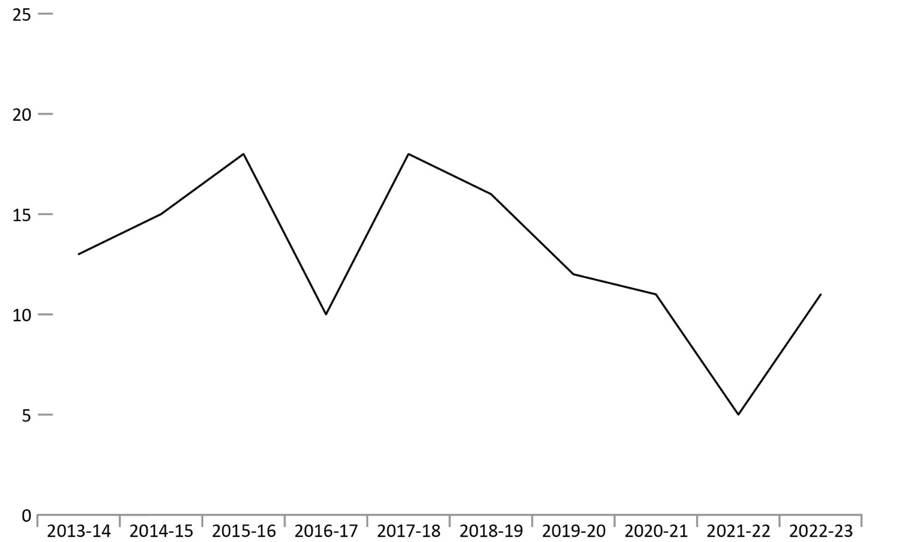
Source: Correctional Service of Canada.
- In 2022-23, there were 10 escape incidents involving a total of 11 offenders. 9 of the 11 offenders were recaptured at the time of the extraction.
- Offenders who escaped from federal institutions or healing lodges in 2022-23 represented less than 0.1% of the in-custody population.
- Over the past 10 fiscal years, the number of escapees from federal institutions decreased 15.4% from 13 in 2013-14 to 11 in 2022-23.
Notes
An escape incident refers to any act or attempted act to breach (break) prison, escape from lawful custody, or without lawful excuse be at large before the expiration of a term of imprisonment to which that person has been sentenced.
The data represent the number of escape incidents from federal facilities or Healing Lodges during each fiscal year. An escape can involve more than one offender.
These numbers are subject to change further to new information becoming available.
Figure C29 in the 2023 CCRSO corresponds to Figure C25 in the 2022 CCRSO.
Reported year periods reflect fiscal years. A fiscal year runs from April 1 to March 31 of the following year.

Table C29. Number of escapees from federal institutions
Fiscal year | Total number of escape incidents | Total number of escapees
2013-14 | 11 | 13
2014-15 | 14 | 15
2015-16 | 16 | 18
2016-17 | 10 | 10
2017-18 | 14 | 18
2018-19 | 16 | 16
2019-20 | 10 | 12
2020-21 | 11 | 11
2021-22 | 5 | 5
2022-23 | 10 | 11
Total number of escape incidents and escapees | 117 | 129
Source: Correctional Service of Canada.
Notes
An escape incident refers to any act or attempted act to breach (break) prison, escape from lawful custody, or without lawful excuse be at large before the expiration of a term of imprisonment to which that person has been sentenced.
The data represent the number of escape incidents from federal facilities or Healing Lodges during each fiscal year. An escape can involve more than 1 offender.
These numbers are subject to change further to new information becoming available.
Table C29 in the 2023 CCRSO corresponds to Table C25 in the 2022 CCRSO.
Reported year periods reflect fiscal years. A fiscal year runs from April 1 to March 31 of the following year.

CSC offenders in community under supervision: 10-year trend

Figure C30. In community under supervision population at fiscal year end
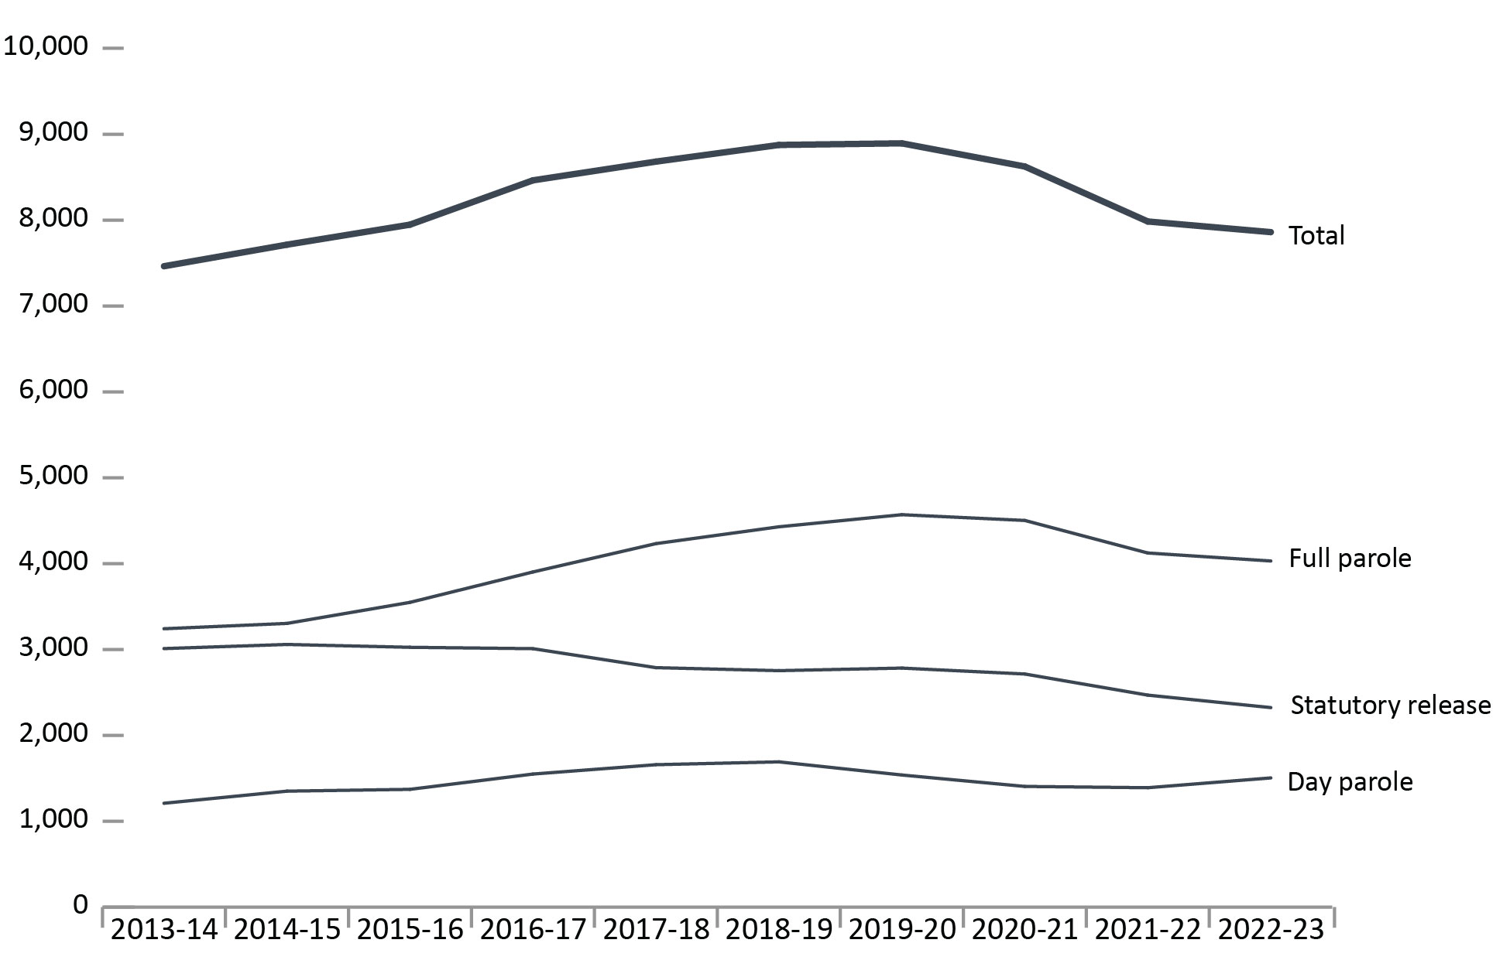
Source: Correctional Service of Canada.
- Over the past 5 years (from 2018-19 to 2022-23), the total offender population supervised in the community decreased by 11.4%. For the same period, the total number of offenders on full parole decreased by 9.0% while the proportion of offenders on statutory release decreased by 15.6%. At the end of fiscal year 2022-23, there were 7,208 males and 652 females on active community supervision.
- Over the past 10 years (from 2013-14 to 2022-23), the total offender population supervised in the community increased by 5.3%. For the same period, the total number of offenders on full parole increased by 24.3% and the proportion of offenders on statutory release decreased by 22.8%.
Notes
The data reflect the offender population in the community under supervision, which includes all active offenders on day parole, full parole, statutory release, offenders who are temporarily detained in a non-CSC facility, offenders who are unlawfully at large for less than 90 days, offenders on remand in a non-CSC facility, and offenders supervised and subject to an immigration hold by Canada Border Services Agency.
The data presented above do not include offenders who were on long-term supervision orders (See Figure/Table E4).
As a result of a data quality issue, supervision information on one offender was not available at the time of the data extraction.
Day parole is a type of conditional release granted by the Parole Board of Canada whereby offenders are permitted to participate in community-based activities in preparation for full parole or statutory release. The conditions require offenders to return nightly to an institution or halfway house unless otherwise authorized by the Parole Board of Canada.
Full parole is a type of conditional release granted by the Parole Board of Canada whereby the remainder of the sentence is served under supervision in the community.
Statutory release refers to a conditional release that is subject to supervision after the offender has served two-thirds of the sentence.
Percent change is measured from the previous year.
Figure C30 in the 2023 CCRSO corresponds to Figure C26 in the 2022 CCRSO.
These cases reflect the number of offenders on active supervision at fiscal year-end. A fiscal year runs from April 1 to March 31 of the following year.

Table C30. In community under supervision population at fiscal year end
Supervision type | 2013-14 | 2014-15 | 2015-16 | 2016-17 | 2017-18 | 2018-19 | 2019-20 | 2020-21 | 2021-22 | 2022-23
Day parole total | 1,210 | 1,351 | 1,372 | 1,550 | 1,659 | 1,692 | 1,539 | 1,406 | 1,391 | 1,505
Females | 106 | 115 | 124 | 158 | 197 | 192 | 163 | 148 | 162 | 181
Males | 1,104 | 1,236 | 1,248 | 1,392 | 1,462 | 1,500 | 1,376 | 1,258 | 1,229 | 1,324
Intersex | NR | NR | NR | NR | NR | NR | 0 | 0 | 0 | 0
Full parole total | 3,242 | 3,304 | 3,549 | 3,903 | 4,233 | 4,429 | 4,571 | 4,503 | 4,124 | 4,031
Females | 225 | 239 | 273 | 316 | 369 | 370 | 406 | 398 | 351 | 329
Males | 3,017 | 3,065 | 3,276 | 3,587 | 3,864 | 4,059 | 4,164 | 4,105 | 3,773 | 3,702
Intersex | NR | NR | NR | NR | NR | NR | 1 | 0 | 0 | 0
Statutory release total | 3,011 | 3,059 | 3,026 | 3,010 | 2,789 | 2,754 | 2,784 | 2,715 | 2,469 | 2,324
Females | 153 | 150 | 177 | 154 | 145 | 159 | 152 | 161 | 122 | 142
Males | 2,858 | 2,909 | 2,849 | 2,856 | 2,644 | 2,595 | 2,632 | 2,554 | 2,347 | 2,182
Intersex | NR | NR | NR | NR | NR | NR | 0 | 0 | 0 | 0
Total | 7,463 | 7,714 | 7,947 | 8,463 | 8,681 | 8,875 | 8,894 | 8,624 | 7,984 | 7,860
Females | 484 | 504 | 574 | 628 | 711 | 721 | 721 | 707 | 635 | 652
Males | 6,979 | 7,210 | 7,373 | 7,835 | 7,970 | 8,154 | 8,172 | 7,917 | 7,349 | 7,208
Intersex | NR | NR | NR | NR | NR | NR | 1 | 0 | 0 | 0
Source: Correctional Service of Canada.
Notes
“Not reported” is abbreviated to “NR” in this table due to formatting.
On November 28, 2019, the new choice “Another sex” was added as a choice in the sex field of the Offender Management System. On September 24, 2022, “Another sex” was changed to “Intersex” to use an appropriate term based on the definition of sex. Per Commissioner's Directive 100, an offender’s current “sex” is determined solely by their current genitalia and must not be changed unless there is a change to the offender’s genitalia following gender-affirming surgery.
The data reflect the offender population in the community under supervision, which includes all active offenders on day parole, full parole, statutory release, offenders who are temporarily detained in a non-CSC facility, offenders who are unlawfully at large for less than 90 days, offenders on remand in a non-CSC facility, and offenders supervised and subject to an immigration hold by Canada Border Services Agency.
The data presented above do not include offenders who were on long-term supervision orders (See Figure/Table E4).
As a result of a data quality issue, supervision information on 1 offender was not available at the time of the data extraction.
Day parole is a type of conditional release granted by the Parole Board of Canada whereby offenders are permitted to participate in community-based activities in preparation for full parole or statutory release. The conditions require offenders to return nightly to an institution or half-way house unless otherwise authorized by the Parole Board of Canada.
Full parole is a type of conditional release granted by the Parole Board of Canada whereby the remainder of the sentence is served under supervision in the community.
Statutory release refers to a conditional release that is subject to supervision after the offender has served two-thirds of the sentence.
Percent change is measured from the previous year.
Table C30 in the 2023 CCRSO corresponds to Figure C26 in the 2022 CCRSO.
These cases reflect the number of offenders on active supervision at fiscal year-end. A fiscal year runs from April 1 to March 31 of the following year.

Offenders under provincial/territorial supervision on probation or conditional sentence: 10-year trend

Figure C31. Average offender counts
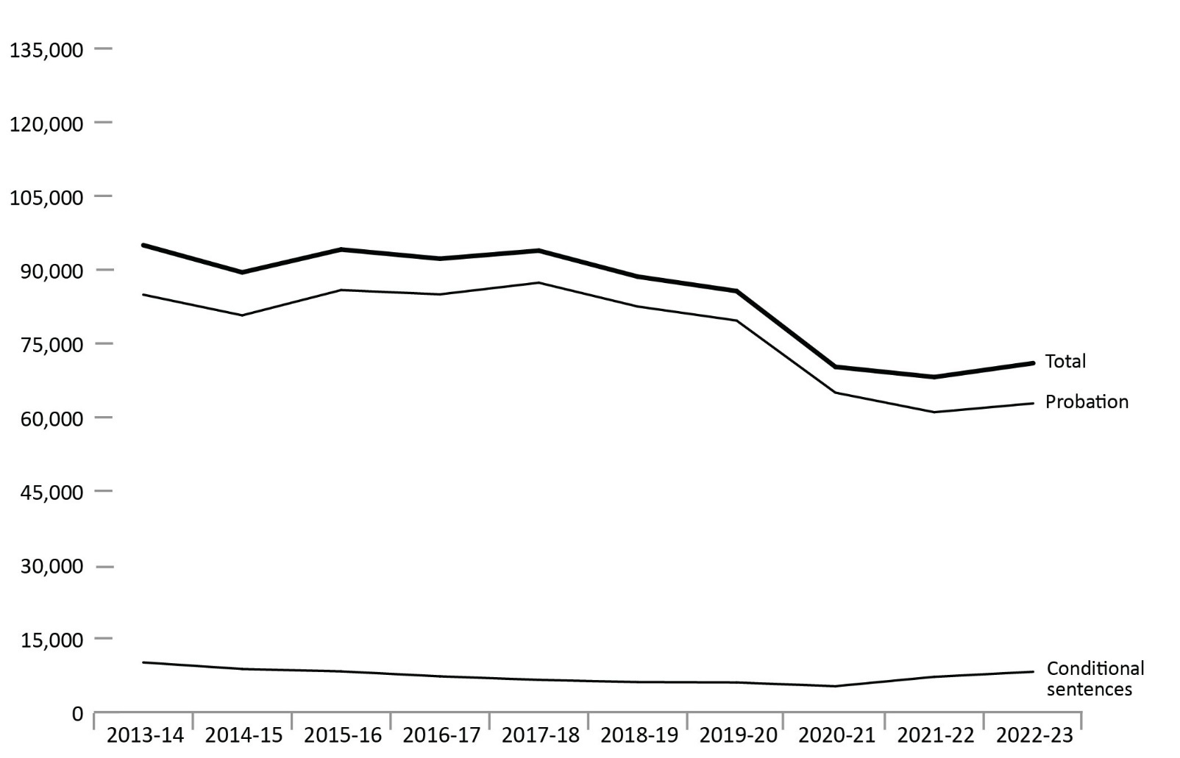
Source: Table 35-10-0154-01, Corrections Key Indicator Report for Adults and Youth, Canadian Centre for Justice and Community Safety Statistics, Statistics Canada.
- Between 2013-14 to 2022-23, there was a 25.3% decrease in the provincial/territorial community corrections population. The 2022-23 rate was 4.1% higher than in 2021-22 and 19.9% lower than the rate in 2018-19.
- The number of offenders on conditional sentence orders decreased 18.8% from 10,077 in 2013-14 to 8,181 in 2022-23. The 2022-23 rate was 14.4% higher than 2021-22 and 34.5% higher than the rate 5 years prior in 2018-19.
- The number of offenders on probation decreased 26.0% from 2013-14 to 2022-23. The 2022-23 rate was 2.9% higher than in 2021-22 and 23.9% lower than the rate in 2018-19.

Notes
Data points reflect the average daily count of adult offenders on probation/conditional sentence over the 12-month fiscal year period.
A conditional sentence is a disposition of the court where the offender serves a term of imprisonment in the community under specified conditions. This type of sentence can only be imposed in cases where the term of imprisonment would be less than 2 years. Conditional sentences have been a provincial and territorial sentencing option since September 1996.
The figure includes data from the most recent year available at the time of preparation.
Figure C31 in the 2023 CCRSO corresponds to Figure C27 in the 2022 CCRSO.
Reported year periods reflect a fiscal year. A fiscal year runs from April 1 to March 31 of the following year.

Table C31. Average offender counts
Fiscal year | Average offender counts on probation | Average offender counts on conditional sentence | Total
2013-14 | 84,905 | 10,077 | 94,981
2014-15 | 80,705 | 8,746 | 89,451
2015-16 | 85,845 | 8,259 | 94,104
2016-17 | 84,978 | 7,249 | 92,228
2017-18 | 87,342 | 6,529 | 93,871
2018-19 | 82,500 | 6,082 | 88,582
2019-20 | 79,652 | 5,996 | 85,648
2020-21 | 64,971 | 5,246 | 70,216
2021-22 | 60,994 | 7,150 | 68,144
2022-23 | 62,790 | 8,181 | 70,971
Source: Table 35-10-0154-01, Corrections Key Indicator Report for Adults and Youth, Canadian Centre for Justice and Community Safety Statistics, Statistics Canada.
Notes
Data points reflect the average daily count of adult offenders on probation/conditional sentence over the 12-month fiscal year period.
A conditional sentence is a disposition of the court where the offender serves a term of imprisonment in the community under specified conditions. This type of sentence can only be imposed in cases where the term of imprisonment would be less than 2 years. Conditional sentences have been a provincial and territorial sentencing option since September 1996.
The figure includes data from the most recent year available at the time of preparation.
Table C31 in the 2023 CCRSO corresponds to Table C27 in the 2022 CCRSO.
Reported year periods reflect a fiscal year. A fiscal year runs from April 1 to March 31 of the following year.

Population of offenders on provincial parole: 10-year trend

Figure C32. Average counts of offenders on provincial day or full parole
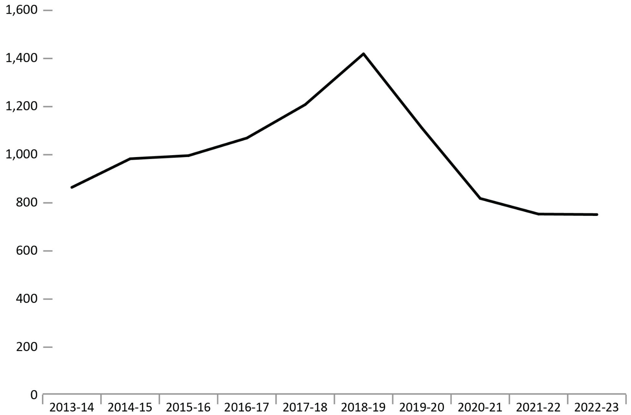
Source: Table 35-10-0154-01, Statistics Canada, Canadian Centre for Justice and Community Safety Statistics, Corrections Key Indicator Report for Adults.
- The number of offenders on provincial parole remained stable from 2021-22 to 2022-23 (742 offenders to 740).
- In the 5 years between 2018-19 to 2022-23, there was a 47.4% decrease in the number of offenders on provincial parole, down from 1,408 in 2018-19 to 740 in 2022-23.
Notes
Provincial parole boards operate in Quebec, Ontario, and Alberta. On April 1, 2007, the Parole Board of Canada assumed responsibility for parole decisions relating to offenders serving sentences in British Columbia's provincial correctional facilities. The Parole Board of Canada has jurisdiction over granting parole to provincial offenders in the Atlantic and Prairie provinces, British Columbia, and to territorial offenders in Yukon, Nunavut, and the Northwest Territories.
The figure includes data from the most recent year available at the time of preparation.
Figure C32 in the 2023 CCRSO corresponds to Figure C28 in the 2022 CCRSO.
Reported year periods reflect a fiscal year. A fiscal year runs from April 1 to March 31 of the following year.

Table C32. Average counts of offenders on provincial day or full parole
Fiscal year | Quebec provincial board | Ontario provincial board | Alberta provincial board | Total provincial boards | Parole Board of Canada* | Total provincial and federal boards |  | % change
2013-14 | 527 | 172 | NR | 699 | 154 |  | 853 |  | 100.0
2014-15 | 612 | 207 | NR | 821 | 151 |  | 972 |  | 12.3
2015-16 | 639 | 207 | NR | 846 | 139 |  | 985 |  | 1.3
2016-17 | 701 | 205 | NR | 907 | 151 |  | 1,058 |  | 6.9
2017-18 | 792 | 242 | NR | 1,034 | 163 |  | 1,197 |  | 11.6
2018-19 | 858 | 398 | NR | 1,256 | 152 |  | 1,408 |  | 15.0
2019-20 | 682 | 289 | NR | 973 | 127 |  | 1,100 |  | -28.1
2020-21 | 490 | 197 | 2 | 690 | 117 |  | 807 |  | -36.3
2021-22 | 489 | 140 | 20 | 649 | 93 |  | 742 |  | -8.8
2022-23 | 475 | 162 | 22 | 658 | 82 |  | 740 |  | -0.2
Source: Table 35-10-0154-01, Statistics Canada, Canadian Centre for Justice and Community Safety Statistics, Corrections Key Indicator Report for Adults.
Notes
* Includes provincial offenders on full parole and day parole.
“Not reported” is abbreviated to “NR” in this table due to formatting.
In 2020, provincial parole boards operated in Quebec and Ontario. The provincial parole board in Alberta was officially introduced on February 1st, 2021. Thus, data related to the latter is only available beginning in 2020-21. On April 1, 2007, the Parole Board of Canada assumed responsibility for parole decisions relating to offenders serving sentences in British Columbia's provincial correctional facilities. The Parole Board of Canada has jurisdiction over granting parole to provincial offenders in the Atlantic and Prairie provinces, British Columbia, and to territorial offenders in Yukon, Nunavut, and the Northwest Territories.
The table includes data from the most recent year available at the time of preparation.
Table C32 in the 2023 CCRSO corresponds to Table C28 in the 2022 CCRSO.
Reported year periods reflect fiscal years. A fiscal year runs from April 1 to March 31 of the following year.

Section D:
Conditional Release



Number of CSC offenders granted temporary absences: 10-year trend

Figure D1. Number of offenders granted temporary absences and work releases
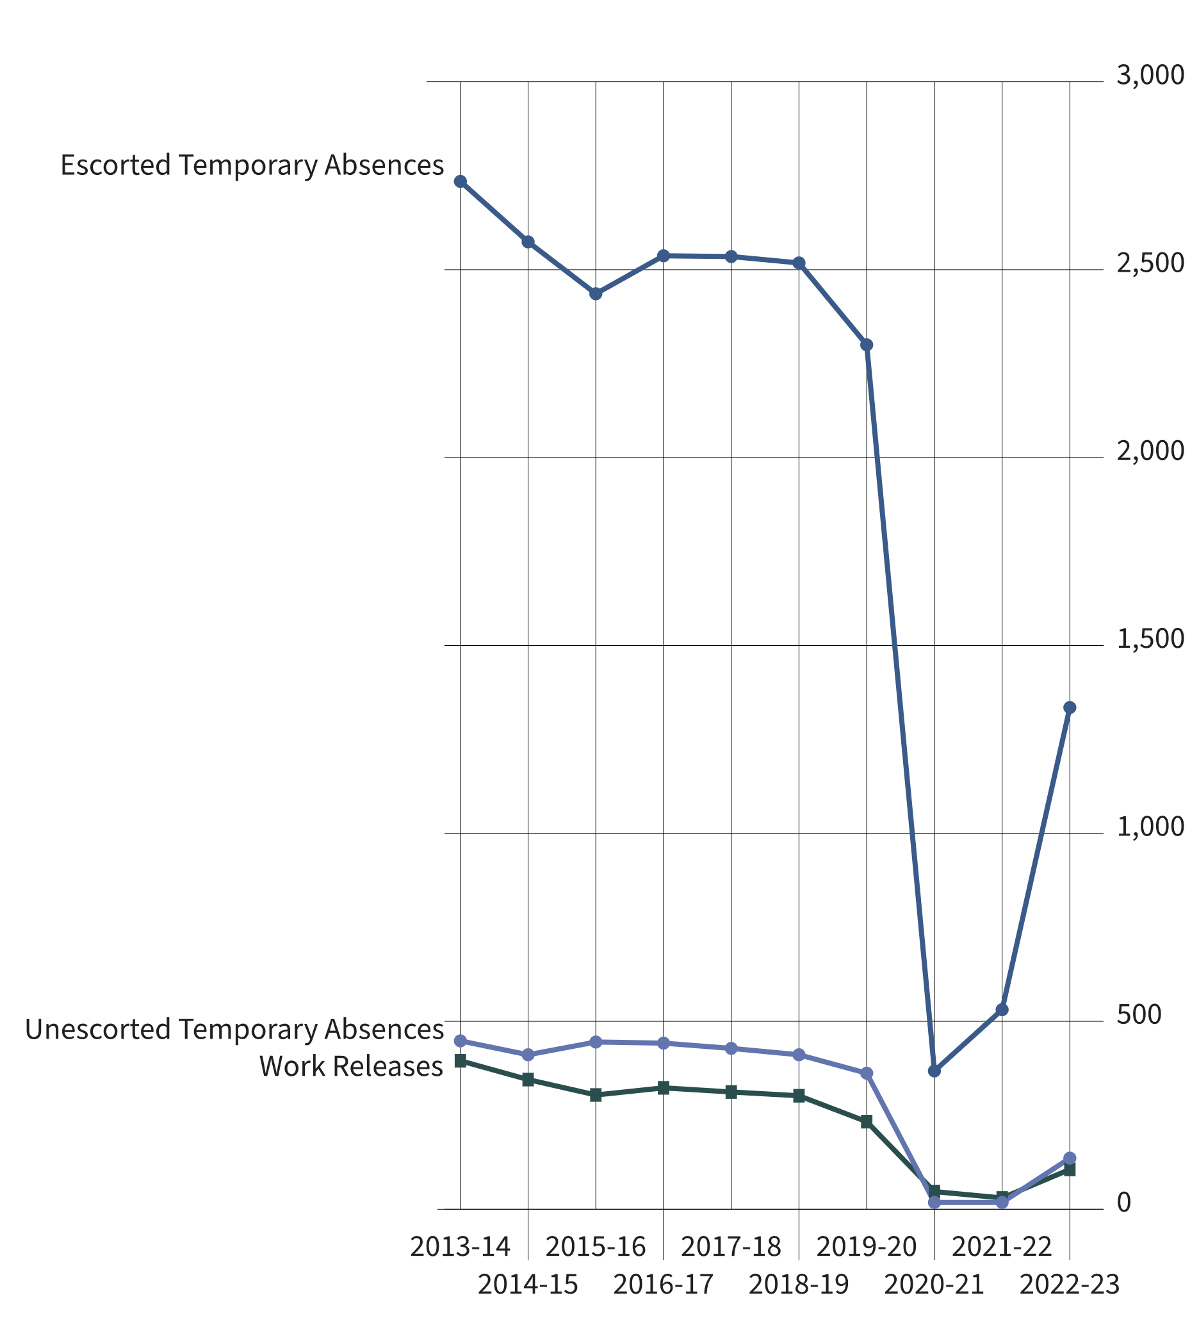
Source: Correctional Service of Canada.
- There was an increase in the number of offenders receiving escorted temporary absences, from 531 in 2021-22 to 1,335 in 2022-23.
- There was an increase in the number of offenders receiving unescorted temporary absences, from 18 in 2021-22 to 136 in 2022-23.
- The number of offenders receiving work releases increased from 30 in 2021-22 to 106 in 2022-23.
- For the past 10 years (from 2013-14 to 2022-23), the average successful completion rates for escorted temporary absences was 99.6%, 98.7% for unescorted temporary absences, and 93.6% for work releases.
Notes
Successful completion includes temporary absences or work releases with a completion status of “on time” or “extension”.
A temporary absence is permission given to an eligible offender to be away from the normal place of confinement for medical, administrative, community service, family contact, personal development for rehabilitative purposes, or compassionate reasons, including parental responsibilities.
A work release is a structured program of release of specified duration for work or community service outside the penitentiary, under the supervision of a staff member or other authorized person or organization.
These numbers depict the number of offenders who received at least one temporary absence permit (excluding those for medical purposes) or at least one work release. An offender may be granted more than one temporary absence permit or work release over a period of time.
Reported year periods reflect fiscal years. A fiscal year runs from April 1 to March 31 of the following year.

Table D1. Number of offenders granted temporary absences and work releases
Fiscal year | Escorted temporary absences (# of offenders) |  | Escorted temporary absences (# of permits) | Unescorted temporary absences (# of offenders) | Unescorted temporary absences (# of permits) | Work releases (# of offenders) | Work releases (# of permits)
2013-14 | 2,735 | 49,481 |  | 448 | 4,005 | 395 | 626
2014-15 | 2,574 | 49,628 |  | 411 | 3,563 | 345 | 489
2015-16 | 2,436 | 47,066 |  | 445 | 4,079 | 304 | 418
2016-17 | 2,537 | 48,567 |  | 442 | 3,782 | 323 | 481
2017-18 | 2,535 | 50,472 |  | 428 | 3,163 | 312 | 443
2018-19 | 2,518 | 55,918 |  | 411 | 2,819 | 302 | 434
2019-20 | 2,300 | 50,991 |  | 362 | 2,891 | 233 | 314
2020-21 | 368 | 2,600 |  | 18 | 59 | 47 | 54
2021-22 | 531 | 3,861 |  | 18 | 44 | 30 | 36
2022-23 | 1,335 | 19,939 |  | 136 | 761 | 106 | 135
Source: Correctional Service of Canada.
Notes
Successful completion includes temporary absences or work releases with a completion status of “on time” or “extension”.
A temporary absence is permission given to an eligible offender to be away from the normal place of confinement for medical, administrative, community service, family contact, personal development for rehabilitative purposes, or compassionate reasons, including parental responsibilities.
A work release is a structured program of release of specified duration for work or community service outside the penitentiary, under the supervision of a staff member or other authorized person or organization.
These numbers depict the number of offenders who received at least one temporary absence permit (excluding those for medical purposes) or at least one work release. An offender may be granted more than one temporary absence permit or work release over a period of time.
Reported year periods reflect fiscal years. A fiscal year runs from April 1 to March 31 of the following year.

Offenders released from federal institutions including Healing Lodges on parole: 10-year trend

Figure D2. Percentage* of offenders released from a federal institution or Healing Lodge
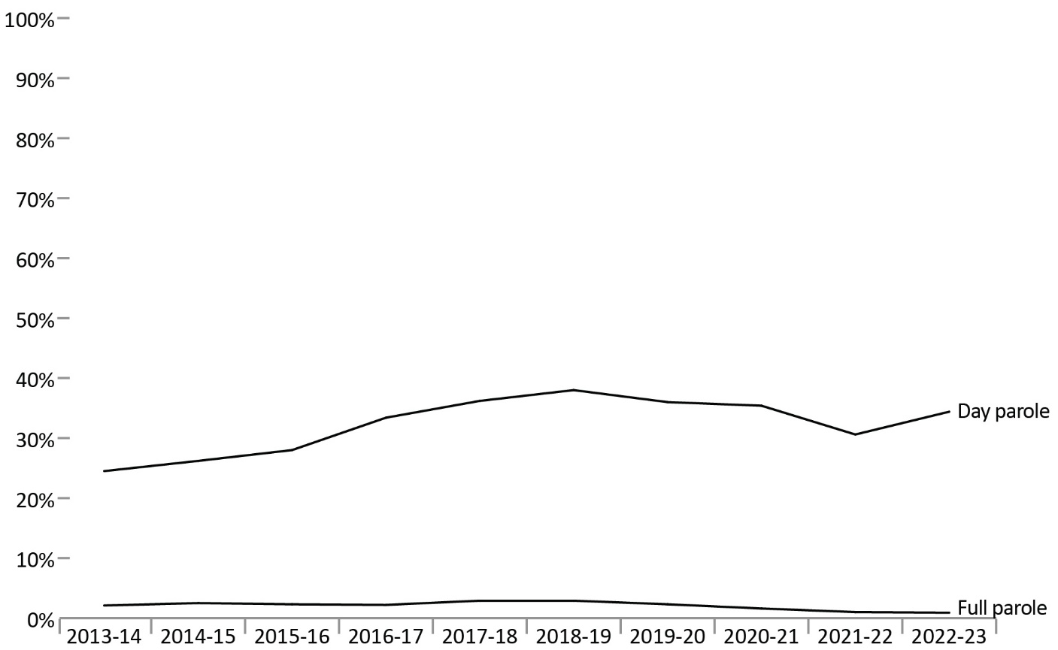
Source: Correctional Service of Canada.
- In fiscal year 2022-23, 34.4% of all releases from federal institutions were on day parole and 0.9% were on full parole.
- In fiscal year 2022-23, 22.8% of releases for Indigenous offenders were on day parole and 0.4% were on full parole, compared to 40.9% and 1.2%, respectively, for non-Indigenous offenders.
- In fiscal year 2022-23, 33.0% of releases from federal institutions for male offenders were on day parole and 1.0% were on full parole, compared to 51.9% and 0.6%, respectively, for female offenders.
- Over the past 10 fiscal years (from 2013-14 to 2022-23), the percentage of releases on day parole increased from 24.5% to 34.4%, and the percentage of releases on full parole decreased from 2.1% to 0.9%.
Notes
All releases include: Conditional releases of day parole, full parole or statutory release.
The data include all releases from a federal institution or Healing Lodge in a given fiscal year excluding offenders with quashed sentences, offenders who died in custody, LTSO releases, offenders released at warrant expiry, and offenders transferred to foreign countries. An offender may be released more than once during the reporting timeframe in cases where a previous release was subject to revocation, suspension, temporary detention, interruption, or in cases where an offender served more than one sentence.
Day parole is a type of conditional release granted by the Parole Board of Canada whereby offenders are permitted to participate in community-based activities in preparation for full parole or statutory release. The conditions require offenders to return nightly to an institution or halfway house unless otherwise authorized by the Parole Board of Canada.
Full parole is a type of conditional release granted by the Parole Board of Canada whereby the remainder of the sentence is served under supervision in the community.
*Percentage is calculated based on the number of day and full paroles compared to the total releases for each offender group.
Reported year periods reflect fiscal years. A fiscal year runs from April 1 to March 31 of the following year.

Table D2a. Indigenous offenders released from a federal institution or Healing Lodge
Fiscal year | Day parole | % | Full parole | % | Total Indigenous releases
2013-14 | 291 | 14.1 | 19 | 0.9 | 2,060
2014-15 | 312 | 14.9 | 10 | 0.5 | 2,089
2015-16 | 348 | 16.9 | 14 | 0.7 | 2,059
2016-17 | 442 | 21.4 | 14 | 0.7 | 2,061
2017-18 | 504 | 24.1 | 26 | 1.2 | 2,088
2018-19 | 556 | 27.3 | 33 | 1.6 | 2,038
2019-20 | 518 | 23.7 | 24 | 1.1 | 2,182
2020-21 | 491 | 23.5 | 16 | 0.8 | 2,090
2021-22 | 437 | 19.7 | 5 | 0.2 | 2,216
2022-23 | 510 | 22.8 | 10 | 0.4 | 2,235
Source: Correctional Service of Canada.

Table D2b. Non-Indigenous offenders released from a federal institution or Healing Lodge
Fiscal year | Day parole | % | Full parole | % | Total non-Indigenous releases
2013-14 | 1,591 | 28.3 | 144 | 2.6 | 5,621
2014-15 | 1,663 | 30.6 | 175 | 3.2 | 5,443
2015-16 | 1,782 | 32.1 | 164 | 3.0 | 5,557
2016-17 | 2,085 | 37.8 | 153 | 2.8 | 5,516
2017-18 | 2,118 | 41.0 | 182 | 3.5 | 5,162
2018-19 | 2,127 | 42.3 | 175 | 3.5 | 5,026
2019-20 | 2,023 | 41.5 | 140 | 2.9 | 4,879
2020-21 | 1,822 | 41.0 | 87 | 2.0 | 4,447
2021-22 | 1,524 | 36.4 | 57 | 1.4 | 4,183
2022-23 | 1,645 | 40.9 | 49 | 1.2 | 4,025
Source: Correctional Service of Canada.

Table D2c. Male offenders released from a federal institution or Healing Lodge
Fiscal year | Day parole | % | Full parole | % | Total male releases
2013-14 | 1,729 | 23.7 | 148 | 2.0 | 7,281
2014-15 | 1,790 | 25.2 | 165 | 2.3 | 7,091
2015-16 | 1,923 | 27.0 | 160 | 2.2 | 7,112
2016-17 | 2,245 | 32.0 | 143 | 2.0 | 7,015
2017-18 | 2,301 | 34.4 | 188 | 2.8 | 6,682
2018-19 | 2,369 | 36.4 | 193 | 3.0 | 6,516
2019-20 | 2,248 | 34.5 | 155 | 2.4 | 6,522
2020-21 | 2,076 | 34.2 | 91 | 1.5 | 6,064
2021-22 | 1,709 | 28.9 | 57 | 1.0 | 5,914
2022-23 | 1,915 | 33.0 | 56 | 1.0 | 5,798
Source: Correctional Service of Canada.

Table D2d. Female offenders released from a federal institution or Healing Lodge
Fiscal year | Day parole | % | Full parole | % | Total female releases
2013-14 | 153 | 38.3 | 15 | 3.8 | 400
2014-15 | 185 | 42.0 | 20 | 4.5 | 441
2015-16 | 207 | 41.1 | 18 | 3.6 | 504
2016-17 | 282 | 50.2 | 24 | 4.3 | 562
2017-18 | 321 | 56.5 | 20 | 3.5 | 568
2018-19 | 314 | 57.3 | 15 | 2.7 | 548
2019-20 | 293 | 54.4 | 9 | 1.7 | 539
2020-21 | 237 | 50.1 | 12 | 2.5 | 473
2021-22 | 252 | 52.0 | 5 | 1.0 | 485
2022-23 | 240 | 51.9 | 3 | 0.6 | 462
Source: Correctional Service of Canada.

Table D2e. Total offenders released from a federal institution or Healing Lodge
Fiscal year | Day parole | % | Full parole | % | Total releases
2013-14 | 1,882 | 24.5 | 163 | 2.1 | 7,681
2014-15 | 1,975 | 26.2 | 185 | 2.5 | 7,532
2015-16 | 2,130 | 28.0 | 178 | 2.3 | 7,616
2016-17 | 2,527 | 33.4 | 167 | 2.2 | 7,577
2017-18 | 2,622 | 36.2 | 208 | 2.9 | 7,250
2018-19 | 2,683 | 38.0 | 208 | 2.9 | 7,064
2019-20 | 2,541 | 36.0 | 164 | 2.3 | 7,061
2020-21 | 2,313 | 35.4 | 103 | 1.6 | 6,537
2021-22 | 1,961 | 30.6 | 62 | 1.0 | 6,399
2022-23 | 2,155 | 34.4 | 59 | 0.9 | 6,260
Source: Correctional Service of Canada.
Notes
All releases include: Conditional releases of day parole, full parole or statutory release.
The data include all releases from a federal institution or Healing Lodge in a given fiscal year excluding offenders with quashed sentences, offenders who died in custody, LTSO releases, offenders released at warrant expiry, and offenders transferred to foreign countries. An offender may be released more than once during the reporting timeframe in cases where a previous release was subject to revocation, suspension, temporary detention, interruption, or in cases where an offender served more than one sentence.
Day parole is a type of conditional release granted by the Parole Board of Canada whereby offenders are permitted to participate in community-based activities in preparation for full parole or statutory release. The conditions require offenders to return nightly to an institution or halfway house unless otherwise authorized by the Parole Board of Canada.
Full parole is a type of conditional release granted by the Parole Board of Canada whereby the remainder of the sentence is served under supervision in the community.
Percentage is calculated based on the number of day and full paroles compared to the total releases for each offender group.
Reported year periods reflect fiscal years. A fiscal year runs from April 1 to March 31 of the following year.

Federal day and full parole grant rates: 10-year trend

Figure D3. Federal parole grant rates*
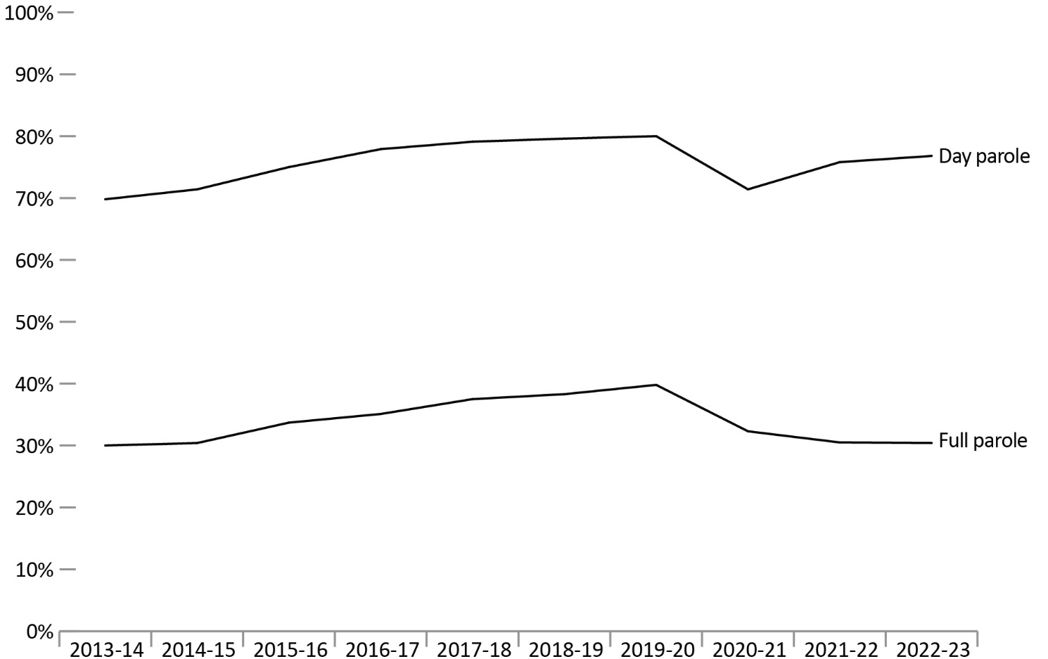
Source: Parole Board of Canada.
- In 2022-23, the federal day parole grant rate* remained stable (76.8%, +1.0%) compared to the previous fiscal year.
- In 2022-23, the federal full parole grant rate* remained stable (30.4%, -0.1%) compared to the previous fiscal year.
- Over the past 10 fiscal years (from 2013-14 to 2022-23), women offenders had a much higher grant rate* of federal day parole and full parole (89.1% and 45.5%) than men offenders (74.5% and 33.1%).
Notes
*The grant rate represents the percentage of pre-release reviews resulting in a grant by the Parole Board of Canada.
Day parole is a type of conditional release granted by the Parole Board of Canada in which offenders are permitted to participate in community-based activities in preparation for full parole or statutory release. The conditions require offenders to return nightly to an institution, half-way house, or other location deemed appropriate for managing their risk, unless otherwise authorized by the Parole Board of Canada. Not all offenders apply for day parole, and some apply more than once before being granted day parole.
Full parole is a type of conditional release granted by the Parole Board of Canada in which the remainder of the sentence is served under supervision in the community. The Parole Board of Canada must review the cases of all offenders for full parole at the time prescribed by legislation, unless the offender advises the Parole Board of Canada in writing that they do not wish to be considered for full parole.
Not included were offenders in the category ‘Another gender’.
On March 28, 2011, Bill C-59 (Abolition of Early Parole Act) eliminated the accelerated parole review (APR) process, affecting first-time non-violent offenders serving sentences for Schedule II and non-Schedule offences, who in 2011-12 were no longer eligible for an APR review. These offenders are now assessed on general reoffending as compared to the APR risk assessment, which considered the risk of committing a violent offence only. To better illustrate historical trends, APR decisions were excluded.
Even though comparisons were made between federal regular day parole and full parole grant rates only, they nevertheless contain an APR residual effect between 2011-12 and 2015-16 as a sufficiently large proportion of the APR-affected population was granted regular federal day parole and full parole, perhaps inflating the grant rates.
Reported year periods reflect fiscal years. A fiscal year runs from April 1 to March 31 of the following year.

Table D3a. Federal day parole grant rates*
Fiscal year | Granted: Women | Denied: Women | Grant rate*: Women (%) | Granted: Men | Denied: Men | Grant rate*: Men (%) | Grant rate*: Total (%) |  | APR** Directed | APR**Total
2013-14 | 248 | 58 | 81.0 | 2,823 | 1,268 | 69.0 | 69.8 |  | 39 | 47
2014-15 | 294 | 56 | 84.0 | 3,025 | 1,276 | 70.3 | 71.4 |  | 38 | 45
2015-16 | 291 | 58 | 83.4 | 3,092 | 1,072 | 74.3 | 75.0 |  | 86 | 90
2016-17 | 402 | 52 | 88.5 | 3,442 | 1,036 | 76.9 | 77.9 |  | 80 | 83
2017-18 | 441 | 34 | 92.8 | 3,608 | 1,035 | 77.7 | 79.1 |  | 100 | 106
2018-19 | 470 | 31 | 93.8 | 3,735 | 1,049 | 78.1 | 79.6 |  | 56 | 58
2019-20 | 434 | 43 | 91.0 | 3,589 | 964 | 78.8 | 80.0 |  | 48 | 48
2020-21 | 353 | 58 | 85.9 | 3,407 | 1,451 | 70.1 | 71.4 |  | 25 | 25
2021-22 | 384 | 27 | 93.4 | 2,919 | 1,026 | 74.0 | 75.8 |  | 20 | 22
2022-23 | 405 | 40 | 91.0 | 3,222 | 1,053 | 75.4 | 76.8 |  | 19 | 20
Source: Parole Board of Canada.

Table D3b. Federal full parole grant rates*
Fiscal year | Granted: Women | Denied: Women | Grant rate*: Women (%) | Granted: Men | Denied: Men | Grant rate*: Men (%) | Grant rate*: Total (%) |  | APR** Directed | APR**Total
2013-14 | 84 | 111 | 43.1 | 903 | 2,194 | 29.2 | 30.0 |  | 126 | 142
2014-15 | 87 | 110 | 44.2 | 969 | 2,302 | 29.6 | 30.4 |  | 119 | 137
2015-16 | 96 | 134 | 41.7 | 1,063 | 2,147 | 33.1 | 33.7 |  | 166 | 185
2016-17 | 137 | 165 | 45.4 | 1,238 | 2,375 | 34.3 | 35.1 |  | 122 | 126
2017-18 | 154 | 179 | 46.2 | 1,362 | 2,353 | 36.7 | 37.5 |  | 161 | 165
2018-19 | 159 | 179 | 47.0 | 1,449 | 2,415 | 37.5 | 38.3 |  | 66 | 67
2019-20 | 183 | 167 | 52.3 | 1,384 | 2,200 | 38.6 | 39.8 |  | 60 | 60
2020-21 | 138 | 154 | 47.3 | 1,283 | 2,828 | 31.2 | 32.3 |  | 37 | 38
2021-22 | 113 | 150 | 43.0 | 960 | 2,297 | 29.5 | 30.5 |  | 23 | 23
2022-23 | 113 | 164 | 40.8 | 1,024 | 2,442 | 29.5 | 30.4 |  | 19 | 19
Source: Parole Board of Canada.
Notes
*The grant rate represents the percentage of pre-release reviews resulting in a grant by the Parole Board of Canada.
**On March 28, 2011, Bill C-59 (Abolition of Early Parole Act) eliminated the accelerated parole review (APR) process, affecting first-time non-violent offenders serving sentences for Schedule II and non-Schedule offences, who in 2011-12 were no longer eligible for an APR review. These offenders are now assessed on general reoffending as compared to the APR risk assessment, which considered the risk of committing a violent offence only. To better illustrate historical trends, APR decisions were excluded.
Day parole is a type of conditional release granted by the Parole Board of Canada in which offenders are permitted to participate in community-based activities in preparation for full parole or statutory release. The conditions require offenders to return nightly to an institution, half-way house, or other location deemed appropriate for managing their risk, unless otherwise authorized by the Parole Board of Canada. Not all offenders apply for day parole, and some apply more than once before being granted day parole.
Full parole is a type of conditional release granted by the Parole Board of Canada in which the remainder of the sentence is served under supervision in the community. The Parole Board of Canada must review the cases of all offenders for full parole at the time prescribed by legislation, unless the offender advises the Parole Board of Canada in writing that they do not wish to be considered for full parole.
Not included were offenders in the category ‘Another gender’.
Even though comparisons were made between federal regular day parole and full parole grant rates only, they nevertheless contain an APR residual effect between 2011-12 and 2015-16 as a sufficiently large proportion of the APR-affected population was granted regular federal day parole and full parole, perhaps inflating the grant rates.
Reported year periods reflect fiscal years. A fiscal year runs from April 1 to March 31 of the following year.

Federal day and full parole grant rates by Indigenous and non-Indigenous offenders: 10-year trend

Figure D4. Federal parole grant rates* by Indigenous and non-Indigenous offenders
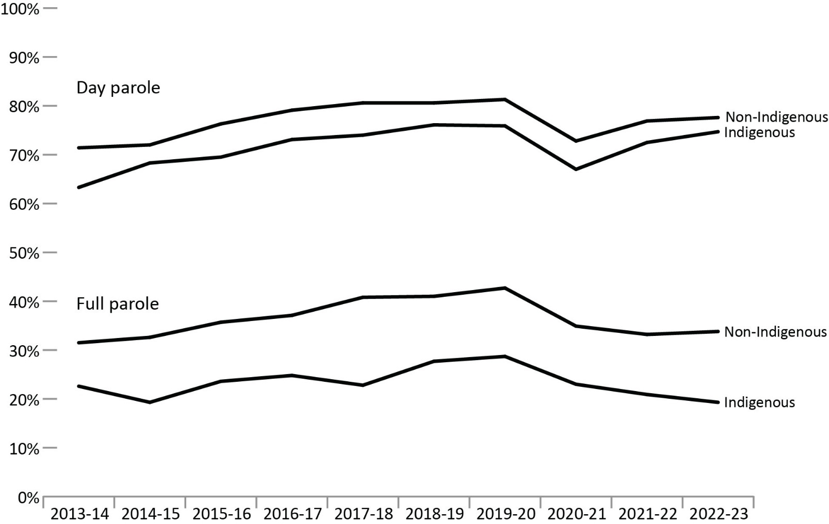
Source: Parole Board of Canada.
- In 2022-23, the federal day parole grant rate increased for Indigenous offenders (74.7%; +2.1%) and remained relatively stable for non-Indigenous offenders (77.6%; +0.8%) compared to 2021-22.
- In 2022-23, the federal full parole grant rate decreased slightly for Indigenous offenders (19.3%; -1.6%) and remained relatively stable for non-Indigenous offenders (33.8%; +0.6%) compared to 2021-22.
- For each of the past 10 fiscal years (from 2013-14 to 2022-23), lower federal day and full parole grant rates were reported for Indigenous offenders than for non-Indigenous offenders.

Notes
*The grant rate represents the percentage of pre-release reviews resulting in a grant by the Parole Board of Canada.
Day parole is a type of conditional release granted by the Parole Board of Canada in which offenders are permitted to participate in community-based activities in preparation for full parole or statutory release. The conditions require offenders to return nightly to an institution, halfway house, or other location deemed appropriate for managing their risk, unless otherwise authorized by the Parole Board of Canada. Not all offenders apply for day parole, and some apply more than once before being granted day parole.
Full parole is a type of conditional release granted by the Parole Board of Canada in which the remainder of the sentence is served under supervision in the community. The Parole Board of Canada must review the cases of all offenders for full parole at the time prescribed by legislation, unless the offender advises the Parole Board of Canada in writing that they do not wish to be considered for full parole.
Even though comparisons were made between federal regular day parole and full parole grant rates only, they nevertheless contain an accelerated parole review (APR) residual effect between 2011-12 and 2015-16 as a sufficiently large proportion of the APR-affected population was granted regular federal day parole and full parole, perhaps inflating the grant rates.
On March 28, 2011, Bill C-59 (Abolition of Early Parole Act) eliminated the accelerated parole review (APR) process, affecting first-time non-violent offenders serving sentences for Schedule II and non-Schedule offences, who in 2011-12 were no longer eligible for an APR review. These offenders are now assessed on general reoffending as compared to the APR risk assessment, which considered the risk of committing a violent offence only. To better illustrate historical trends, APR decisions were excluded.
Reported year periods reflect fiscal years. A fiscal year runs from April 1 to March 31 of the following year.

Table D4a. Federal day parole grant rates* by offender race group
Race group | 2013-14 | 2014-15 | 2015-16 | 2016-17 | 2017-18 | 2018-19 | 2019-20 | 2020-21 | 2021-22 | 2022-23
Indigenous  grant rate (%) | 63.3 | 68.3 | 69.5 | 73.1 | 74.0 | 76.1 | 75.9 | 67.0 | 72.5 | 74.7
Granted (#) | 535 | 577 | 623 | 725 | 833 | 944 | 910 | 875 | 779 | 920
Denied (#) | 310 | 268 | 273 | 267 | 293 | 296 | 289 | 430 | 295 | 312
Asian grant rate (%) | 79.7 | 77.1 | 75.5 | 82.1 | 82.7 | 83.9 | 80.6 | 76.3 | 84.8 | 84.7
Granted (#) | 196 | 199 | 163 | 192 | 187 | 198 | 191 | 193 | 179 | 216
Denied (#) | 50 | 59 | 53 | 42 | 39 | 38 | 46 | 60 | 32 | 39
Black grant rate (%) | 66.1 | 69.4 | 70.0 | 76.0 | 72.4 | 77.8 | 76.0 | 67.4 | 70.9 | 72.4
Granted (#) | 191 | 220 | 238 | 244 | 252 | 287 | 308 | 289 | 256 | 260
Denied (#) | 98 | 97 | 102 | 77 | 96 | 82 | 97 | 140 | 105 | 99
Caucasian grant rate (%) | 71.7 | 72.1 | 76.9 | 79.2 | 81.3 | 80.6 | 81.6 | 73.0 | 77.5 | 77.3
Granted (#) | 2,057 | 2,218 | 2,200 | 2,462 | 2,550 | 2,577 | 2,406 | 2,223 | 1,928 | 1,996
Denied (#) | 810 | 857 | 661 | 648 | 585 | 619 | 541 | 823 | 560 | 585
Other grant rate (%) | 61.6 | 67.3 | 79.6 | 80.1 | 80.2 | 81.0 | 86.1 | 75.8 | 71.9 | 80.3
Granted (#) | 93 | 107 | 160 | 221 | 227 | 200 | 210 | 182 | 161 | 236
Denied (#) | 58 | 52 | 41 | 55 | 56 | 47 | 34 | 58 | 63 | 58
Total day parole  grant rate (%) | 69.8 | 71.4 | 75.0 | 77.9 | 79.1 | 79.5 | 80.0 | 71.3 | 75.8 | 76.8
Total granted (#) | 3,072 | 3,321 | 3,384 | 3,844 | 4,049 | 4,206 | 4,025 | 3,762 | 3,303 | 3,628
Total denied (#) | 1,326 | 1,333 | 1,130 | 1,089 | 1,069 | 1,082 | 1,007 | 1,511 | 1,055 | 1,093
Source: Parole Board of Canada.

Table D4b. Federal full parole grant rates* by offender race group
Race group | 2013-14 | 2014-15 | 2015-16 | 2016-17 | 2017-18 | 2018-19 | 2019-20 | 2020-21 | 2021-22 | 2022-23
Indigenous  grant rate (%) | 22.6 | 19.3 | 23.6 | 24.8 | 22.8 | 27.7 | 28.7 | 23.0 | 20.9 | 19.3
Granted (#) | 126 | 109 | 138 | 157 | 172 | 236 | 231 | 226 | 163 | 171
Denied (#) | 431 | 455 | 446 | 475 | 581 | 617 | 573 | 755 | 618 | 715
Asian grant rate (%) | 37.7 | 40.5 | 44.3 | 46.8 | 48.4 | 49.4 | 47.6 | 44.3 | 39.8 | 46.9
Granted (#) | 78 | 94 | 81 | 104 | 107 | 121 | 108 | 113 | 76 | 99
Denied (#) | 129 | 138 | 102 | 118 | 114 | 124 | 119 | 142 | 115 | 112
Black grant rate (%) | 36.0 | 34.5 | 30.8 | 38.1 | 40.1 | 37.2 | 43.2 | 35.8 | 33.9 | 32.8
Granted (#) | 89 | 89 | 90 | 101 | 124 | 113 | 150 | 147 | 121 | 109
Denied (#) | 158 | 169 | 202 | 164 | 185 | 191 | 197 | 264 | 236 | 223
Caucasian grant rate (%) | 30.3 | 31.8 | 35.3 | 35.8 | 39.5 | 40.3 | 41.7 | 33.1 | 32.2 | 32.7
Granted (#) | 650 | 724 | 784 | 910 | 993 | 1,029 | 971 | 838 | 639 | 674
Denied (#) | 1,492 | 1,555 | 1,438 | 1,632 | 1,523 | 1,524 | 1,359 | 1,692 | 1,344 | 1,385
Other grant rate (%) | 32.1 | 29.4 | 41.5 | 40.4 | 48.2 | 44.0 | 47.3 | 42.5 | 35.1 | 32.8
Granted (#) | 45 | 40 | 66 | 103 | 120 | 109 | 107 | 97 | 74 | 84
Denied (#) | 95 | 96 | 93 | 152 | 129 | 139 | 119 | 131 | 137 | 172
Total full parole  grant rate (%) | 30.0 | 30.4 | 33.7 | 35.1 | 37.5 | 38.3 | 39.8 | 32.3 | 30.5 | 30.4
Total granted (#) | 988 | 1,056 | 1,159 | 1,375 | 1,516 | 1,608 | 1,567 | 1,421 | 1,073 | 1,137
Total denied (#) | 2,305 | 2,413 | 2,281 | 2,541 | 2,532 | 2,595 | 2,367 | 2,984 | 2,450 | 2,607
Source: Parole Board of Canada.

Table D4c. Accelerated parole review (APR)**
Parole type | 2013-14 | 2014-15 | 2015-16 | 2016-17 | 2017-18 | 2018-19 | 2019-20 | 2020-21 | 2021-22 | 2022-23
Day parole: Directed (#) | 39 | 38 | 86 | 80 | 100 | 56 | 48 | 25 | 20 | 19
Day parole:  Total (#) | 47 | 45 | 90 | 83 | 106 | 58 | 48 | 25 | 22 | 20
Full parole: Directed (#) | 126 | 119 | 166 | 122 | 161 | 66 | 60 | 37 | 23 | 19
Full parole:  Total (#) | 142 | 137 | 185 | 126 | 165 | 67 | 60 | 38 | 23 | 19
Source: Parole Board of Canada.
Notes
*The grant rate represents the percentage of pre-release reviews resulting in a grant by the Parole Board of Canada.
**Accelerated Parole Review (APR): A parole review mechanism – eliminated on March 28, 2011, under the Abolition of Early Parole Act (AEPA) – that was available to non-violent offenders serving a first-time sentence in a federal institution. These offenders became eligible for APR after serving the greater of six months or one-sixth of their sentence. The AEPA’s transitional provisions have been a matter of federal and provincial litigation, which has resulted in variations in their application across Canada.
During intake assessment, parole officers ask federal offenders to self-identify their race and this information is entered into the Correctional Service of Canada’s (CSC) Offender Management System. Parole Board of Canada (PBC) uses the term “race grouping” as this is the term used by CSC to collect the information from offenders and also reflects how the data is captured in CSC’s and PBC’s data tables.
Day parole is a type of conditional release granted by the Parole Board of Canada in which offenders are permitted to participate in community-based activities in preparation for full parole or statutory release. The conditions require offenders to return nightly to an institution, halfway house, or other location deemed appropriate for managing their risk, unless otherwise authorized by the Parole Board of Canada. Not all offenders apply for day parole, and some apply more than once before being granted day parole.
Full parole is a type of conditional release granted by the Parole Board of Canada in which the remainder of the sentence is served under supervision in the community. The Parole Board of Canada must review the cases of all offenders for full parole at the time prescribed by legislation, unless the offender advises the Parole Board of Canada in writing that they do not wish to be considered for full parole.
Reported year periods reflect fiscal years. A fiscal year runs from April 1 to March 31 of the following year.

Number of federal Elder-Assisted parole hearings: 10-year trend

Figure D5. Federal Elder-Assisted parole hearings
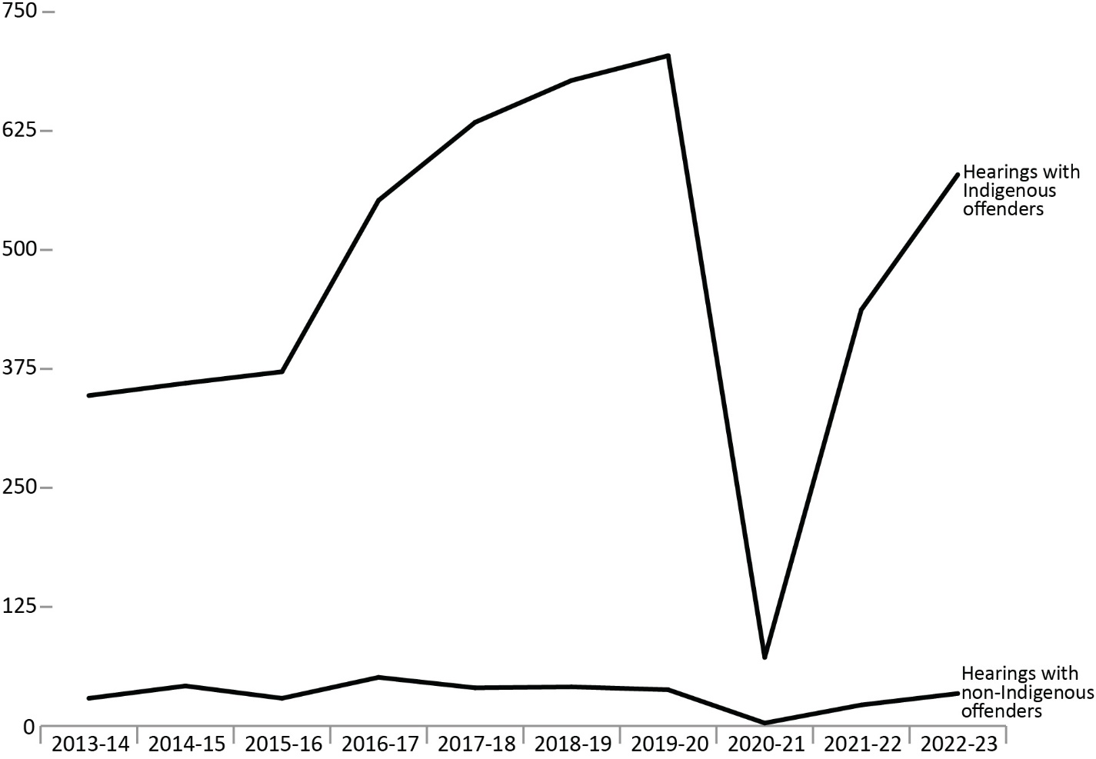
Source: Parole Board of Canada.
- After reporting a decrease of 89.9% in 2020-21 due to health and safety measures put in place to address the COVID-19 pandemic, the number of federal Elder-Assisted parole hearings increased significantly in 2021-22 (to 459 from 75). In 2022-23, the number of Elder-Assisted Hearings increased 33.6% to 613, approaching pre-pandemic levels.
- In 2022-23, 35.5% (579) of all federal parole hearings involving Indigenous offenders were Elder-Assisted Hearings.
- In 2022-23, 0.9% (34) of all federal parole hearings for offenders who did not self-identify as Indigenous were Elder-Assisted Hearings.
Notes
Elder Assisted Hearings are captured under the umbrella term ‘Culturally Responsive Hearings’ following the national expansion of Culturally Responsive Hearings for Black individuals in January 2024. Per section 9.1.1 Board of Canada’s Decision-Making Policy Manual, the objective of Culturally Responsive Hearings is to provide adapted hearing processes for Indigenous and Black offenders that adhere to the decision-making criteria set out in law. Culturally Responsive Hearings for Black Individuals have not been captured in this report as the reporting period precedes the national launch.
Reported year periods reflect fiscal years. A fiscal year runs from April 1 to March 31 of the following year.

Table D5a. Federal Elder-Assisted parole hearings for Indigenous offenders
Fiscal year | Total hearings for Indigenous offenders | With an Elder | % with an Elder
2013-14 | 947 | 347 | 36.6
2014-15 | 896 | 360 | 40.2
2015-16 | 973 | 372 | 38.2
2016-17 | 1,312 | 552 | 42.1
2017-18 | 1,559 | 634 | 40.7
2018-19 | 1,645 | 678 | 41.2
2019-20 | 1,615 | 704 | 43.6
2020-21 | 1,746 | 72 | 4.1
2021-22 | 1,545 | 437 | 28.3
2022-23 | 1,632 | 579 | 35.5
Source: Parole Board of Canada.

Table D5b. Federal Elder-Assisted parole hearings for non-Indigenous offenders
Fiscal year | Total hearings for non-Indigenous offenders | With an Elder | % with an Elder
2013-14 | 3,641 | 29 | 0.8
2014-15 | 3,805 | 42 | 1.1
2015-16 | 3,937 | 29 | 0.7
2016-17 | 4,468 | 51 | 1.1
2017-18 | 4,826 | 40 | 0.8
2018-19 | 4,920 | 41 | 0.8
2019-20 | 4,527 | 38 | 0.8
2020-21 | 4,384 | 3 | 0.1
2021-22 | 3,807 | 22 | 0.6
2022-23 | 3,854 | 34 | 0.9
Source: Parole Board of Canada.

Table D5c. Federal Elder-Assisted parole hearings for all offenders
Fiscal year | Total hearings for all offenders | With an Elder | % with an Elder
2013-14 | 4,588 | 376 | 8.2
2014-15 | 4,701 | 402 | 8.6
2015-16 | 4,910 | 401 | 8.2
2016-17 | 5,780 | 603 | 10.4
2017-18 | 6,385 | 674 | 10.6
2018-19 | 6,565 | 719 | 11.0
2019-20 | 6,142 | 742 | 12.1
2020-21 | 6,130 | 75 | 1.2
2021-22 | 5,352 | 459 | 8.6
2022-23 | 5,486 | 613 | 11.2
Source: Parole Board of Canada.
Notes
Elder Assisted Hearings are captured under the umbrella term ‘Culturally Responsive Hearings’ following the national expansion of Culturally Responsive Hearings for Black individuals in January 2024. Per section 9.1.1 Board of Canada’s Decision-Making Policy Manual, the objective of Culturally Responsive Hearings is to provide adapted hearing processes for Indigenous and Black offenders that adhere to the decision-making criteria set out in law. Culturally Responsive Hearings for Black Individuals have not been captured in this report as the reporting period precedes the national launch.
Reported year periods reflect fiscal years. A fiscal year runs from April 1 to March 31 of the following year.

Proportion of sentence served prior to being released on parole: 10-year trend

Figure D6. Proportion of sentence served in custody before first federal parole
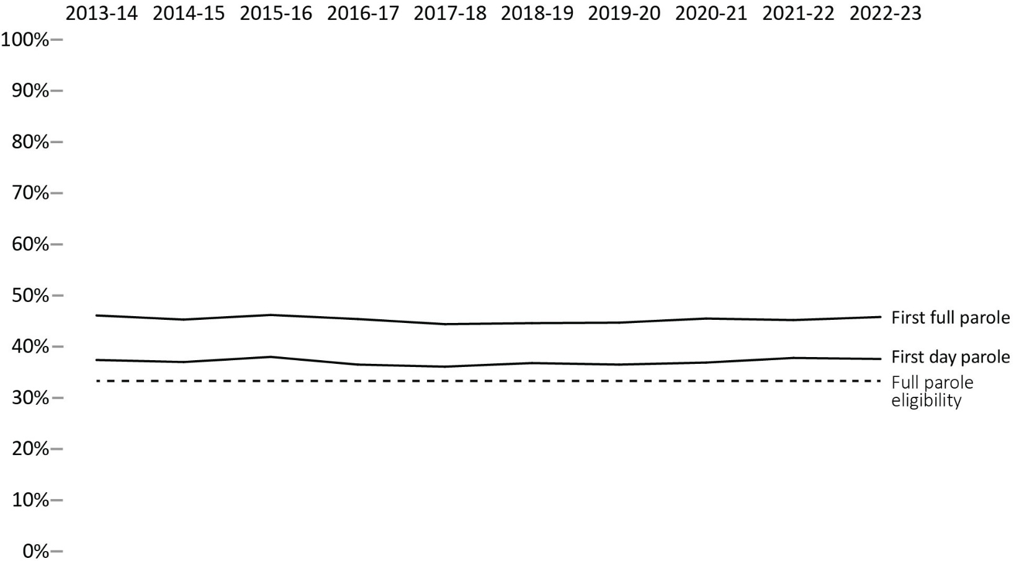
Source: Parole Board of Canada.
- In 2022-23, the average proportion of sentence served before the first federal day parole release for offenders serving determinate sentences remained stable (to 37.6%; -0.2%) from the previous fiscal year.
- The proportion of sentence served prior to the first federal full parole release for offenders serving determinate sentences remained stable (to 45.8%; +0.6%) in 2022-23 when compared to the previous fiscal year.
- In 2022-23, men offenders served a higher proportion of their sentences before being released on their first federal day parole and full parole (37.9%; 46.0%) than women offenders (35.5%; 44.0%).
- In 2022-23, women offenders served an average of 1.1% more of their sentence prior to their first federal day parole release while the average proportion of sentence served by men offenders before their first federal day parole release remained stable (+0.2%) compared to 2013-14.
- In 2022-23, the average proportion of sentence served before the first federal full parole release for both women and men offenders remained stable (+0.3% and -0.3%, respectively) compared to 2013-14.
Notes
Full parole is a type of conditional release granted by the Parole Board of Canada in which the remainder of the sentence is served under supervision in the community. The Parole Board of Canada must review the cases of all offenders for full parole at the time prescribed by legislation, unless the offender advises the Parole Board of Canada in writing that they do not wish to be considered for full parole.
Day parole is a type of conditional release granted by the Parole Board of Canada in which offenders are permitted to participate in community-based activities in preparation for full parole or statutory release. The conditions require offenders to return nightly to an institution, half-way house, or other location deemed appropriate for managing their risk, unless otherwise authorized by the Parole Board of Canada. Not all offenders apply for day parole, and some apply more than once before being granted day parole.
Timing of parole in the sentence refers to the percentage of the sentence served at the time the first day parole or full parole starts during the sentence. In most cases a full parole is preceded by a day parole. These calculations are based on sentences under federal jurisdiction, excluding life sentences and indeterminate sentences. Offenders (other than those serving life or indeterminate sentences or subject to judicial determination) normally become eligible for full parole after serving 1/3 of their sentence or 7 years, whichever is less. Eligibility for day parole is normally at 6 months before full parole eligibility.
Reported year periods reflect fiscal years. A fiscal year runs from April 1 to March 31 of the following year.

Table D6a. Proportion of sentence served in custody before first federal day parole
Fiscal year | Women (%) |  | Men (%) |  | Total (%)
2013-14 |  | 34.4 |  | 37.7 |  | 37.4
2014-15 |  | 34.8 |  | 37.2 |  | 37.0
2015-16 |  | 36.5 |  | 38.1 |  | 38.0
2016-17 |  | 33.1 |  | 37.0 |  | 36.5
2017-18 |  | 32.5 |  | 36.6 |  | 36.1
2018-19 |  | 32.0 |  | 37.4 |  | 36.8
2019-20 |  | 30.4 |  | 37.3 |  | 36.5
2020-21 |  | 33.3 |  | 37.3 |  | 36.9
2021-22 |  | 34.2 |  | 38.4 |  | 37.8
2022-23 |  | 35.5 |  | 37.9 |  | 37.6
Source: Parole Board of Canada.

Table D6b. Proportion of sentence served in custody before first federal full parole
Fiscal year | Women (%) | Men (%) | Total (%)
2013-14 | 43.7 | 46.3 | 46.1
2014-15 | 44.3 | 45.4 | 45.3
2015-16 | 44.9 | 46.3 | 46.2
2016-17 | 43.3 | 45.7 | 45.4
2017-18 | 41.7 | 44.8 | 44.4
2018-19 | 41.5 | 44.9 | 44.6
2019-20 | 41.4 | 45.1 | 44.7
2020-21 | 42.7 | 45.8 | 45.5
2021-22 | 42.3 | 45.6 | 45.2
2022-23 | 44.0 | 46.0 | 45.8
Source: Parole Board of Canada.
Notes
Full parole is a type of conditional release granted by the Parole Board of Canada in which the remainder of the sentence is served under supervision in the community. The Parole Board of Canada must review the cases of all offenders for full parole at the time prescribed by legislation, unless the offender advises the Parole Board of Canada in writing that they do not wish to be considered for full parole.
Day parole is a type of conditional release granted by the Parole Board of Canada in which offenders are permitted to participate in community-based activities in preparation for full parole or statutory release. The conditions require offenders to return nightly to an institution, halfway house, or other location deemed appropriate for managing their risk, unless otherwise authorized by the Parole Board of Canada. Not all offenders apply for day parole, and some apply more than once before being granted day parole.
Timing of parole in the sentence refers to the percentage of the sentence served at the time the first day parole or full parole starts during the sentence. In most cases a full parole is preceded by a day parole. These calculations are based on sentences under federal jurisdiction, excluding life sentences and indeterminate sentences. Offenders (other than those serving life or indeterminate sentences or subject to judicial determination) normally become eligible for full parole after serving 1/3 of their sentence or 7 years, whichever is less. Eligibility for day parole is normally at 6 months before full parole eligibility.
Reported year periods reflect fiscal years. A fiscal year runs from April 1 to March 31 of the following year.

Proportion of sentence served prior to being released on parole by Indigenous and non-Indigenous offenders: 10-year trend

Figure D7a. Proportion of sentence served in custody before first federal day parole
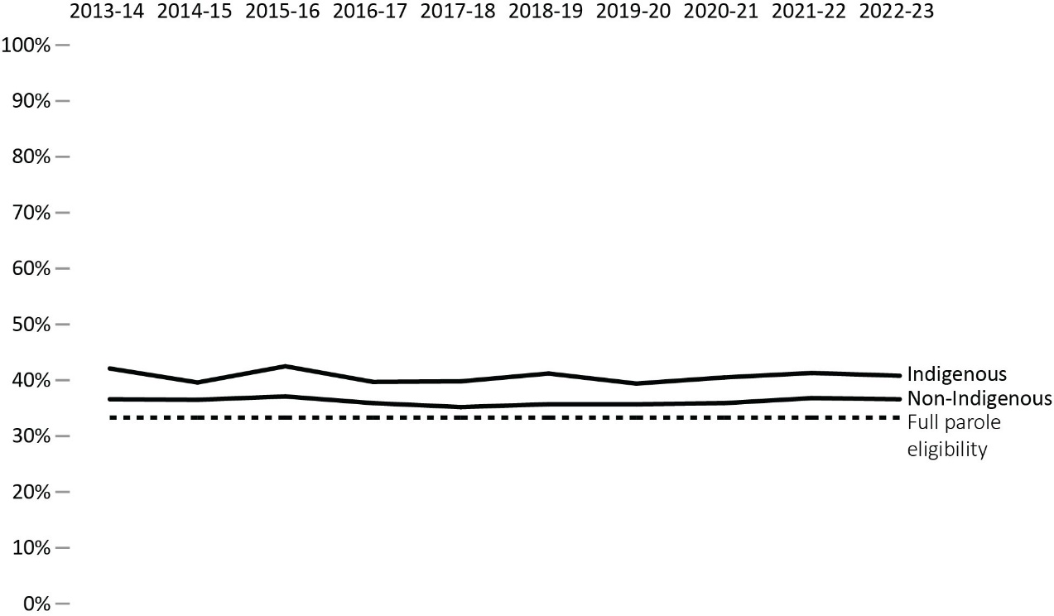

Figure D7b. Proportion of sentence served in custody before first federal full parole
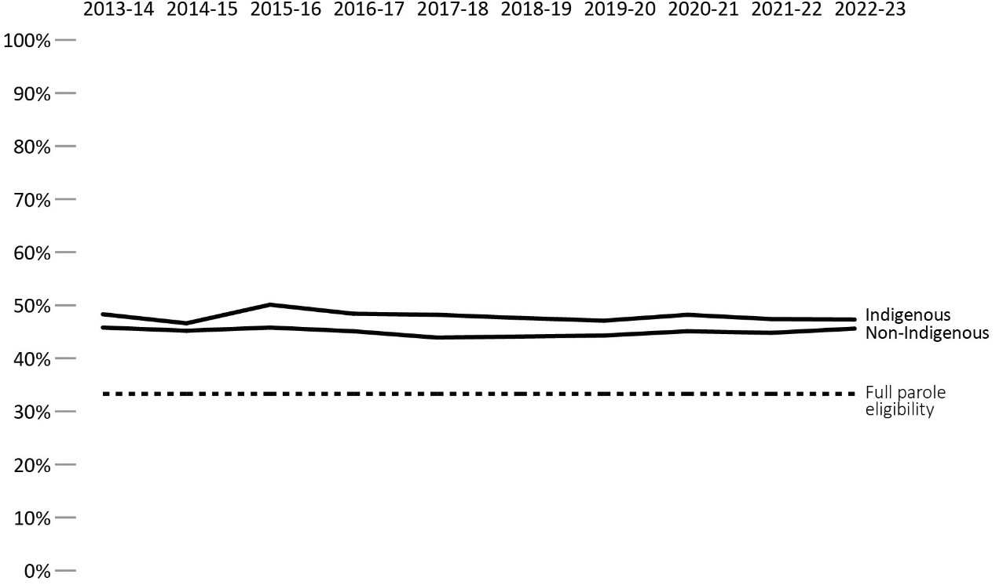
Source: Parole Board of Canada.
- In 2022-23, Indigenous offenders served a higher proportion of their sentences before being released on their first federal day parole (40.8% vs 36.6%) and full parole (47.3% vs 45.6%) than non-Indigenous offenders.
- In 2022-23, the average proportion of sentence served by Indigenous offenders before their first federal day parole release and full parole release decreased 1.2% and 1.0%, respectively, compared to 2013-14.
- In 2022-23, the average proportion of sentence served by non-Indigenous offenders before their first federal day parole release remained identical, and was also relatively stable for full parole (-0.2%) compared to 2013-14.
Notes
Full parole is a type of conditional release granted by the Parole Board of Canada in which the remainder of the sentence is served under supervision in the community. The Parole Board of Canada must review the cases of all offenders for full parole at the time prescribed by legislation, unless the offender advises the Parole Board of Canada in writing that they do not wish to be considered for full parole.
Day parole is a type of conditional release granted by the Parole Board of Canada in which offenders are permitted to participate in community-based activities in preparation for full parole or statutory release. The conditions require offenders to return nightly to an institution, halfway house, or other location deemed appropriate for managing their risk, unless otherwise authorized by the Parole Board of Canada. Not all offenders apply for day parole, and some apply more than once before being granted day parole.
Timing of parole in the sentence refers to the percentage of the sentence served at the time the first day parole or full parole starts during the sentence. In most cases a full parole is preceded by a day parole. These calculations are based on sentences under federal jurisdiction, excluding life sentences and indeterminate sentences. Offenders (other than those serving life or indeterminate sentences or subject to judicial determination) normally become eligible for full parole after serving 1/3 of their sentence or 7 years, whichever is less. Eligibility for day parole is normally at 6 months before full parole eligibility.
Reported year periods reflect fiscal years. A fiscal year runs from April 1 to March 31 of the following year.

Table D7a. Proportion of sentence served in custody before first federal day parole (%)
Race group | 2013-14 | 2014-15 | 2015-16 | 2016-17 | 2017-18 | 2018-19 | 2019-20 | 2020-21 | 2021-22 | 2022-23
Indigenous | 42.1 | 39.6 | 42.5 | 39.7 | 39.9 | 41.2 | 39.4 | 40.5 | 41.3 | 40.8
Asian | 35.0 | 33.1 | 34.0 | 32.5 | 32.2 | 35.0 | 33.8 | 33.6 | 34.8 | 33.8
Black | 39.2 | 40.4 | 38.9 | 39.4 | 36.6 | 38.9 | 34.7 | 36.9 | 38.0 | 38.1
Caucasian | 36.6 | 36.4 | 37.2 | 36.0 | 35.3 | 35.5 | 36.2 | 36.2 | 36.9 | 36.9
Other | 34.3 | 36.7 | 35.6 | 33.5 | 34.5 | 34.2 | 34.4 | 34.4 | 36.9 | 35.7
Total | 37.4 | 37.0 | 38.0 | 36.5 | 36.1 | 36.8 | 36.5 | 36.9 | 37.8 | 37.6
Source: Parole Board of Canada.

Table D7b. Proportion of sentence served in custody before first federal full parole (%)
Race group | 2013-14 | 2014-15 | 2015-16 | 2016-17 | 2017-18 | 2018-19 | 2019-20 | 2020-21 | 2021-22 | 2022-23
Indigenous | 48.3 | 46.6 | 50.1 | 48.4 | 48.3 | 47.6 | 47.1 | 48.2 | 47.4 | 47.3
Asian | 45.4 | 43.6 | 43.7 | 45.2 | 41.3 | 42.6 | 43.2 | 42.5 | 43.1 | 44.9
Black | 45.1 | 44.6 | 47.8 | 45.0 | 43.8 | 43.4 | 45.6 | 45.0 | 44.5 | 46.7
Caucasian | 46.0 | 45.6 | 45.9 | 45.4 | 44.2 | 44.6 | 44.3 | 45.4 | 45.2 | 45.6
Other | 44.6 | 43.5 | 43.7 | 42.2 | 44.4 | 43.0 | 43.8 | 45.9 | 44.3 | 44.6
Total | 46.1 | 45.3 | 46.2 | 45.4 | 44.4 | 44.6 | 44.7 | 45.5 | 45.2 | 45.8
Source: Parole Board of Canada.
Notes
During intake assessment, parole officers ask federal offenders to self-identify their race and this information is entered into the Correctional Service of Canada’s (CSC) Offender Management System. Parole Board of Canada (PBC) uses the term “race grouping” as this is the term used by CSC to collect the information from offenders and also reflects how the data is captured in CSC’s and PBC’s data tables.
Full parole is a type of conditional release granted by the Parole Board of Canada in which the remainder of the sentence is served under supervision in the community. The Parole Board of Canada must review the cases of all offenders for full parole at the time prescribed by legislation, unless the offender advises the Parole Board of Canada in writing that they do not wish to be considered for full parole.
Day parole is a type of conditional release granted by the Parole Board of Canada in which offenders are permitted to participate in community-based activities in preparation for full parole or statutory release. The conditions require offenders to return nightly to an institution, halfway house, or other location deemed appropriate for managing their risk, unless otherwise authorized by the Parole Board of Canada. Not all offenders apply for day parole, and some apply more than once before being granted day parole.
Timing of parole in the sentence refers to the percentage of the sentence served at the time the first day parole or full parole starts during the sentence. In most cases a full parole is preceded by a day parole. These calculations are based on sentences under federal jurisdiction, excluding life sentences and indeterminate sentences. Offenders (other than those serving life or indeterminate sentences or subject to judicial determination) normally become eligible for full parole after serving 1/3 of their sentence or 7 years, whichever is less. Eligibility for day parole is normally at 6 months before full parole eligibility.
Reported year periods reflect fiscal years. A fiscal year runs from April 1 to March 31 of the following year.

Outcome of federal day parole supervision periods

Figure D8. Day parole outcomes – 10-year trend
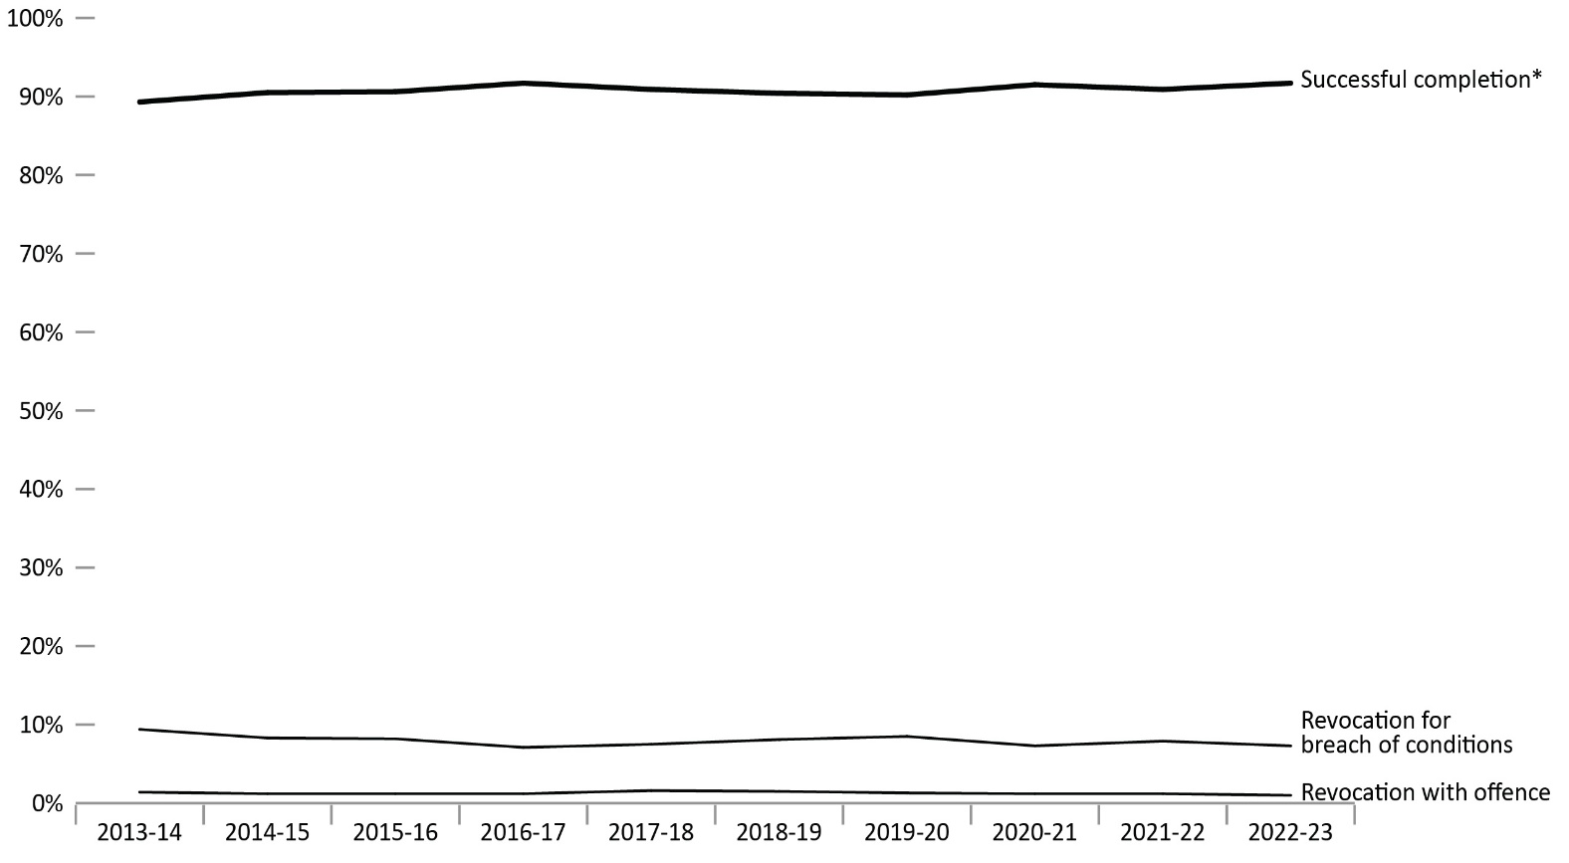
Source: Parole Board of Canada.
- In the past 10 fiscal years (from 2013-14 to 2022-23), the successful completion* rate of federal day parole supervision periods was on average 90.8%. Of the 9.2% of unsuccessful completions, most were for breach of conditions.
- In 2022-23, the successful completion* rate of federal day parole supervision periods remained stable (91.7%; +0.8%) compared to 2021-22.
- During the 5-fiscal-year period between 2018-19 and 2022-23, the successful completion* rate of federal regular day parole supervision periods was on average 6.0% lower than the rate of federal accelerated parole review (APR) day parole supervision periods (90.8% and 96.8%, respectively).
- The rate of violent reoffending of federal day parole supervision periods has been very low in the past 5 fiscal years, averaging 0.2%.
Notes
*Federal parole outcomes reflect the performance of offenders who were on conditional release during the supervision period in question. Supervision periods end in one of the following ways: (1) Successful completion: supervision periods that are completed without a breach of condition or a new offence; (2) revocation for breach of condition: a positive intervention, which reduces the risk of reoffending; (3) revocation with non-violent / violent offence: a negative end to the supervision period, which results in a new conviction.
Accelerated Parole Review (APR): A parole review mechanism – eliminated on March 28, 2011, under the Abolition of Early Parole Act (AEPA) – that was available to non-violent offenders serving a first-time sentence in a federal institution. These offenders became eligible for APR after serving the greater of six months or one-sixth of their sentence. The AEPA’s transitional provisions have been a matter of federal and provincial litigation, which has resulted in variations in their application across Canada.
Violent offences include murder and Schedule I offences (listed in the Corrections and Conditional Release Act) such as assaults, sexual offences, arson, abduction, robbery, and some weapon offences.
Reported year periods reflect fiscal years. A fiscal year runs from April 1 to March 31 of the following year.

Table D8. Day parole outcomes
Federal day parole  outcomes | 2018-19 | % |  | 2019-20 | % |  | 2020-21 | % |  | 2021-22 | % |  | 2022-23 | %
Successful completion* total | 3,704 |  | 90.4 | 3,772 |  | 90.2 | 3,564 |  | 91.5 | 3,025 |  | 90.9 | 3,073 |  | 91.7
Regular | 3,629 |  | 90.3 | 3,715 |  | 90.1 | 3,522 |  | 91.5 | 3,001 |  | 90.8 | 3,057 |  | 91.7
Accelerated | 75 |  | 98.7 | 57 |  | 91.9 | 42 |  | 97.7 | 24 |  | 100.0 | 16 |  | 100.0
Revocation for breach of conditions total | 330 |  | 8.1 | 356 |  | 8.5 | 284 |  | 7.3 | 263 |  | 7.9 | 245 |  | 7.3
Regular | 329 |  | 8.2 | 352 |  | 8.5 | 284 |  | 7.4 | 263 |  | 8.0 | 245 |  | 7.3
Accelerated | 1 |  | 1.3 | 4 |  | 6.5 | 0 |  | 0.0 | 0 |  | 0.0 | 0 |  | 0.0
Revocation with non-violent offence total | 55 |  | 1.3 | 47 |  | 1.1 | 34 |  | 0.9 | 36 |  | 1.1 | 30 |  | 0.9
Regular | 55 |  | 1.4 | 46 |  | 1.1 | 33 |  | 0.9 | 36 |  | 1.1 | 30 |  | 0.9
Accelerated | 0 |  | 0.0 | 1 |  | 1.6 | 1 |  | 2.3 | 0 |  | 0.0 | 0 |  | 0.0
Revocation with violent offence total | 8 |  | 0.2 | 9 |  | 0.2 | 11 |  | 0.3 | 4 |  | 0.1 | 2 |  | 0.1
Regular | 8 |  | 0.2 | 9 |  | 0.2 | 11 |  | 0.3 | 4 |  | 0.1 | 2 |  | 0.1
Accelerated | 0 |  | 0.0 | 0 |  | 0.0 | 0 |  | 0.0 | 0 |  | 0.0 | 0 |  | 0.0
Total regular | 4,021 |  | 98.1 | 4,122 |  | 98.5 | 3,850 |  | 98.9 | 3,304 |  | 99.3 | 3,334 |  | 99.5
Total accelerated | 76 |  | 1.9 | 62 |  | 1.5 | 43 |  | 1.1 | 24 |  | 0.7 | 16 |  | 0.5
Total (regular and accelerated) | 4,097 |  | 100.0 | 4,184 |  | 100.0 | 3,893 |  | 100.0 | 3,328 |  | 100.0 | 3,350 |  | 100.0
Source: Parole Board of Canada.
Notes
*Federal parole outcomes reflect the performance of offenders who were on conditional release during the supervision period in question. Supervision periods end in one of the following ways: (1) Successful completion: supervision periods that are completed without a breach of condition or a new offence; (2) revocation for breach of condition: a positive intervention, which reduces the risk of reoffending; (3) revocation with non-violent / violent offence: a negative end to the supervision period, which results in a new conviction.
Accelerated Parole Review (APR): A parole review mechanism – eliminated on March 28, 2011, under the Abolition of Early Parole Act (AEPA) – that was available to non-violent offenders serving a first-time sentence in a federal institution. These offenders became eligible for APR after serving the greater of 6 months or one-sixth of their sentence. The AEPA’s transitional provisions have been a matter of federal and provincial litigation, which has resulted in variations in their application across Canada.
Violent offences include murder and Schedule I offences (listed in the Corrections and Conditional Release Act) such as assaults, sexual offences, arson, abduction, robbery, and some weapon offences.
Reported year periods reflect fiscal years. A fiscal year runs from April 1 to March 31 of the following year.

Outcome of federal full parole supervision periods
Figure D9. Full parole outcomes* – 10-year trend
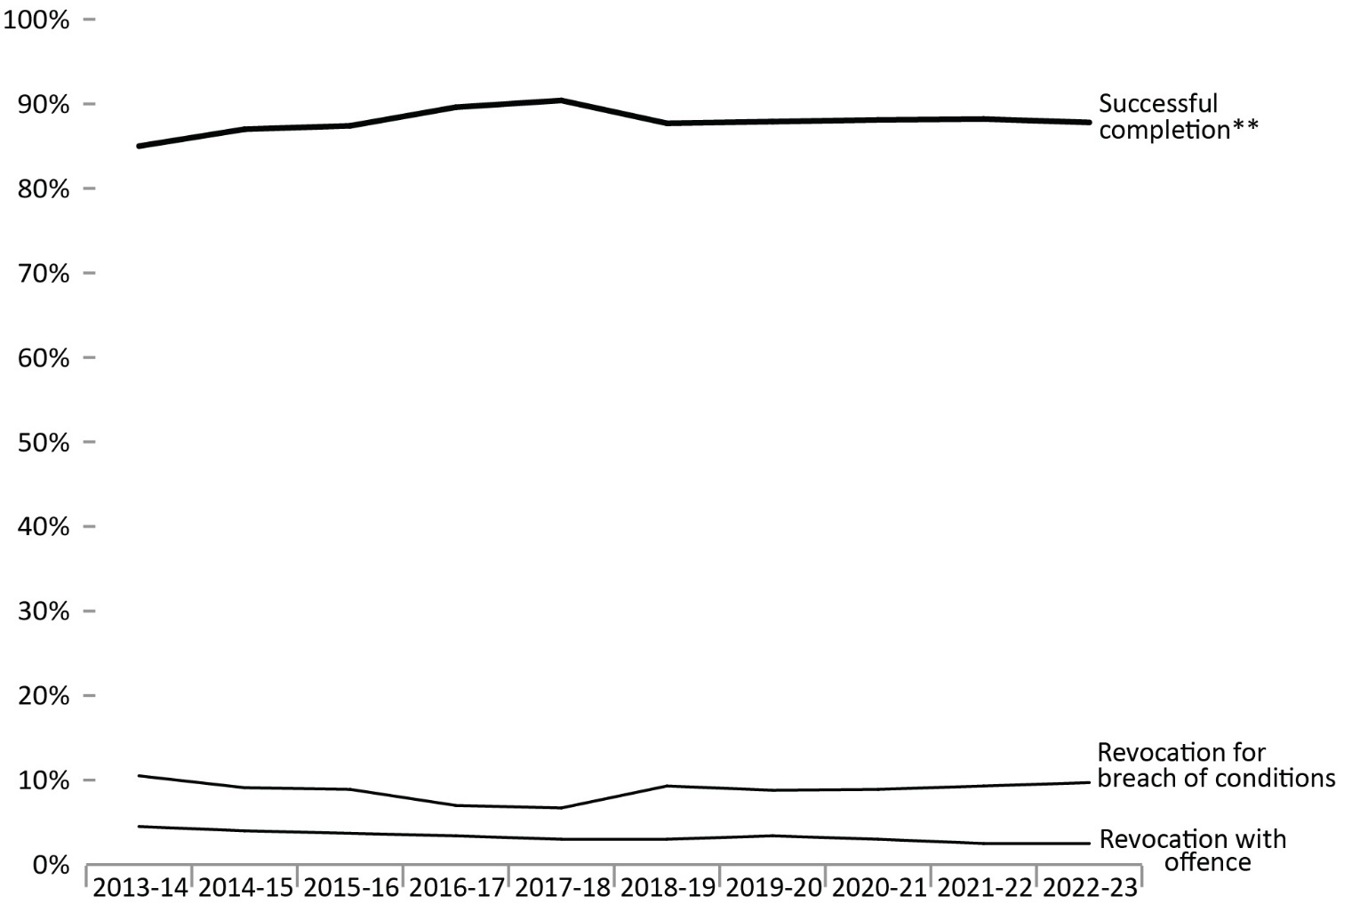
Source: Parole Board of Canada.
- In the past 10 fiscal years (from 2013-14 to 2022-23), the successful completion rate** of federal full parole supervision periods for offenders serving determinate sentences was on average 88.0%.
- During the 5-fiscal year period between 2018-19 and 2022-23, the successful completion rate** of federal regular full parole supervision periods was on average 6.8% lower than the rate of federal accelerated parole review (APR) full parole supervision periods (87.5% and 94.2%, respectively).
- The rate of violent reoffending of federal full parole supervision periods has been low in the past 5 fiscal years, averaging 0.7% (and ranging from 0.5% to 0.8%).
Notes
*Excludes offenders serving indeterminate sentences because they do not have a warrant expiry date and can only successfully complete full parole upon (their) death.
**Federal parole outcomes reflect the performance of offenders who were on conditional release during the supervision period in question. Supervision periods end in one of the following ways: (1) Successful completion: supervision periods that are completed without a breach of condition or a new offence; (2) revocation for breach of condition: a positive intervention, which reduces the risk of reoffending; (3) revocation with non-violent / violent offence: a negative end to the supervision period, which results in a new conviction.
Accelerated Parole Review (APR): A parole review mechanism – eliminated on March 28, 2011, under the Abolition of Early Parole Act (AEPA) – that was available to non-violent offenders serving a first-time sentence in a federal institution. These offenders became eligible for APR after serving the greater of 6 months or one-sixth of their sentence. The AEPA’s transitional provisions have been a matter of federal and provincial litigation, which has resulted in variations in their application across Canada.
Violent offences include murder and Schedule I offences (listed in the Corrections and Conditional Release Act) such as assaults, sexual offences, arson, abduction, robbery, and some weapon offences.
Reported year periods reflect fiscal years. A fiscal year runs from April 1 to March 31 of the following year.

Table D9. Full parole outcomes*
Federal full parole  outcomes | 2018-19 | % |  | 2019-20 | % |  | 2020-21 | % |  | 2021-22 | % |  | 2022-23 | %
Successful completion** total | 1,177 |  | 87.7 | 1,274 |  | 87.9 | 1,273 |  | 88.1 | 1,254 |  | 88.2 | 996 |  | 87.8
Regular | 1,063 |  | 86.9 | 1,170 |  | 87.6 | 1,176 |  | 87.6 | 1,171 |  | 87.8 | 936 |  | 87.4
Accelerated | 114 |  | 95.8 | 104 |  | 91.2 | 97 |  | 94.2 | 83 |  | 95.4 | 60 |  | 95.2
Revocation for breach of conditions total | 125 |  | 9.3 | 127 |  | 8.8 | 128 |  | 8.9 | 132 |  | 9.3 | 110 |  | 9.7
Regular | 121 |  | 9.9 | 120 |  | 9.0 | 123 |  | 9.2 | 128 |  | 9.6 | 108 |  | 10.1
Accelerated | 4 |  | 3.4 | 7 |  | 6.1 | 5 |  | 4.9 | 4 |  | 4.6 | 2 |  | 3.2
Revocation with non-violent offence total | 30 |  | 2.2 | 37 |  | 2.6 | 37 |  | 2.6 | 25 |  | 1.8 | 21 |  | 1.9
Regular | 29 |  | 2.4 | 36 |  | 2.7 | 37 |  | 2.8 | 25 |  | 1.9 | 20 |  | 1.9
Accelerated | 1 |  | 0.8 | 1 |  | 0.9 | 0 |  | 0.0 | 0 |  | 0.0 | 1 |  | 1.6
Revocation with violent offence total | 10 |  | 0.7 | 12 |  | 0.8 | 7 |  | 0.5 | 10 |  | 0.7 | 7 |  | 0.6
Regular | 10 |  | 0.8 | 10 |  | 0.7 | 6 |  | 0.4 | 10 |  | 0.7 | 7 |  | 0.7
Accelerated | 0 |  | 0.0 | 2 |  | 1.8 | 1 |  | 1.0 | 0 |  | 0.0 | 0 |  | 0.0
Total regular | 1,223 |  | 91.1 | 1,336 |  | 92.1 | 1,342 |  | 92.9 | 1,334 |  | 93.9 | 1,071 |  | 94.4
Total accelerated | 119 |  | 8.9 | 114 |  | 7.9 | 103 |  | 7.1 | 87 |  | 6.1 | 63 |  | 5.6
Total (regular and accelerated) | 1,342 |  | 100.0 | 1,450 |  | 100.0 | 1,445 |  | 100.0 | 1,421 |  | 100.0 | 1,134 |  | 100.0
Source: Parole Board of Canada.
Notes
*Excludes offenders serving indeterminate sentences because they do not have a warrant expiry date and can only successfully complete full parole upon (their) death.
**Federal parole outcomes reflect the performance of offenders who were on conditional release during the supervision period in question. Supervision periods end in one of the following ways: (1) Successful completion: supervision periods that are completed without a breach of condition or a new offence; (2) revocation for breach of condition: a positive intervention, which reduces the risk of reoffending; (3) revocation with non-violent / violent offence: a negative end to the supervision period, which results in a new conviction.
Accelerated Parole Review (APR): A parole review mechanism – eliminated on March 28, 2011, under the Abolition of Early Parole Act (AEPA) – that was available to non-violent offenders serving a first-time sentence in a federal institution. These offenders became eligible for APR after serving the greater of 6 months or one-sixth of their sentence. The AEPA’s transitional provisions have been a matter of federal and provincial litigation, which has resulted in variations in their application across Canada.
Violent offences include murder and Schedule I offences (listed in the Corrections and Conditional Release Act) such as assaults, sexual offences, arson, abduction, robbery, and some weapon offences.
Reported year periods reflect fiscal years. A fiscal year runs from April 1 to March 31 of the following year.

Offenders released from federal institutions including Healing Lodges on statutory release: 10-year trend

Figure D10. Percentage* of offenders released on statutory release
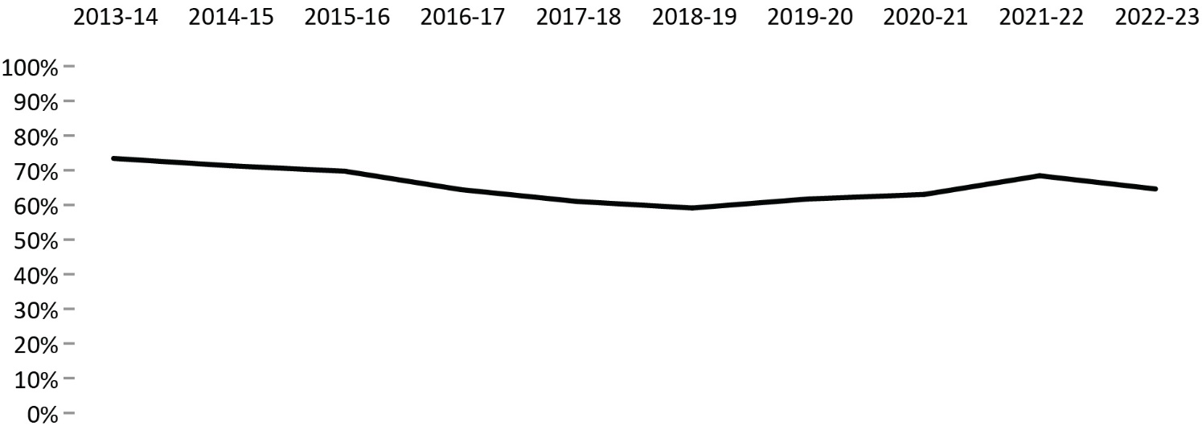
Source: Correctional Service of Canada.
- In fiscal year 2022-23, 64.6% of all releases from federal institutions were at statutory release.
- In fiscal year 2022-23, 76.7% of releases for Indigenous offenders were at statutory release, compared to 57.9% of releases for non-Indigenous offenders.
- In fiscal year 2022-23, 66.0% of all releases for male offenders from federal institutions were at statutory release, compared to 47.4% of releases for female offenders.
- Over the past 10 fiscal years (from 2013-14 to 2022-23), the percentage of releases at statutory release decreased from 73.4% to 64.6%.
Notes
The data include all releases from a federal institution or Healing Lodge in a given fiscal year excluding offenders with quashed sentences, offenders who died in custody, LTSO releases, offenders released at warrant expiry, and offenders transferred to foreign countries. An offender may be released more than once during the reporting timeframe in cases where a previous release was subject to revocation, suspension, temporary detention, interruption, or in cases where an offender served more than one sentence.
Statutory release refers to a conditional release that is subject to supervision after the offender has served two-thirds of the sentence.
*Percentage is calculated based on the number of statutory releases compared to the total releases for each offender group.
Reported year periods reflect fiscal years. A fiscal year runs from April 1 to March 31 of the following year.

Table D10a. Offenders released on statutory release by Indigenous and non-Indigenous
Fiscal year | Indigenous: Statutory release | Indigenous: Total releases | %* | Non-Indigenous: Statutory release | Non-Indigenous: Total releases | %*
2013-14 | 1,750 | 2,060 | 85.0 | 3,886 | 5,621 | 69.1
2014-15 | 1,767 | 2,089 | 84.6 | 3,605 | 5,443 | 66.2
2015-16 | 1,697 | 2,059 | 82.4 | 3,611 | 5,557 | 65.0
2016-17 | 1,605 | 2,061 | 77.9 | 3,278 | 5,516 | 59.4
2017-18 | 1,558 | 2,088 | 74.6 | 2,862 | 5,162 | 55.4
2018-19 | 1,449 | 2,038 | 71.1 | 2,724 | 5,026 | 54.2
2019-20 | 1,640 | 2,182 | 75.2 | 2,716 | 4,879 | 55.7
2020-21 | 1,583 | 2,090 | 75.7 | 2,538 | 4,447 | 57.1
2021-22 | 1,774 | 2,216 | 80.1 | 2,602 | 4,183 | 62.2
2022-23 | 1,715 | 2,235 | 76.7 | 2,331 | 4,025 | 57.9
Source: Correctional Service of Canada.

Table D10b. Offenders released on statutory release by sex
Fiscal year | Male:  Statutory release | Male:  Total releases | %* | Female:  Statutory release | Female:  Total releases | %*
2013-14 | 5,404 | 7,281 | 74.2 | 232 | 400 | 58.0
2014-15 | 5,136 | 7,091 | 72.4 | 236 | 441 | 53.5
2015-16 | 5,029 | 7,112 | 70.7 | 279 | 504 | 55.4
2016-17 | 4,627 | 7,015 | 66.0 | 256 | 562 | 45.6
2017-18 | 4,193 | 6,682 | 62.8 | 227 | 568 | 40.0
2018-19 | 3,954 | 6,516 | 60.7 | 219 | 548 | 40.0
2019-20 | 4,119 | 6,522 | 63.2 | 237 | 539 | 44.0
2020-21 | 3,897 | 6,064 | 64.3 | 224 | 473 | 47.4
2021-22 | 4,148 | 5,914 | 70.1 | 228 | 485 | 47.0
2022-23 | 3,827 | 5,798 | 66.0 | 219 | 462 | 47.4
Source: Correctional Service of Canada.

Table D10c. Total offenders released on statutory release
Fiscal year | Statutory release | Total releases | %*
2013-14 | 5,636 | 7,681 | 73.4
2014-15 | 5,372 | 7,532 | 71.3
2015-16 | 5,308 | 7,616 | 69.7
2016-17 | 4,883 | 7,577 | 64.4
2017-18 | 4,420 | 7,250 | 61.0
2018-19 | 4,173 | 7,064 | 59.1
2019-20 | 4,356 | 7,061 | 61.7
2020-21 | 4,121 | 6,537 | 63.0
2021-22 | 4,376 | 6,399 | 68.4
2022-23 | 4,046 | 6,260 | 64.6
Source: Correctional Service of Canada.
Notes
The data include all releases from a federal institution or Healing Lodge in a given fiscal year excluding offenders with quashed sentences, offenders who died in custody, LTSO releases, offenders released at warrant expiry, and offenders transferred to foreign countries. An offender may be released more than once during the reporting timeframe in cases where a previous release was subject to revocation, suspension, temporary detention, interruption, or in cases where an offender served more than one sentence.
Statutory release refers to a conditional release that is subject to supervision after the offender has served two-thirds of the sentence.
*Percentage is calculated based on the number of statutory releases compared to the total releases for each offender group.
Reported year periods reflect fiscal years. A fiscal year runs from April 1 to March 31 of the following year.

Outcome of federal statutory release supervision periods

Figure D11. Statutory release* outcomes – 10-year trend
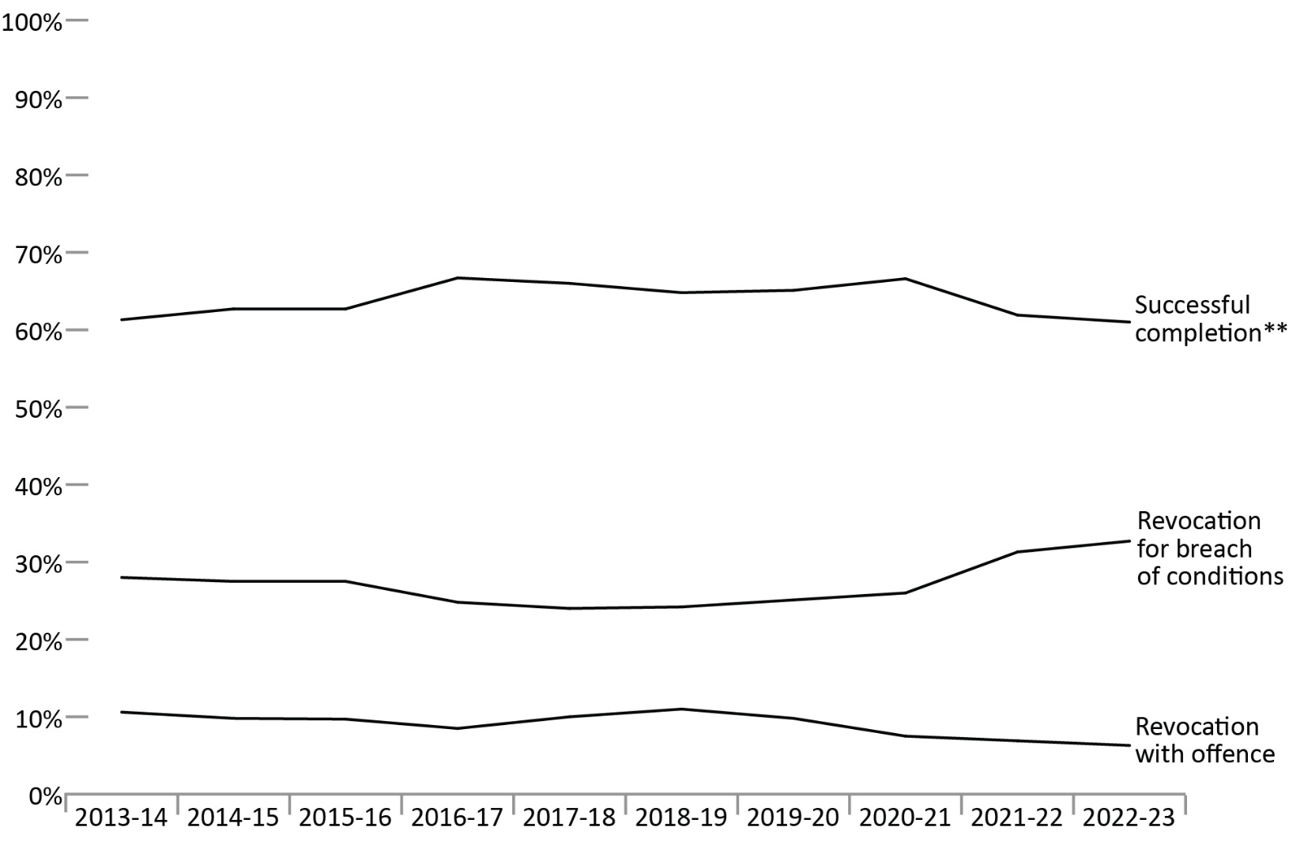
Source: Parole Board of Canada.
- In 2022-23, the successful completion** rate of statutory release* supervision remained stable (61.0%; -0.9%) compared to 2021-22.
- Over the past 5 fiscal years (from 2018-19 to 2022-23), the revocation with violent offence rates were, on average, 8.0 times higher for offenders on statutory release than for offenders on federal day parole and 2.1 times higher than for offenders on federal full parole.
- The rate of revocation with a violent offence of statutory release* supervision periods was on average 1.5% over the past 5 fiscal years (from 2018-19 to 2022-23).
Notes
*Statutory release refers to a conditional release that is subject to supervision after the offender has served two-thirds of the sentence.
**A statutory release supervision period is considered successful if it was completed without a return to prison for a breach of conditions or for a new offence.
Revocation for breach of conditions includes revocation with outstanding charges.
Violent offences include murder and Schedule I offences (listed in the Corrections and Conditional Release Act) such as assaults, sexual offences, arson, abduction, robbery, and some weapon offences.
An offender serving a determinate sentence, if not detained, will be subject to statutory release after serving two-thirds of their sentence if they are not on full parole at that time. On statutory release, an offender is subject to supervision until the end of their sentence.
Reported year periods reflect fiscal years. A fiscal year runs from April 1 to March 31 of the following year.

Table D11. Statutory release* outcomes
Statutory release*  outcomes | 2018-19 | % | 2019-20 | % | 2020-21 | % | 2021-22 | % | 2022-23 | %
Successful  completion** | 3,289 | 64.8 | 3,385 | 65.1 | 3,333 | 66.6 | 3,241 | 61.9 | 2,912 | 61.0
Revocation for breach of conditions | 1,229 | 24.2 | 1,302 | 25.1 | 1,301 | 26.0 | 1,639 | 31.3 | 1,560 | 32.7
Revocation with  non-violent offence | 461 | 9.1 | 405 | 7.8 | 300 | 6.0 | 298 | 5.7 | 272 | 5.7
Revocation with violent offence | 96 | 1.9 | 104 | 2.0 | 74 | 1.5 | 62 | 1.2 | 31 | 0.6
Total | 5,075 | 100.0 | 5,196 | 100.0 | 5,008 | 100.0 | 5,240 | 100.0 | 4,775 | 100.0
Source: Parole Board of Canada.
Notes
*Statutory release refers to a conditional release that is subject to supervision after the offender has served two-thirds of the sentence.
**A statutory release supervision period is considered successful if it was completed without a return to prison for a breach of conditions or for a new offence.
Revocation for breach of conditions includes revocation with outstanding charges.
Violent offences include murder and Schedule I offences (listed in the Corrections and Conditional Release Act) such as assaults, sexual offences, arson, abduction, robbery, and some weapon offences.
An offender serving a determinate sentence, if not detained, will be subject to statutory release after serving two-thirds of their sentence if they are not on full parole at that time. On statutory release, an offender is subject to supervision until the end of their sentence.
Reported year periods reflect fiscal years. A fiscal year runs from April 1 to March 31 of the following year.

Rates of violent offence convictions for offenders on federal conditional release: 10-year trend

Figure D12. Rates of violent offence convictions per 1,000 supervised offenders
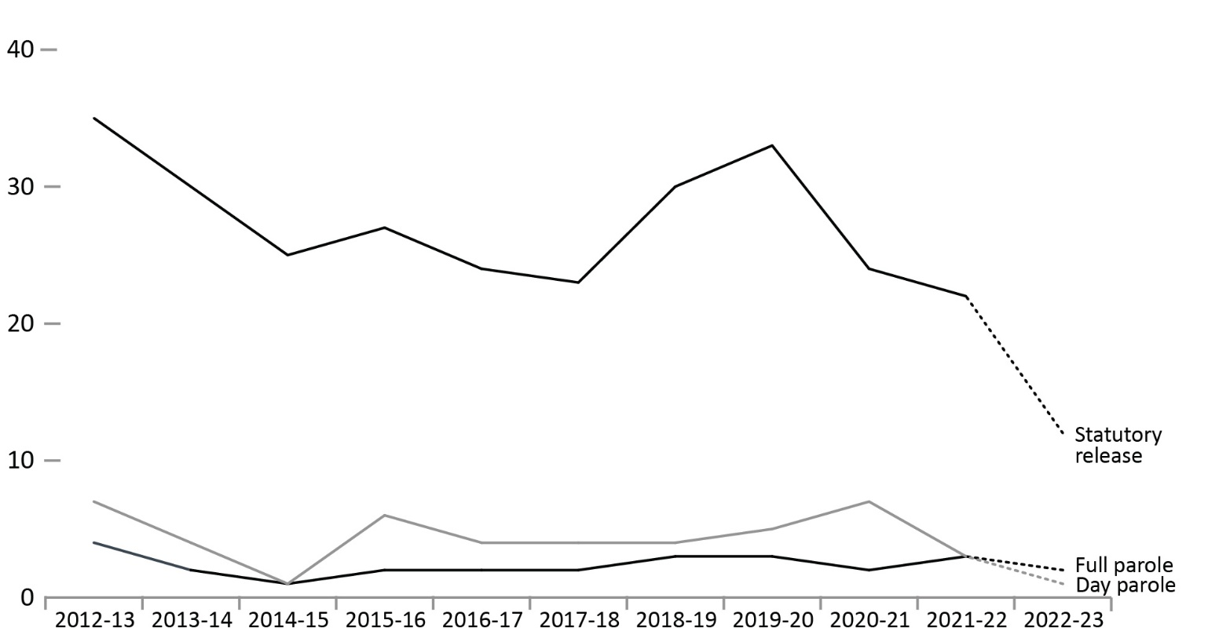
Source: Parole Board of Canada.
- During the 10-fiscal year period between 2012-13 and 2021-22*, the number of convictions for a violent offence for offenders on federal conditional release decreased 45.8% (from 142 in 2012-13 to 77 in 2021-22). Over this period, the annual average number of convictions for violent offences was 7.0 for offenders on day parole, 9.4 for offenders on full parole, and 90.6 for offenders on statutory release.
- During the 10-fiscal-year period between 2012-13 and 2021-22*, convictions for violent offences on statutory release accounted for 84.7% of all convictions by offenders on federal conditional release.
- When comparing the rates of conviction for violent offences per 1,000 supervised offenders (between 2012-13 and 2021-22*), offenders on statutory release were 12.0 times more likely to commit a violent offence during their supervision periods than offenders on full parole, and 5.8 times more likely to commit a violent offence than offenders on day parole.
Notes
*The dotted line between 2021-22 and 2022-23 is intended to signify that due to delays in the court process, these numbers under-represent the actual number of convictions, as verdicts may not have been reached by year-end.
Violent offences include murder and Schedule I offences (listed in the Corrections and Conditional Release Act) such as assaults, sexual offences, arson, abduction, robbery, and some weapon offences.
Supervised offenders include offenders who are on parole and statutory release, those temporarily detained in federal institutions, and those who are deported or extradited.
Statutory release refers to a conditional release that is subject to supervision after the offender has served two-thirds of the sentence.
Day and full parole include those offenders serving determinate and indeterminate sentences.
Reported year periods reflect fiscal years. A fiscal year runs from April 1 to March 31 of the following year.

Table D12a. Number of convictions for violent offences
Fiscal year | Day parole | Full parole | Statutory release | Total
2012-13 | 9 | 12 | 121 | 142
2013-14 | 5 | 8 | 106 | 119
2014-15 | 1 | 4 | 87 | 92
2015-16 | 9 | 7 | 95 | 111
2016-17 | 7 | 8 | 85 | 100
2017-18 | 7 | 8 | 76 | 91
2018-19 | 8 | 15 | 96 | 119
2019-20 | 9 | 13 | 104 | 126
2020-21 | 11 | 8 | 74 | 93
2021-22 | 4 | 11 | 62 | 77
2022-23 | 2 | 9 | 31 | 42
Source: Parole Board of Canada.

Table D12b. Rates of violent offence convictions per 1,000 supervised offenders
Fiscal year | Day parole | Full parole | Statutory release
2012-13 | 7 | 4 | 35
2013-14 | 4 | 2 | 30
2014-15 | 1 | 1 | 25
2015-16 | 6 | 2 | 27
2016-17 | 4 | 2 | 24
2017-18 | 4 | 2 | 23
2018-19 | 4 | 3 | 30
2019-20 | 5 | 3 | 33
2020-21 | 7 | 2 | 24
2021-22 | 3 | 3 | 22
2022-23 | 1 | 2 | 12
Source: Parole Board of Canada.
Notes
Violent offences include murder and Schedule I offences (listed in the Corrections and Conditional Release Act) such as assaults, sexual offences, arson, abduction, robbery, and some weapon offences.
Supervised offenders include offenders who are on parole and statutory release, those temporarily detained in federal institutions, and those who are deported or extradited.
Statutory release refers to a conditional release that is subject to supervision after the offender has served two-thirds of the sentence.
Day and full parole include those offenders serving determinate and indeterminate sentences.
Reported year periods reflect fiscal years. A fiscal year runs from April 1 to March 31 of the following year.

Section E:
Special Applications of Criminal Justice



Number of initial detention reviews: 10-year trend

Figure E1. Number of initial detention reviews
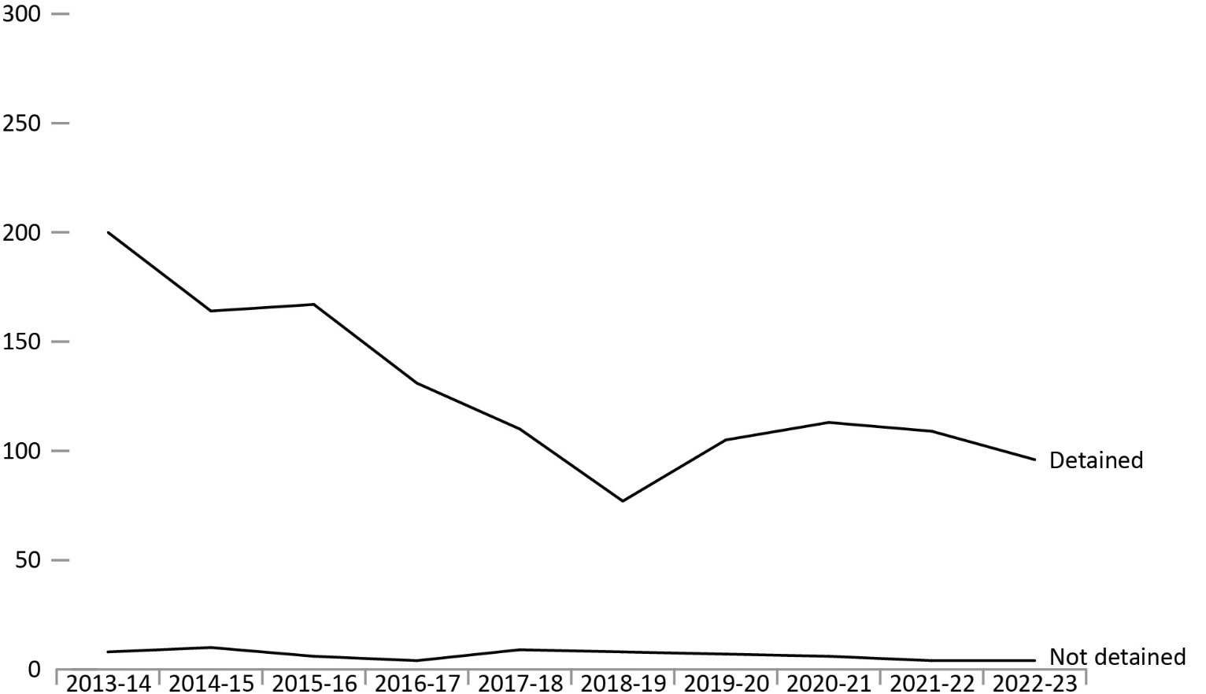
Source: Parole Board of Canada.
- In 2022-23, the number of referrals for detention decreased from 113 to 100 when compared to 2021-22. The detention rate was 96.0%.
- By race group, the proportion of Indigenous offenders and Caucasian offenders detained as a result of an initial detention review was 96.0% and 94.4%, respectively, while the proportion of Asian offenders, Black offenders, and offenders in the “Other” race group detained as a result of an initial detention review was 100% in 2022-23.
- As of April 9, 2023, Indigenous offenders accounted for 32.0% of federal incarcerated offenders serving determinate sentences, Asian offenders accounted for 4.5%, Black offenders accounted for 8.7%, Caucasian offenders accounted for 47.4%, and offenders in the “Other” race group accounted for 7.4%.
- In 2022-23, Indigenous offenders accounted for 50.0% of offenders referred for detention, Asian offenders accounted for 3.0%, Black offenders accounted for 8.0%, Caucasian offenders accounted for 36.0% and offenders in the “Other” race group accounted for 3.0%.
Notes
During intake assessment, parole officers ask federal offenders to self-identify their race and this information is entered into the Correctional Service of Canada’s (CSC) Offender Management System. Parole Board of Canada (PBC) uses the term “race grouping” as this is the term used by CSC to collect the information from offenders and also reflects how the data is captured in CSC’s and PBC’s data tables.
Initial Detention Review: In accordance with subsection 130(1) of the Corrections and Conditional Release Act, a review conducted upon referral by the Correctional Service of Canada. On completion of its review, the Board may order that an individual not be released from imprisonment before the expiration of their sentence according to law – except on an escorted temporary absence for medical or administrative reasons – if it is satisfied that the individual is likely, if released, to commit an offence causing the death of or serious harm to another person, a sexual offence involving a child, or a serious drug offence before the end of their sentence. Detention orders are subject to review within 1 or 2 years, depending on the type of offence.
Reported year periods reflect fiscal years. A fiscal year runs from April 1 to March 31 of the following year.

Table E1. Number of initial detention reviews by race group

Outcome: Detained
Race group | 2013-14 | 2014-15 | 2015-16 | 2016-17 | 2017-18 | 2018-19 | 2019-20 | 2020-21 | 2021-22 | 2022-23
Indigenous | 92 | 71 | 75 | 55 | 51 | 38 | 50 | 58 | 49 | 48
Asian | 2 | 3 | 2 | 1 | 1 | 1 | 1 | 2 | 4 | 3
Black | 18 | 10 | 13 | 10 | 10 | 6 | 6 | 12 | 10 | 8
Caucasian | 86 | 70 | 76 | 59 | 47 | 28 | 43 | 38 | 42 | 34
Other | 2 | 10 | 1 | 6 | 1 | 4 | 5 | 3 | 4 | 3
Total (#) | 200 | 164 | 167 | 131 | 110 | 77 | 105 | 113 | 109 | 96
Total (%) | 96.2 | 94.3 | 96.5 | 97.0 | 92.4 | 90.6 | 93.8 | 95.0 | 96.5 | 96.0

Outcome: Statutory Release
Race group | 2013-14 | 2014-15 | 2015-16 | 2016-17 | 2017-18 | 2018-19 | 2019-20 | 2020-21 | 2021-22 | 2022-23
Indigenous | 4 | 5 | 2 | 2 | 5 | 6 | 4 | 2 | 1 | 2
Asian | 0 | 0 | 1 | 1 | 0 | 0 | 0 | 0 | 0 | 0
Black | 0 | 1 | 2 | 0 | 1 | 0 | 1 | 1 | 2 | 0
Caucasian | 4 | 4 | 1 | 1 | 3 | 2 | 2 | 3 | 0 | 2
Other | 0 | 0 | 0 | 0 | 0 | 0 | 0 | 0 | 1 | 0
Total (#) | 8 | 10 | 6 | 4 | 9 | 8 | 7 | 6 | 4 | 4
Total (%) | 3.8 | 5.7 | 3.5 | 3.0 | 7.6 | 9.4 | 6.3 | 5.0 | 3.5 | 4.0

Total outcomes
Race group | 2013-14 | 2014-15 | 2015-16 | 2016-17 | 2017-18 | 2018-19 | 2019-20 | 2020-21 | 2021-22 | 2022-23
Indigenous | 96 | 76 | 77 | 57 | 56 | 44 | 54 | 60 | 50 | 50
Asian | 2 | 3 | 3 | 2 | 1 | 1 | 1 | 2 | 4 | 3
Black | 18 | 11 | 15 | 10 | 11 | 6 | 7 | 13 | 12 | 8
Caucasian | 90 | 74 | 77 | 60 | 50 | 30 | 45 | 41 | 42 | 36
Other | 2 | 10 | 1 | 6 | 1 | 4 | 5 | 3 | 5 | 3
Total (#) | 208 | 174 | 173 | 135 | 119 | 85 | 112 | 119 | 113 | 100
Total (%) | 100.0 | 100.0 | 100.0 | 100.0 | 100.0 | 100.0 | 100.0 | 100.0 | 100.0 | 100.0
Source: Parole Board of Canada.
Notes
During intake assessment, parole officers ask federal offenders to self-identify their race and this information is entered into the Correctional Service of Canada’s (CSC) Offender Management System. Parole Board of Canada (PBC) uses the term “race grouping” as this is the term used by CSC to collect the information from offenders and also reflects how the data is captured in CSC’s and PBC’s data tables.
Initial Detention Review: In accordance with subsection 130(1) of the Corrections and Conditional Release Act, a review conducted upon referral by the Correctional Service of Canada. On completion of its review, the Board may order that an individual not be released from imprisonment before the expiration of their sentence according to law – except on an escorted temporary absence for medical or administrative reasons – if it is satisfied that the individual is likely, if released, to commit an offence causing the death of or serious harm to another person, a sexual offence involving a child, or a serious drug offence before the end of their sentence. Detention orders are subject to review within 1 or 2 years, depending on the type of offence.
Reported year periods reflect fiscal years. A fiscal year runs from April 1 to March 31 of the following year.

Annual judicial review hearings

Figure E2. Judicial review hearings between fiscal year 1987-88 and fiscal year 2022-23
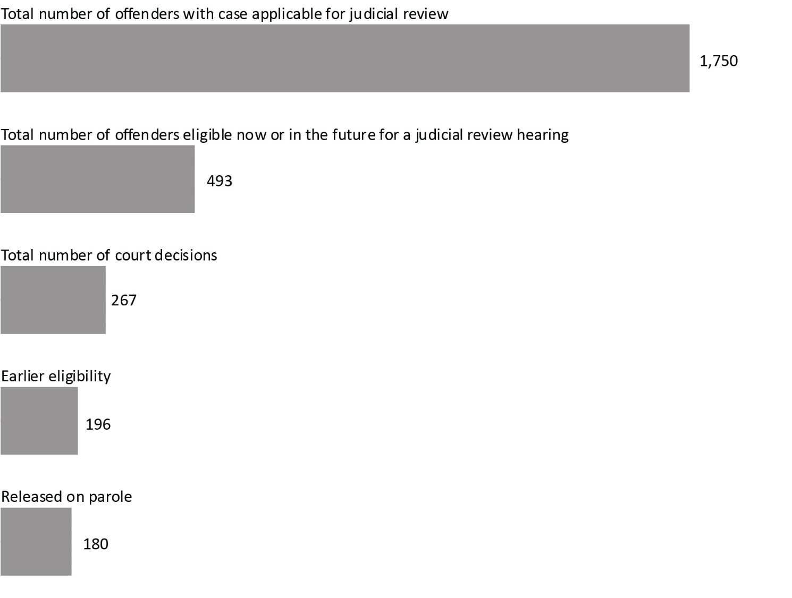
Source: Correctional Service of Canada.
- Since the first judicial review hearing in 1987, there have been a total of 267 court decisions (i.e., between fiscal year 1987-88 and the end of fiscal year 2022-23).
- Of these cases, 73.4% of the court decisions resulted in a reduction of the period that must be served before parole eligibility.
- Of the 493 offenders eligible to apply for a judicial review, 285 have already served 15 years of their sentence, whereas 208 have not.
- Of the 196 offenders who had their parole eligibility date moved closer, 192 had reached their revised Day Parole eligibility date. Of these offenders, 180 were released on parole, and 116 were being actively supervised in the community*.
- A higher percentage of second degree (81.5%) than first degree (72.5%) murder cases have resulted in a reduction of the period required to be served before parole eligibility.
Notes
* Of the 64 offenders who were no longer under active supervision, 6 were in custody, 48 were deceased, 6 were deported, and 4 were temporarily detained.
Judicial review is an application to the court for a reduction in the time required to be served before being eligible for parole. Judicial review procedures apply to offenders who have been sentenced to imprisonment for life without eligibility for parole until more than 15 years of their sentence has been served. Offenders can apply when they have served at least 15 years of their sentence. Judicial reviews are conducted in the province where the conviction took place.
A fiscal year runs from April 1 to March 31 of the following year.

Table E2. Judicial review hearings between fiscal year 1987-88 and fiscal year 2022-23

Parole ineligibility reduced by court
Province/territory of judicial review | 1st degree murder | 2nd degree murder
Northwest Territories | 1 | 0
Nunavut | 0 | 0
Yukon Territories | 0 | 0
Newfoundland & Labrador | 0 | 0
Prince Edward Island | 0 | 0
Nova Scotia | 1 | 1
New Brunswick | 1 | 0
Quebec | 79 | 16
Ontario | 27 | 0
Manitoba | 8 | 4
Saskatchewan | 7 | 0
Alberta | 20 | 0
British Columbia | 30 | 1
Total | 174 | 22

Reduction denied by court
Province/territory of judicial review | 1st degree murder | 2nd degree murder
Northwest Territories | 0 | 0
Nunavut | 0 | 0
Yukon Territories | 0 | 0
Newfoundland & Labrador | 0 | 0
Prince Edward Island | 0 | 0
Nova Scotia | 1 | 0
New Brunswick | 1 | 0
Quebec | 7 | 2
Ontario | 34 | 1
Manitoba | 1 | 0
Saskatchewan | 3 | 0
Alberta | 9 | 1
British Columbia | 10 | 1
Total | 66 | 5

Total parole ineligibility reduced by court and reduction denied by court
Province/territory of judicial review | 1st degree murder | 2nd degree murder
Northwest Territories | 1 | 0
Nunavut | 0 | 0
Yukon Territories | 0 | 0
Newfoundland & Labrador | 0 | 0
Prince Edward Island | 0 | 0
Nova Scotia | 2 | 1
New Brunswick | 2 | 0
Quebec | 86 | 18
Ontario | 61 | 1
Manitoba | 9 | 4
Saskatchewan | 10 | 0
Alberta | 29 | 1
British Columbia | 40 | 2
Total | 240 | 27
Source: Correctional Service of Canada.
Notes
Judicial review is an application to the court for a reduction in the time required to be served before being eligible for parole. Judicial review procedures apply to offenders who have been sentenced to imprisonment for life without eligibility for parole until more than 15 years of their sentence has been served. Offenders can apply when they have served at least 15 years of their sentence. Judicial reviews are conducted in the province where the conviction took place.
A fiscal year runs from April 1 to March 31 of the following year.

Number of Dangerous Offender designations

Figure E3. Number of Dangerous Offenders designated
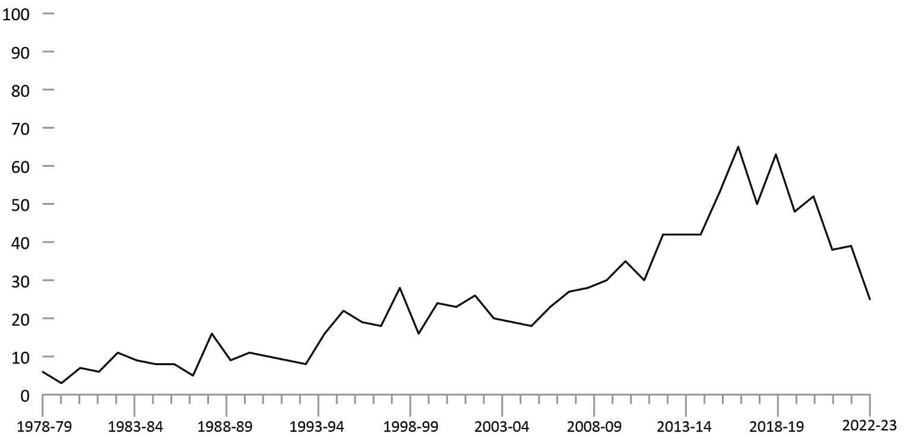
Source: Correctional Service of Canada.
- At the end of fiscal year 2022-23, 1,107 Dangerous Offender designations were ordered by the court since 1978.
- At the end of fiscal year 2022-23 there were 910 offenders with a Dangerous Offender designation under the responsibility of Correctional Service Canada, and of those, 74.5% had indeterminate sentences.
- Of these 910 offenders with a Dangerous Offender designation, 741 were in custody (representing 5.7% of the total in-custody population) and 169 were in the community under supervision. There were ten female offenders with a Dangerous Offender designation. Indigenous offenders accounted for 36.6% of the offenders with a Dangerous Offender designation and 28.6% of the total offender population.
Notes
The number of Dangerous Offenders designated per year does not include overturned decisions.
Offenders who have died since receiving designations are no longer classified as “active”; however, they are still represented in the above graph, which depicts the total number of offenders “designated”.
The percentage of offenders with a Dangerous Offender designation who had at least one current conviction for a sexual offence is not available.
Dangerous Offender legislation came into effect in Canada on October 15, 1977, replacing the Habitual Offender and Dangerous Sexual Offender provisions that were abolished. A Dangerous Offender is an individual given an indeterminate or a determinate sentence on the basis of a particularly violent crime or pattern of serious violent offences where it is judged that the offender’s behaviour is unlikely to be inhibited by normal standards of behavioural restraint (see section 753 of the Criminal Code of Canada).
In addition to the offenders with a Dangerous Offender designation, there were seven Dangerous Sexual Offenders and two offenders with an Habitual Offender designation under the responsibility of Correctional Service Canada at the end of fiscal 2022-23.
Determinate sentence for Dangerous Offenders must be a minimum punishment of imprisonment for a term of 2 years — and have an order that the offender be subject to long-term supervision for a period that does not exceed 10 years.
A fiscal year runs from April 1 to March 31 of the following year.

Table E3a. Number of Active Dangerous Offenders designated (2022-23)
Province/territory of designation | # of indeterminate offenders | # of determinate offenders |  | Total
Newfoundland & Labrador | 7 |  | 2 |  | 9
Nova Scotia | 19 |  | 3 |  | 22
Prince Edward Island | 0 |  | 0 |  | 0
New Brunswick | 4 |  | 0 |  | 4
Quebec | 98 |  | 30 |  | 128
Ontario | 290 |  | 119 |  | 409
Manitoba | 26 |  | 4 |  | 30
Saskatchewan | 59 |  | 39 |  | 98
Alberta | 55 |  | 9 |  | 64
British Columbia | 109 |  | 20 |  | 129
Yukon Territories | 2 |  | 3 |  | 5
Northwest Territories | 9 |  | 1 |  | 10
Nunavut | 0 |  | 2 |  | 2
Total | 678 |  | 232 |  | 910
Source: Correctional Service of Canada.

Table E3b. Number of designations (designated since 1978)
Province/territory of designation | All designations (designated since 1978)
Newfoundland & Labrador | 15
Nova Scotia | 29
Prince Edward Island | 0
New Brunswick | 8
Quebec | 152
Ontario | 485
Manitoba | 34
Saskatchewan | 113
Alberta | 78
British Columbia | 171
Yukon Territories | 7
Northwest Territories | 11
Nunavut | 4
Total | 1,107
Source: Correctional Service of Canada.
Notes
The number of Dangerous Offenders designated per year does not include overturned decisions.
Offenders who have died since receiving designations are no longer classified as “active”; however, they are still represented in the above graph, which depicts the total number of offenders “designated”.
The percentage of offenders with a Dangerous Offender designation who had at least one current conviction for a sexual offence is not available.
Dangerous Offender legislation came into effect in Canada on October 15, 1977, replacing the Habitual Offender and Dangerous Sexual Offender provisions that were abolished. A Dangerous Offender is an individual given an indeterminate or a determinate sentence on the basis of a particularly violent crime or pattern of serious violent offences where it is judged that the offender’s behaviour is unlikely to be inhibited by normal standards of behavioural restraint (see section 753 of the Criminal Code of Canada).
In addition to the offenders with a Dangerous Offender designation, there were seven Dangerous Sexual Offenders and two offenders with an Habitual Offender designation under the responsibility of Correctional Service Canada at the end of fiscal 2022-23.
Determinate sentence for Dangerous Offenders must be a minimum punishment of imprisonment for a term of two years — and have an order that the offender be subject to long-term supervision for a period that does not exceed 10 years.
A fiscal year runs from April 1 to March 31 of the following year.

Number of long-term supervision orders imposed

Figure E4. Number of long-term supervision orders imposed (2022-23)
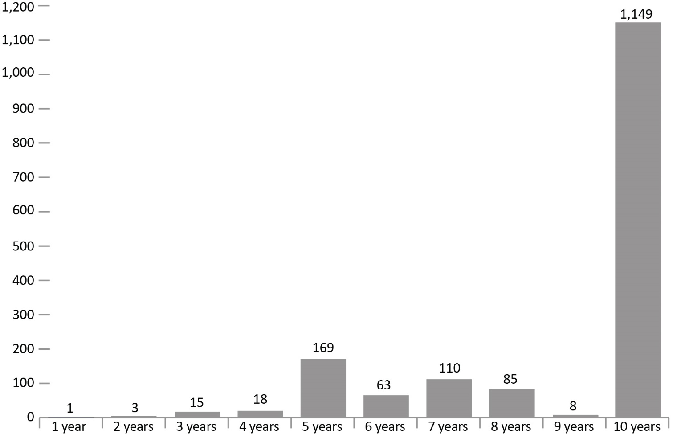
Source: Correctional Service of Canada.
- At the end of fiscal year 2022-23, the courts had imposed 1,621 long-term supervision orders since the legislation came into effect in 1997. Of these, 70.9% were for a period of 10 years.
- At the end of fiscal year 2022-23, there were 960 offenders with long-term supervision orders under the responsibility of Correctional Service Canada. There were 16 females with long-term supervision orders under the responsibility of Correctional Service Canada.
- There were 469 offenders being supervised in the community on their long-term supervision order at the end of the fiscal year 2022-23. Of these, 388 offenders were supervised in the community, 6 offenders were temporarily detained, 64 offenders were on remand, 10 offenders were unlawfully at large for less than 90 days, and one offender was supervised and subject to an immigration hold by Canada Border Services Agency.

Notes
Long-Term Supervision Order (LTSO) legislation, which came into effect in Canada on August 1, 1997, allows the court to impose a LTSO which requires an offender to be supervised in the community for a period not exceeding 10 years following the warrant expiry date.
137 offenders under these provisions have died, and 441 offenders have completed their long term supervision period.
The percentage of long term supervision orders that had at least one current conviction for a sexual offence is not available.
Remand is the temporary detention of a person while awaiting trial, sentencing, or the commencement of a custodial disposition.
A fiscal year runs from April 1 to March 31 of the following year.

Table E4a. Number of long-term supervision orders imposed by length (2022-23)
Province or territory of order | 1 year | 2 years | 3 years | 4 years | 5 years | 6 years | 7 years | 8 years | 9 years | 10 years | Total
Newfoundland & Labrador | 0 | 0 | 0 | 0 | 0 | 0 | 0 | 1 | 0 | 13 | 14
Nova Scotia | 0 | 0 | 0 | 0 | 4 | 0 | 1 | 3 | 0 | 17 | 25
Prince Edward Island | 0 | 0 | 0 | 0 | 1 | 0 | 0 | 0 | 0 | 1 | 2
New Brunswick | 0 | 0 | 1 | 0 | 2 | 0 | 0 | 1 | 0 | 8 | 12
Quebec | 1 | 2 | 10 | 6 | 100 | 27 | 55 | 25 | 3 | 360 | 589
Ontario | 0 | 0 | 1 | 8 | 20 | 16 | 25 | 31 | 0 | 372 | 473
Manitoba | 0 | 0 | 0 | 0 | 1 | 2 | 3 | 2 | 0 | 39 | 47
Saskatchewan | 0 | 1 | 1 | 1 | 12 | 10 | 15 | 11 | 3 | 95 | 149
Alberta | 0 | 0 | 1 | 0 | 9 | 1 | 1 | 1 | 0 | 79 | 92
British Columbia | 0 | 0 | 0 | 2 | 14 | 4 | 7 | 8 | 0 | 137 | 172
Yukon Territories | 0 | 0 | 0 | 0 | 2 | 0 | 3 | 1 | 1 | 19 | 26
Northwest Territories | 0 | 0 | 0 | 0 | 2 | 1 | 0 | 0 | 1 | 4 | 8
Nunavut | 0 | 0 | 1 | 1 | 2 | 2 | 0 | 1 | 0 | 5 | 12
Total | 1 | 3 | 15 | 18 | 169 | 63 | 110 | 85 | 8 | 1,149 | 1,621
Source: Correctional Service of Canada.

Table E4b. Current status of long-term supervision orders imposed (2022-23)
Province or territory of order | Incarcerated | DP, FP or SR* | LTSO period | LTSO interrupted** | Total
Newfoundland & Labrador | 1 | 1 | 6 | 1 | 9
Nova Scotia | 5 | 0 | 4 | 2 | 11
Prince Edward Island | 0 | 0 | 0 | 0 | 0
New Brunswick | 0 | 0 | 4 | 2 | 6
Quebec | 135 | 22 | 149 | 58 | 364
Ontario | 71 | 14 | 160 | 41 | 286
Manitoba | 4 | 2 | 8 | 5 | 19
Saskatchewan | 36 | 1 | 40 | 30 | 107
Alberta | 14 | 0 | 26 | 4 | 44
British Columbia | 16 | 4 | 60 | 7 | 87
Yukon Territories | 6 | 0 | 10 | 1 | 17
Northwest Territories | 4 | 0 | 1 | 0 | 5
Nunavut | 4 | 0 | 1 | 0 | 5
Total | 296 | 44 | 469 | 151 | 960
Source: Correctional Service of Canada.
Notes
Long-Term Supervision Order (LTSO) legislation, which came into effect in Canada on August 1, 1997, allows the court to impose a LTSO which requires an offender to be supervised in the community for a period not exceeding 10 years following the warrant expiry date.
137 offenders under these provisions have died, and 441 offenders have completed their long term supervision period.
The percentage of long-term supervision orders that had at least one current conviction for a sexual offence is not available.
* This category includes offenders whose current status is either supervised on day parole (DP), full parole (FP), or statutory release (SR).
** This category includes offenders convicted of a new offence while on the supervision portion of an LTSO. When this occurs, the LTSO supervision period is interrupted until the offender has served the new sentence to its warrant expiry date. At that time, the LTSO supervision period resumes where it left off. From the 151, 109 offenders were in custody, 29 were supervised in the community (27 on statutory release, 1 on full parole, and 1 on a long- term supervision order), 10 offenders were temporarily detained, 2 offenders were unlawfully at large for less than 90 days, and 1 offender was on remand.
Remand is the temporary detention of a person while awaiting trial, sentencing or the commencement of a custodial disposition.
A fiscal year runs from April 1 to March 31 of the following year.

Record suspensions and pardons: 5-year trend

Figure E5. Number of record suspension and pardon applications received*
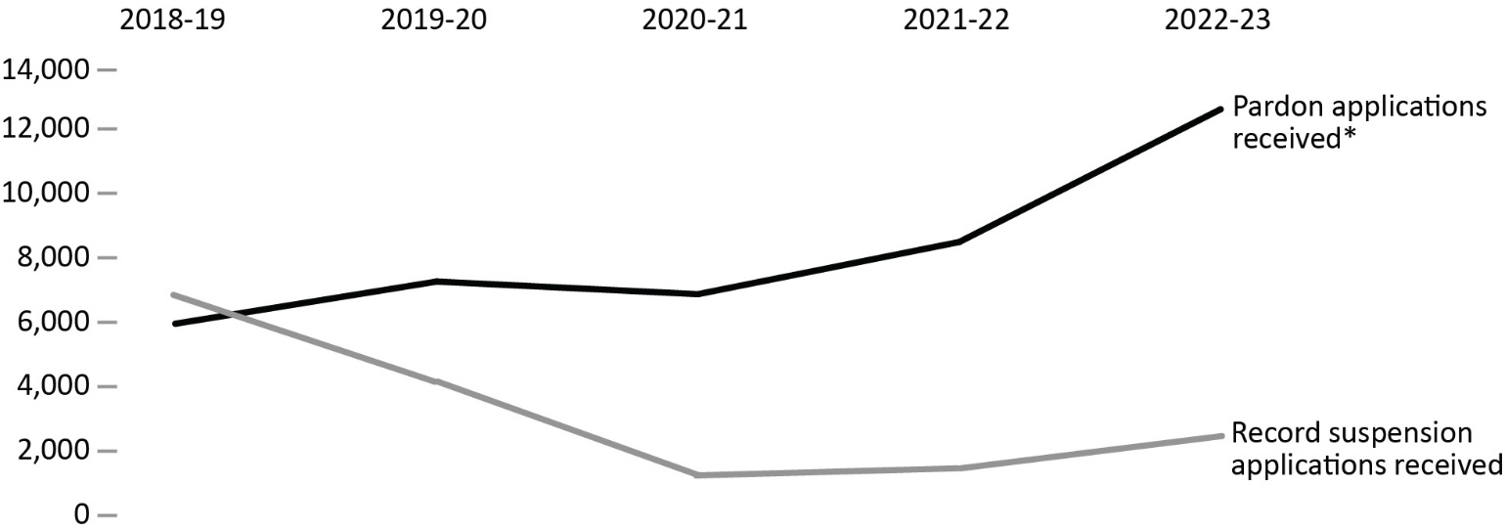
Source: Parole Board of Canada.
- In 2022-23, the Parole Board of Canada received 2,979 record suspension applications and accepted 2,072 applications for processing. The Board also received 13,122 pardon applications and accepted 9,546 applications for processing. The acceptance rate was 72.2%.
- In 2022-23, the Parole Board of Canada rendered 7,501 pardon decisions, granting/issuing a pardon in 97.5% of cases and denying a pardon in 2.5% of cases.
- In 2022-23, the Parole Board of Canada made 1,957 record suspension decisions; 97.5% of record suspensions were ordered and 2.5% were refused.
- In the past 5 fiscal years (from 2018-19 to 2022-23), the number of pardons applications received by the Parole Board of Canada increased 102.9%. In the same time frame, the number of record suspension applications received decreased 59.5%*.
- Since 1970, when the pardon/record suspension process began, 571,831 pardons/record suspensions have been granted/issued and ordered.
Notes
*On March 13, 2012, Bill C-10 amended the Criminal Records Act (CRA) by replacing the term pardon with the term record suspension. In 2017-18, following British Columbia Supreme Court and Ontario Superior Court decisions, the application of the CRA amendments for applicants who had committed an offence prior to the implementation of these amendments were struck down and the Board resumed processing pardon cases for residents of Ontario and British Columbia based on the criteria that were in force on the day on which the offence was committed. In response to the March 2020 Federal Court of Canada decision in P.H. v. Canada (Attorney General) (P.H.), all applications are processed according to the CRA decision-making criteria that was in force at the time the first offence was committed and not the date the application was received by the PBC. Where applications span multiple legislative schemes, policy was amended to specify that the applicable version of the CRA is to be determined based on the first offence on the criminal record.
Reported year periods reflect fiscal years. A fiscal year runs from April 1 to March 31 of the following year.

Table E5. Number of record suspension and pardon applications received*

Record suspension applications processed
Record suspension applications | 2018-19 | 2019-20 | 2020-21 | 2021-22 | 2022-23
Received | 7,360 | 4,667 | 1,757 | 1,978 | 2,979
Accepted | 5,341 | 2,964 | 1,344 | 1,249 | 2,072
% accepted | 72.6 | 63.5 | 76.5 | 63.1 | 69.6

Record suspensions
Record suspensions | 2018-19 | 2019-20 | 2020-21 | 2021-22 | 2022-23
Ordered | 6,028 | 5,287 | 1,403 | 1,559 | 1,909
Refused | 225 | 209 | 103 | 56 | 48
Total ordered/refused | 6,253 | 5,496 | 1,506 | 1,615 | 1,957
% ordered | 96.4 | 96.2 | 93.2 | 96.5 | 97.5

Pardon applications processed
Pardon applications | 2018-19 | 2019-20 | 2020-21 | 2021-22 | 2022-23
Received | 6,466 | 7,774 | 7,383 | 9,003 | 13,122
Accepted | 5,186 | 6,749 | 6,207 | 6,020 | 9,546
% accepted | 80.2 | 86.8 | 84.1 | 66.9 | 72.7

Pardons
Pardons | 2018-19 | 2019-20 | 2020-21 | 2021-22 | 2022-23
Granted | 2,631 | 3,155 | 4,846 | 4,669 | 3,812
Issued | 1,772 | 1,552 | 2,467 | 2,054 | 3,501
Denied | 42 | 209 | 219 | 247 | 188
Total granted/issued/denied | 4,445 | 4,916 | 7,532 | 6,970 | 7,501
% granted/issued | 99.1 | 95.7 | 97.1 | 96.5 | 97.5

Pardon/record suspension revocations/cessations
Pardon/record suspension revocations/cessations | 2018-19 | 2019-20 | 2020-21 | 2021-22 | 2022-23
Revocations** | 59 | 410 | 314 | 251 | 220
Cessations | 527 | 440 | 271 | 307 | 343
Total revocations/cessations | 586 | 850 | 585 | 558 | 563
Cumulative # granted/issued and ordered*** Ordered****** | 535,617 | 545,611 | 554,327 | 562,609 | 571,831
Cumulative # revocations/cessations*** | 27,269 | 28,119 | 28,704 | 29,262 | 29,825
Source: Parole Board of Canada.
Notes
*On March 13, 2012, Bill C-10 amended the Criminal Records Act (CRA) by replacing the term pardon with the term record suspension. In 2017-18, following British Columbia Supreme Court and Ontario Superior Court decisions, the application of the CRA amendments for applicants who had committed an offence prior to the implementation of these amendments were struck down and the Board resumed processing pardon cases for residents of Ontario and British Columbia based on the criteria that were in force on the day on which the offence was committed. In response to the March 2020 Federal Court of Canada decision in P.H. v. Canada (Attorney General) (P.H.), all applications are processed according to the CRA decision-making criteria that was in force at the time the first offence was committed and not the date the application was received by the PBC. Where applications span multiple legislative schemes, policy was amended to specify that the applicable version of the CRA is to be determined based on the first offence on the criminal record.
**Revocations fluctuate due to resource re-allocation to address backlogs.
***Cumulative data reflects activity since 1970, when the pardon process was established under the Criminal Records Act.
Reported year periods reflect fiscal years. A fiscal year runs from April 1 to March 31 of the following year.

Section F:
Federal Services to Registered Victims



Number of contacts with registered victims: 5-year trend

Figure F1. Number of contacts with registered victims
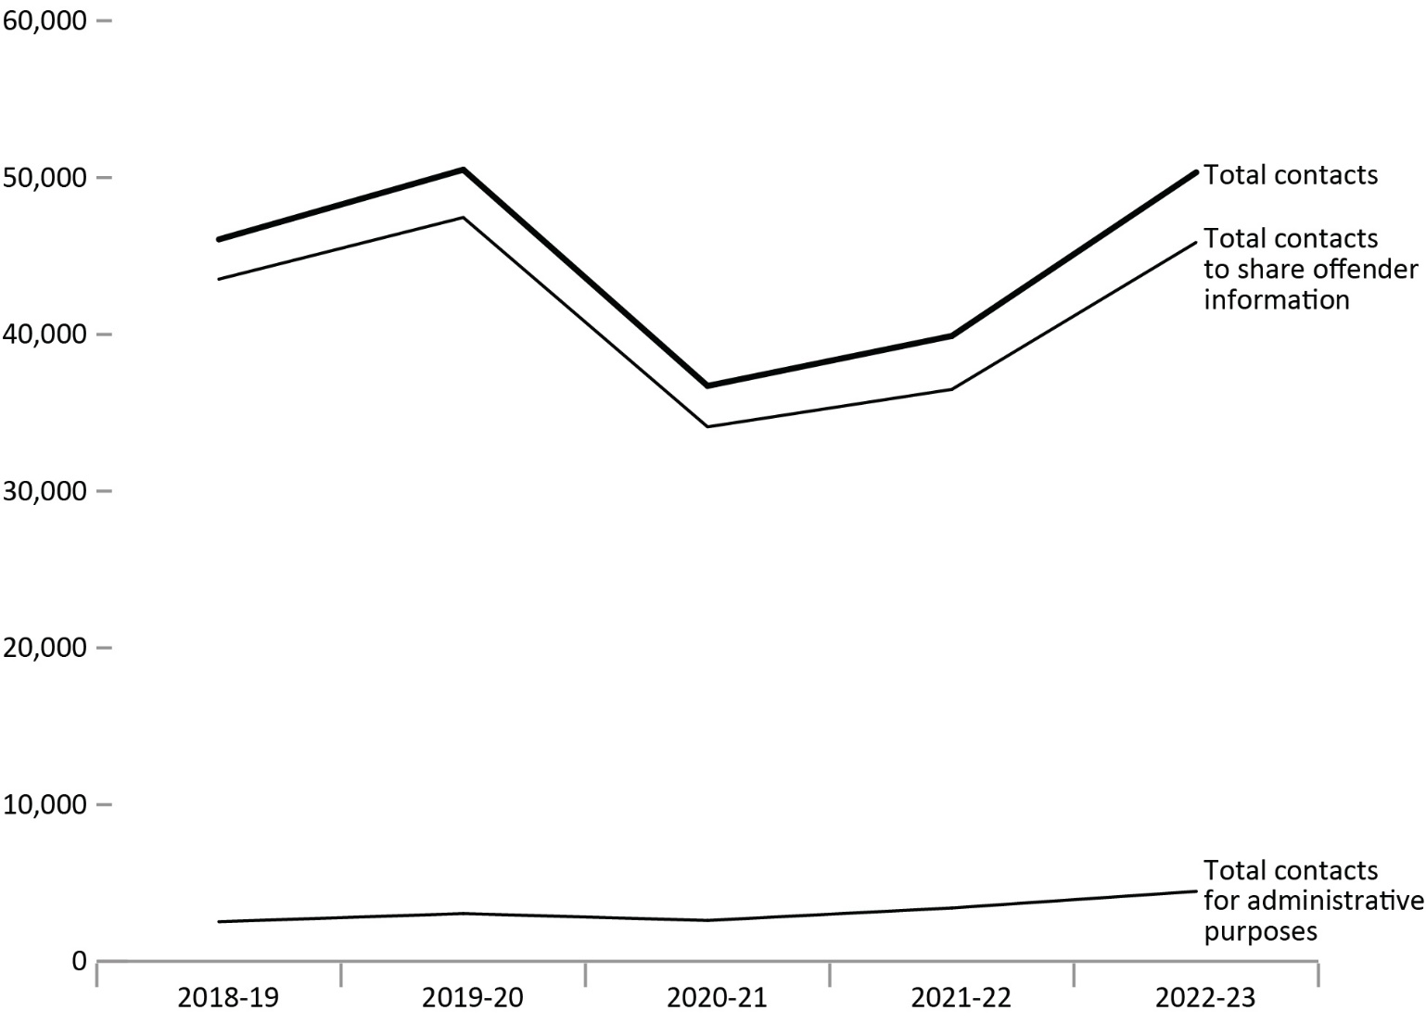
Source: Correctional Service of Canada.
- The majority of contacts with registered victims (91.1%) was to share offender information. From 2018-19 to 2022-23, the proportion of contacts with registered victims to share offender information decreased from 94.5% to 91.1%.
- The total number of contacts with registered victims decreased by 13.4 % from 2018-19 to 2021-22 (46,057 to 39,900), and then increased by 26.2% from 2021-22 to 2022-23 (39,900 to 50,335).
Notes
The Canadian Victims Bill of Rights defines a victim as any individual who has suffered physical or emotional harm, property damage, or economic loss as the result of the commission of an offence. The law also allows a spouse, a relative or dependent, an individual who is responsible for the care or support of the victim or the care or support of a dependent of the victim, to act on behalf of a victim if the victim cannot act on their own behalf. Victims include persons harmed by the offender regardless of whether the offender has been prosecuted or not, as long as an official complaint has been made to the police or to the Crown.
Victims do not automatically receive information about the offender who harmed them. If they have been harmed by an offender serving a sentence of 2 years or more, victims must register with the Correctional Service of Canada (CSC) or the Parole Board of Canada to receive information or access services. Registration allows CSC to verify that the individual meets the definition of victim, which is required by law before sharing protected offender information. https://www.csc-scc.gc.ca/victims/003006-7001-en.shtml
Contacts to share offender information include those where the CSC Victim Services Unit communicates offender information to victims. This might include information such as temporary absences, transfers, travel permits, conditional release, and sentencing information. Contacts for administrative reasons include tasks such as updating contact information, discussing the Restorative Opportunities program, and referrals to provincial or community stakeholders.
Activity types that are used to document either a contact with a victim or an internal administrative task are excluded from the numbers above.
Reported year periods reflect fiscal years. A fiscal year runs from April 1 to March 31 of the following year.

Table F1. Number of contacts with registered victims
Contact type | 2018-19 | 2019-20 | 2020-21 | 2021-22 | 2022-23
Total contacts to share offender information | 43,522 | 47,454 | 34,098 | 36,490 | 45,867
Total contacts for administrative purposes | 2,535 | 3,051 | 2,613 | 3,410 | 4,468
Total contacts | 46,057 | 50,505 | 36,711 | 39,900 | 50,335
Source: Correctional Service of Canada.

Notes
The Canadian Victims Bill of Rights defines a victim as any individual who has suffered physical or emotional harm, property damage, or economic loss as the result of the commission of an offence. The law also allows a spouse, a relative or dependent, an individual who is responsible for the care or support of the victim or the care or support of a dependent of the victim, to act on behalf of a victim if the victim cannot act on their own behalf. Victims include persons harmed by the offender regardless of whether the offender has been prosecuted or not, as long as an official complaint has been made to the police or to the Crown.
Victims do not automatically receive information about the offender who harmed them. If they have been harmed by an offender serving a sentence of 2 years or more, victims must register with the Correctional Service of Canada (CSC) or the Parole Board of Canada to receive information or access services. Registration allows CSC to verify that the individual meets the definition of victim, which is required by law before sharing protected offender information. https://www.csc-scc.gc.ca/victims/003006-7001-en.shtml
Contacts to share offender information include those where the CSC Victim Services Unit communicates offender information to victims. This might include information such as temporary absences, transfers, travel permits, conditional release, and sentencing information. Contacts for administrative reasons include tasks such as updating contact information, discussing the Restorative Opportunities program, and referrals to provincial or community stakeholders.
Activity types that are used to document either a contact with a victim or an internal administrative task are excluded from the numbers above.
Reported year periods reflect fiscal years. A fiscal year runs from April 1 to March 31 of the following year.

Number of victim statements received for consideration in release decisions: 5-year trend

Figure F2. Number of victim statements received for consideration in release decisions
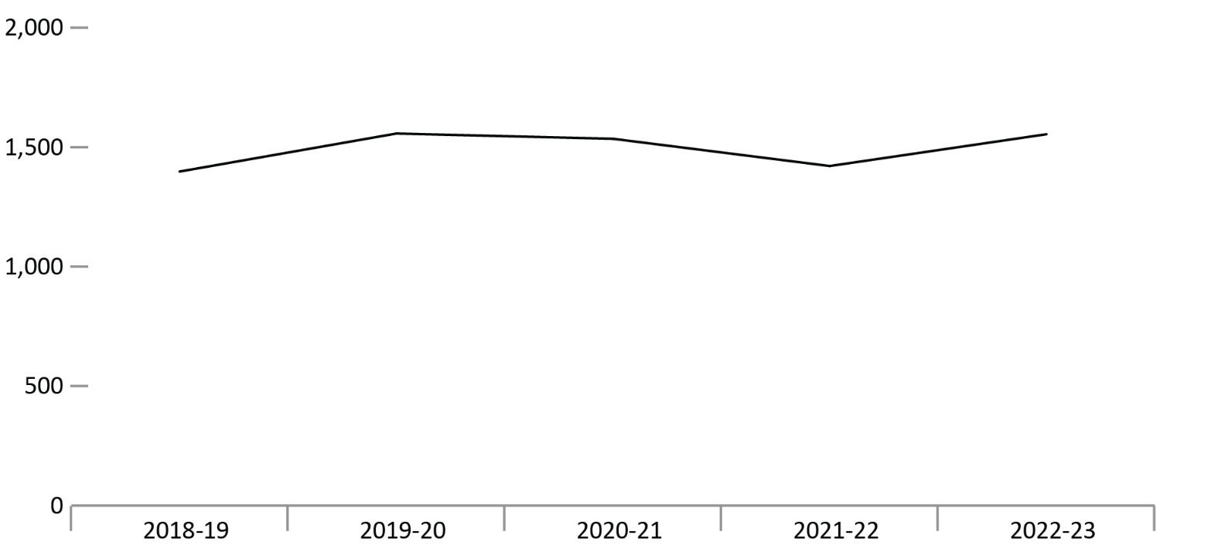
Source: Correctional Service of Canada.
- The number of victim statements received for consideration increased by 11.2% from 1,398 in 2018-19 to 1,554 in 2022-23.
Notes
The Canadian Victims Bill of Rights defines a victim as any individual who has suffered physical or emotional harm, property damage, or economic loss as the result of the commission of an offence. The law also allows a spouse, a relative or dependent, an individual who is responsible for the care or support of the victim or the care or support of a dependent of the victim, to act on behalf of a victim if the victim cannot act on their own behalf. Victims include persons harmed by the offender regardless of whether the offender has been prosecuted or not, as long as an official complaint has been made to the police or to the Crown.
CSC will consider statements from victims who choose not to register.
Not all statements received will be considered when release decisions are made; victims may choose to withdraw their statement before it is considered. In previous years, these withdrawn statements were included in the reported totals, but they have been excluded from the totals above given they are withdrawn before being considered.
Reported year periods reflect fiscal years. A fiscal year runs from April 1 to March 31 of the following year.

Table F2. Number of victim statements received for consideration in release decisions
Fiscal year | #
2018-19 | 1,398
2019-20 | 1,557
2020-21 | 1,535
2021-22 | 1,421
2022-23 | 1,554
Source: Correctional Service of Canada.
Notes
The Canadian Victims Bill of Rights defines a victim as any individual who has suffered physical or emotional harm, property damage, or economic loss as the result of the commission of an offence. The law also allows a spouse, a relative or dependent, an individual who is responsible for the care or support of the victim or the care or support of a dependent of the victim, to act on behalf of a victim if the victim cannot act on their own behalf. Victims include persons harmed by the offender regardless of whether the offender has been prosecuted or not, as long as an official complaint has been made to the police or to the Crown.
CSC will consider statements from victims who choose not to register.
Not all statements received will be considered when release decisions are made; victims may choose to withdraw their statement before it is considered. In previous years, these withdrawn statements were included in the reported totals, but they have been excluded from the totals above given they are withdrawn before being considered.
Reported year periods reflect fiscal years. A fiscal year runs from April 1 to March 31 of the following year.

Requests for financial assistance to attend parole hearings: 5-year trend

Figure F3. Number of requests for financial assistance to attend parole hearings
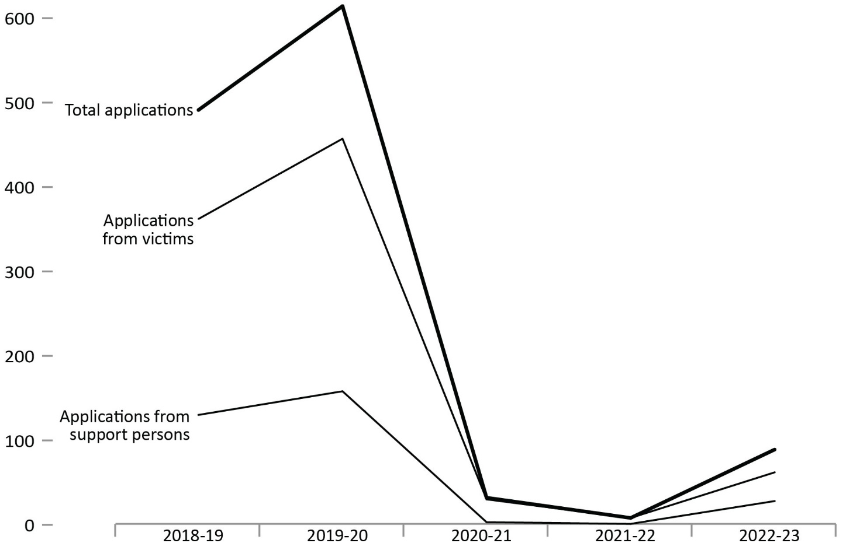
Source: Justice Canada.
- The number of victim applications for financial assistance increased between 2018-19 and 2019-20 and then had a sharp decline between 2019-20 and 2021-22. This decline was impacted by the COVID-19 pandemic related restrictions and limited access to CSC institutions, which began in mid-March 2020. To adapt to COVID-19, Parole Board of Canada hearings were conducted primarily by teleconference and/or video conference in 2020-21 and 2021-22.
- Between fiscal years 2021-22 and 2022-23, the total number of applications for financial assistance increased from 7 to 61.
Notes
The number of applications in 2022-23 include applications for hearings that ended up being changed from “in person” to “virtual”, and for hearings that were cancelled altogether.
Victims can apply for financial assistance for a support person to accompany them to a parole hearing.
Reported year periods reflect fiscal years. A fiscal year runs from April 1 to March 31 of the following year.

Table F3. Number of requests for financial assistance to attend parole hearings
Application type | 2018-19 | 2019-20 | 2020-21 | 2021-22 | 2022-23
Number of applications for financial assistance received from victims | 361 | 456 | 29 | 7 | 61
Number of applications for financial assistance received from support persons | 129 | 157 | 2 | 0 | 27
Total number of applications | 490 | 613 | 31 | 7 | 88
Source: Justice Canada.
Notes
The number of applications in 2022-23 include applications for hearings that ended up being changed from “in person” to “virtual”, and for hearings that were cancelled altogether.
Victims can apply for financial assistance for a support person to accompany them to a parole hearing.
Reported year periods reflect fiscal years. A fiscal year runs from April 1 to March 31 of the following year.

Number of Parole Board of Canada contacts with victims: 10-year trend

Figure F4. Number of PBC contacts with victims
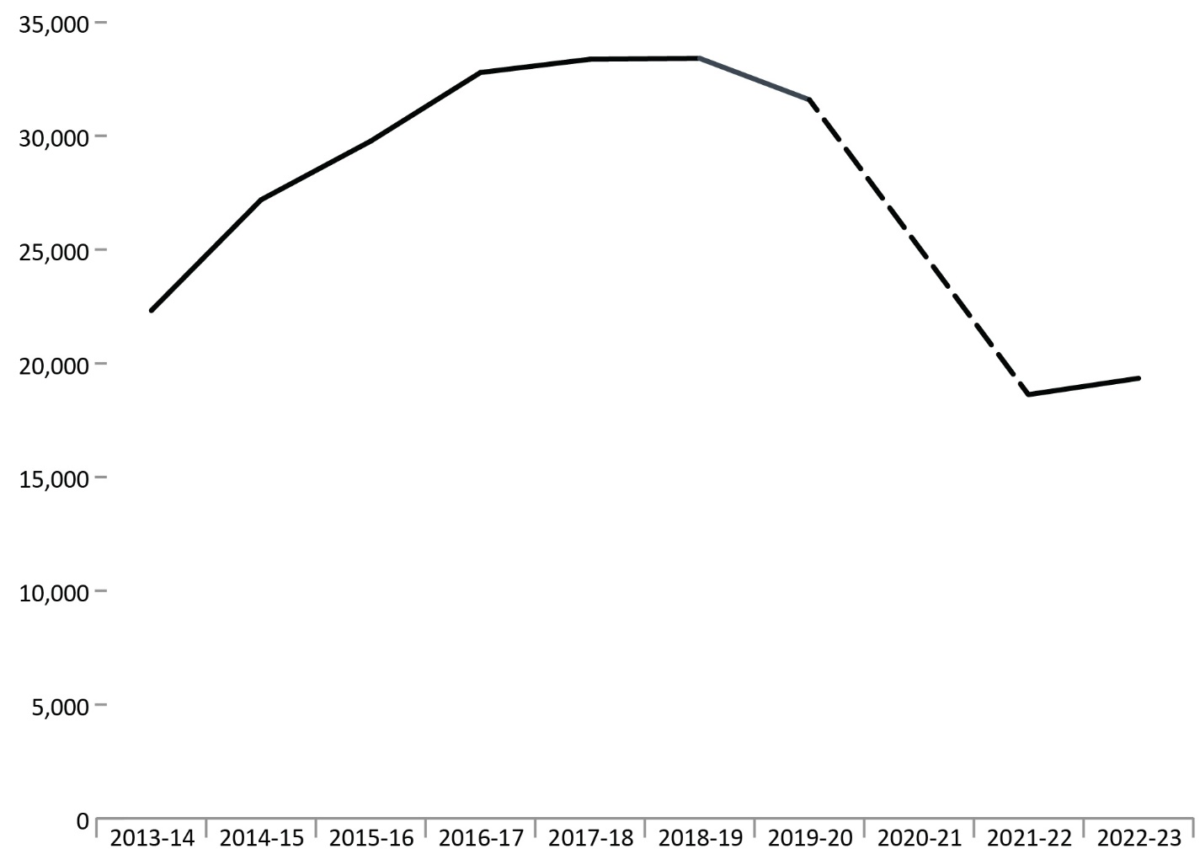
Source: Parole Board of Canada.
- In 2022-23, the Parole Board of Canada (PBC) reported 19,344 contacts with victims, an increase of 3.8% compared to 2021-22.
- In the past 10 fiscal years (from 2013-14 to 2022-23), the number of PBC contacts with victims decreased by 13.3% (2,979 fewer contacts)*.
Notes
*Data for 2020-21 are not available as the PBC transitioned from manual data collection to using an automated system, the Victims Application Module, during this timeframe. The reduction in contacts with victims between 2019-20 and 2021-22 is also the result of this transition to an automated system. A victim contact refers to each time the PBC has contact with a victim by mail, fax, telephone, in person, or through the Victims Portal.
Reported year periods reflect fiscal years. A fiscal year runs from April 1 to March 31 of the following year.

Table F4. Number of PBC contacts with victims
Fiscal year | Number of contacts
2013-14 | 22,323
2014-15 | 27,191
2015-16 | 29,771
2016-17 | 32,786
2017-18 | 33,370
2018-19 | 33,408
2019-20 | 31,587
2020-21 | NA*
2021-22 | 18,629
2022-23 | 19,344
Source: Parole Board of Canada.
Notes
“Not applicable” is abbreviated to “NA” in this table due to formatting.
*Data for 2020-21 are not available as the PBC transitioned from manual data collection to using an automated system, the Victims Application Module, during this timeframe. The reduction in contacts with victims between 2019-20 and 2021-22 is also the result of this transition to an automated system. A victim contact refers to each time the PBC has contact with a victim by mail, fax, telephone, in person, or through the Victims Portal.
Reported year periods reflect fiscal years. A fiscal year runs from April 1 to March 31 of the following year.

Victim presentations at PBC Hearings: 10-year trend

Figure F5. Number of victim presentations and number of hearings with victim presentations
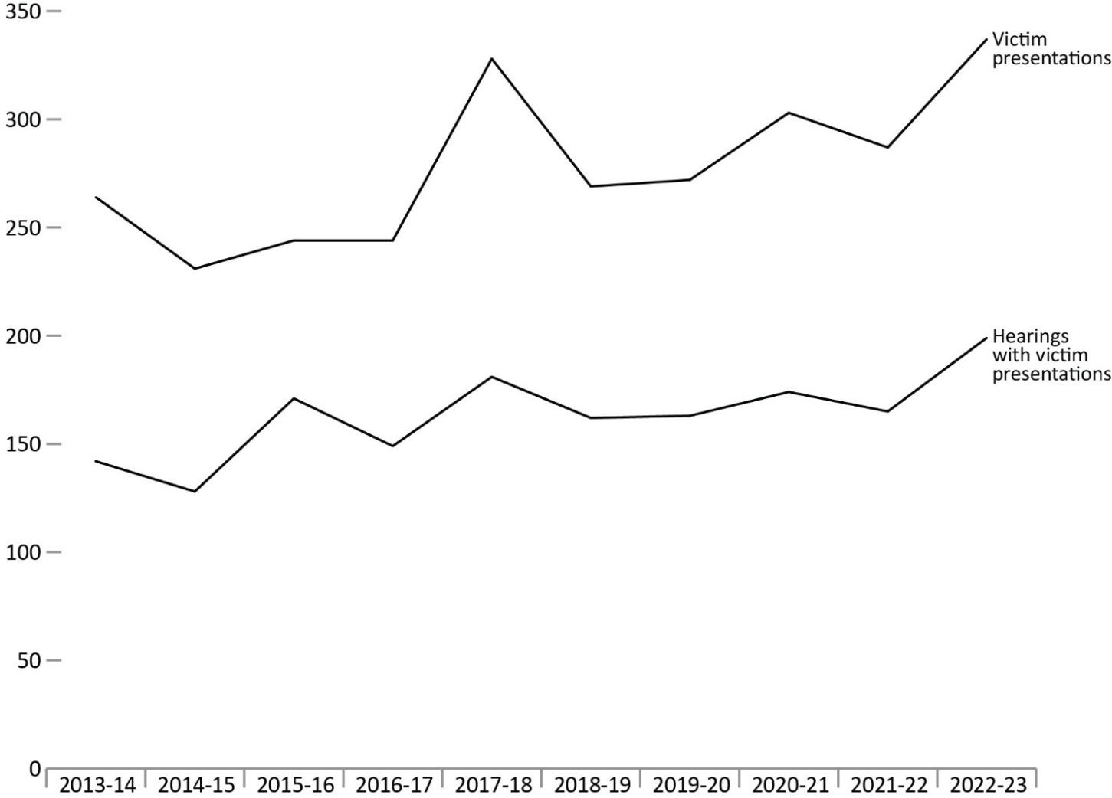
Source: Parole Board of Canada.
- In 2022-23, victims made 337 presentations (an increase of 17.4% or 50 presentations) at 199 hearings (an increase of 20.6% or 34 more hearings) compared to 2021-22.
- In 2022-23, there was a 2.6% increase (139 more hearings) in the total number of Parole Board of Canada hearings (with or without victim presentations) compared to 2021-22.
- In the past 10 fiscal years (from 2013-14 to 2022-23), the number of presentations made by victims at hearings has been fluctuating. In 2022-23, this number increased by 27.7% (73 more presentations) compared to 2013-14.
Notes
Reported year periods reflect fiscal years. A fiscal year runs from April 1 to March 31 of the following year.

Table F5. Number of victim presentations and number of hearings with victim presentations
Fiscal year | Number of hearings with presentations | Victim presentations
2013-14 | 142 | 264
2014-15 | 128 | 231
2015-16 | 171 | 244
2016-17 | 149 | 244
2017-18 | 181 | 328
2018-19 | 162 | 269
2019-20 | 163 | 272
2020-21 | 174 | 303
2021-22 | 165 | 287
2022-23 | 199 | 337
Source: Parole Board of Canada.
Notes
Reported year periods reflect fiscal years. A fiscal year runs from April 1 to March 31 of the following year.

Number of requests made by victims to access the PBC decision registry: 10-year trend

Figure F6. Total number of requests to access the decision registry vs. number of requests made by victims to access the decision registry*
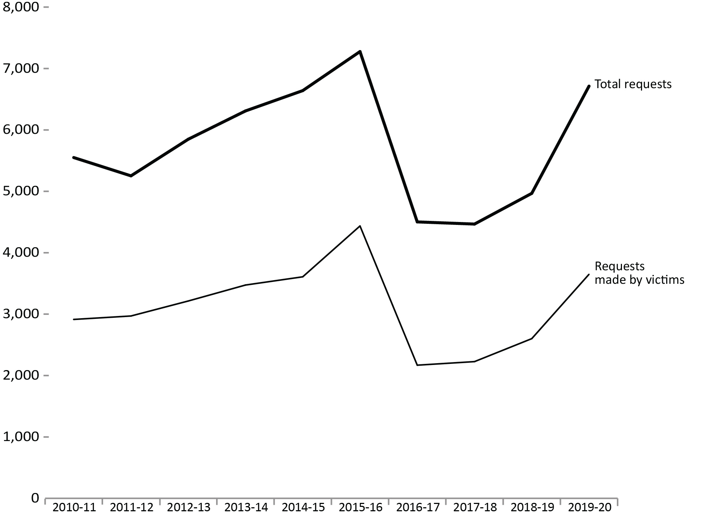
Source: Parole Board of Canada.
- In 2019-20, the number of requests to access the decision registry made by victims increased by 40.3% to 3,649 and the proportion of requests made by victims increased 2.0 percentage points to 54.4% compared to 2018-19.
- As of 2020, data on the number of requests are no longer reported and have been replaced by data on the number of decisions sent**.

Notes
Figure F6 in the 2023 CCRSO reflect the same data as the 2022 CCRSO.
* Additional information about the decision registry can be found at: https://www.canada.ca/en/parole-board/services/decision-registry.htm
** Presented in Figure/Table F7 in the 2023 CCRSO.
The Corrections and Conditional Release Act (CCRA) requires the Parole Board of Canada (PBC) to maintain a decision registry that includes the decisions made and the reasons for those decisions. The purpose of the decision registry is to contribute to public understanding of conditional release decision making and to promote openness and accountability. Anyone may request a copy of these decisions.
Victims also include victims' agents and victim organizations.
Reported year periods reflect fiscal years. A fiscal year runs from April 1 to March 31 of the following year.

Table F6. Total number of requests to access the decision registry vs. number of requests made by victims to access the decision registry*
Fiscal year | Requests made by victims | % | Total number of requests
2010-11 | 2,914 | 52.5 | 5,550
2011-12 | 2,970 | 56.5 | 5,252
2012-13 | 3,214 | 55.0 | 5,848
2013-14 | 3,474 | 55.1 | 6,309
2014-15 | 3,608 | 54.3 | 6,640
2015-16 | 4,436 | 61.0 | 7,276
2016-17 | 2,169 | 48.2 | 4,502
2017-18 | 2,227 | 49.9 | 4,467
2018-19 | 2,601 | 52.4 | 4,967
2019-20 | 3,649 | 54.4 | 6,713
Source: Parole Board of Canada.

Notes
Figure F6 in the 2023 CCRSO reflect the same data as the 2022 CCRSO.
* Additional information about the decision registry can be found at: https://www.canada.ca/en/parole-board/services/decision-registry.htm
The Corrections and Conditional Release Act (CCRA) requires the Parole Board of Canada (PBC) to maintain a decision registry that includes the decisions made and the reasons for those decisions. The purpose of the decision registry is to contribute to public understanding of conditional release decision making and to promote openness and accountability. Anyone may request a copy of these decisions.
Victims also include victims' agents and victim organizations.
As of 2020, data on the number of requests are no longer reported and will be replaced by data on the number of decisions sent. In 2020-21, the PBC transitioned from manual data collection to using an automated system.
Reported year periods reflect fiscal years. A fiscal year runs from April 1 to March 31 of the following year.

Number of decisions sent from PBC decision registry

Figure F7. Total number of decisions sent from the decision registry vs. number of decisions sent to victims from the decision registry*
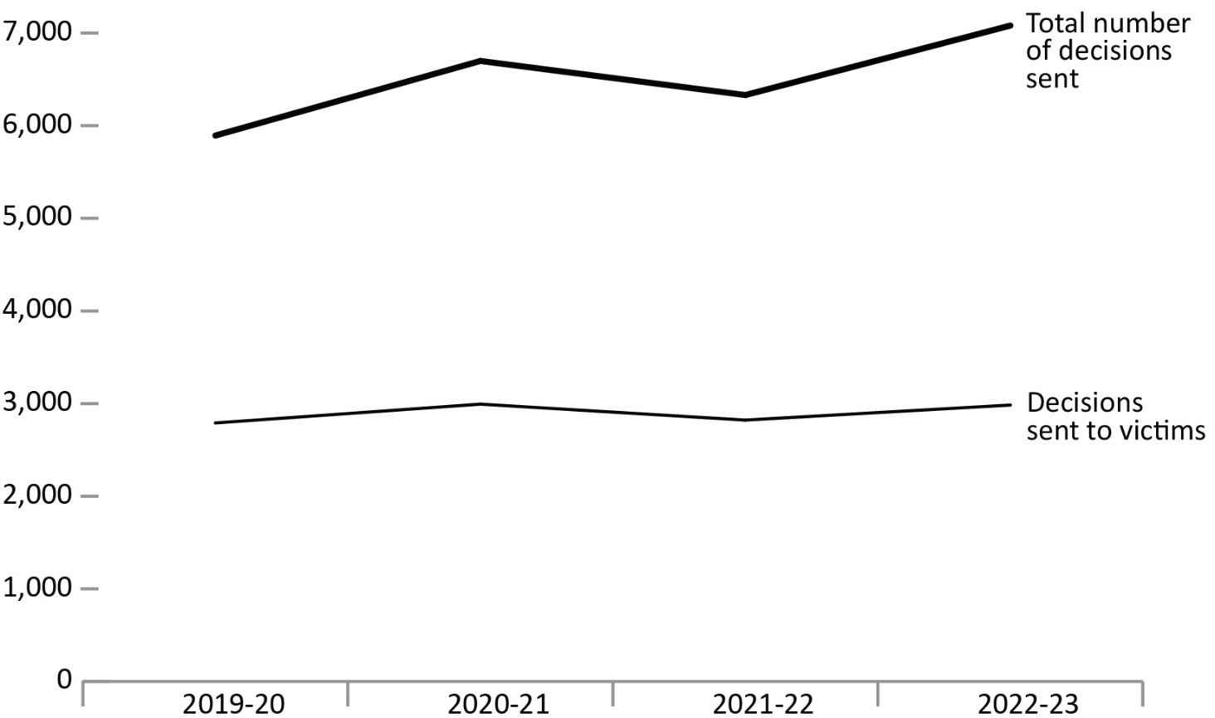
Source: Parole Board of Canada.
- In 2022-23, the number of decisions sent to victims from the decision registry increased by 5.7% to 2,984 while the proportion of decisions sent to victims decreased by 2.4 percentage points to 42.1% compared to 2021-22.
Notes
In 2020-21, the PBC transitioned from manual data collection to using an automated system, the Victims Application Module.
* Additional information about the decision registry can be found at: https://www.canada.ca/en/parole-board/services/decision-registry.htm
The Corrections and Conditional Release Act (CCRA) requires the Parole Board of Canada (PBC) to maintain a decision registry that includes the decisions made and the reasons for those decisions. The purpose of the decision registry is to contribute to public understanding of conditional release decision making and to promote openness and accountability. Anyone may request a copy of these decisions.
Victims also include victims' agents and victim organizations.
Reported year periods reflect fiscal years. A fiscal year runs from April 1 to March 31 of the following year.

Table F7. Total number of decisions sent from the decision registry vs. number of decisions sent to victims from the decision registry*
Fiscal year | Decisions sent to victims | % |  | Total number of decisions sent
2019-20 | 2,791 | 47.4 |  | 5,894
2020-21 | 2,994 | 44.7 |  | 6,699
2021-22 | 2,822 | 44.6 |  | 6,331
2022-23 | 2,984 | 42.1 |  | 7,081
Source: Parole Board of Canada.
Notes
In 2020-21, the PBC transitioned from manual data collection to using an automated system, the Victims Application Module.
* Additional information about the decision registry can be found at: https://www.canada.ca/en/parole-board/services/decision-registry.htm
The Corrections and Conditional Release Act (CCRA) requires the Parole Board of Canada (PBC) to maintain a decision registry that includes the decisions made and the reasons for those decisions. The purpose of the decision registry is to contribute to public understanding of conditional release decision making and to promote openness and accountability. Anyone may request a copy of these decisions.
Victims also include victims' agents and victim organizations.
Reported year periods reflect fiscal years. A fiscal year runs from April 1 to March 31 of the following year.

